All Saints Anglican Church
6904 Lougheed Highway, Agassiz, B.C. V0M 1A0
Bulletin June 15th, 2026 – June 21st, 2026

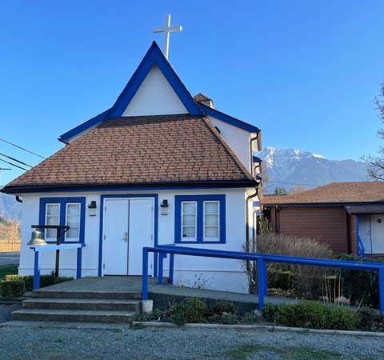


‘The ground we walk does not belong to us; for thousands of years it has been - and remains - the territory of the Stó:lō. We are grateful for their sharing.

Phone: 604-796-3553
Website: www.allsaints-agassiz.ca
https://www.facebook.com/groups/AllSaintsFamily
OUR DOOR IS OPEN AND ALL ARE WELCOME
June 21st, 2026, National Indigenous Day of Prayer
Priest in Charge: The Reverend Philip Barker
Hosts: Graham Featherstone/Jennifer Pinlac
Intercessor: Sheila Barker
Lay Administrator: Dorothy Cresswell
Announcer: Virginia Jennings
Organ/Piano: Francesca Froehlich
Readers: Andrea Hansen/Greg Veltman
Vicar’s cell phone: Revd. Philip Barker. 778-867-2461

Vicar’s Warden: Ginny Jennings. 604-796-2206
People’s Warden: Lynn Laughlin. 604-799-5131
Parish email: revpb1950@gmail.com
Please contact either warden if you have an issue that needs to be brought to the attention of the Vicar - or contact the Vicar direct (see above for details).

All Saint’s Calendar/Announcements:

- Book Club – On June 10th Book Club will be starting "Sensible Shoes" by Sharon Garlough Brown, an experienced leader of spiritual formation retreats in the UK and US. It follows 4 very different and very relatable female characters on their journey together through 12 one-day retreats.
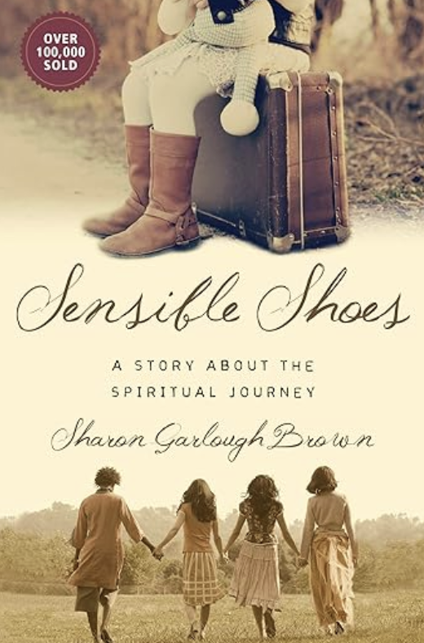

Please contact Sheila Barker at sjbarker0379@gmail.com
if you would like an invitation to the Zoom meetings
at 5.00 pm on Wednesdays or a copy of the book.
The book is available on amazon for $34.11 including tax.

- Bible Study is every Saturday morning 0830-0900 on Zoom. All are welcome to preview and discuss the readings for the Sunday service. Please ask Valerie to add your email address to the invitation list.

- Prayer Requests can be given on a piece of paper to either of the Wardens or the Vicar or entered in the Prayer Request Book on the lectern. Alternatively, you can contact Anthea Lewis at antheamlewis@shaw.ca for Pray First Prayer Circle, which is a confidential online prayer circle.

- Music Requests may be given to the Wardens or the Vicar.

- AA meets in the hall every Tuesday and Friday at noon.

- Every Thursday in the hall 1100-1200 we have a social time with coffee, games if you like or just talk.

- At 1000-1100 on Thursdays there is an Interactive Bible Study on the day’s Lectionary readings. All are welcome – discover the treasures in this amazing book!

- 5th Sunday of each month will be a potluck lunch after the service

Ministerial Meandering
Bookworm

“I read it somewhere!” - I complain, when someone asks me where on earth I got such an absurd idea from. And that’s the problem, I find. I have this annoying habit of remembering quite a lot of what I read - but I haven’t the vaguest notion of where I read it, when, or who the devil wrote it. Just a week ago I went off at a tangent in my sermon - as I am wont to do - and then attributed a quote to a French polymath (René Descartes), when it should have been François-Marie Arouet - pen-name, Voltaire - who wasn’t born until almost 50 years after Descartes had died. Thankfully, one knowledgeable parishioner (Rick Probert) set me right later that week.

There is a coaster in our house that gives me reassurance whenever I glance at it; advice for life is written upon it with the words; ‘Read good books - drink good tea.’ I am slow at both. Tea is always too hot to approach when you sit down with your ‘good book’, and by the time you have been able to set aside said book, the tea is tepid and half an hour has passed. You must zap the tea in the microwave to make it palatable, and then the whole process starts again - until you give up, drink the tea almost cold, and settle in with your book.

In the last few years I have taken to increasing my library by buying electronic books to read on my pad. (Note careful and impressive avoidance of any brand names here.) I tell myself that this is so that I will not have to physically transport all of the literature in paper form to our next house, wherever that may be. However, given what my electronic library now contains, I will definitely need to survive (before the cheese slides totally off my cracker) into my 90’s, as my father did and my uncle continues to do, in order to be able to mutter “I read it somewhere!” to whoever has the sheer obstinacy to be living with me at the time.

Nevertheless, one of the joys of reading is that I am constantly being introduced to new authors - new to me, at least, even if they have been dead for centuries. Occasionally, these new authors are still living and exciting to read; occasionally, they are still living - and really should have been dead for centuries.

It is helpful, in this regard, to have had the opportunity (if it should arise) to watch these worthies speak. You Tube is a helpful outlet for such characters, and I have found that when they are logical and articulate, and make interesting arguments in debate, then I am usually happy with their written oeuvre. There are others who are undoubtedly highly gifted and intelligent, but are quite incapable of forming a sentence that doesn’t contain at least three knight’s moves, requiring you to replay that section several times to see if you can get even the gist of their verbal gymnastics.

Modern access to written material comes at a cost. The feel and smell of an old book in a hard cover, with slightly yellowed pages, and a dedication or inscription inside the front cover to someone called ‘Digby’ or ‘Freda’, written lovingly in sloping, cursive black ink, ‘on the occasion of your twenty-first birthday’ and dated 1892 - all these pleasures are irreplaceable by electronic readers, and so are lost.

Just so, but the world of the written word carries its own music, whether it be fact or fantasy, and because it does, I am incapable of reading with any kind of musical background. I either do the one or the other - read or listen. It really doesn’t matter as both may put me in touch with the transcendent - and frequently the numinous. At present, reading is quieter.

Philip+

A Little Chuckle…



Diocesan Cycle of Prayer: We Pray for the Clergy and Congregation:

St. Michael Centre, Burnaby – Mr Tony Sauder, The Revd Justin Cheng; St. Philip, Vancouver - The Revd Anne Privett

Anglican Church of Canada Cycle of Prayer – We Pray for:

The Provincial Synod of the Ecclesiastical Province of Northern Lights. The National Indigenous Day of Prayer: for healing and reconciliation between Indigenous and non-Indigenous Peoples

Collect

O God our defender, storms rage about us and cause us to be afraid. Rescue your people from despair, deliver your sons and daughters from fear, and preserve us all from unbelief; through your Son, Jesus Christ our Lord, who lives and reigns with you and the Holy Spirit, one God, now and ever.

Isaiah 40:25-31 Andrea Hansen

²⁵ “To whom will you compare me?
Or who is my equal?” says the Holy One.
²⁶ Lift up your eyes and look to the heavens:
Who created all these?
He who brings out the starry host one by one
and calls forth each of them by name.
Because of his great power and mighty strength,
not one of them is missing.

²⁷ Why do you complain, Jacob?
Why do you say, Israel,
“My way is hidden from the Lord;
my cause is disregarded by my God”?
²⁸ Do you not know?
Have you not heard?
The Lord is the everlasting God,
the Creator of the ends of the earth.
He will not grow tired or weary,
and his understanding no one can fathom.
²⁹ He gives strength to the weary
and increases the power of the weak.
³⁰ Even youths grow tired and weary,
and young men stumble and fall;
³¹ but those who hope in the Lord
will renew their strength.
They will soar on wings like eagles;
they will run and not grow weary,
they will walk and not be faint.

Psalm 19

¹ The heavens declare the glory of God;
the skies proclaim the work of his hands.
² Day after day they pour forth speech;
night after night they reveal knowledge.
³ They have no speech, they use no words;
no sound is heard from them.
⁴ Yet their voice goes out into all the earth,
their words to the ends of the world.
In the heavens God has pitched a tent for the sun.
⁵ It is like a bridegroom coming out of his chamber,
like a champion rejoicing to run his course.
⁶ It rises at one end of the heavens
and makes its circuit to the other;
nothing is deprived of its warmth.

⁷ The law of the Lord is perfect,
refreshing the soul.
The statutes of the Lord are trustworthy,
making wise the simple.
⁸ The precepts of the Lord are right,
giving joy to the heart.
The commands of the Lord are radiant,
giving light to the eyes.
⁹ The fear of the Lord is pure,
enduring forever.
The decrees of the Lord are firm,
and all of them are righteous.

¹⁰ They are more precious than gold,
than much pure gold;
they are sweeter than honey,
than honey from the honeycomb.
¹¹ By them your servant is warned;
in keeping them there is great reward.
¹² But who can discern their own errors?
Forgive my hidden faults.
¹³ Keep your servant also from willful sins;
may they not rule over me.
Then I will be blameless,
innocent of great transgression.

¹⁴ May these words of my mouth and this meditation of my heart
be pleasing in your sight,
Lord, my Rock and my Redeemer.

Philippians 4:4-9 Greg Veltman

⁴ Rejoice in the Lord always. I will say it again: Rejoice! ⁵ Let your gentleness be evident to all. The Lord is near. ⁶ Do not be anxious about anything, but in every situation, by prayer and petition, with thanksgiving, present your requests to God. ⁷ And the peace of God, which transcends all understanding, will guard your hearts and your minds in Christ Jesus.

⁸ Finally, brothers and sisters, whatever is true, whatever is noble, whatever is right, whatever is pure, whatever is lovely, whatever is admirable—if anything is excellent or praiseworthy—think about such things. ⁹ Whatever you have learned or received or heard from me, or seen in me—put it into practice. And the God of peace will be with you.

John 1:1-18 Vicar Philip Barker
¹In the beginning was the Word, and the Word was with God, and the Word was God. ² He was with God in the beginning. ³ Through him all things were made; without him nothing was made that has been made. ⁴ In him was life, and that life was the light of all mankind. ⁵ The light shines in the darkness, and the darkness has not overcome it.

⁶ There was a man sent from God whose name was John. ⁷ He came as a witness to testify concerning that light, so that through him all might believe. ⁸ He himself was not the light; he came only as a witness to the light.

⁹ The true light that gives light to everyone was coming into the world. ¹⁰ He was in the world, and though the world was made through him, the world did not recognize him. ¹¹ He came to that which was his own, but his own did not receive him. ¹² Yet to all who did receive him, to those who believed in his name, he gave the right to become children of God— ¹³ children born not of natural descent, nor of human decision or a husband’s will, but born of God.

¹⁴ The Word became flesh and made his dwelling among us. We have seen his glory, the glory of the one and only Son, who came from the Father, full of grace and truth.

¹⁵ (John testified concerning him. He cried out, saying, “This is the one I spoke about when I said, ‘He who comes after me has surpassed me because he was before me.’”) ¹⁶ Out of his fullness we have all received grace in place of grace already given. ¹⁷ For the law was given through Moses; grace and truth came through Jesus Christ. ¹⁸ No one has ever seen God, but the one and only Son, who is himself God and is in closest relationship with the Father, has made him known.

