Prelude – Surely the Presence of the Lord is in This Place Jan Knewtson

Words of Welcome

╬ Call to Worship
We come together seeking God's mercy, grace, and truth.
God knows us completely, yet still welcomes us into His presence.
We trust in the Lord and seek His wisdom above our own understanding.
We lift our hearts in praise to the Lord!
Come, let us worship the God who guides our path;
We worship the One who leads us in righteousness. Amen!

╬ Passing the Peace
All may greet one another in the name of the Lord.
╬ Guide Me, O Thou Great Jehovah № 127
Joys & Concerns
Pastoral Prayer

The Lord’s Prayer

Children’s Time

╬ Prayer for Illumination
Gracious God, as we hear Your Word this day,
open our minds to Your wisdom and our hearts to Your truth.
Keep us from trusting only in our own understanding,
and guide us in the way that leads to life.
By Your Holy Spirit, help us receive Your Word with faith, humility, and obedience. Through Jesus Christ our Lord. Amen.

Scripture: Proverbs 14:9 - 12

╬ Gloria Patri № 70

Sermon: These Things I Know – “Sin is Still Sin”

Moments of Reflection

╬ Dear Jesus, In Whose Life I See № 468
Tithes and Offerings
Offertory – All Because of God’s Amazing Grace Jan Knewtson
╬ Doxology № 95

╬ Prayer of Dedication
Generous God, all that we have comes from You.
Receive these gifts and use them for Your purposes in the world.
As we dedicate these offerings, we also offer ourselves - our time, talents, and hearts - to Your service. Guide us in Your wisdom and lead us in the paths of righteousness; through Jesus Christ our Lord. Amen.

╬ Take My Life, and Let It Be № 399

╬ Connections

╬ Benediction
Go in the wisdom of God, trusting His way above all others.
We will walk in His truth, follow His path, and serve Him with joy. Amen.

Postlude – The Lord Bless You and Keep You Jan Knewtson

CALENDAR OF EVENTS – WEEK OF June 21st- June 27th
Today 9:30 am Sunday Worship| HAPPY FATHER’ DAY
NOISY CAN | PIZZA HUT SUNDAY
June 22nd 7:00 am UMM Men’s Breakfast (Final one)
4:45 pm Boot Camp at Calvary Life Center
June 23rd 8 am & 4:45 pm Boot Camp at Calvary Life Center
6:30 pm Boy Scouts at Calvary Life Center
June 24th 8am & 4:45pm Boot Camp at Calvary Life Center
June 25th 8am & 4:45pm Boot Camp at Calvary Life Center
1:00 pm Prayer Shawls at Wesley UMC
4:00 pm TOPS at Calvary Life Center
June 26th 8:00 am Boot Camp at Calvary Life Center
All Day Offices Closed
June 27th

OUR PRAYERS AND THOUGHTS
Please be in prayer for: Independence 1st UMC. Pastor Sangyeop Han.
Continuing Prayers: Spencer & Helen Ambler, Debbie Spait, Chris Callier, Beverly Franklin, Terry & Sandy Rodgers, Jerry Smith, David Wichman, Sandy Wolf - Buche, Vernon Miller, Maria (infant great-granddaughter of Larry & Pam Hart), Vic Edwards (Son-in-Law of Marvin & Donna Valentine), Craig Sargeant (Brenda Sargeant’s Son), Jack Stanley, Linda Johnson, Jeff Jackson (Norma Jackson’s Son), Matt Schwenk (Karen Lee’s Son-in-law), Penny Miller (Joann Miller’s Daughter), Becky Rourk, Donna Beebe, Bill Mentzer(Shellie Regehr’s Uncle), Yvonne Dunlap, The Friends & Family of Fred Church & Susan Catron.
Care Home Residents: Baldwin Rehab: Cheryl Moyer. Greystone: Barbara Letsinger, Kathleen Sinclair, Dianna Cuppy, Eleanor Ross, Deanna Buche- Wright. Oswego Health & Rehab: Lois Kerns, Pittsburg Health & Rehabilitation: Jan Powell Credo Senior Living: Ken Groves. Dignity Care Home: Joann Maxwell Heartland: Jean Roberts.
Hometouch: Debbi Sebbert, Don & Frances Wiles, Betty & Jerry Skidmore.

Pastor Owen is available by phone (620.228.1976), text, or email
(iolawesleypastor@gmail.com) Monday - Thursday during his office hours 9:00 - 3:30. After
hours, for emergency only. All prayer requests should be submitted to the church office by phone at 620.365.2285 or by email iolawesley@gmail.com

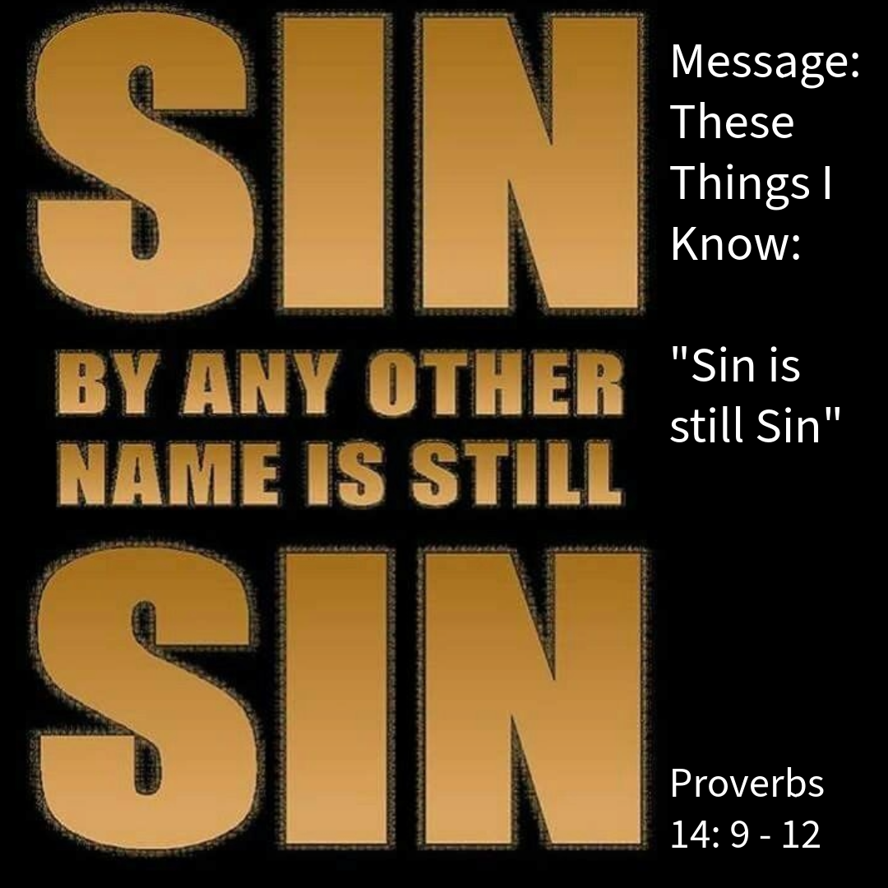
Wesley United Methodist Church
June 21, 2026
Proverbs 14:9 - 12
Fools mock at the guilt offering,^{[a]}
but the upright enjoy God’s favor.
¹⁰ The heart knows its own bitterness,
and no stranger shares its joy.
¹¹ The house of the wicked is destroyed,
but the tent of the upright flourishes.
¹² There is a way that seems right to a person,
but its end is the way to death.^{[b]}

