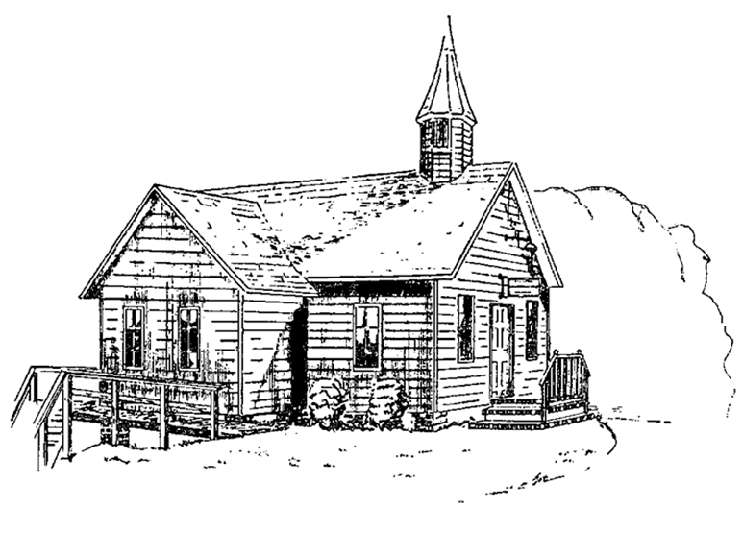
Colington United Methodist Church
June 21, 2026
Fourth Sunday after Pentecost

welcome and announcements
introit
Let’s Just Praise the Lord
prelude and lighting of altar candles
I Love You, Lord Klein/Griffin
call to worship
The Lord is in his holy temple;
Let all the earth keep silence before him.
O come, let us worship and bow down.
Let us kneel before the Lord, our maker!
†opening medley
Let the Redeemed
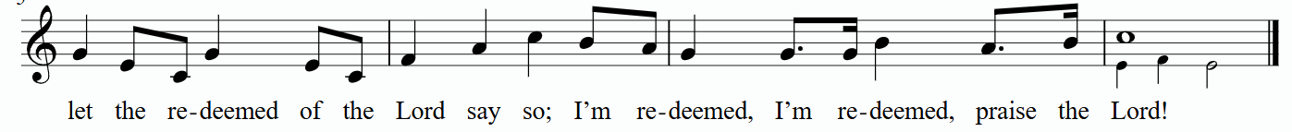
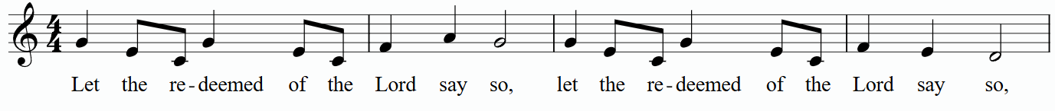

We Bring the Sacrifice

He Has Made Me Glad

He Is Here

the prayers of the people
the first lesson
Jeremiah 20:7-13
anthem
Standing On the Promises
the second lesson
Genesis 21:8-21
sermon
“Do What Sarah Says” ǀ Rev. Jack Colenda
silent reflection
†affirmation of praise
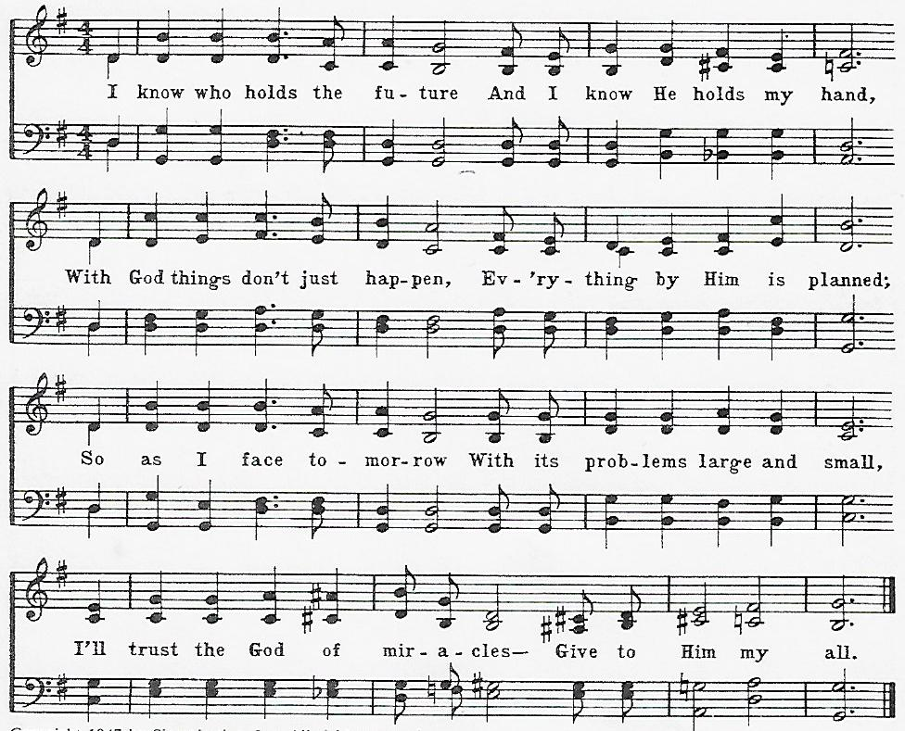
I Know Who Holds the Future

holy communion
†closing hymn
When We All Get to Heaven ǀ UMH 701

†benediction

this week at colington
These opportunities to serve as the Body of Christ are available.
Tuesday – 9 am – Prayer Group
6:15pm – Beach fellowship at Ocean Bay Blvd. beach access.
Wednesday – 10am – Knitters and crocheters meet.
1:45pm - Volunteers to Beach Food Pantry.

coming up
Next Sunday – 8:15 – choir practice
9:30 am – Worship, in-person and Facebook Live

Thanks to today’s volunteers!
Ushers – Steve Knowles/ Ozzie Gray
Scripture Reader – Sherry Rollason
Communion Assistant – Ozzie Gray

The flowers on the altar are given by Becky Eanet in celebration of her niece Zea’s birthday.

