Frankston Methodist Church
P. O. Box 355
If you would like to change the way you receive the newsletter, please call Jennie at the church oﬃce, 903.876.2235, or email the oﬃce at fmc@frankstonmethodist.org 6/2026
Frankston, TX 75763-0035


 Frankston Methodist Messenger
“Making Disciples of Jesus Christ Who Worship Passionately, Love Extravagantly, and Witness Boldly”

Summer is an exciting season in the life of the church, especially for our children and youth. Two of the greatest opportunities we have to help young people grow in their faith are Vacation Bible School (VBS) and church camp. These ministries are much more than just summer activities—they are opportunities for lives to be changed by the love of Jesus Christ. For many children, VBS and church camp become moments they remember for the rest of their lives. They are places where seeds of faith are planted, friendships are formed, and young hearts begin to understand who God is and how deeply He loves them.
VBS creates a fun and welcoming environment where children can learn about Jesus through Bible stories, music, crafts, games, and fellowship. While children may come for the excitement and activities, they leave having heard the truth of the Gospel. VBS also gives churches a unique opportunity to reach families in the community who may not regularly attend church. A simple invitation to VBS can open the door for a child—and sometimes an entire family—to begin a relationship with Christ and become connected to the church family.
Church camp often allows young people to step away from distractions and spend time focused on God. Away from phones, schedules, and daily routines, students have the opportunity to worship, study Scripture, and build meaningful Christian friendships. Many pastors, church leaders, and faithful Christians can point back to a church camp experience as a turning point in their spiritual journey. It is often at camp where young people feel called into ministry, surrender their lives to Christ, or deepen their faith in powerful ways.
As we get into our summer activities, I ask that you pray for our VBS and Church Camp this year that the people, adults and children, will be moved by God and strengthened in their relationship with him. If you have young children who you think would enjoy VBS, please get them signed up! Lastly, consider joining the fun next year for camp and make lifelong memories.
Blessings, Pastor Jacob

JUNE CALENDAR
Jun 2 6 pm Choir practice, sanctuary
Jun 3 6 pm Deadline for donating items for the Rummage Sale, FLC
Jun 4 8 am – 6 pm Final workday to prepare for Rummage Sale, FLC
Jun 5 7 am – 6 pm RUMMAGE SALE, FLC Jun 6 7 am – 1 pm RUMMAGE SALE, FLC
Jun 7 9:45 am Sunday School for everyone Jun 7 11 am Communion Worship service Jun 8 8:30 am Stocking Rainbow House, FLC Jun 8 5 pm Finance Committee meets, FLC Jun 8 5 – 7 pm Volleyball for anyone, FLC Jun 9 6 pm Choir practice, sanctuary
Jun 11 5 – 7 pm Pickleball & Cornhole for all, FLC
Jun 14 9:45 am Sunday School for everyone Jun 14 11 am Singing Sunday Worship service Jun 14 Noon Council of Ministries meets, fellowship hall, brown bag lunch, if necessary
Jun 15 5 – 7 pm Volleyball for anyone, FLC Jun 16 6 pm Choir practice, sanctuary
Jun 17 6 pm VBS leaders meet, FLC
Jun 18 5 – 7 pm Pickleball & Cornhole, FLC Jun 21 9:45 am Sunday School for everyone Jun 21 11 am Father’s Day Worship service Jun 22 8:30 am Stocking Rainbow House, FLC Jun 22 5 – 7 pm Volleyball for anyone, FLC Jun 23 9 – 11:30 am Rainbow House, FLC
Jun 23 6 pm Choir practice, sanctuary
Jun 25 5 – 6 pm Pickleball & Cornhole for all, FLC
Jun 25 6 pm Thursday Evening Praise Service, FLC
Jun 26 10 am – 2 pm Blood Drive, FLC
Jun 28 9:45 am Sunday School for everyone Jun 28 11 am Worship service
Jun 29 5 – 7 pm Volleyball for anyone, FLC Jun 30 6 pm Choir practice, sanctuary
Jun
6 pm Choir practice, sanctuary


June 14 is “Singing Sunday”!

Trinity Conference
Pastor Jacob and Ethan Lade (our lay delegate to Conference) will be attending Annual Conference, held in College Station, TX, June 4 – 6. Please pray that all attending will be led by the Holy Spirit in worship and in the decision-making work of the meetings.
We’ll be worshipping God through scripture and music — old favorites and new songs

too! Don’t miss the fun.

Council of

Following Worship on June 14 Fellowship Hall
All members have a vote – come and be a part of the decisions of our church!
Brown bag lunch, if desired.

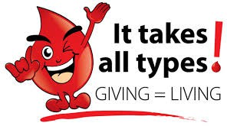
FRIDAY, JUNE 26
10 AM – 2 PM FAMILY LIFE CENTER



VBS – JULY 14-16
6 – 8 pm Family Life Center



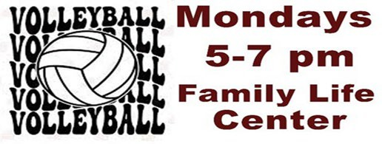
Welcoming all children, aged 4 – entering 6th grade. Please call 903.876.2235 for more information.

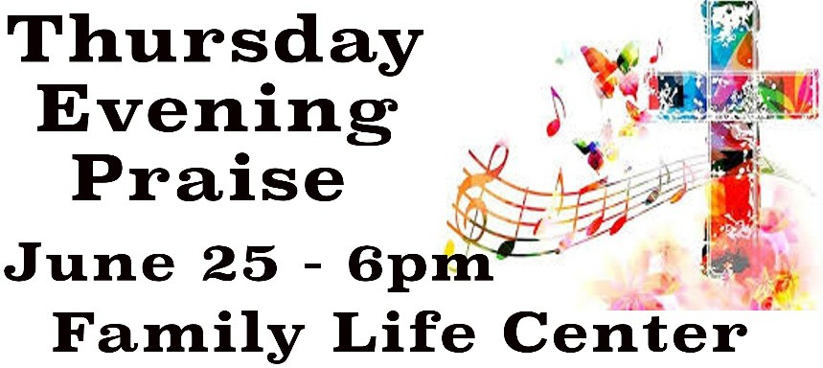

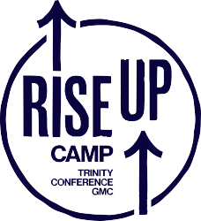
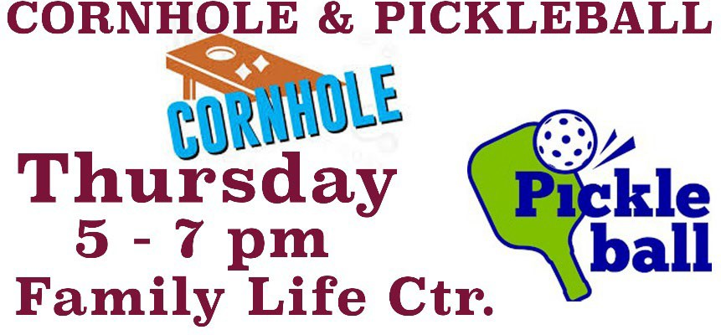
Please pray for a blessed and meaningful camp experience for all campers! Pastor Jacob and Kala Clary will be there June 8-12.

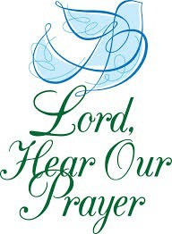
We Pray For….Family of Rudy Hambrick; Family of Kenneth Lookabaugh; Family of Scott Starkey, Tyler Firefighter friend of Hunt Vinzant; Family of Doug Steger; Family of Una Mae Nichols; Family of Marie Chaneyworth; Billy Miller, longtime LaRue firefighter, on ventilator due to
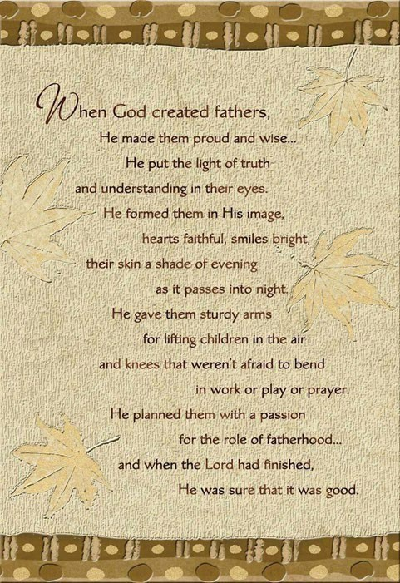
severe infection; Barbara McCune, upcoming knee replacement, then chemo; Les Langdon, rehab after knee replacement; Katherine Daughtery, friend of Susan McCutcheon, upcoming brain surgery; Kathy Kinney, Elizabeth Lade’s mother, ongoing health concerns; Marlane Gaines, Barbara McCune’s sister, recovering from broken hip; Mary Kay Hoffman, Ann Tatum’s sister, recovering from hip replacement; those affected by war; military personnel and families; Eugene Brooks, ALS: Estelle Marble, Rita Pennell;s sister, ongoing health concerns; Jackee Taylor, Rainbow House friend, ongoing battle with Lupus; Ruby Havens Wagoner, continued cancer treatment; JoBeth Miller, Jody Henson’s daughter, ongoing weakness; Jody Henson, ongoing concerns with pain; Rachel Homan, ongoing health issues; Jim Dwyer, continued cancer treatment; Brenda Jaggers, continued serious health issues; Families affected by violence; Christians worldwide, who are being persecuted; those in nursing homes or shut in due to health; police, fire, and first responders; those in need, but unnamed. Pray for peace in our world and for our world leaders. Pray for our church.
Pray for Our Military

Alfredo Balderas PSC 840, Box 42
FPO, AE 09649
CPT. Allen, Jonathan 6174 Walking Stick Way Ft. Moore, GA 31905


13 Mark Tatum, Brian Frink
15 Steven Dennis 23 Cheryl Gee
22 Mark Lookabaugh
25 Maegan Stanly, Jupiter Martinez
29 Steven Johnson 30 Joe Brown

JUNE ACOLYTES
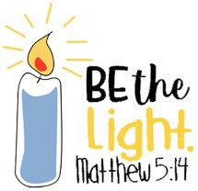
June 7 Gavin Lade June 14 Bellamy Lively June 21 N/A
June 28 Kala Clary

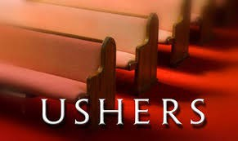
JUNE USHERS
June 7 Jamey Lade Family June 14 Frank Sweeney Family
June 21 Jim Johnson & Randy Randle June 28 Chris Sabulsky & Rick Seymour

A big “Thank You” to all who provided gift cards for our high school seniors. They were pleased and excited to get the cards and it really helped make the Senior Lunch extra special. Thanks also to you men who gave your time & energy to help us and to the Methodist Men for their monetary donation.
Frankston Methodist Women

