



This Week at PPBC
July 11, 2026

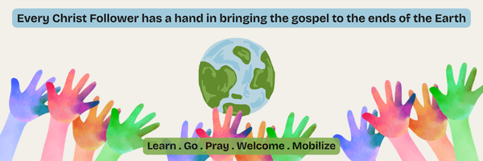A Prayer Request from the Lambs, they are asking us to pray for the Numonohi Christian Academy (NCA) in Papua New Guinea (PNG). This is the mission school Martin attended as a child. There is currently a desperate need for 4 schoolteachers. Please pray for us in this and please share this need in your circles of influence. Due to the timing of work permits and entry visas, etc. there is urgency to get the word out over the next two months in order to have teachers by August.


Notes

Sunday Ministry Schedules

Below are ministry schedules for Nursery, Jr. Church, Greeters, Ushers, and Sound & Video:

Nursery
June 21: Jan Gerrow, Jen Werner, Brantley Colwell
June 28: Laura Saunders, Amber Saunders, Grace Brown

Jr. Church; ages 3 to grade 1
June 21: Justine McKenzie
June 28: Ellianne McLaren, Abby Saunders

Jr. Church; Grades 2 to 6
June 21: Tracy Ballanger, Jen Owens
June 28: Gregg & Karen Anderson, Kim St-Onge

Greeters
June 21: Leno & Donna Araujo
June 28: Paul & Helen Jones

Ushers
June 21: Nick Woytowich, Eric Duchesne
June 28: Graeme Foster, Leno Araujo

Sound & Video
June 21: Sound: Charlie Deane | Video: Joshua Bolsonello
June 28: Sound: Wyatt Werner | Video: Josh Myers

Help Wanted
We're looking for 5 Parking Attendants to join the Welcome Team.
We are in need of assistance with our parking lot on Sunday mornings.
Help us keep our parking lot safe and orderly by considering serving in this way.
Please speak with Paul Sammut if you are interested.
Thank you

Sunday Service
Welcome
Song – Behold Our God
Scripture
Song – The Solid Rock
Song- My Worth is Not in What I Own
Prayer
Song – Speak O Lord
Message – Pastor Jim Clemens
Song – Facing a Task Unfinished

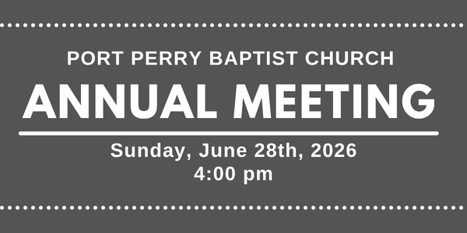

Praise & Prayer Highlights
PRAISE for the engagement of Peter and Kate Anderson. PRAY for them and their families as they prepare for their wedding and marriage in the fall.
PRAISE for Josh & Chelse Myers as they are expecting another baby in December. PRAY for them as they prepare and that mom and baby would continue to be healthy and safe.
PRAY for our Soccer Outreach continuing this Wednesday. PRAY for the Volunteers as they demonstrate the gospel to the children & their families. PRAY that hearts would be open and respond to the gospel.
PRAY for Dave & Mandy Myers. Dave was in a serious car crash last week. PRAY for continued health and recovery for Dave.
PRAY for Martin & Tina McCurley and their ongoing health concerns.
PRAY for Rob & Shelley VanUden and their nieces family. Their nieces daughter Bryte passed away. PRAY for Lindsey, her husband and their family as they mourn this loss. PRAY for Gods comfort and peace through this time.
PRAY for the Youth as they end their school year and prepare for summer jobs and camps. PRAY for their spiritual growth as they are away from home throughout the summer.

Giving
Just as a reminder, there are several ways you can give:
In Person using the offering box located on the back wall of the sanctuary. Donation envelopes are available at the Welcome Centre. Please contact the church office if you would like a box of donation envelopes (office@portperrybaptist.ca)
Through your online banking, you may send electronic transfers to ppbcdonations@gmail.com.
You can also give through Canada Helps. Donation receipts will be provided by Canada Helps, and transaction fees apply.
***********************************************************************
Weekly Newsletter
The PPBC Newsletter is emailed to the church family every Friday. If you would like to be added to the weekly email list, please contact the office by phone: 905-985-8681 or by email: office@portperrybaptist.ca.
*****************************************************************
Church Information:
Location:
2210 Hwy 7A
Port Perry, ON
L9L 1B4
Office Hours:
Monday: 8:30am – 4:00pm
Tuesday: 8:30am – 4:00pm
Wednesday: Closed
Thursday: 8:30am – 4:00pm
Friday: 8:30 am - 3:00 pm
Contact:
Phone: 905.985.8681
Email: office@portperrybaptist.ca
Website: www.portperrybaptist.ca
Staff:
Sr. Pastor – Rev. Jim Clemens
Administrative Assistant – Madeline Werner
Family Ministries Director – Josh Anderson
Pastoral Intern – Scott McKenzie

PPBC Newsletter
Sunday, June 21st, 2026


Sunday Starting Point
Sunday, June 21st, 2026 - 9:30 am
“Beginning the day with the Word and prayer”
Adults:
Adults will meet in the sanctuary for a time of study and prayer.
Youth:
Jr High (Grades 7-8) will meet in room 18 with Kate Anderson to study Thessalonians.
Children:
Children ages 3 - grade 6 will meet in room 26.
(Please note nursery is unavailable during Starting Point)
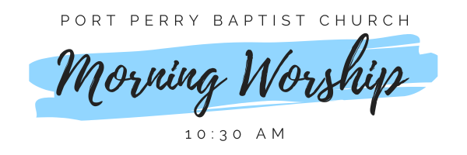Sunday Morning Worship
Sunday, June 21st, 2026 - 10:30 am
We are meeting in the sanctuary and will continue to live-stream for those who are unable to attend.
Message: Its Not About Me
Scripture: 1 Corinthians 9:1-23
Pastor Jim Clemens

