City Road United Methodist Church
A Lighthouse Congregation

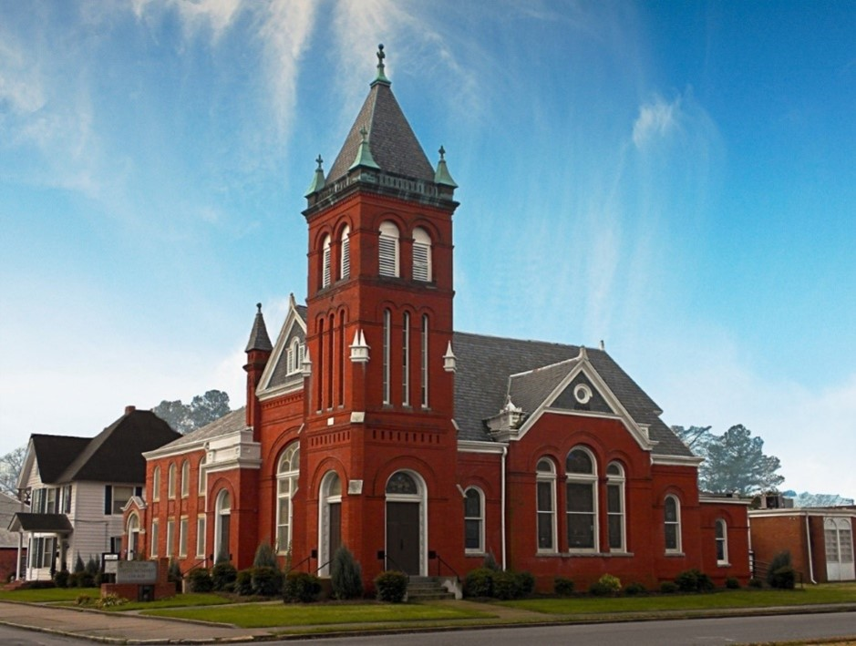
Rev. Josh Tester, Pastor

Office: (252) 335-2658
cityroadec.net crumcec@gmail.com

Facebook: https://www.facebook.com/CityRoadUMC

Sunday School: 10:00 a.m.
Sanctuary Worship: 11:00 a.m.

Tommy Venters- Organist/Choir Director
Dawn Baker- Secretary/Technology Specialist
JoAnn Herring- We Care

Service of Word
Pentecost Season
June 21st, 2026 11:00 am
Gathering
Prelude
*Introit “Spirit of the Living God” UMH 393
Words of Welcome
*Call to Worship
God meets us in surprising yet ordinary places—under a tree, in the smile of a stranger, in a refreshing breeze that comes at just the right time.
God, open our hearts to notice your presence all around us.
God speaks to us in surprising yet ordinary ways—in a well-placed word from a friend, in a prayer that comes at just the right time, in a song that resonates through our entire being.
God, open our minds to recognize your voice all around us.
God fulfills God’s promises in surprising yet ordinary ways—in an unexpected act of kindness, in providing just what we need at just the right time, in sending someone to listen when we feel alone.
God, open our hands to receive your blessings all around us.
Beloved, in the surprising and ordinary ways that God shows up among us, may we meet God and our neighbors with open hearts, minds, and hands, ready to encounter God’s miraculous work.

Let us Pray:
God, open our lives to receive your blessings, that we may share together in the joy, wonder, and laughter of God’s miraculous works all around us. Amen

*Sharing Peace
The Peace be with you!
And also with you!

*Hymn of Praise “Praise to the Lord, the Almighty” UMH 139

Proclamation & Response
Pastoral Prayer
The Lord’s Prayer
Our Father who art in heaven, hallowed be thy name. Thy kingdom come; thy will be done on earth as it is in heaven. Give us this day our daily bread, and forgive us our trespasses, as we forgive those who trespass against us; and lead us not into temptation but deliver us from evil. For thine is the kingdom, and power, and glory forever. Amen

Children’s Time
Call to the Offering
Offertory
*Doxology UMH 95
*Prayer of Dedication

*Hymn of Preparation “Amazing Grace” UMH 378
Verse 1

Anthem Chancel Choir

Old Testament Lesson Genesis 18:1-5
Message “A Miracle Called Laughter” Pastor Josh

*Affirmation of Faith
We believe in God, creator of the world and of all people; and in Jesus Christ, incarnate among us,who died and rose again; and in the Holy Spirit, present with us to guide, strengthen, and comfort.
We believe; God, help our unbelief.
We rejoice in every sign of God's kingdom: in the upholding of human dignity and community; in every expression of love, justice, and reconciliation; in each act of self-giving on behalf of others; in the abundance of God's gifts entrusted to us that all may have enough; in all responsible use of the earth's resources.
Glory be to God on high; And on earth, peace.
We commit ourselves individually and as a community to the way of Christ: to take up the cross; to seek abundant life for all humanity; to struggle for peace with justice and freedom; to risk ourselves in faith, hope, and love, praying that God's kingdom may come.
Thy kingdom come on earth as it is in heaven. Amen.

Sending Fourth
*Sending Hymn “Faith of Our Fathers” UMH710
*Benediction
*Postlude

