TLC Weekly: Sunday, June 21 – June 28
Vicar Angie DeSmith cell: 507-828-4941 email: amgiedesmith316@gmail.com
The Radio Broadcast (KMHL 1400AM or 101.7FM) is sponsored by Ronnie and Carol Dahl in memory of Ole & Joyce Grinde
Sunday, June 21 Happy Fathers Day
9am Worship/Communion
10am Coffee Fellowship
Monday, June 22 9am Men in Mission
Wednesday, June 24 9am Do Day Mission Work Day
Friday, June 26 OFFICE CLOSED
Sunday, June 28 9am Worship
10am Coffee Fellowship

Please continue to Remember in Prayer:
Please…
We are happy to include people in our prayer list, but we must have their permission to be included. Many folks are very private about what is happening in their lives and we want to honor that.
Peggy Isaacson – LaVerne Jessen’s daughter, cancer
Steve Vickerman – health issues
Kim Mickelson – cancer-cousin of Kari Meyer & Kris Tiegs
Vicki Schaar – Cancer
Lawrence Nyquist – Cancer, starting treatments, uncle of Dan &
Carl Nyquist
Mike Hemish – son of Doris Hemish

June Acolyte: Jared Swenhaugen, Caroline Engelkes

June Altar Preparation: Darcy Carlson, Sandy Fultz

June Communion Servers: Addison Kainz, Gail Kropp. Sue Magnuson

Coffee Fellowship: Sunday, June 21 Missie Erbes, Lina Munson
Sunday, June 28 Dennis & Anita Fultz

Scripture Readers: Sunday, June 21 Brenda Wieme
Sunday, June 28 Sheila Helleson

Greeters: Sunday, June 21 OPEN
Sunday, June 28 OPEN

Sunday Counters: Sunday, June 21 Jamie Leonard
Sunday, June 28 Matt LaVoy

Ushers: Sunday, June 21 Keith Hoffbeck, Scott Torkelson, Gabe Torkelson, Oliver Torkelson
Sunday, June 28 Chris Kamrud, Ronnie Dahl, Wayne Anderson, Darrell Christian

Radio opening for the month of July: 12th and 26th

Today our members who would like input on sanctuary carpet can vote on a carpet color. Meet in the sanctuary immediately following service.
Tracy Area Garden and Quilt Tour is July 8th, 2-7:30pm. Tickets $20 includes St Mary’s Pie and ice cream served at Key Largo. Check the kiosk for further details.

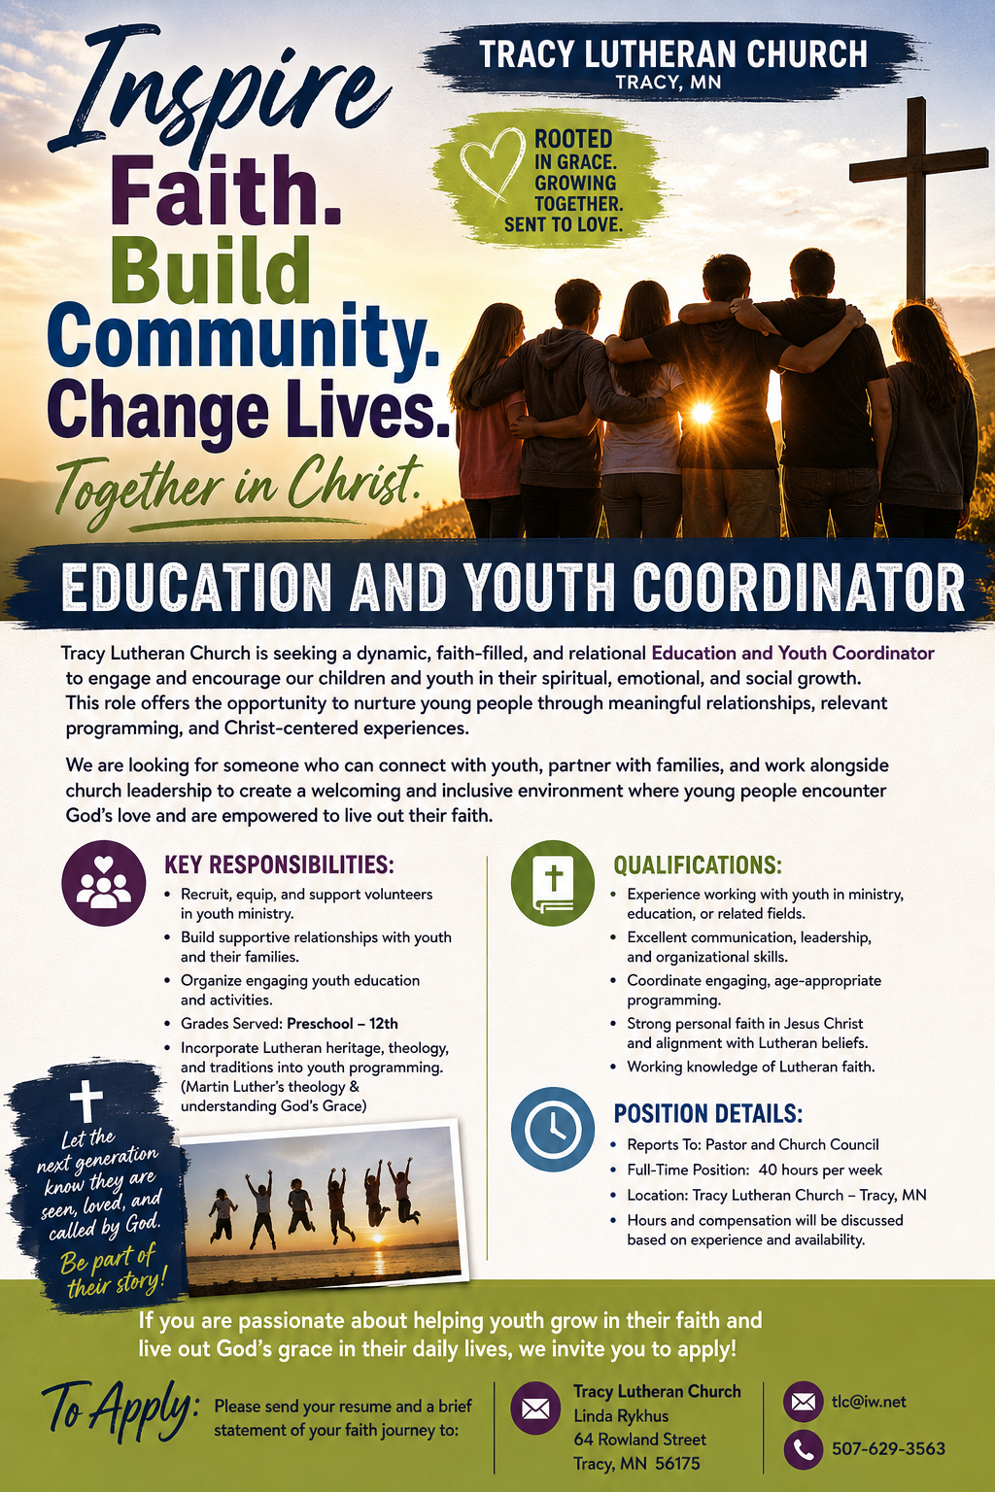
At the request of council president, Dennis Fultz, Tracy Lutheran Church is recognized as a Synod -Authorized Ministry site. Angie DeSmith has been authorized by Southwestern Minnesota Synod Bishop Dee Pederson to preach and preside for
Holy Communion in the congregation . The authorization is granted in accord with the ELCA’s guiding statement, The Use of the Means of Grace , which recognizes the witness of the sacrament as a celebration of the Church, serving its unity and
proclaiming the Gospel; and that where it is not possible to provide ordained pastoral leadership, a synod bishop may authorize a properly trained person to preside at a certain time.

