 | GLOW SCHOLARSHIP RECIPIENTS 2026

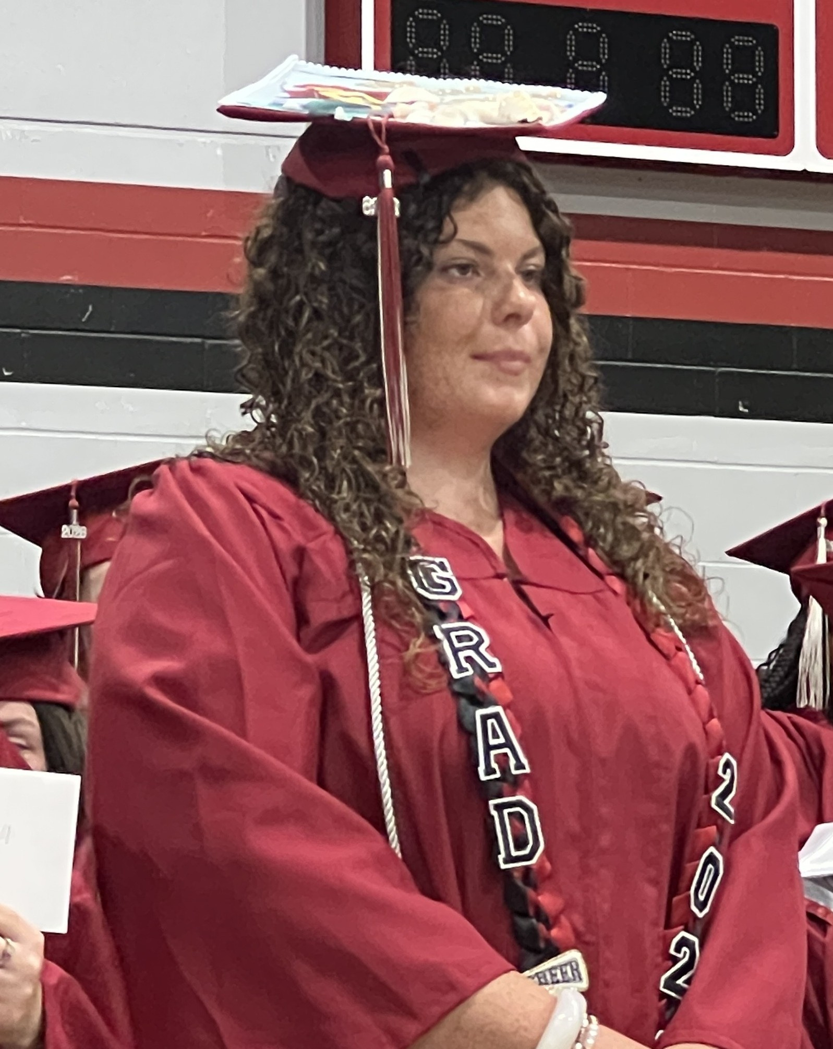 | MaKenna is a Franklin County graduate and proud first-generation college student who will be only the second in her family to pursue higher education. She plans to attend Lively Technical College for cosmetology, focusing on nails and waxing — a passion rooted in her love of helping others feel confident. A three-year Varsity cheer captain, competitive cheer captain and Homecoming Queen, MaKenna leads by example. Growing up in a lower-income household, she is deeply grateful for this scholarship — not only for what it means for her future, but for the financial relief it brings to parents who have sacrificed so much for her success.
MaKenna’s mentor is Bobbi Carey, owner of Lagom Salon in Eastpoint. After completing BOCES cosmetology training in New York in 1980, she joined a nationally recognized Connecticut salon featured in Vogue and Cosmopolitan, receiving advanced color training and studying cutting techniques with Vidal Sassoon. She went on to hold leadership roles including Artistic Director, Regional Manager and Talent Recruiter before opening her own studio in Ann Arbor. In 2021, she brought her expertise to Florida’s Forgotten Coast – making her a great mentor to guide MaKenna in her education.

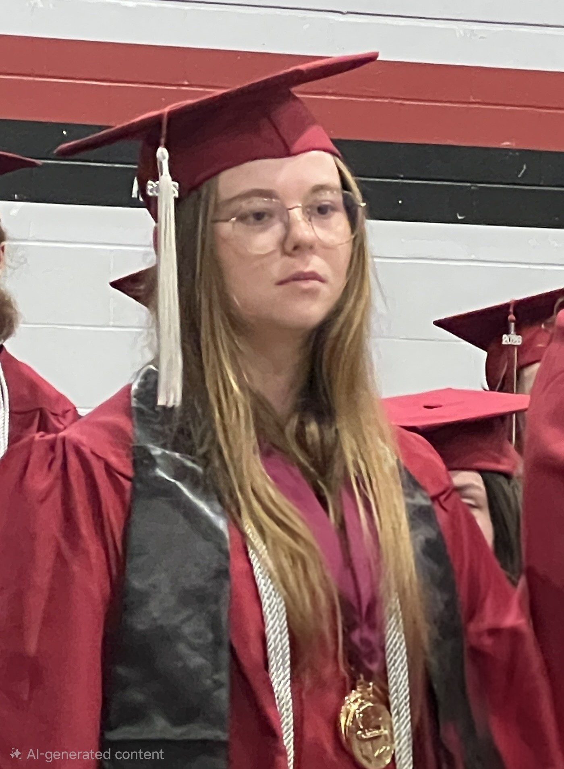 | Sheyanne is a driven Franklin County student graduating a full year early with a perfect 4.0 GPA — all while dual enrolled, playing sports and involved in multiple clubs. Her goal is to become a Certified Registered Nurse Anesthetist (CRNA). She has a clear five-step plan to get there, from earning her BSN to completing a DNAP program. A longtime GLOW participant and Cadet Corps member, Sheyanne has both benefited from and given back to the program. She is grateful for this scholarship because she believes hard work should be rewarded — especially when it helps someone build a future dedicated to helping others.
Sheyanne’s mentor is Ms. Nancy Gentry of St. George Island. Ms. Gentry earned her nursing diploma from Charity Hospital School of Nursing, a Bachelor of Science from Incarnate Word College and a Master’s in Public Health from the University of North Carolina. During her military career, she served at multiple Air Force bases and rose to the rank of Lieutenant Colonel. Her medical specialties include hemodialysis, medical-surgical nursing, renal dialysis, nephrology and oncology — making her an exceptional guide for Sheyanne as she pursues her dream of becoming a CRNA.

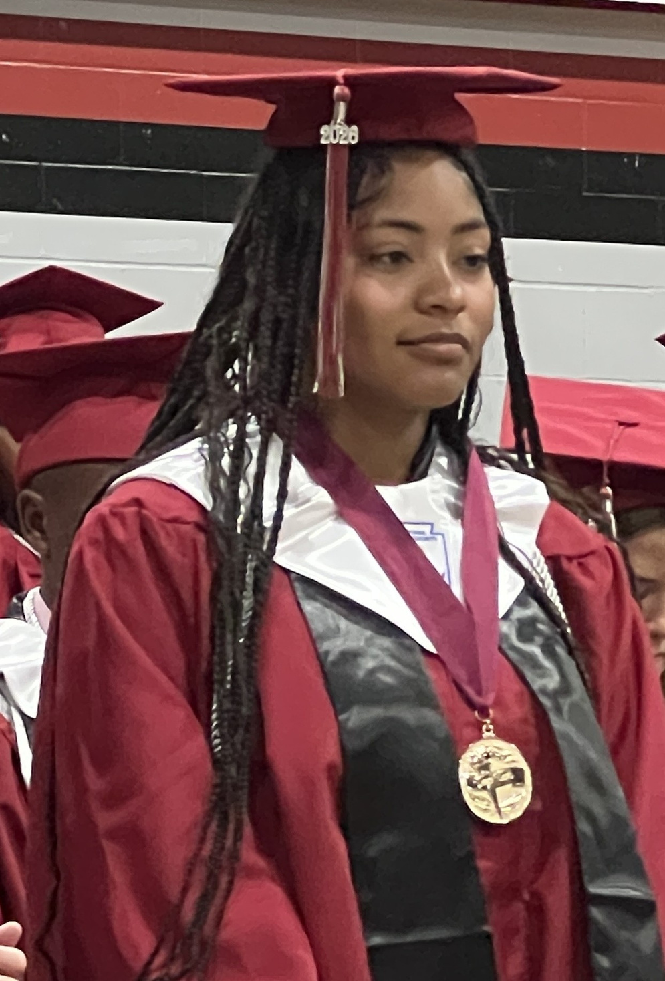 | Robyn is a determined Franklin County graduate with her sights set on becoming an FBI agent. She plans to attend college and major in Criminal Justice, driven by a lifelong passion for law enforcement, investigations and protecting others. Throughout high school, Robyn has balanced academics, competition cheer and work — building discipline, teamwork and independence along the way. She is committed to gaining internships and leadership experience in college to prepare for a career in federal law enforcement. Robyn is grateful for this scholarship because it will ease the financial burden of college and bring her one step closer to her dream of making a meaningful difference in her community.
Robyn’s mentor is Police Sgt. Ashley Webb of the Apalachicola Police Department, where she also serves as Public Information Officer. Sgt. Webb holds an A.A. in Criminal Justice from Gulf Coast State College, a B.S. in Criminology from Florida State University and a Master’s in Criminal Justice from Troy University. Her career spans the Florida Department of Corrections, the Franklin County Sheriff’s Office — where she served as School Resource Officer, Evidence Custodian, and Domestic Violence Investigator — and nearly five years with the Apalachicola Police Department. She is an ideal mentor for Robyn’s FBI ambitions.

