All Saints Anglican Church
6904 Lougheed Highway, Agassiz, B.C. V0M 1A0
Bulletin June 8th, 2026 – June 14th, 2026

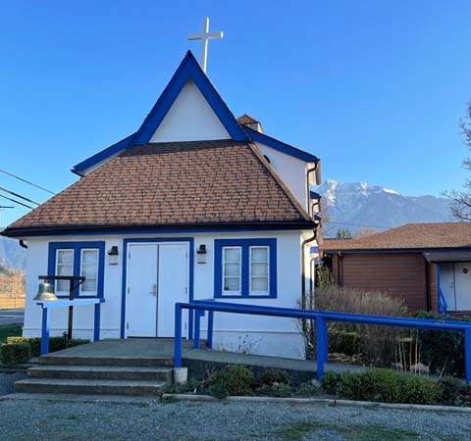

‘The ground we walk does not belong to us; for thousands of years it has been - and remains - the territory of the Stó:lō. We are grateful for their sharing.

Phone: 604-796-3553
Website: www.allsaints-agassiz.ca
https://www.facebook.com/groups/AllSaintsFamily
OUR DOOR IS OPEN AND ALL ARE WELCOME
June 14th, 2026, Third Sunday After Pentecost
Priest in Charge: The Reverend Philip Barker
Hosts: Graham Featherstone/Jennifer Pinlac
Intercessor: Jennifer Pinlac
Lay Administrator: Dorothy Cresswell
Announcer: Virginia Jennings
Organ/Piano: Francesca Froehlich
Readers: Dorothy Cresswell/Liane Loeppky
Vicar’s cell phone: Revd. Philip Barker. 778-867-2461

Vicar’s Warden: Ginny Jennings. 604-796-2206
People’s Warden: Lynn Laughlin. 604-799-5131
Parish email: revpb1950@gmail.com
Please contact either warden if you have an issue that needs to be brought to the attention of the Vicar - or contact the Vicar direct (see above for details).

All Saint’s Calendar/Announcements:

- Book Club – On June 10th Book Club will be starting "Sensible Shoes" by Sharon Garlough Brown, an experienced leader of spiritual formation retreats in the UK and US. It follows 4 very different and very relatable female characters on their journey together through 12 one-day retreats.
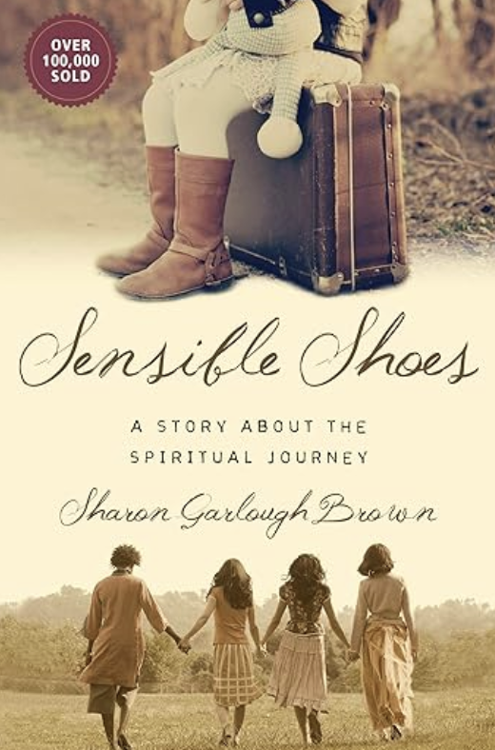

Please contact Sheila Barker at sjbarker0379@gmail.com
if you would like an invitation to the Zoom meetings
at 5.00 pm on Wednesdays or a copy of the book.
The book is available on amazon for $34.11 including tax.

- Bible Study with Karol is every Saturday morning 0830-0900 on Zoom.

- Prayer Requests can be given on a piece of paper to either of the Wardens or the Vicar or entered in the Prayer Request Book on the lectern. Alternatively, you can contact Anthea Lewis at antheamlewis@shaw.ca for Pray First Prayer Circle, which is a confidential online prayer circle.

- Music Requests may be given to the Wardens or the Vicar.

- AA meets in the hall every Tuesday and Friday at noon.

- Every Thursday in the hall 1100-1200 we have a social time with coffee, games if you like or just talk.

- At 1000-1100 on Thursdays there is an Interactive Bible Study on the day’s Lectionary readings. All are welcome – discover the treasures in this amazing book!

- 5th Sunday of each month will be a potluck lunch after the service

Ministerial Meandering
Billy the Bee 3

For Billy there was no greater authority than his queen. But he also knew that she would one day die, and that saddened him. ‘How wonderful’, he thought, ‘it would be if there was always someone to whom he could turn for advice at any time, and who would be a source of wisdom and comfort,’ - but his queen was too busy laying eggs to have any time for Billy. At least he knew his place and role in his society; that was what made him different from the lost humans he saw around him every day.

He wondered if they had a source of wisdom, advice, and comfort to whom they turned - and he set to observing them more closely. For most of them - especially the young ones - it seemed not. So they found other activities, it appeared.

Strangely, they did not talk to each other face to face very much, but talked or spent hours playing with little black or coloured slabs they held in their hands, their heads down, totally absorbed, and seemingly oblivious to the amazing world around them. Often they had small buds in their ears that must have made them deaf - or at least shut out the beauty of birdsong - and made those who wore them have a vacant expression and even less aware of anything around them - even dangers.
Others, with similar vacant expressions, looked around for others who would give them pills or powders to take; these would make them either crazy or seem to send them into a dream. They couldn’t ever seem to get enough of these substances, and were clearly as miserable as could be.
Yet others seemed to get pleasure from going around in groups. They would be having a happy time it appeared - for a while - and then they would attack someone and hurt them, sometimes even kill them, for no apparent reason - or perhaps because they were the wrong colour - whatever colour they were supposed to be. He could never work that out.
There were some, however, who didn’t appear quite so lost, and they seemed to come from small hives that had a couple of adult humans to whom they actually talked. They seemed happier and more focussed - there was a purpose in their step and an apparent direction in their lives. Indeed, there were schools or academies where whole large groups of young humans would be taught by instructors who showed them many things. These young humans had a presence and bearing completely different from the lost ones.

And he saw, too, that there were some humans who went to a building on a regular basis where they seemed to learn a different sort of lesson or teaching, and where they had music and singing, and afterwards the whole group in the building would have food and drink together and actually talk to each other, face to face - even the young ones. They were somehow different again from the lost ones. They seemed to have a quiet peace about them, and a sense of knowing their place in their society and their world. Billy felt happy about them; perhaps they had a queen who really cared.

Philip+

Something to think about…..

“I've learned that people will forget what you said, people will forget what you did, but people will never forget how you made them feel.”
Maya Angelou

Diocesan Cycle of Prayer: We Pray for the Clergy and Congregation:

The Coming Home Society – Mrs Linda Adams, ODNW, President; St. Anselm, Vancouver - The Revd Alecia Greenfield

Anglican Church of Canada Cycle of Prayer – We Pray for:

The Most Rev. Gregory Kerr-Wilson, Metropolitan, and the clergy and people of the Ecclesiastical Province of Northern Lights. Global partners and companions.

Collect

Almighty God, without you we are not able to please you. Mercifully grant that your Holy Spirit may in all things direct and rule our hearts; through Jesus Christ our Lord, who is alive and reigns with you and the Holy Spirit,
one God, now and for ever.

Genesis 18:1-15, 21:1-7 Dorothy Cresswell

¹The Lord appeared to Abraham near the great trees of Mamre while he was sitting at the entrance to his tent in the heat of the day. ² Abraham looked up and saw three men standing nearby. When he saw them, he hurried from the entrance of his tent to meet them and bowed low to the ground.

³ He said, “If I have found favor in your eyes, my lord, do not pass your servant by. ⁴ Let a little water be brought, and then you may all wash your feet and rest under this tree. ⁵ Let me get you something to eat, so you can be refreshed and then go on your way—now that you have come to your servant.”

“Very well,” they answered, “do as you say.”

⁶ So Abraham hurried into the tent to Sarah. “Quick,” he said, “get three seahs of the finest flour and knead it and bake some bread.”

⁷ Then he ran to the herd and selected a choice, tender calf and gave it to a servant, who hurried to prepare it. ⁸ He then brought some curds and milk and the calf that had been prepared, and set these before them. While they ate, he stood near them under a tree.

⁹ “Where is your wife Sarah?” they asked him.

“There, in the tent,” he said.

¹⁰ Then one of them said, “I will surely return to you about this time next year, and Sarah your wife will have a son.”

Now Sarah was listening at the entrance to the tent, which was behind him. ¹¹ Abraham and Sarah were already very old, and Sarah was past the age of childbearing. ¹² So Sarah laughed to herself as she thought, “After I am worn out and my lord is old, will I now have this pleasure?”

¹³ Then the Lord said to Abraham, “Why did Sarah laugh and say, ‘Will I really have a child, now that I am old?’ ¹⁴ Is anything too hard for the Lord? I will return to you at the appointed time next year, and Sarah will have a son.”

¹⁵ Sarah was afraid, so she lied and said, “I did not laugh.”

But he said, “Yes, you did laugh.”

¹Now the Lord was gracious to Sarah as he had said, and the Lord did for Sarah what he had promised. ² Sarah became pregnant and bore a son to Abraham in his old age, at the very time God had promised him. ³ Abraham gave the name Isaac to the son Sarah bore him. ⁴ When his son Isaac was eight days old, Abraham circumcised him, as God commanded him. ⁵ Abraham was a hundred years old when his son Isaac was born to him.

⁶ Sarah said, “God has brought me laughter, and everyone who hears about this will laugh with me.” ⁷ And she added, “Who would have said to Abraham that Sarah would nurse children? Yet I have borne him a son in his old age.”

Psalm 116:1, 10-17

¹ I love the Lord, for he heard my voice;
he heard my cry for mercy.

¹⁰ I trusted in the Lord when I said,
“I am greatly afflicted”;
¹¹ in my alarm I said,
“Everyone is a liar.”

¹² What shall I return to the Lord
for all his goodness to me?

¹³ I will lift up the cup of salvation
and call on the name of the Lord.
¹⁴ I will fulfill my vows to the Lord
in the presence of all his people.

¹⁵ Precious in the sight of the Lord
is the death of his faithful servants.
¹⁶ Truly I am your servant, Lord;
I serve you just as my mother did;
you have freed me from my chains.

¹⁷ I will sacrifice a thank offering to you
and call on the name of the Lord.

Romans 5:1-8 Liane Loeppky

¹Therefore, since we have been justified through faith, we have peace with God through our Lord Jesus Christ, ² through whom we have gained access by faith into this grace in which we now stand. And we boast in the hope of the glory of God. ³ Not only so, but we also glory in our sufferings, because we know that suffering produces perseverance; ⁴ perseverance, character; and character, hope. ⁵ And hope does not put us to shame, because God’s love has been poured out into our hearts through the Holy Spirit, who has been given to us.

⁶ You see, at just the right time, when we were still powerless, Christ died for the ungodly. ⁷ Very rarely will anyone die for a righteous person, though for a good person someone might possibly dare to die. ⁸ But God demonstrates his own love for us in this: While we were still sinners, Christ died for us.

Matthew 9:35-10:8-23 Vicar Philip Barker
³⁵ Jesus went through all the towns and villages, teaching in their synagogues, proclaiming the good news of the kingdom and healing every disease and sickness. ³⁶ When he saw the crowds, he had compassion on them, because they were harassed and helpless, like sheep without a shepherd. ³⁷ Then he said to his disciples, “The harvest is plentiful but the workers are few. ³⁸ Ask the Lord of the harvest, therefore, to send out workers into his harvest field.”

¹⁰Jesus called his twelve disciples to him and gave them authority to drive out impure spirits and to heal every disease and sickness.

² These are the names of the twelve apostles: first, Simon (who is called Peter) and his brother Andrew; James son of Zebedee, and his brother John; ³ Philip and Bartholomew; Thomas and Matthew the tax collector; James son of Alphaeus, and Thaddaeus; ⁴ Simon the Zealot and Judas Iscariot, who betrayed him.

⁵ These twelve Jesus sent out with the following instructions: “Do not go among the Gentiles or enter any town of the Samaritans. ⁶ Go rather to the lost sheep of Israel. ⁷ As you go, proclaim this message: ‘The kingdom of heaven has come near.’ ⁸ Heal the sick, raise the dead, cleanse those who have leprosy, drive out demons. Freely you have received; freely give.

⁹ “Do not get any gold or silver or copper to take with you in your belts— ¹⁰ no bag for the journey or extra shirt or sandals or a staff, for the worker is worth his keep. ¹¹ Whatever town or village you enter, search there for some worthy person and stay at their house until you leave. ¹² As you enter the home, give it your greeting. ¹³ If the home is deserving, let your peace rest on it; if it is not, let your peace return to you. ¹⁴ If anyone will not welcome you or listen to your words, leave that home or town and shake the dust off your feet. ¹⁵ Truly I tell you, it will be more bearable for Sodom and Gomorrah on the day of judgment than for that town.

¹⁶ “I am sending you out like sheep among wolves. Therefore be as shrewd as snakes and as innocent as doves. ¹⁷ Be on your guard; you will be handed over to the local councils and be flogged in the synagogues. ¹⁸ On my account you will be brought before governors and kings as witnesses to them and to the Gentiles. ¹⁹ But when they arrest you, do not worry about what to say or how to say it. At that time you will be given what to say, ²⁰ for it will not be you speaking, but the Spirit of your Father speaking through you.

²¹ “Brother will betray brother to death, and a father his child; children will rebel against their parents and have them put to death. ²² You will be hated by everyone because of me, but the one who stands firm to the end will be saved. ²³ When you are persecuted in one place, flee to another. Truly I tell you, you will not finish going through the towns of Israel before the Son of Man comes.

