Name of Assembly: United Apostolic Church
Type of service: Bible Study
Date: June 16th & 23rd, 2026
Series Topic: “Living the 7 Ministry Pillars”
Lesson 7D: “Sacrificial Giving — Utilizing Your Talents”
Text: 1 Peter 4:10

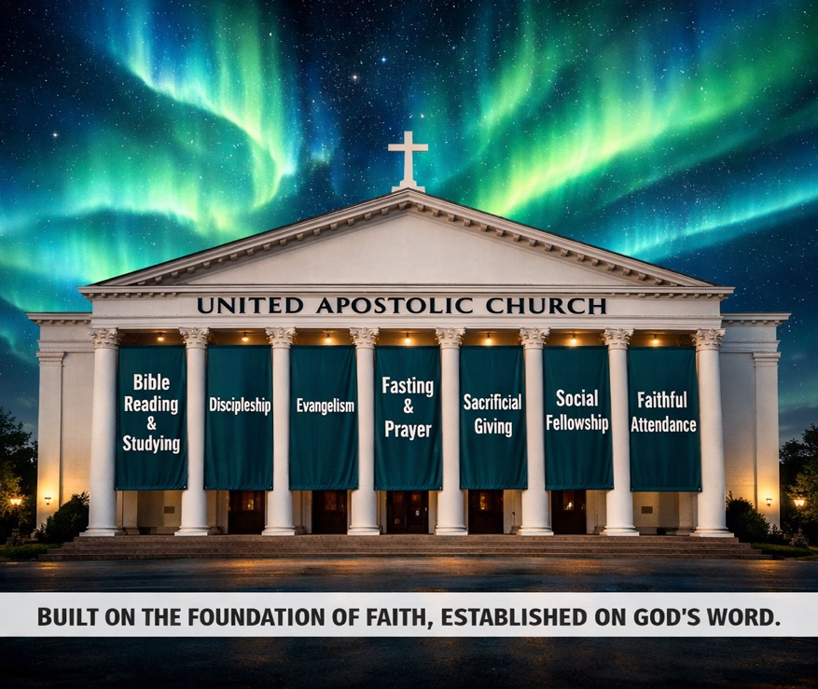
INTRODUCTION


We are continuing our Bible Study on Pillar #5, exploring “Sacrificial Giving — Utilizing Your Talents.”

One of the most profound truths of the Christian faith is this: God does not leave any of His children empty-handed. Every disciple has received a unique combination of gifts — spiritual, natural, and acquired abilities — that together form a one-of-a-kind offering to the Body of Christ.

These gifts are not accidents of biology; they are intentional endowments from a generous Creator who designed each person with purpose and with His Kingdom’s needs in mind. The question is not whether you have been gifted — Scripture settles that. The question is whether you are using what you have been given.

Three Categories of God-Given Endowment
Understanding your full range of gifts begins with the assurance that God equips His people intentionally and with great wisdom. Through Scripture, we discover the spiritual gifts He gives to empower ministry and strengthen the Church. Through life experience, we come to recognize the natural strengths and inclinations He has woven into our design. And through training, discipline, and practice, He develops acquired abilities that can be offered back to Him. Together, these three dimensions form a unified, God-orchestrated preparation for faithful Kingdom service.
- Spiritual Gifts: Supernatural endowments given by the Holy Spirit to empower believers for ministry and service within the Church and beyond.

- Natural Skills: Natural aptitudes and strengths you were born with — creativity, leadership, empathy, or analytical thinking — woven into you by God’s design.

- Acquired Abilities: Skills developed through education, training, or life experience — teaching, technology, communication, craftsmanship — every learned skill can be offered back to God.

What Are Spiritual Gifts?
Spiritual gifts are supernatural endowments given by the Holy Spirit to every born-again, Spirit-filled believer. They are not earned or developed through human effort — they are sovereignly distributed according to God’s wisdom and the needs of His Church. Key Scriptures: 1 Corinthians 4:4-11; Romans 12:6-8; Ephesians 4:11-12; 1 Peter 4:10-11.

A Survey of Spiritual Gifts

Like a living tapestry woven by the Spirit, the New Testament reveals a rich diversity of spiritual gifts, each sovereignly distributed. “All these are the work of one and the same Spirit, and He distributes them to each one, just as He determines” (1 Cor. 12:11 – NIV). These gifts shine across three key passages — Romans 12, 1 Corinthians 12 and Ephesians 4 — and no single list is intended to be exhaustive.

The three lists of gifts are as follows:

The Service Gifts (Romans 12:6-8)

- Prophecy
- Ministry
- Teaching
- Exhortation
- Giving
- Leading (ruling in KJV)
- Showing mercy

The Ministerial Office Gifts (Ephesians 4:11)

  - Apostles
  - Prophets
  - Evangelists
  - Pastors
  - Teachers

The Supernatural Spiritual Gifts (1 Corinthians 12:8-10)

- Word of wisdom
- Word of knowledge
- Faith
- Gifts of healings
- Working of miracles
- Prophecy
- Discerning of spirits
- Different kinds of tongues
- Interpretation of tongues

Discovering Your Spiritual Gifts

Many believers want to identify their spiritual gifts but are unsure where to start. The process is both prayerful and practical — it happens in community, in service, and over time.

God rarely reveals your gifts in isolation. It is in the act of serving that gifts become evident — both to you and to those around you. As you step out in faith, the Holy Spirit confirms and sharpens what He has placed within you.

Innate Skills — Born for a Purpose

Before you ever attended a class, read a book, or received formal training, God was already at work. Innate skills are natural talents embedded in you—part of how God created you in His image for His divine purposes.

These may encompass creative thinking, natural leadership, deep empathy, analytical skills, athletic coordination, musical sensitivity, or an effortless ability to connect with others. The psalmist stated: “I am fearfully and wonderfully made” (Psalm 139:14). Your innate strengths are no accident—they reflect the intentional craftsmanship of God.

Examples of Innate Skills in Scripture
The Bible is filled with men and women whose natural aptitudes were consecrated to God and used mightily for His Kingdom. Their stories remind us that natural ability, when surrendered to God, becomes extraordinary.

- Bezalel — Artistry (Exodus 31:1–5) God specifically chose Bezalel and filled him with the Spirit of God in skill, ability, and knowledge in all kinds of crafts to construct the Tabernacle.

- David — Leadership & Music (1 Samuel 16) David’s natural gifts of courage, musical talent, and leadership — honed in the fields as a shepherd — were the very tools God used to shape a king and a worshiper.

- Apollos — Eloquence (Acts 18:24) Apollos was described as “an eloquent man, competent in the Scriptures.” His natural gift for communication was surrendered to God and used to powerfully advance the Gospel.

Acquired Abilities — Learning as an Offering
Every skill you have developed through education, training, mentorship, or hard experience is a resource that belongs to God. Whether you have spent years mastering a trade, building expertise in technology, studying medicine, developing communication skills, or learning the craft of teaching, these are not merely career assets. They are Kingdom assets.
Paul’s training as a Pharisee under Gamaliel (Acts 22:3) — the very training that seemed like a liability — became the intellectual foundation for his theological masterworks. God wastes nothing. Every skill you have acquired, even in seasons you felt distant from God, can be redeemed and repurposed for His glory.

Acquired Abilities in Action
We often divide abilities into “sacred” and “secular,” but Scripture reminds us that everything we are and everything we do belongs to Him. As Colossians 3:23 teaches, “And whatsoever ye do, do it heartily, as to the Lord, and not unto men.” The accountant, the artist, the engineer, and the nurse can serve God with just as much power and purpose as the pastor or missionary. When surrendered to Christ, your vocation and your skills become a ministry.
- Technology & Media—website development, video production, social media management and audio engineering— can all amplify the Church’s mission and reach.

- Teaching & Training - Educators, coaches, and trainers can disciple others, lead Bible studies, mentor youth, and equip the next generation of servants.
- Trades & Craftsmanship - Carpenters, electricians, plumbers, and builders serve their communities through church maintenance, mission trip construction, and by volunteering their time and service.
- Healthcare & Counseling — Medical professionals, therapists, and counselors bring healing — physical, emotional, and spiritual — to those in need, both locally and on the mission field.

The Stewardship Mindset
“As every man hath received the gift, even so minister the same one to another, as good stewards of the manifold grace of God” — 1 Peter 4:10.
Peter’s language is deliberate: we are stewards, not owners. A steward manages what belongs to someone else — with care, accountability, and the master’s interests at heart. Your gifts, skills, and abilities were never truly yours to keep. They were entrusted to you for a purpose greater than personal success or comfort.

What a Steward Does:
      - Recognizes that all gifts belong to God.
      - Develops and invests what is entrusted.
      - Deploys gifts in service to others.
      - Remains accountable for how gifts are used.

The Parable of the Talents
In Matthew 25:14–30, Jesus makes the stakes unmistakably clear: the servant who buried his talent was rebuked, while those who invested and multiplied theirs were celebrated. Faithful stewardship is active, not passive.

Gifts Are for the Body, Not Just the Individual
One of the most important correctives in the New Testament is this: spiritual gifts are not given primarily for your personal benefit. They are given for the health, growth, and flourishing of the entire Body of Christ.
Paul uses the metaphor of the human body in 1 Corinthians 12 to show that every member — every gift — is indispensable. When you withhold your gift, the Body suffers. When you deploy it faithfully, the whole community benefits. Your unique contribution cannot be replaced by anyone else.

Common Barriers to Using Your Gifts
Even sincere believers sometimes struggle to step into their giftedness. Recognizing these common barriers is the first step to overcoming them in the power of the Holy Spirit.
- Fear & Self-Doubt— “I’m not qualified enough.” Remember Timothy, who was urged to “fan into flame the gift of God” despite his timidity (2 Tim. 1:6–7). God’s calling overrides our insecurities.

- Comparison & Envy— “My gift is not as impressive as theirs.” Paul warns against this mindset (1 Cor. 12:15–16). God intentionally designed a diversity of gifts, making each one essential and none greater than another.

- Busyness & Distraction— “I don’t have the time.” Sacrificial service requires intentional prioritization. What we treasure, we make time for. Ask God to show you where to invest your gifts first.

- Waiting for the “Right” Opportunity- “I’ll serve when the time is right.” Begin where you are, with what you have. Faithfulness in small things opens doors to greater Kingdom impact (Matthew 25:21).

Consecrating Your Talents to God
The turning point for every believer is the moment of deliberate consecration — when you come before God and recognize that your gifts, skills, and abilities were never meant to be held back for yourself alone. As Romans 12:1 (KJV) reminds us, “I beseech you therefore, brethren, by the mercies of God, that ye present your bodies a living sacrifice, holy, acceptable unto God, which is your reasonable service.” Consecration is not about giving up what God has placed in you; it is about redirecting it under His lordship so it can be used with maximum Kingdom impact. That surrender may feel costly and vulnerable, but God honors what is freely placed in His hands and multiplies it for His purposes. So today, with open hands and a willing heart, present yourself to Him and say, “Lord, all that I am is Yours—use me fully for Your glory.”

Application Challenge

Take Inventory — Then Take Action
This week, set aside a quiet hour for prayerful reflection. Come before God with an open heart and a journal, and work through the following exercise:

- List Your Spiritual Gifts — Write down the spiritual gifts you believe God has given you. If you’re unsure, consider taking a spiritual gifts assessment or reflecting on where ministry feels most natural and fruitful.
- Identify Your Innate Skills— What comes naturally to you? What do others consistently affirm in you? Write down the natural aptitudes and strengths God wove into you from birth.

- Catalog Your Acquired Abilities— What have you learned through school, work, training, or life experience? List every skill, certification, and area of expertise — no matter how “ordinary" it seems.
- Prayerfully Choose One New Way to Serve- Look at your list and ask God: “Where do You want me to use one of these gifts in service to You or others this week?” Then take one concrete step of obedience.

