THE ORDER OF WORSHIP
June 14, 2026/Third Sunday after Pentecost
Greeter: Dale Dixon and Rachel Hawk
Please fill out your Prayer & Praise Cards. Announcements are on the screens. Please come to the front pews to meet with a member of our Prayer Team before or after the service.
Gathering
Prayer of Consecration: Pastor John
One: Wake up, sleeper, rise from the dead,
All: and Christ will shine on you. Jesus, I belong to you. I lift up my heart to you. I set my mind on you. I fix my eyes on you. I offer my body to you as a living sacrifice. Jesus, we belong to you. Praying in the name of the Father, and the Son, and the Holy Spirit, amen.

Opening Chorus: “God Is So Good” No. 52 Vs. 1 & 2
Prelude: “Rejoice, Ye Pure in Heart” Lani Smith
Bringing In the Light of Christ: Rachel Hawk
Welcome and Announcement: Jenny Nelson

*Call to Worship: Jenny Nelson
One: You, O God, love us from the moment of our conception,
All: You know us and you love us in the womb,
One: You love us and you call us from before the moment of our first breath,
All: and you love us when we first see the light of day.
One: As a parent loves a child before ever seeing it,
All: and then embraces it gently from the moment of its birth,
One: so you love us—and we thank you.
All: Help us, dear God, to love one another in this way. Amen.

Greeting Our Brothers and Sisters in Christ

Proclamation and Response
*Opening Hymn: “O For a Thousand Tongues to Sing” No. 1
(Collection of Prayer & Praise Cards)

Joys and Concerns: Pastor John
Prayer Chorus: “Jesus Be Praised” No. 2079 TFWS (Sing Twice)
Silent Prayer & Pastoral Prayer /Lord’s Prayer: Pastor John

Anthem: “Uncreated One” Chris Tomlin/Adult Chancel Choir
Collection of Tithes and Offerings: Kirby Miller & John Turner
*The Doxology: “My Tribute” On the Screen
*The Apostle’s Creed: No.691

Scripture Reading: Series: Letters of John/1 John 2:7-11
One: The word of God for the people of God.
All: Thanks be to God and I believe it.

Sermon: “Hate, The Word We Hate” Pastor John

Sending Forth
*Closing Hymn: “How Great Thou Art” No. 32
Postlude: “Jacob’s Ladder” Franklin Ritter

Please be seated. You are invited to close your eyes and use the few moments of music at the end of our service to practice Listening Prayer. This is a time to expect God to speak to you before you leave the sanctuary. In John 10:17, Jesus tells us; “My sheep hear my voice, and I know them, and they follow me.” Let’s try listening as we are silent and still. Members of the prayer team will remain on the front pews after the service. Feel free to come forward.
Benediction: Pastor John
ANNOUNCEMENTS

TO OUR VISITORS: We welcome you to Laurel Hill and hope that you feel at home. We invite you to join Laurel Hill if you do not have a church home. Please call our church office at 804-795-2772. You will find our Laurel Hill family both warm and eager to welcome you into our fellowship. Please fill out a visitor’s card and place it in the offering plate. The password for our public WiFi is LivingHope - feel free to connect with us.

THE ALTAR FLOWERS are presented to the Glory of Almighty God and given in memory of Shirley E. Hicks, Sr. to remembers his June 17th birthday and Father’s Day. They flowers are given by Mary and Eugene Hicks.

THE VASE OF FLOWERS on the pedestal is presented to the Glory of Almighty God and given in loving memory of our Mothers and Grandmothers by Patrice and Carl Moore.

OUR HEALING SERVICE will be this afternoon at 2:00 P.M. Rev. Penny Cory will be our leader and Rev. Ed Johnson will bring the message. Hope you will come and be blessed.

OUR FISH COLLECTION FOR JUNE is stew or any other non-perishable foods. Thank you for your continued support of this very important ministry to Eastern Henrico. In July and August we will collect bookbags and school supplies. If you see them on sale you will know that collection is coming up soon. Thanks again.

FISH is in need of children’s clothes. If you have gently used items to donate, bring them to church and Pam will take them to FISH for you. Thank you.

OPERATION CHRISTMAS CHILD SHOEBOXES…As we continue to collected for our shoeboxes this month, please consider giving school items like pens, pencils, sharpeners, crayons, markers, small notebooks and coloring books. Thank you.

SICK AND SHUT-INS – Kim Davis, Jean Miller, Mary Hicks, Evelyn Steele, Kathleen McKinsey, Phyllis and Sara Nelson, Regina Humphrey, John Brockman, David Torrence, Dot Gay, Sharon Loving & Family and ML Yuhas.

KEEP IN OUR PRAYERS
- Our Weekday School – Margo Keeles (Director), our teachers, students and families.
- Our community of Varina and all the residents, our churches in our neighborhoods, schools, students, teachers, administrators and all employees.
- Our state of Virginia, our residents and leaders.
- The United States of America, our citizens and leaders, the countries of the world, their people and leaders. May God bless us all and His will be done.
- Those affected by war in Israel and Ukraine

WEEKLY CALENDAR

Monday 10:30 AM New Life House Church (804) 303-4828
7:00 PM Bible Study/Hebrews, in person and Zoom.

Tuesday 7:30 AM “Listening to God” on Zoom

Wednesday 9:00 AM Prayer in Sanctuary with Holy Communion

10:30 AM Bible Study on “Finding the Holy Spirit”

Thursday 7:30 AM “Listening to God” on Zoom

7:00 PM PTL House Church at the Wilson’s (804) 795-7723

Friday 10:00 AM Thankful Hearts House Church (804) 737-7450

Saturday 9:00 AM Prayer Station at Dorey Park.

Sunday 10:00 AM Sunday School
10:30 AM Chancel Choir
11:00 AM Sunday Worship Service – (also available online)
FATHER’S DAY

1 Peter 4:10: Stewardship and Spiritual Gifts
By Gary G. Hoag, Ph.D., www.generositymonk.com

I like to summarize our responsibilities as stewards in God’s kingdom with three words: gifts, goods, and gospel. Every Christ-follower is a steward of spiritual gifts and material goods to make known the eternal gospel. This blog post focuses on our stewardship of spiritual gifts. Few NT passages provide clearer instructions on this topic than one profound statement by Peter, directed to Christ-followers exiled throughout the Roman Empire.

“Each of you should use whatever gift you have received to serve others, as faithful stewards of God’s grace in its various forms” (1 Peter 4:10). This statement helped early church Christians know how to live so that their lives (both individually and collectively) would glorify God. It also offers at least three insights for us today.

How can you give at Laurel Hill GMC?

1 – Cash and checks may be placed in the offering plate. Please contact the church office for offering envelopes.
2 - You may also give online. The QR code below will take you to our website’s giving page: https://laurelhill.tithelysetup.com/give

3 – Planned giving – including the LHGMC in your will is a wonderful way to ensure the ministries we are called to provide for Varina will continue into the future.

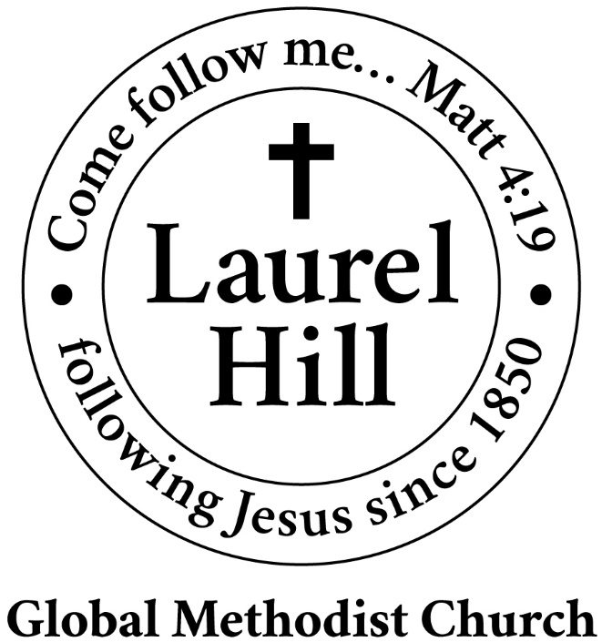
Our Mission: The Global Methodist Church exists to make disciples
of Jesus Christ and spread scriptural holiness across the globe.

1919 New Market Road, Henrico, VA 23231
On the web @ laurelhillchurch.org
Email to laurelhillchurch.varina@gmail.com
Phone: Office/804.795.2772 Pastor/804.437.0937

STAFF
Pastor: Rev. John Bright Organist/Choir Director: Pam Wilson
Secretary: Barbara Wendel School Director: Margo Keeles
Communications Assistant: Ben Wilson

that we you in thought, word, and deed.

