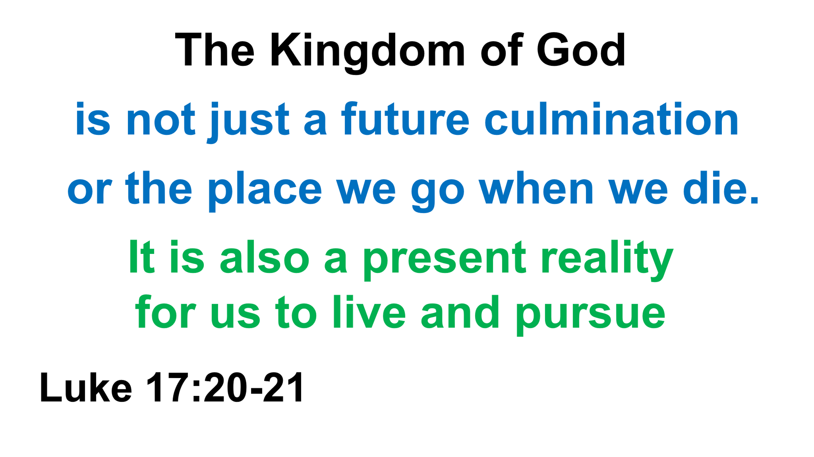

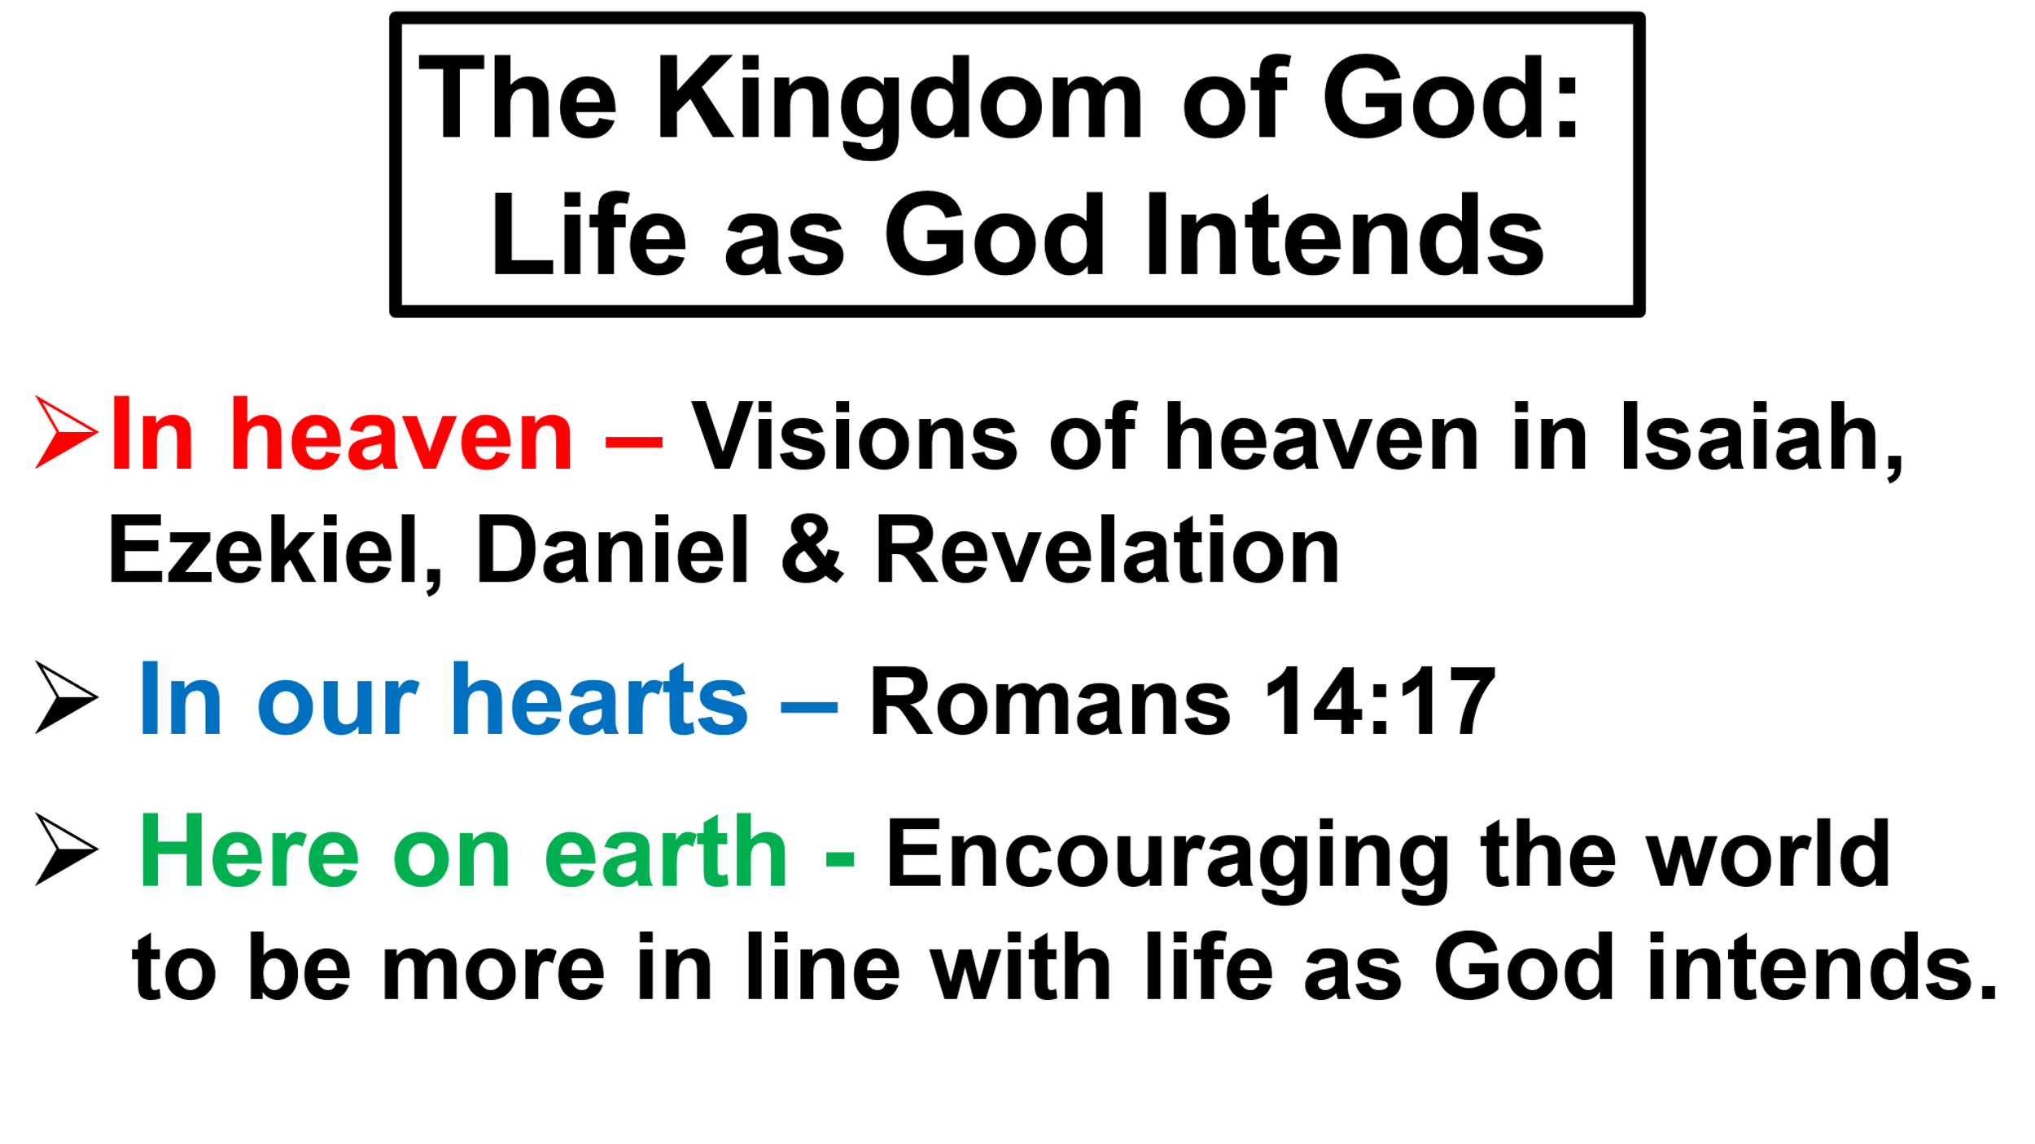

Welcome and Announcements

Passing the Peace

Prelude Burton Bells

Greeting/Call to Worship (Based on Isaiah 11:1-9)
A shoot will come up from the stump of Jesse; from his roots a Branch will bear fruit.
Lord Jesus, thank you for making the Kingdom of God a future culmination to joyously anticipate and a present reality for us to live and pursue.
The Spirit of the Lord will rest on him, the Spirit of wisdom and of understanding, the Spirit of counsel and of might, the Spirit of the knowledge and fear of the Lord—
Lord Jesus, thank you for making the Kingdom of God a future culmination to joyously anticipate and a present reality for us to live and pursue.
and he will delight in the fear of the Lord. He will not judge by what he sees with his eyes or decide by what he hears with his ears; but with righteousness he will judge the needy, with justice he will give decisions for the poor of the earth. He will strike the earth with the rod of his mouth; with the breath of his lips, he will slay the wicked.
Righteousness will be his belt and faithfulness the sash around his waist.
Lord Jesus, thank you for making the Kingdom of God a future culmination to joyously anticipate and a present reality for us to live and pursue.
The wolf will live with the lamb, the leopard will lie down with the goat, the calf and the lion and the yearling together; and a little child will lead them.
The cow will feed with the bear, their young will lie down together, and the lion will eat straw like the ox. The infant will play near the cobra’s den, and the young child will put its hand into the viper’s nest. They will neither harm nor destroy on all my holy mountain, for the earth will be filled with the knowledge of the Lord as the waters cover the sea.
Lord Jesus, thank you for making the Kingdom of God a future culmination to joyously anticipate and a present reality for us to live and pursue. Amen.
Opening Song* Come-Now Is The Time To Worship On Screens

Opening Prayer*
Wonderful and awesome God, you call us to love everyone unconditionally. We have a hard time doing that. Change our hearts and empower us to do that. Wonderful and awesome God, you call us to care for the earth. We have a hard time doing that. Change our hearts and empower us to do that. Wonderful and awesome God, you call us to seek justice for poor, oppressed, and marginalized people. We have a hard time doing that. Change our hearts and empower us to do that. Enable us, O Lord, to act justly, love mercy, and walk humbly with you. In the name of the Father, Son, and Holy Spirit, Amen.

Affirmation of Faith Affirmation of Faith
(Litany to United Methodist Social Principles) On Screens

Gloria Patri* UMH #70 / On Screens

Old Testament Isaiah 11:1-9
“This is the word of God for the people of God"
"Thanks be to God”

Children’s Sermon

New Testament * Matthew 6:33 and Luke 17:20-21
“This is the word of God for the people of God"
"Thanks be to God”

Presentation of Prayers and Praises

Prayer Song Give Us Clean Hands On Screens

Prayer

Receiving God’s Tithes and Sacrifices

Offertory Song Instrumental

Doxology* UMH #95 / On Screens

Message "The Kingdom of God: Life as God Intends"
Pastor David Charlton

Closing Song* He Lives On Screens

Benediction(Hebrews 13:20-21)
Go in the name of the FATHER, SON, and HOLY SPIRIT. May God’s grace empower you to act justly, love mercy, and walk humbly God. Go in peace. Amen.
(*) Indicates to stand if able.

Welcome!
We are glad you are here! May you experience the transforming power of God’s love as you worship with us.

The following is our mission statement:
We are an uncommon church for common people offering a love of neighbor without boundaries. We share the gospel of love when we gather to celebrate a faith relationship with Christ. We serve both God and his children through our ongoing prayers, talents, gifts, and dedication of time until he comes again in glory.

I would love to sit down with you over coffee or a meal. If you would like that, please let me know. My contact info is:
407-687-2226, pastordavidc12@yahoo.com

David Charlton
Pastor



April 12, 2026
10 am

93001 Overseas Hwy MM 93
Tavernier, FL 33070
(305) 852-2581 / (fax) 852-4917
Office hours:
Mon. – Thurs. 9:00 am – 4:00 pm
Fri. office closed

Pastor: David Charlton

Email: pastordavidc12@yahoo.com
Web Page: www.BMUMC.net
Church Email:
bmumc_office@yahoo.com

We are the church on the curve.
This Week
Sunday (04/12):
10:00 am – Worship Service (Sanctuary)
Burton Memorial
6:30 PM – Chosen Series (Sanctuary)
Monday (04/13):
6:30 pm – Tai Chi Class (Fellowship Hall)
6:30 pm – Bible study reflecting on The Chosen
Wednesday (04/15):
9:00 am – Food Pantry (Fellowship Hall)
4:30 pm - Choir Bell Practice
Thursday (04/16)
5:00 pm – Food Pantry (Fellowship Hall)
5:00 pm – God’s Kitchen (Fellowship Hall)

6:30 pm – Prayer Shawl Meeting (Joy Classroom)
Friday (04/17): Office Closed
A United Methodist Church
Burton Memorial
A United Methodist Church
Upcoming Events
Saturday, April 18, 12-4 PM - Earth Day Celebration at Coral Isles Church
Tuesday, April 28 , 6 PM – United Methodist Men location TBD

