
For more information about this
Our mailing address is Oasis Youth Ministries PO Box 445, Holbrook, AZ 86025
ministry or to join our prayer
and support team,
you can go online to
www.oasisyouthministries.com

Dear Friends and Family, March 2026

Hello! We pray you are doing well.

After having almost no winter here in Holbrook, we seem to have skipped much of spring as well; it has been in the 80s and even the 90s for a few weeks here in the high desert.

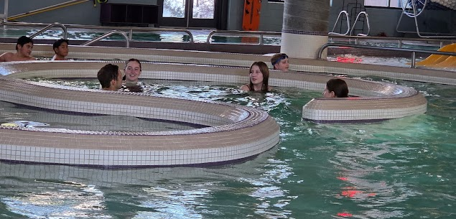
We have had two monthly events since sending out a newsletter (we sent the February newsletter out before the actual February event, and have now done the March event as well).


In February we took a group of 15 young people to the Flagstaff Aquaplex (picture at right), a large sports complex with a series of indoor pools and water slides and such. After several hours of swimming we had food from Chik-Fil-A and one of our leaders, Levi, discussed the theme of water in the Bible, both in terms of judgment and salvation.

Our March event saw us returning to Flagstaff, this time to ice skate at the Jay Lively Activity Center. We took 26 kids who skated, and a few adventurous adults skated as well. Some of us, not wanting to be in pain for several weeks, did not. During a break in the skating, we ate pizza and our daughter Abi, visiting during spring break from college, talked to the group about finding our identity in Christ and not in what others think of us.

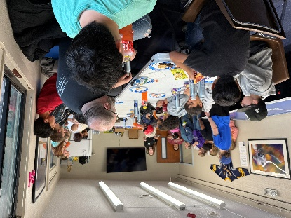
The Well continues to meet weekly. For the month of March we met at First Assembly of God who graciously provided us with lots of food! Cookies, chips, sandwiches, veggies, pizza, burgers, hot dogs—they always put out quite a spread for the kids and it is much appreciated! The younger group is continuing their journey through the Bible; they just finished going over the Gospels. In the older group we have been looking recently at Bible verses that encourage us to seek wisdom and knowledge and to love God with all our minds.

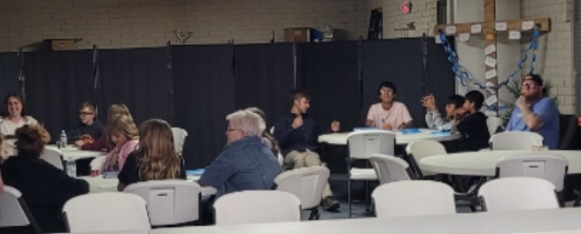
We are planning to have 12 teens attend the annual Worldview Academy at Arizona Christian University in the Phoenix area in June. We recently had our first fundraiser which was a Navajo (frybread) taco sale led by one of our leaders, Shivanna, that was very successful. And the Navajo tacos were delicious, as always! We will be having other fundraising opportunities coming up for the teens to raise the necessry funds to go.

As always, THANK YOU so very much for your part in this ministry; we truly could not do it without your prayers and giving!

Prayer Requests:
- Praise that Shivanna finished AIT training. Please pray for her to be accepted as active duty in the Army.
- Please pray for students coming to the Well, the Next Chapter, and the events, that God will use His word and the testimonies of our pastors and leaders this semester to grow them closer to Him.
- Pray for our fundraisinng efforts for our students attending Worldview Academy. We still need around $6,000.

Grace and Peace,
Jerad and Carrie Burgess, Abi, Naomi & Sarah

