Name: Rodney Mooney
Subject: Miracles
Title: Obedience That Unlocks the Impossible — The Miraculous Catches of Fish
Date: 6/14/26
Confession: This is my Bible, the Living Word of God. I am, what the Word says I am. I have, what the Word says I have. I can do, everything the Word says I can do, and I will do it, IN JESUS NAME!
Text: Luke 5:1–11; Matthew 17:24–27; John 21:1–17
Luke 5:1-11 On one occasion, while Jesus was standing by the Lake of Gennesaret (Sea of Galilee) with the crowd pressing in on Him to hear the word of God, 2He saw two boats at the edge of the lake. The fishermen had left them and were washing their nets. 3Jesus got into the boat belonging to Simon and asked him to put out a little from shore. And sitting down, He taught the people from the boat. 4When Jesus had finished speaking, He said to Simon, “Put out into deep water and let down your nets for a catch.” 5“Master,” Simon replied, “we have worked hard all night without catching anything. But because You say so, I will let down the nets.” 6When they had done so, they caught such a large number of fish that their nets began to tear. 7So they signaled to their partners in the other boat to come and help them, and they came and filled both boats so full that they began to sink. 8When Simon Peter saw this, he fell at Jesus’ knees. “Go away from me, Lord,” he said, “for I am a sinful man.” 9For he and his companions were astonished at the catch of fish they had taken, 10and so were his partners James and John, the sons of Zebedee. “Do not be afraid,” Jesus said to Simon. “From now on you will catch men.” 11And when they had brought their boats ashore, they left everything and followed Him.
INTRODUCTION — Peter didn’t meet Jesus at his best — he met Him at his emptiest. Empty nets. Empty hands. Empty heart.
And Jesus said, “Try again.” That moment became the first step in a faith journey that would change the world.
When you obey Jesus’ word — even when it makes no sense — the impossible becomes possible.
This is about faith that obeys even when tired, faith that obeys even when it didn’t work before, faith that obeys even when logic disagrees, faith that obeys simply because Jesus said so.

- THE SETTING — EMPTY NETS, EMPTY HANDS, EMPTY HEARTS
Luke 5:1–2 — “The fishermen… were washing their nets.”
- Jesus steps into their workplace
- The Boat
- Galilee’s fishing industry used wooden boats about 27’ long, 7.5’ wide, and 4.3’ deep.
- The boats were propelled by oars and a single square sail.
- These boats would typically have a fishing crew of 4-5, but could transport as many as 15.
- 3 types of nets:
- The Cast Net
Description: A small, circular, and highly portable net.
Appearance: It was weighted with lead or stone sinkers all along the outer edge.
Usage: A fisherman would stand in the shallows or on the bow of the boat, coiling it over their arm before hurling it in an arc so it spread flat over the water. As it sank, the weighted edges would trap fish underneath.
- The Dragnet or Seine
Description: A massive net used for catching large volumes of fish near the shoreline.
Appearance: It could span several hundred feet (up to 1,000 feet long) and featured floats made of cork or Scots pine bark on the top rope and stone/lead sinkers on the bottom. Usage: The net was stacked onto the back of the boat and deployed in a large semicircle around a school of fish. Teams of up to 15-20 men standing on the shore would then pull both ends of the ropes, drawing the net in and scooping the trapped fish.
- The Trammel Net
Description: A compound, wall-like net favored for night fishing.
Appearance: This net was made of three distinct layers of linen. Two outer layers had very large, wide mesh, while the middle layer was fine, loose-fitting, and larger in area than the outer ones.
Usage: When fish swam into the net, they would push the middle netting through the large mesh of the second outer net, creating a tangled, inescapable pocket. This is likely the type of net Peter and his partners were "mending" and "washing" after a frustrating night of fishing.
- They were doing what fishermen do after a long night: washing nets — cleaning, repairing, preparing for the next attempt.
- Jesus steps into:
- their workplace
- their frustration
- their exhaustion
- their disappointment
- They are tired professionals who did everything right… and still came up empty.
- They are exhausted
- “We worked hard all night…” kopiaó (kop-ee-ah'-o)— to labor to the point of weariness, depletion.
- Jesus steps into their failure
- He doesn’t wait for ideal conditions.
- He steps into the moment when they have nothing left and gives them a Word and with it a decision.
- Am I going to act on His Word or keep cleaning the nets and go home and sleep?

- MAN’S PART — CASTING THE NET WHERE JESUS SAID
Luke 5:4 — “Put out into the deep…”
- Jesus gives a new instruction
- This instruction defies:
- timing (daytime fishing with nets does NOT work)
- technique (deep water — fishing is down best in shallow waters)
- experience (they knew better)
- logic (they had already tried everything they the professionals know to do. Am I going to now listen to a preacher tell me about how to fish?)
- But faith is not about what makes sense — faith is about DOING what Jesus says!
- “We toiled all night…”
- Peter is honest:
- “We tried that already.”
- “We’ve done everything we know.”
- “We’re tired.”
- “We’re empty.”
- This is where many believers stop. But Peter doesn’t.
- “But because You say so, I will let down the nets.”
- Peter pushes past:
- “His experience…”
- “His feelings…”
- “His logic…”
- “His exhaustion…”
- “But because You say so, I will…”
- Faith is not the absence of opposition — faith is obedience in spite of it.

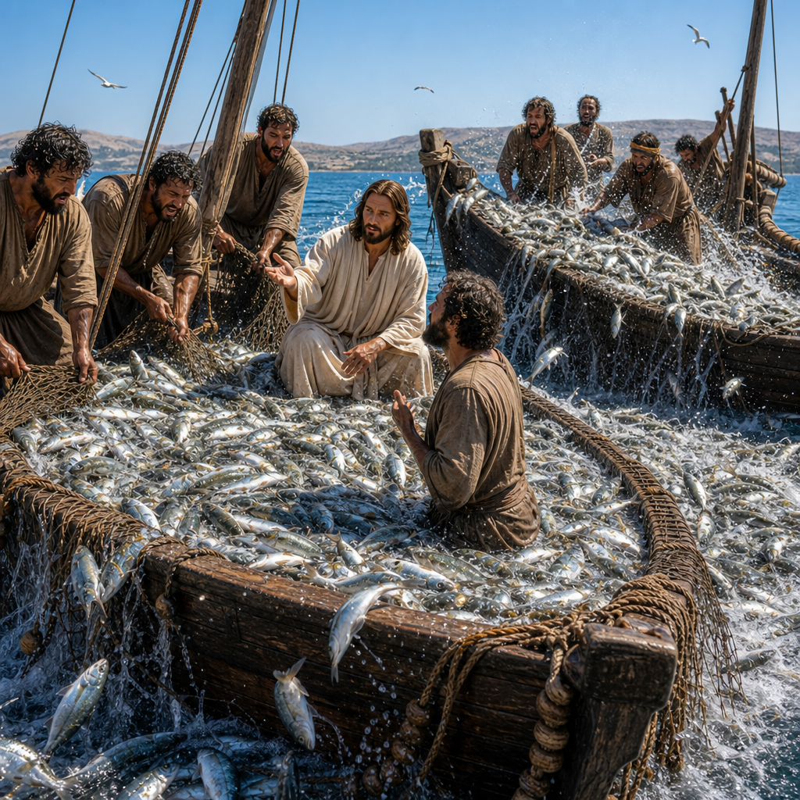

III. JESUS’ PART — THE MIRACLE IN THE DEEP
Luke 5:6 — “Their nets began to tear.”
- The nets overflow
- Jesus didn’t give them:
- a better technique
- a better boat
- a better net
- a better time of day
- He gave them a better word.
2. The miracle reveals His identity
- Peter falls at Jesus’ knees:
“Go away from me, Lord — I am a sinful man.”
- Why this reaction?
- Because the miracle revealed:
- Jesus’ authority
- Jesus’ holiness
- Peter suddenly realizes:
- “This is no ordinary rabbi.”
- I am a sinful man.
3. The miracle becomes a calling
“From now on you will catch men.”
- Jesus was not intimidated by Peter’s past.
- Jesus speaks to Peter’s destiny.
- God ONLY speaks the end result, calling things that be not, as though they were.
- The miracle wasn’t about fish — it was about faith and calling.
- This was Peter’s commissioning into the ministry.

- THE SECOND MIRACLE — THE COIN IN THE FISH’S MOUTH
Matthew 17:24–27 After they had arrived in Capernaum, the collectors of the two-drachma tax came to Peter and asked, “Does your Teacher pay the two drachmas?” 25“Yes,” he answered. When Peter entered the house, Jesus preempted him. “What do you think, Simon?” He asked. “From whom do the kings of the earth collect customs and taxes: from their own sons, or from others?” 26“From others,” Peter answered. “Then the sons are exempt,” Jesus said to him. 27“But so that we may not offend them, go to the sea, cast a hook, and take the first fish you catch. When you open its mouth, you will find a four-drachma coin. Take it and give it to them for My tax and yours.”
- Peter faces a moment of testing, not a crisis of lack
- The temple tax collectors approach Peter — not Jesus — and question him about Jesus’ commitment to the Law.
- This moment is not about money. It’s about Peter learning how Jesus provides for His own.
- Peter answers— perhaps too quickly — and Jesus uses the moment to disciple him.
2. Jesus gives another unusual instruction
- “Go to the sea… take the first fish you catch… open its mouth… you will find a four-drachma coin.”
- This instruction is:
- illogical
- supernatural
- unexpected
- unnecessary from a practical standpoint
- Jesus could have simply handed Peter the money as it about 4 days wages for the both of them. But He chose a miracle instead of a wallet.
- Why?
- Because Jesus is forming Peter’s faith.
- Always check with Him first to see what He would have you do in every situation.
3. Peter obeys immediately
- No hesitation. No argument. No confusion. No “But Lord…”
- He simply goes.
- This is maturity. This is growth. This is faith formed through repeated obedience.
4. The miracle confirms Jesus’ provision
- The coin is exactly the amount needed.
- Jesus is teaching Peter:
- “I provide for what I call you to do.”
- “Obedience releases supernatural supply.”
- “You will never lack doing My work.”
- This is not about money — it’s about trust.

- THE THIRD MIRACULOUS CATCH
JOHN 21:1-17 Later, by the Sea of Tiberias, Jesus again revealed Himself to the disciples. He made Himself known in this way: 2Simon Peter, Thomas called Didymus, Nathanael from Cana in Galilee, the sons of Zebedee, and two other disciples were together. 3Simon Peter told them, “I am going fishing.” “We will go with you,” they said. So they went out and got into the boat, but caught nothing that night. 4Early in the morning, Jesus stood on the shore, but the disciples did not recognize that it was Jesus. 5So He called out to them, “Children, do you have any fish?” “No,” they answered. 6He told them, “Cast the net on the right side of the boat, and you will find some.” So they cast it there, and they were unable to haul it in because of the great number of fish. 7Then the disciple whom Jesus loved said to Peter, “It is the Lord!” As soon as Simon Peter heard that it was the Lord, he put on his outer garment (for he had removed it) and jumped into the sea. 8The other disciples came ashore in the boat. They dragged in the net full of fish, for they were not far from land, only about a hundred yards. 9When they landed, they saw a charcoal fire there with fish on it, and some bread. 10Jesus told them, “Bring some of the fish you have just caught.” 11So Simon Peter went aboard and dragged the net ashore. It was full of large fish, 153, but even with so many, the net was not torn. 12“Come, have breakfast,” Jesus said to them. None of the disciples dared to ask Him, “Who are You?” They knew it was the Lord. 13Jesus came and took the bread and gave it to them, and He did the same with the fish. 14This was now the third time that Jesus appeared to the disciples after He was raised from the dead. 15When they had finished eating, Jesus asked Simon Peter, “Simon son of John, do you love Me more than these?” “Yes, Lord,” he answered, “You know I love You.” Jesus replied, “Feed My lambs.” 16Jesus asked a second time, “Simon son of John, do you love Me?” “Yes, Lord,” he answered, “You know I love You.” Jesus told him, “Shepherd My sheep.” 17Jesus asked a third time, “Simon son of John, do you love Me?” Peter was deeply hurt that Jesus had asked him a third time, “Do you love Me?” “Lord, You know all things,” he replied. “You know I love You.” Jesus said to him, “Feed My sheep.
- After The disciples have returned to fishing at the Sea of Galilee
- John 21:6 — “Cast the net on the right side…”
- Same instruction. Same obedience. Same result.
- Jesus is reminding Peter: “Your calling didn’t die with your failure.”
- The miracle restores Peter
- The miracle wasn’t about fish — it was about healing a disciple’s heart and restoring him.
- Jesus reinstates him:
“Feed My sheep.”
- The miracle wasn’t about fish — it was about healing a disciple’s heart.

- FAITH DYNAMICS — WHAT WE LEARN FROM THESE MIRACLES
1. Faith obeys even when tired
- Luke 5 — “We toiled all night…”
- Peter obeys when he has nothing left in the tank.
2. Faith obeys even when it didn’t work before
- Luke 5 — “Caught nothing…”
- Past failure doesn’t get the final say — Jesus does.
3. Faith obeys even when it makes no sense
- Luke 5 — “Put out into the deep…”
- Faith steps beyond logic, expertise, and experience.
4. Faith obeys simply because Jesus said so
- Luke 5 — “Because You say so…”
- This is the foundation of discipleship.
5. Faith obeys in practical, everyday needs
- Matthew 17 — “Go catch a fish…”
- Jesus trains Peter to trust Him not just in ministry, but in responsibility, provision, and real-life pressure.
6. Faith obeys immediately, without argument
- Matthew 17 — Peter goes without hesitation
- Obedience becomes Peter’s reflex, not his struggle.
7. Faith obeys in seasons of confusion and failure
- John 21 — “Cast on the right side…”
- Even when Peter feels disqualified, he still obeys the voice he recognizes.
8. Faith turns emptiness into abundance
- Luke 5 — nets break
- John 21 — nets overflow
- Obedience transforms lack into overflow.
9. Faith turns calling into purpose
- Luke 5 — “You will catch men.”
- John 21 — “Feed My sheep.”
- Obedience reveals assignment — and obedience sustains it.
10. Faith turns shame into restoration
- John 21 — Peter is restored by the same miracle that called him.
- Jesus uses the familiar to heal the broken.
11. Faith grows through repeated obedience
- Peter obeyed tired.
- Peter obeyed confused.
- Peter obeyed broken.
- Peter obeyed restored.
- This is how Jesus forms a disciple — one act of obedience at a time.

