In our prayers

Worldwide
Church of the Province of South East Asia

Our Diocese – Chebucto #6
St. George’s, Halifax, NS
St. Margaret of Scotland, Halifax, NS

Our Parish
Jim, Florence, Peggy, Roger, Nancy, Maverick, Connie

Notices

15th Anniversary Celebrations – July 1, 2026 marks the 15th
Anniversary of this parish. Celebrations and special events are
being planned for this Fall. If you would like to get involved,
speak to Allyson Dye or Fr. Jonathan.

The Anglican Church of the Apostles
6670 Bayers Road
Halifax, NS B3L 2B5
902-455-7142
apostlesanglican@bellaliant.com
Rector: Rev’d Jonathan Rowe

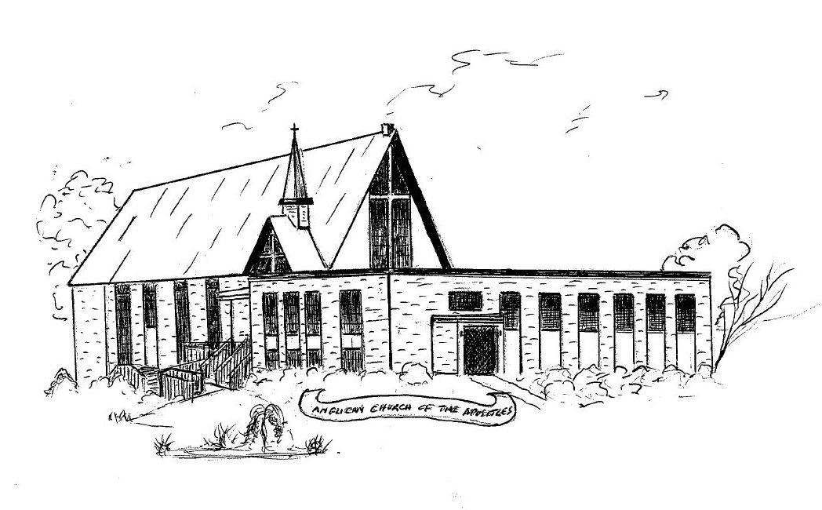

Third Sunday after Pentecost
June 14, 2026

Celebration of Holy Communion
10:30 a.m. Service

CELEBRATION OF HOLY COMMUNION
According to the Rite of the Book of Common Prayer
(Hymns are from the Book of Common Praise)
Prelude

THE ENTRANCE RITE
Opening Hymn: Stand Up and Bless the Lord #350
Lord’s Prayer & Collect for Purity page 67
The Summary of the Law page 69
Kyrie Eleison page 70
The Collects

THE PROCLAMATION OF THE WORD
First Reading: Genesis 18:1-15 (Rachel Watt)
Psalm 116:1, 10-17 (Daniel Owolabi)
Refrain: I will lift up the cup of salvation.
I love the Lord, because he has heard the voice of my supplication, because he has inclined his ear to me whenever I called upon him. How shall I repay the Lord for all the good things he has done for me? I will lift up the cup of salvation and call upon the name of the Lord.
R
I will fulfil my vows to the Lord in the presence of all his people.
Precious in the sight of the Lord is the death of his servants.
R
O Lord, I am your servant; I am your servant and the child of your handmaid; you have freed me from my bonds. I will offer you the sacrifice of thanksgiving and call upon the name of the Lord.
R
I will fulfil my vows to the Lord in the presence of all his people. In the courts of the Lord's house, in the midst of you, O Jerusalem. Hallelujah!
R
Glory be to the Father, and to the Son,
and to the Holy Spirit:
as it was in the beginning, is now,
and ever shall be, world without end. Amen.

Second Reading: Romans 5:1-8 (Becky Field)
Gradual: Lord, You Give the Great Commission (vs 1-3) #433
The Holy Gospel: Matthew 9:35 to 10:8
Gradual: Lord, You Give the Great Commission (vs 4-5) #433
The Nicene Creed page 71
Sermon

THE LITURGY OF THE EUCHARIST
The Offertory
Offertory Hymn: Come and Journey with a Saviour #482
Prayer of Intercession page 75
Confession and Absolution page 76
Sursum Corda and Preface page 78
Sanctus and Benedictus page 81
Prayer of Consecration page 82
Prayer of Humble Access page 83
Agnus Dei page 84
The Communion
Communion Hymn: And Now, O Father, Mindful of the Love #66
The Lord’s Prayer
The Gloria page 86
Blessing page 86
Closing Hymn: Rise Up, O Saints of God #586

Dismissal:
V. The Lord be with you; R. And with thy Spirit.
V. Go in peace to love and serve the Lord.
R. Thanks be to God.

Choral Response (printed in back of hymn book)

Postlude

Please note: The Anglican Church of the Apostles provides our Sunday Services as a livestream on Facebook

