WELCOME and OPPORTUNITIES FOR SERVICE

PRELUDE

*CALL TO WORSHIP
Come, people of God!
Let us offer to God a sacrifice of thanksgiving,
and lift up his name in the presence of his people.
For God is gracious and merciful,
full of compassion and love.
While we were still helpless, he came to save us.
Let’s worship God together!
We offer you thanksgiving

*OPENING HYMN Leaning on Everlasting Arms GTG 837

CONFESSION and FORGIVENESS
God of every place and time
We confess that we sometimes close windows against the fresh air of new ideas, against the noise of other people’s worries, against the winds of change.
We confess that we often draw our curtains against people who are different, against world news or community concerns.
Forgive us our insulation in our locked homes, our shuttered churches, the security systems on our hearts.
Open up our lives, and let your Spirit blow through. Amen.

INVITATION TO FORGIVENESS
By the power of the Holy Spirit, we choose to forgive, renew and live again in right relationship with each other and with our God.
All: Thanks be to God!

GREETING AND PASSING OF THE PEACE
May the peace of the Lord be with you
And also with you.
Please share that peace with those around you
My Peace (See screen)

GREETING and PRAYER OF THE DAY:
P: The grace of our Lord Jesus Christ, the love of God, and the fellowship of the Holy Spirit be with you all
All: And also, with you

MESSAGE IN MUSIC The Gift of Love Hal Hopson Alex Rosenleaf, tenor
SCRIPTURE
Psalm 116
Matthew 9:35-10:23

Gloria Patri GTG 581

SERMON Love as Invitation and Engagement Rev. Chuck Carlson

HYMN Jesus, Thy Boundless Love to Me GTG 703

THE PRAYERS
Pastoral Prayer
Prayers of the People
L: Lord, in your mercy
All: Hear our prayer.
The Lord’s Prayer (Malotte)
COLLECTION OF OFFERING
OFFERTORY
*Doxology GTG 606
*Offertory Prayer
*All: Generous God, you tenderly care for each person you have created. You miraculously restore people to health, and shine light into the lives of those who are discouraged. Guide us so that we will not regard others according to outward appearances but seek to find your love in their hearts. We dedicate our offerings and ourselves to contribute to the work of your kingdom on earth until Christ returns in glory. Amen.
*APOSTLE’S CREED
*SENDING HYMN Love Divine,
All Loves Excelling GTG 366

*THE CHARGE
*BENEDICTION
*SENDING
POSTLUDE

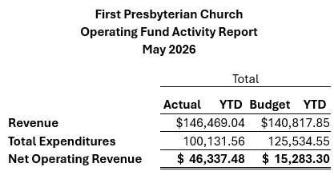

First Presbyterian Church
Welcome
Embracing Grace
Embracing Community
Guest Pastor: The Rev. Dr. Chuck Carlson

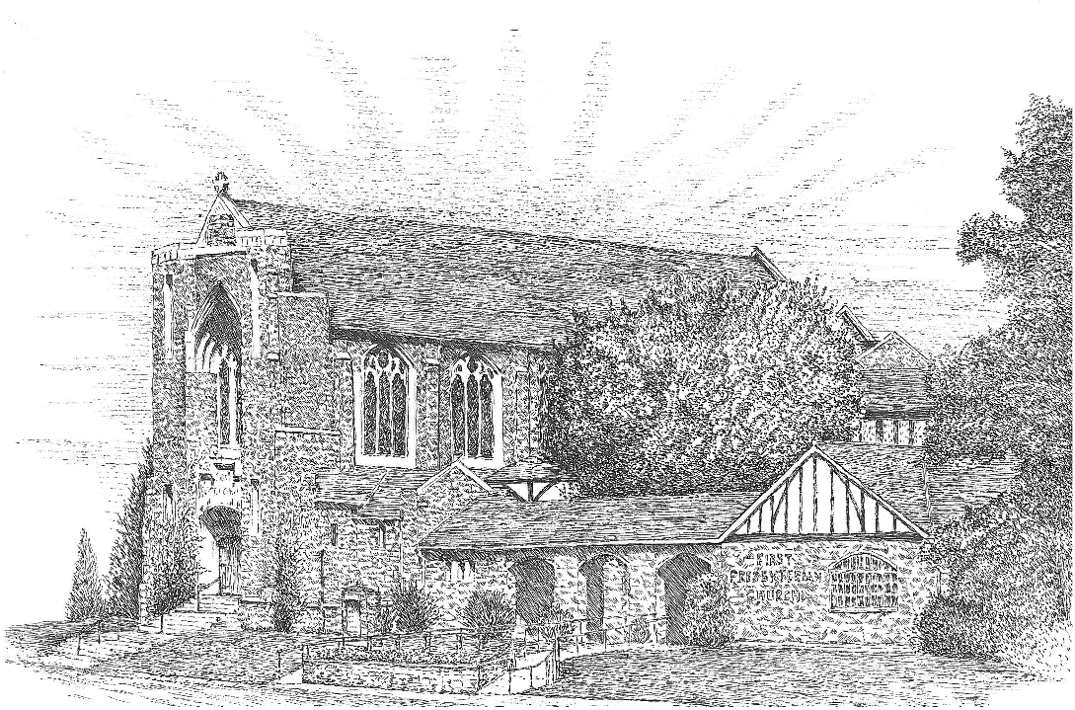

Sunday, June 14, 2026

We Are The Body of Christ
1315 Central Avenue,
Great Falls, Montana 59401-3833
(406) 453-1411
Website: firstpresgfmt.org
Facebook: facebook.com/firstpresgfmt

