Colington United Methodist Church
We are a Lighthouse Congregation, committed to offering safety and stability to United Methodists who have been displaced or wounded through disaffiliation.

_________________________________________
June 14, 2026
Third Sunday after Pentecost

welcome and announcements
call to worship
O Lord, open our lips,
and we shall declare your praise.
O Lord, open our ears,
that we may hear your word.
O Lord, open our hands,
and help us to live generously.
O Lord, open our eyes,
that we may behold your beauty.
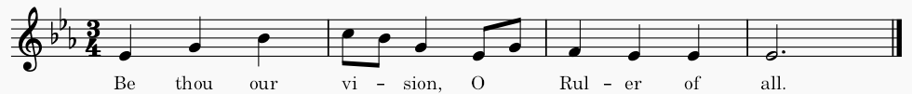
And in opening our eyes, become our eyes.

prelude and lighting of altar candles
Be Thou My Vision Schram/Towner/Hughes
litany of confession
Jesus, you came into the world to save sinners:
Lord, have mercy.
Lord, have mercy.
We have brought sorrow and hurt to you,
to others, and to ourselves:
Christ, have mercy.
Christ, have mercy.
You give yourself to heal and renew us,
and to bring us strength:
Lord, have mercy.
Lord, have mercy.
Know that your sins are forgiven through Jesus Christ, our Savior, and rejoice in his goodness and
grace. Amen. Thanks be to God.
introit
Revive Us Again
opening prayer
Holy Spirit, come upon us this hour without delay; pour out your graces on our souls. Let tongue and soul and mind and strength proclaim your praise. Set our love aflame by the fire of your love, and may its warmth enkindle love in our neighbors. Empower us with your presence in the name of
Christ. Amen.
†opening hymn
Holy, Holy, Holy! ǀ UMH 64
prayers of the people
the first lesson
Genesis 18:1-15
hymn of preparation
In the Garden ǀ UMH 314
the second lesson
Romans 5:1-8
sermon
“This Time Next Year”
silence
†affirmation of praise
El Shaddai ǀ UMH 123
prayer of thanksgiving
†doxology
Give Thanks ǀ UMH inside cover
†closing hymn
Leaning on the Everlasting Arms ǀ UMH 133

this week at colington
These opportunities to serve as the Body of Christ are available.

Tuesday – 9 am – Prayer Group
6:15pm – Beach fellowship at Ocean Bay Blvd. beach access.
Wednesday – 10am – Administrative Council meets.
Thursday – Saturday – NCCUMC Annual Conference at Greenville, NC.
Saturday – 9am – Men’s ministry breakfast meeting. Sign up on clipboard.

coming up
Next Sunday – 8:30am – choir practice
9:30am – Worship, in-person and Facebook Live
Wed., June 24 – 10am – Knitters and crocheters meet.
1:45pm - Volunteers to Beach Food Pantry.

Thanks to today’s volunteers!
Ushers – Steve Knowles / Ozzie Gray
Scripture Reader – Merinda DeHart
The flowers on the altar are given by Sherry Rollason in celebration of Rollason family birthdays.

Last week’s attendance – 67.

