



This Week at PPBC
July 11, 2026


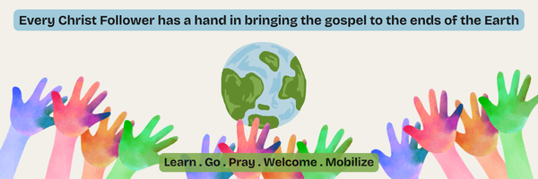
A Prayer Request from the Maria Diaz : Pray for physical health and strength. Maria continues to face health challenges. She is encouraged. She recently wrote to say, “I am going to make a report for the Lord's amazing responses in my area of work.” We look forward to hearing from her.

Notes

Sunday Ministry Schedules
Below are ministry schedules for Nursery, Jr. Church, Greeters, Ushers, and Sound & Video:
Nursery
June 14: Lisa Dallas, Alyssa Summers, Rosalie McLaren
June 21: Jan Gerrow, Laura Saunders, Brantley Colwell
Jr. Church; ages 3 to grade 1
June 14: Christine McLaren, Lena Sammut
June 21: Justine McKenzie
Jr. Church; Grades 2 to 6
June 14: Miriam Bolsonello, Tiffany Green
June 21: Tracy Ballanger, Jen Owens
Greeters
June 14: Tracy & Karen Ballanger
June 21: Leno & Donna Araujo
Ushers
June 14: Nick Woytowich, Matt Saunders
June 21: Roy Wilson, Eric Duchesne
Sound & Video
June 14: Sound: Eric Duchesne | Video: William Conley
June 21: Sound: Charlie Deane | Video: Joshua Bolsonello

Sunday Service

Song – Come People of the Risen King
Welcome
Song – How Firm a Foundation
Song – All of Our Tomorrows
Scripture
Prayer
Song – All Sufficient Merit
Message – Pastor Jim Clemens
Song – Take My Life and Let it Be

Praise & Prayer Highlights
PRAISE for the engagement of Peter and Kate Anderson. PRAY for them and their families as they prepare for their wedding and marriage.
PRAISE for Josh & Chelse Myers as they are expecting another baby in December. PRAY for them as they prepare and that mom and baby would continue to be healthy and safe.
PRAY for our Soccer Outreach continuing this Wednesday. PRAY for the Volunteers as they demonstrate the gospel to the children & their families. PRAY that hearts would be open and respond to the gospel.
PRAY for Dave & Mandy Myers. Dave was in a serious car crash last week. PRAY for continued health and recovery for Dave.
PRAY for Martin & Tina McCurley and their ongoing health concerns.
PRAY for Rob & Shelley VanUden and their nieces family. Their nieces daughter Bryte passed away. PRAY for Lindsey, her husband and their family as they mourn this loss. PRAY for Gods comfort and peace through this time.
PRAY for the Youth as they end their school year and prepare for summer jobs and camps. PRAY for their spiritual growth as they are away from home throughout the summer.

Giving
Just as a reminder, there are several ways you can give:
In Person using the offering box located on the back wall of the sanctuary. Donation envelopes are available at the Welcome Centre. Please contact the church office if you would like a box of donation envelopes (office@portperrybaptist.ca)
Through your online banking, you may send electronic transfers to ppbcdonations@gmail.com.
You can also give through Canada Helps. Donation receipts will be provided by Canada Helps, and transaction fees apply.
***********************************************************************
Weekly Newsletter
The PPBC Newsletter is emailed to the church family every Friday. If you would like to be added to the weekly email list, please contact the office by phone: 905-985-8681 or by email: office@portperrybaptist.ca.
*****************************************************************
Church Information:
Location:
2210 Hwy 7A
Port Perry, ON
L9L 1B4
Office Hours:
Monday: 8:30am – 4:00pm
Tuesday: 8:30am – 4:00pm
Wednesday: Closed
Thursday: 8:30am – 4:00pm
Friday: 8:30 am - 3:00 pm
Contact:
Phone: 905.985.8681
Email: office@portperrybaptist.ca
Website: www.portperrybaptist.ca
Staff:
Sr. Pastor – Rev. Jim Clemens
Administrative Assistant – Madeline Werner
Family Ministries Director – Josh Anderson
Pastoral Intern – Scott McKenzie

PPBC Newsletter
Sunday, June 14th, 2026


Sunday Starting Point
Sunday, June 14th, 2026 - 9:30 am
“Beginning the day with the Word and prayer”
Adults:
Adults will meet in the sanctuary for a time of study and prayer.
Youth:
Jr High (Grades 7-8) will meet in room 18 with Kate Anderson to study Thessalonians.
Children:
Children ages 3 - grade 6 will meet in room 26.
(Please note nursery is unavailable during Starting Point)
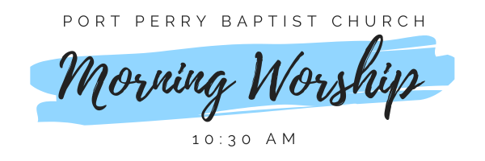Sunday Morning Worship
Sunday, June 14th, 2026 - 10:30 am
We are meeting in the sanctuary and will continue to live-stream for those who are unable to attend.
Message: Contentment In Christ...Commitment To Christ
Scripture: 1 Corinthians 7:17-40
Pastor Jim Clemens

