
THE ANGLICAN PARISH OF ST. MARK
138 Hoylake Road, Qualicum Beach, BC V9K 1K3
Lay Worship Leader: Michael King
Third Sunday after Pentecost, 10:00 am, June 14, 2026
MORNING PRAYER — BAS
In a state of openness, and with a desire to learn the truth of our shared history, we acknowledge that we worship on the unceded territory of the Qualicum First Nation. We give thanks for their careful stewardship of the forests, rivers, oceans, lands and air, so that we might walk with them and celebrate the gift of the Creator. We commit to a lifelong journey of respectful understanding.

Welcome & Announcements
Call to Worship.
Opening Hymn: CP #345 — “King of Glory, King of Peace”
Service begins on Page 47 of our Green Book of Alternate Services
Lord, open our lips…
Summary of the Law: Our Lord Jesus Christ said: “Hear, O Israel… Page 69
The Invitatory: page 48, #12
First Reading: Genesis 18:1-15 (21:1-7)
Psalm 116: 1, 10-17 (read responsively by the half verse) page 864
Second Reading: Romans 5:1-8

Gradual Hymn: CP #586 “Rise Up, O Saints of God” (v. 1–2)
The Gospel: Matthew 9:35-10:23
Before the Gospel: Glory to you, Lord Jesus Christ
After the reading: Praise to you, Lord Jesus Christ
The Sermon – Read by Michael King
Affirmation of Faith: Hear, O Israel page 53
Intercessions & Thanksgivings (Prayers of the People) page 126
Collect for the Day (Said together) page 362
Offertory Hymn: CP #592 “Where Cross the Crowded Ways of Life” (vs 1-3)
Blessing of the Gifts: (Said together) page 362

Our Prayer Ministry
Our Healing team invites you to join them to pray or give thanks to God in the alcove under the exit sign following the service. Confidentiality is assured.

The Lord’s Prayer page 54
The Dismissal:
Let us bless the Lord
People: Thanks be to God
Closing Hymn: CP #602 “Lift High the Cross”

ALTAR FLOWERS
The flowers on the altar are given by your Wardens, Wendy and Sue, To the Glory of God in Thanksgiving for the lives and contributions of all parishioners who have worshipped in the Parish of St. Mark over the past 100 years.

EMERGENCY CONTACTS FOR PASTORAL CARE
Morag Atherstone: 250-240-6731
Cynthia Preyser: 250-954-9122

Service Schedule
Date | Time | Service
TUES June 16 Anniversary | 2:30 pm | BAS Holy Eucharist
Wed June 17 | 11:30 am | No service
Sun June 21 | 8:30 am | BCP Holy Eucharist
 | 10:00 am | Holy Eucharist, Liturgy of the Islands
Sun June 28 | 8:30 am | BCP Morning Prayer
 | 10:00 am | BAS Morning Prayer
Sun June 28 | 8:30 am | BCP Morning Prayer
 | 10:00 am | BAS Morning Prayer
Wed July 1 | 11:30 am | BAS Morning Prayer

ANNOUNCEMENTS
A warm welcome to St. Mark’s this morning. Coffee is served in the hall after the service. We hope you will join us.
TODAY is the last call for signing up for the Anniversary Tea. If you wish to attend the tea following the service on Tuesday, you will need a ticket (free of charge). Please see Sue after the service to sign up and get your ticket.
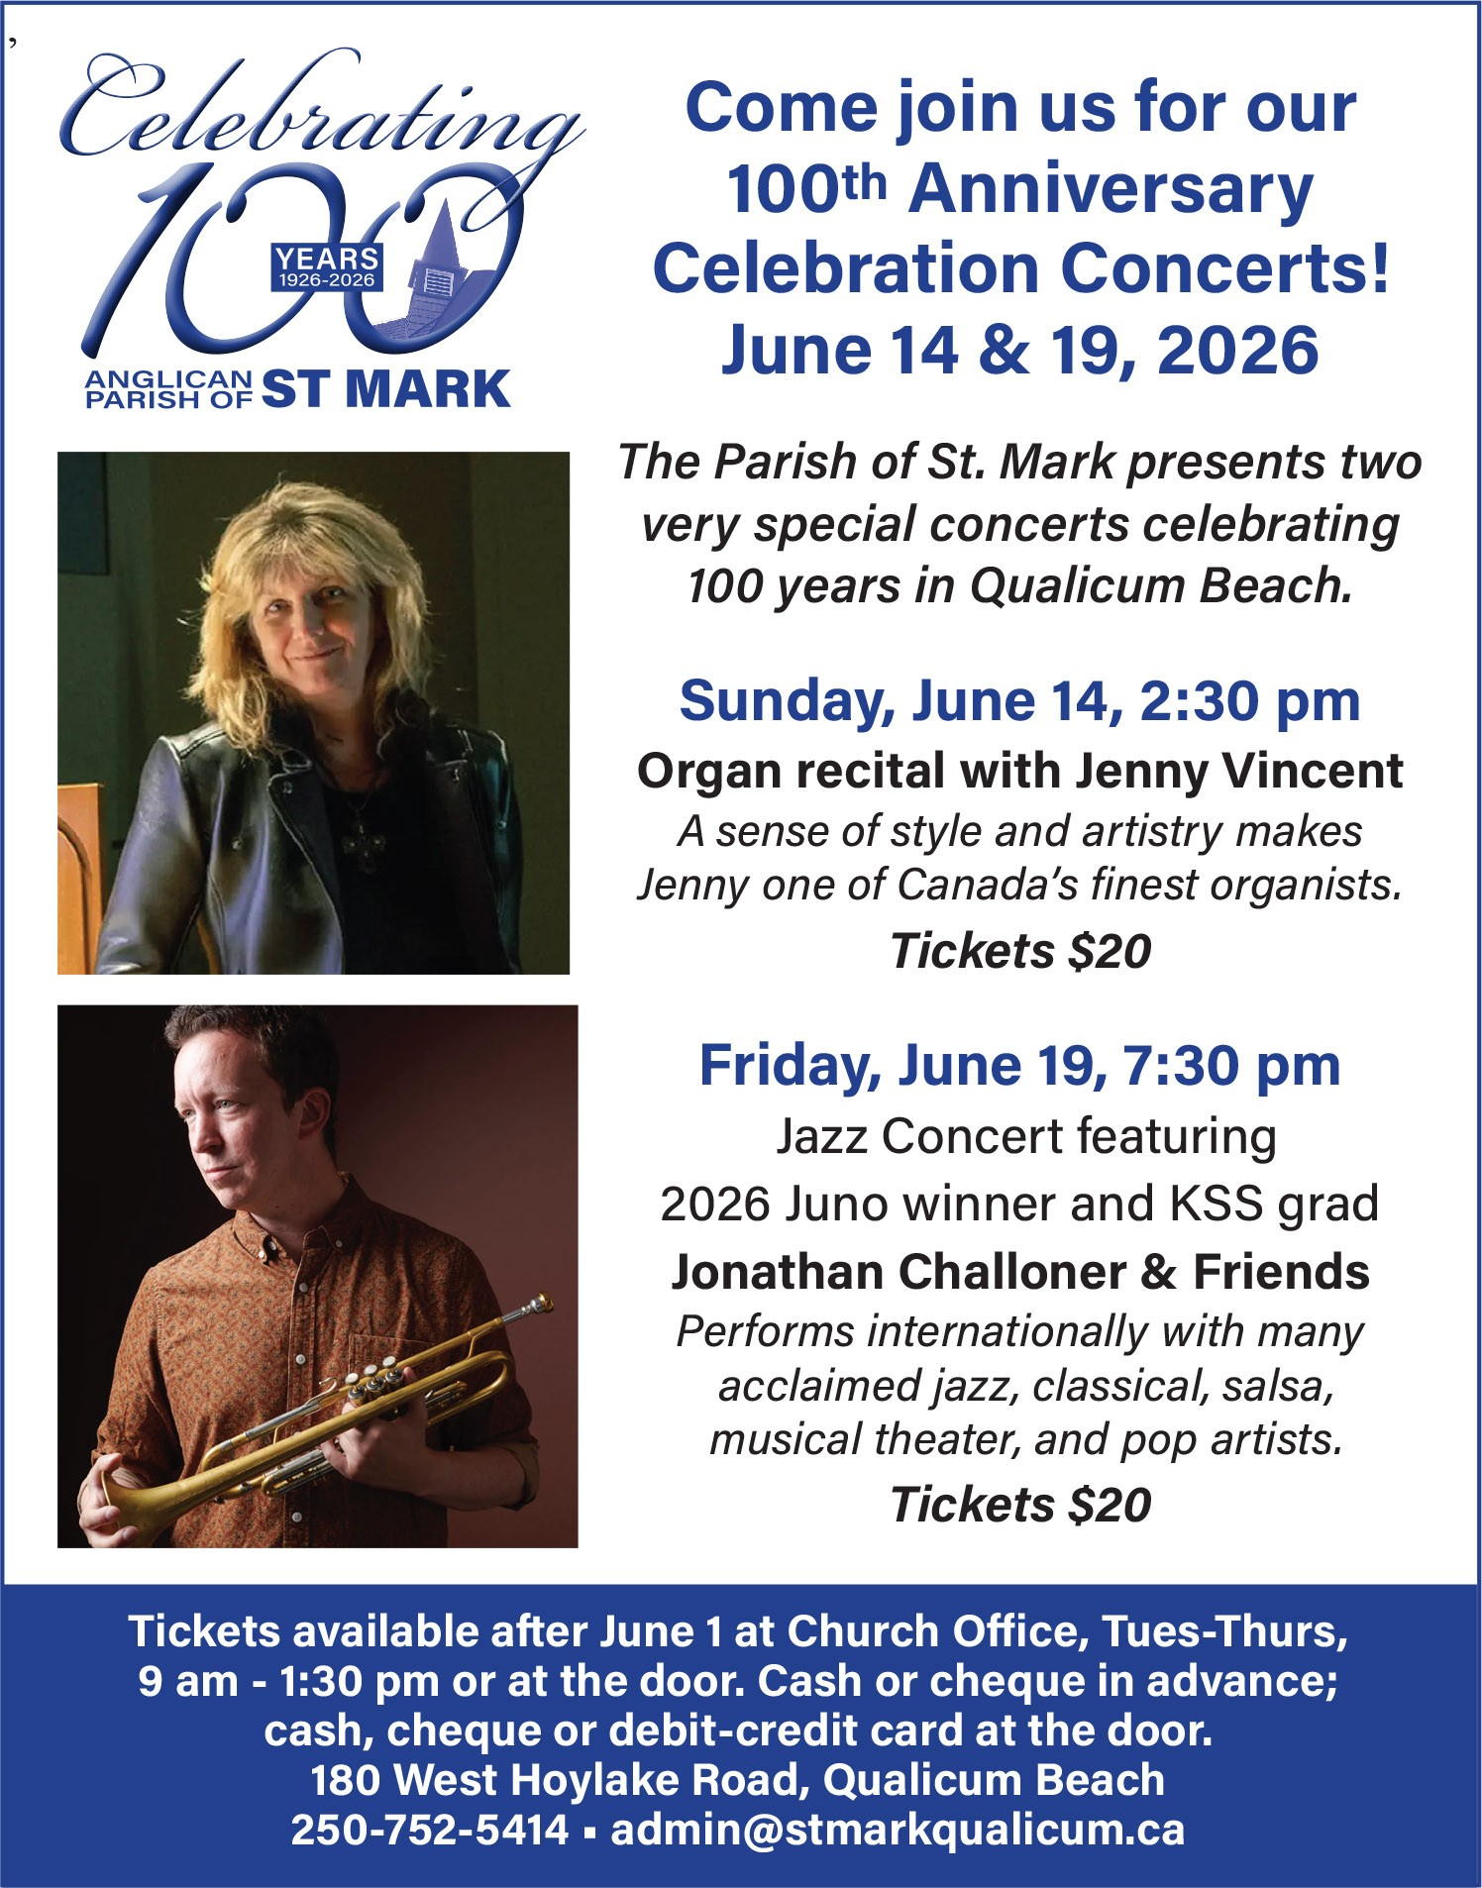
ALSO TODAY, at 2:30 pm is the first of our Anniversary concerts — Jenny Vincent, organ. Jenny is a consummate musician and one of Canada’s leading organists. Her program features a synopsis of music by various composers (Pachelbel, JS Bach, Handel, Elgar, Healey Willan & Rutter) and arrangements of hymns that would have been played over the past 100 years. Tickets ($20, cash or cheque) are available after church today or at the door.
We close our Anniversary Week celebrations on Friday, June 19 at 7:30 pm with a Jazz concert featuring 2026 Juno award winner and KSS grad, Jon Challoner, and Friends. Tickets are $20, available after church, at the church office (Tuesday - Thursday), or at the door.
Copies of the 100th Anniversary Pictorial History by Richard de Candole are for sale after church today ($20 per copy (cash or cheque) or in the church office, Tuesday to Thursday, 9:00 am to 1:00 pm.
Advance notice: The offering being taken at Tuesday’s Anniversary service will be designated for Alongside Hope, in partnership with the Anglican Diocese of Jerusalem, for the purchase of solar panels for St. Luke’s Hospital in Nablus, West Bank, Palestine. Special donation envelopes will be available at the service. Donations of $20 or more are eligible for 2026 income tax receipts.

CALENDAR: June 15 – June 21

Monday, June 15
Set-up for Anniversary

Tuesday, June 16
2:30 pm — Service of Thanksgiving
4:00 pm — 100th Anniversary Tea

Wednesday, June 17
10:00 – 11:00 am — Sermon Circle
5:30 pm — NAC (downstairs)

Thursday, June 18
11:00 am — Margaret Arlene England Celebration of Life
3:30 – 4:30 pm — 52 Ways Discussion Group

Friday, June 19
7:30 pm — Jazz concert featuring Jon Challoner

Sunday, June 21
8:30 am — Holy Eucharist – BCP
10:00 am — Holy Eucharist – Liturgy of the Islands

