PARISH HOUSE: Items for June
Items Needed: Cereal, Cleaning Supplies

Upcoming Events:
June 3rd – 6:00pm Choir Practice
7:00pm Team Leadership Meeting
June 10th – No Choir or “The Chosen”
June 13th – 8:00am Men’s Meeting
` Brushy Fork Community Building

NEEDED: Salads and cookies for Salad
Luncheon during Annual Conference.
Candy will be at Church June 10th at
9:00am. Items can be dropped off or
come and help.

JUNE BIRTHDAYS

Gaye Levering – 3rd, Kevin Strader – 16th,
Shelley Strader – 20th, Peggy Landis – 21st,
Candy George – 24th

JUNE ANNIVERSARIES
Candy & Mark George – 3rd
Larry & Corrine Wamsley – 13th

Tithes and Offerings: Give your gifts,
tithes, and offerings through PayPal. It is
quick, easy, and safe! Just use the
camera on your phone to scan the QR
Code. All donations will be placed into
our General Account unless otherwise
stated.

TENNERTON
United Methodist Church
May 31, 2026
TRINITY SUNDAY
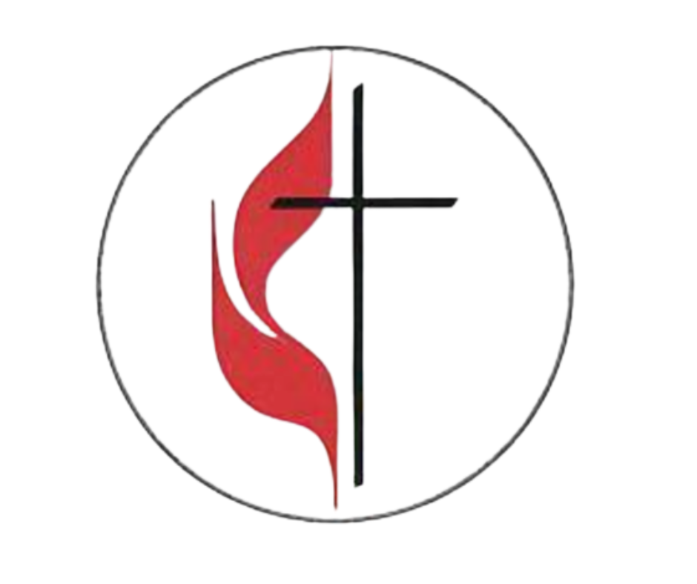
Pastor Jim Minutelli
304-629-9398

Office: 126 Tallmansville Rd.
Buckhannon, WV 26201
Office Phone: 304-472-1064
Sermon by Phone: 304-460-0029
Website: https://tennertonumc.org
Email: umc.tennerton@gmail.com
Facebook: https://www.facebook.com/thetennertonumc
Prayer Concerns: Call Candy George @ 304-613-6424

JOYS & CONCERNS
WELCOME/OPENING PRAYER Pastor
*OPENING HYMN: “Emmanuel, Emmanuel”
( 2 X’s) (6/28) UMH 204

CALL TO WORSHIP: Psalm 8 UMH 743

*OFFERING/DOXOLOGY/PRAYER UMH 95
CHOIR: “Come Thou Almighty King” (2/4) UMH 61
CHILDREN MESSAGE Vickie Snyder
ANNOUNCEMENTS (ON BACK PAGE)
READING: 2 Corinthians 13: 11 – 13

*HYMN: “Holy, Holy, Holy! Lord God Almighty”
(2/8) UMH 64
SCRIPTURE READING:
SERMON:

*CLOSING HYMN: “Precious Lord, Take My Hand”
(16/23) UMH 474
*BENEDICTION

*Please stand if you are able. Don’t Forget to Feed the Pig

GREETERS & WORSHIP LEADERS
If you would like to be a greeter or lead worship service,
print your name on the clip board on the front pew.
This Week
GREETER(S): Shane & Billi West
WORSHIP LEADER: Vickie Snyder
Next Week
GREETER(S): Larry & Corrine Wamsley
WORSHIP LEADER: Lynn Frum

Quote of the Week:

“To speak of the one God of the Bible
is to speak of the Father, Son, and
Spirit - they are each God, but they are
not each other.”
Brandon D. Smith

