Announcements

Monday, June 15
Beaver Valley Band Banquet hall 5:30p.m.

Tuesday, June 16
Community dinner prep Kitchen 9:15a.m.
Montessori School Banquet hall 4:00p.m.
Graduation
Bell practice Banquet hall 7:00p.m.

Wednesday, June 17
Montessori School Banquet hall 10:30a.m.
Concert prep
Community dinner Kitchen / Banquet hall 5:00p.m.
Bay wind Flutes Banquet hall 5:30p.m.

Thursday, June 18
Sunset Manor Service Sunset Manor 10:00a.m.
Board meeting Board room 7:00p.m.
Thursday night group Banquet hall 8:00p.m.

Friday June 19
Montessori School carnival Last day
Montessori School carnival Gym (rain day)

Saturday, June 20
Summer Solstice dinner Kitchen /Banquet hall 6:00p.m.

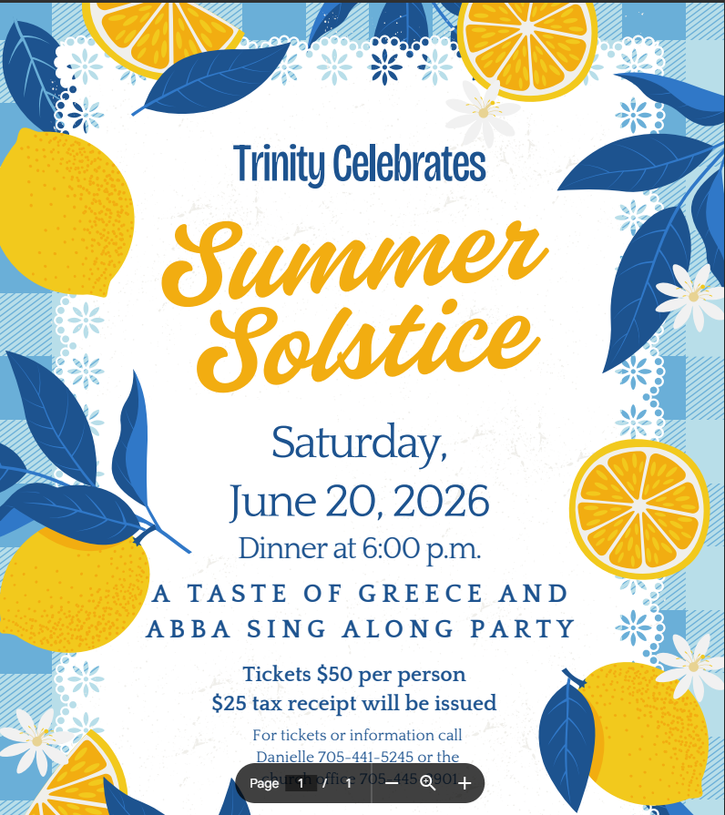

Sunday, June 21 - Indigenous Peoples’ Day

10:30 a.m. Indigenous Day of Prayer Worship Service
12:00-12:30 p.m. Soup and Bannock Lunch (If you can bring a crockpot of soup, let Beth know. We are still looking for 2-3 more pots).
12:30-2 p.m. Workshop with Elaine Wabie, a Collingwood community leader and advocate from the Algonquin First Nation (Wolf Clan)
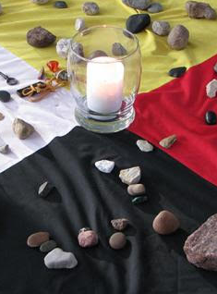
Collingwood Pride Celebrations
Thurs. July 9 - Sign Making Party in the Board Room from 6-8. Come help us make some signs for the Pride Parade on Saturday
Sat. July 11 - Pride Parade - Details about when and where to meet for walkers coming soon. Parade is at 5 p.m.
Sun. July 12 - Pride Worship Service - Singers are invited to come at 9:30 a.m. to sing in a special pop-up choir for the day. Worship is at 10:30 a.m. with refreshments afterwards. Wear your brightest colours!


National Assessment
Our national assessment this year is just over $16,000 - please consider contributing toward that figure with a donation to "National Assessment" - thank you! (tax receiptable!)

Over the Summer, we will be using the Prayer Bench resource “Summer Sabbath” by Janice MacLean as a jumping off point for our final service in June and the Sundays of July. Our themes are as follows:

June 28: “SUNFLOWERS: Pronouncing a Blessing”
July 5: “STRING BEANS: Taking Up the Offerings”
July 12: “RAINBOWS: Shining Brightly”, this is also our Pride Service with a pop-up choir meeting at 9:30 to prepare a special music offering for this joyful celebration
July 19: “MOSQUITOES: Praying Through Hard Times”
July 26: “FIREFLIES: Praying for Others”, this is also our Outdoor Service at the Collingwood Arboretum (weather-permitting, bad weather location is at Trinity)

You can share in this summer reflection series by attending worship in person or online, by picking up a copy of a reflection booklet from either church entrance to take home with you, and/or by following along on our social media (Instagram “collingwoodunited” or Facebook “Trinity United Church, Collingwood’).

Rev. Beth Kerr Vacation time.
Beth will be away on a combination of vacation and study leave in the month of August. Mary Elizabeth Piercy is available for pastoral emergencies (maryelizabethpiercy@gmail.com or 705-445-4740). Our guest worship leaders in August will be:

August 2: Mary Elizabeth Piercy
August 9: Rick Horst
August 16: Mary Elizabeth Piercy
August 23: Danielle York
August 30: Sarah Bruer

Please remember that if you are away during the summer but still want to catch our service, with the exception of our outdoor service on July 26, you can follow us on YouTube https://www.youtube.com/@collingwoodtrinityunitedch5278/streams

Rev. Beth Kerr (she/her)
Diaconal Minister
Trinity United Church
140 Maple Street,
Collingwood, ON L9Y 2P8
www.collingwoodunitedchurch.ca
705-445-3901 (church)
204-872-2370 (cell)
Please note: Friday and Saturday are my sabbath days. I will reply to emails received on those days on the following Monday. For emergencies, please contact my cell phone.

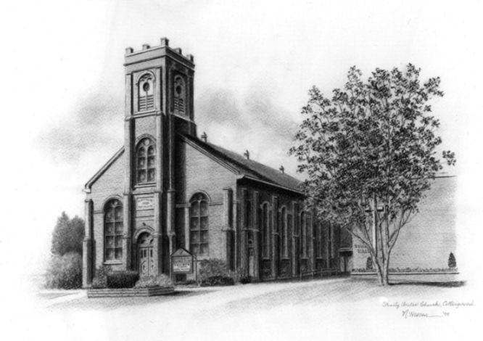

Trinity United .Church: Collingwood
Minister: Rev. Beth Kerr, 204.872.2370 (cell)
Minister’s Email minister@collingwoodunitedchurch.ca
Ministry of Music: Paul Sloan, 705.730.3121 (cell)
Choir Director: Lesley Joosten, 705.984.3243
Handbell Director: Maryellen Burgess, 705.443.1422 (cell)
UCW President: Joy Barr 705.445.0726
Office Assistant: Lori Forsythe
Church Office: office@collingwoodunitedchurch.ca
Office Hours: Tuesday to Friday, 8:30 am-12:00 pm
140 Maple Street, Collingwood, ON L9Y 2P8
Telephone: 705.445.3901
Website: www.collingwoodunitedchurch.ca

