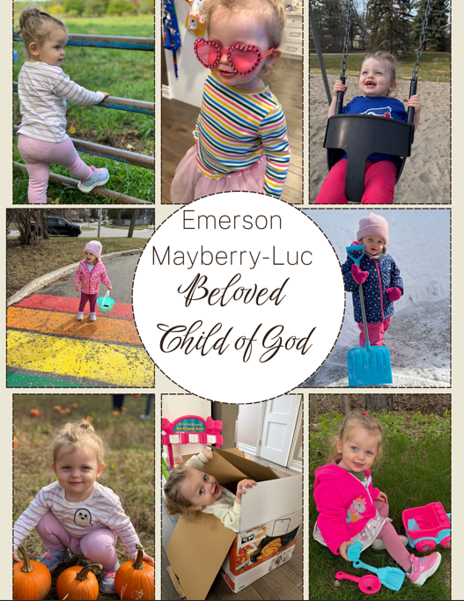

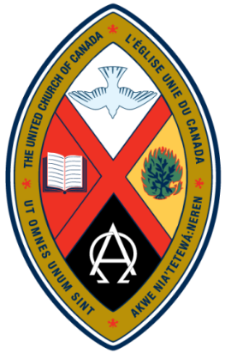

Trinity United Church
June 14, 2026
Proper 6
Celebration of Baptism

Land Acknowledgement
Here at Trinity United Church, we recognize that we share this land with the first inhabitants of this area, the Anishinaabe and other Indigenous and Metis peoples, with whom we seek to live in harmony. We are all treaty people.

God Welcomes Each One of Us with Loving Grace

Lighting the Christ Candle
We light this candle as a symbol of our intention to be open and attentive to Christ’s presence in our time of worship and in our lives.

Introit: VU 399 (verse 1) “God, Whose Love is Reigning O’er Us”

Announcements and Opportunities @Trinity

Gathering Words (by Peter Chynoweth)
One: We delight in the gift of a new day.
All: May God be praised and honoured in all that we do here this day.

Opening Hymn: VU 389 “God is Here”

Opening Prayer (Adapted from a prayer by Wendy McLean)
Great Spirit, Creator, and Lover of the Universe, we give thanks for this day and for all the wonders it holds. We rejoice in the gift of new life. We celebrate the blessing of our baptism and the family of faith in which we belong, as your children. We are delighted to welcome Emmy into this family of faith and we rejoice with her loved ones in all the wonderful love and joy she brings into the world. Remind us, when we forget, that when you called us, you equipped us with love and justice to serve you, and enjoy you, and to love the life we share.
In Christ, we find the way. Amen.

Prayer of Confession (Modified from a prayer by Gord Dunbar)
One: God tugs within our hearts with words of invitation,
All: so that in joy, we respond with discipleship, finding a divine companion in the Spirit, rejoicing in our freedom to journey in faith.
One: God calls and guides,
All: so that in Jesus we find our road map, following the resurrection promise into new life

… a pause for silent contemplation

Words of Assurance:
God’s forgiveness is a gift freely given. May this great gift lighten our hearts and transform our living. Amen.

Theme Conversation (Children’s Time) – “By Water and the Spirit”

Baptism Hymn - VU 444 “Child of Blessing, Child of Promise”

Invitation to Baptism

Presentation of Candidates for Baptism

Profession of Faith

Baptismal Promises

Congregational Commitment
Today we celebrate with you and your child, and we are thankful that you are part of our church family. May our example and words support your efforts to provide a loving, caring home. On behalf of the whole church, wherever your child may grow and search for love and for God, we offer our support, love and care, now and in the days to come.

A New Creed

We are not alone,
we live in God's world.
We believe in God:
who has created and is creating,
who has come in Jesus,
the Word made flesh,
to reconcile and make new,
who works in us and others by the Spirit.
We trust in God.
We are called to be the Church:
to celebrate God's presence,
to live with respect in creation,
to love and serve others,
to seek justice and resist evil,
to proclaim Jesus, crucified and risen,
our judge and our hope.

od is with us.
We are not alone.
Thanks be to God.

Prayer of Thanksgiving and Pouring of Water

Act of Baptism

Presentation of Candle

Hymn - 443 VU “God We Pray”

God Speaks to Us with Peace and Assurance

Prayer for Illumination
God of extravagant grace, may your Spirit refresh our hearts
through the reading of the scriptures that the words spoken here and the thoughts of each one of our hearts might equip us to live as your disciples in this time and place. Amen.

Scripture Readings
- Romans 5: 1-5
- Matthew 10: 1-13

Anthem: “The Earth is the Lord’s”
Word and Music By: Wes and Diane Hannibal
Arranged by Roger Thornhill

Message: “A Roadmap for Life”

Hymn: VU 567 “Will You Come and Follow Me”

God Supports and Lifts Us

Pastoral Prayer and Prayer of Jesus

Acknowledging our Offerings in Support of Trinity United’s ministries
At each baptism we promise to provide a supportive community of faith in which young people and adults can grow in faith throughout their lives. And so we share our gifts of time, talent and treasure to continue this important ministry together. If you are able to support us financially, cash or cheques can be left in the offering plate at either entrance or mailed or dropped off at the church office. You can also give by e-transfer to office@collingwoodunitedchurch.ca or by signing up to donate monthly through PAR. If this is your first donation, please make sure we have your name and address and email address (if available) for tax receipt purposes. Thank you for all the ways you support us with your time, your talents and your financial resources. With grateful hearts we pray:

Holy God, you help to guide us along the pathways of life and sustain us through the difficult moments through the power of your love and the strength of this community of faith. May these gifts be used to further your work in this community and around the world. Amen.

Closing Hymn - VU 639 “One More Step”

Commissioning (by Cindy Randall)
May we leave this place open to God’s call on our lives that each of us might be a source of healing and of kindness in this world. May we go in faith ready to love and to serve in Jesus’ name.

Benediction
God is with us! We are not alone! And we are blessed to be a blessing, now and always. Thanks be to God!

Choral Blessing - VU 298 “When You Walk From Here”

Music to Inspire our Serving

***************************************************************************

