TLC Weekly: Sunday, June 14 – June 21
Vicar Angie DeSmith cell: 507-828-4941 email: amgiedesmith316@gmail.com
The Radio Broadcast (KMHL 1400AM or 101.7FM) is sponsored by LaVerne Jessen.
Sunday, June 14 Food Shelf Sunday
9am Worship
10am Coffee Fellowship
Monday, June 15 9am Men in Mission
5:30pm-7:15pm Vacation Bible School (Pre K thru 3rd grade)
6:30pm Church council
Wednesday, June 17 9am Do Day Mission Work Day
5:30-7:15pm Vacation Bible School (Pre K thru 3rd grade)
Thursday, June 18 5:30-7:15pm Vacation Bible School (Pre K thru 3rd grade)
7pm-Friday 7am Lock-in (4th, 5th, 6th grade)
Friday, June 19 OFFICE CLOSED
Sunday, June 21 Happy Fathers Day
9am Worship/Holy Communion
10am Coffee Fellowship

Please continue to Remember in Prayer:
Please…
We are happy to include people in our prayer list, but we must have their permission to be included. Many folks are very private about what is happening in their lives and we want to honor that.
Peggy Isaacson – LaVerne Jessen’s daughter, cancer
Steve Vickerman – health issues
Kim Mickelson – cancer-cousin of Kari Meyer & Kris Tiegs
Vicki Schaar – Cancer

June Acolyte: Jared Swenhaugen, Caroline Engelkes

June Altar Preparation: Darcy Carlson, Sandy Fultz

June Communion Servers: Addison Kainz, Gail Kropp. Sue Magnuson

Coffee Fellowship: Sunday, June 14 Carolyn Engelkes, Karen Krog
Sunday, June 21 Missie Erbes, Lina Munson

Scripture Readers: Sunday, June 14 Darrell Carlson
Sunday, June 21 Brenda Wieme

Greeters: Sunday, June 14 OPEN
Sunday, June 21 OPEN

Sunday Counters: Sunday, June 14 Missie Erbes
Sunday, June 21

Ushers: Sunday, June 14 Khyle Radke, Trent Fischer, Darrell Carlson
Sunday, June 21 Keith Hoffbeck, Scott Torkelson, Gabe Torkelson, Oliver Torkelson

Radio opening for the month of July: 12th and 26th

Camp out at Denny & Anita Fultz lake home, Friday June 19, 2026 for youth in grade 7-12th and friends. Starting at 3pm Friday until 7am Saturday. Bring swimsuit for water activities and a snack to share with all. Plan on staying overnight, bring a tent, sleeping bag, etc. Hot dogs, chips, smores and drinks will be furnished. We will be swimming, playing games and hanging out. Your welcome to come for part of the event or stay for the whole overnight-completely optional. Sign up is available on the BAND app. Questions: Shelby Johnson 507-706-3480 or Brooke Swenhaugen 507-706-3480.

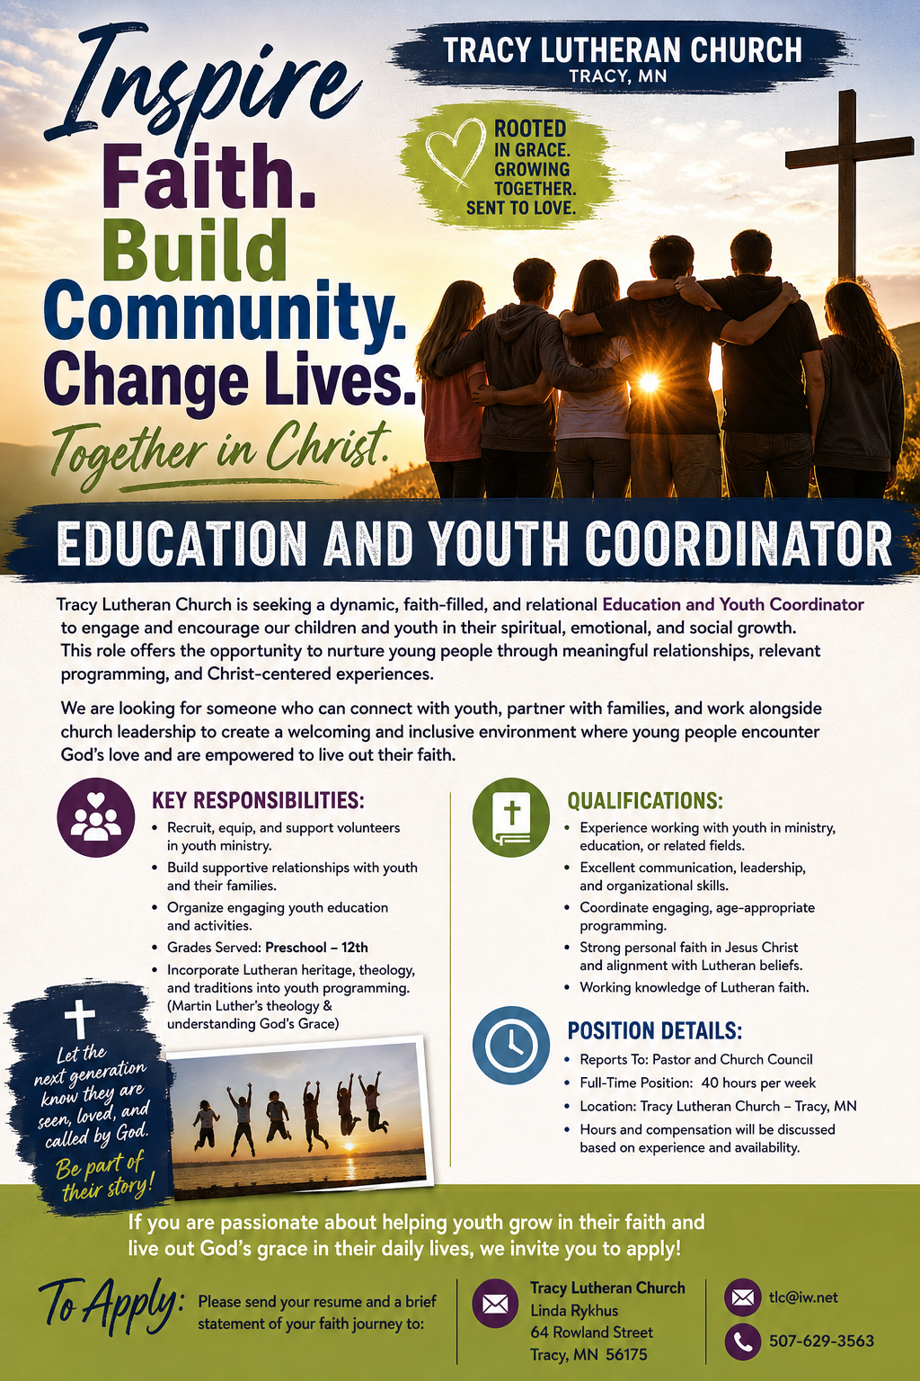
At the request of council president, Dennis Fultz, Tracy Lutheran Church is recognized as a Synod -Authorized Ministry site. Angie DeSmith has been authorized by Southwestern Minnesota Synod Bishop Dee Pederson to preach and preside for
Holy Communion in the congregation . The authorization is granted in accord with the ELCA’s guiding statement, The Use of the Means of Grace , which recognizes the witness of the sacrament as a celebration of the Church, serving its unity and
proclaiming the Gospel; and that where it is not possible to provide ordained pastoral leadership, a synod bishop may authorize a properly trained person to preside at a certain time.

