
Holy Trinity Lutheran Church
150 River Road Red Bank, NJ 07701
Church Office: (732) 741-9241 Fax: (732) 741-9577
email: holytrinitychurch4@verizon.net
Website: htlcredbank.org
Pastor: Rev. John Mack, Jr.
Cell: (336)-392-5839
Minister of Music: Peter Isherwood
Parish Administrator: Deanna Vergari
Council President: Cynthia Kazmac

June 7, 2026

Introduction
Though Jesus was a devout Jew who practiced his faith, he was criticized for eating with tax collectors and sinners—the religiously nonobservant. Jesus criticizes the self-righteous and reminds us that mercy is to be at the heart of our religious practices. God continues to be made known in those on the margins of society, like Matthew the tax collector and the hemorrhaging woman. As we gather each Lord’s day we receive the healing that makes us well and sends us forth to be signs of God’s mercy for the world.

Welcome & Announcements (Please remember to silence your cell phone!)

Prelude (We prayerfully prepare our hearts and minds to worship!)

+ GATHERING +
Call to Worship
P: Make a joyful noise unto the Lord, all you lands.
C: Serve the Lord with gladness; come before his presence with singing.

P: Enter into his gates with thanksgiving, and into his courts with praise. Be thankful to him and bless his name.
C: For the Lord is good; his mercy is everlasting, and his truth endures to all generations. (Psalm 100:1-2, 4-5)

*Gathering Hymn ELW 510 Word of God, Come Down on Earth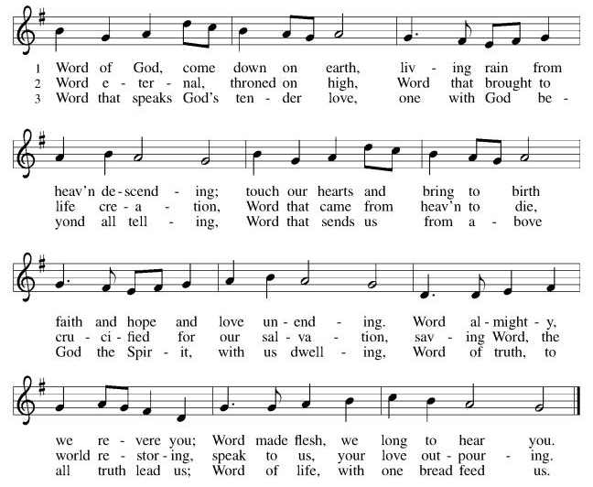

*Pastoral Greeting

P: The Grace of our Lord Jesus Christ, the love of God, and the communion of the Holy Spirit be with you all.

C: And also with you!

Kyrie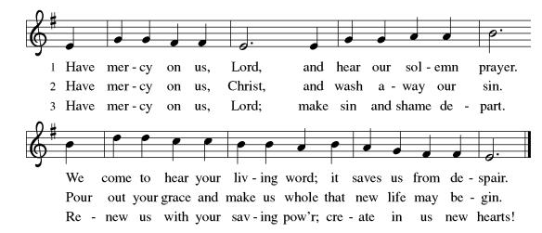

Prayer of the Day
P: O God, you are the source of life and the ground of our being. By the power of your Spirit bring healing to this wounded world, and raise us to the new life of your Son, Jesus Christ, our Savior and Lord.C: Amen!

Children’s Message

+WORD+

First First Reading: Hosea 5:15—6:6
Because the people have trusted in military powers and not God, God decides to withdraw from the scene until Israel acknowledges its guilt and seeks God’s face. The response of the people does not acknowledge this guilt and is as fickle as fog or dew burned away quickly by the sun. God desires loyalty rather than words or meaningless deeds.

¹⁵ I will return again to my place
until they acknowledge their guilt and seek my face.
In their distress they will beg my favor:
^{6:1} “Come, let us return to the Lord,
for it is he who has torn, and he will heal us;
he has struck down, and he will bind us up.
² After two days he will revive us;
on the third day he will raise us up,
that we may live before him.
³ Let us know, let us press on to know the Lord;
his appearing is as sure as the dawn;
he will come to us like the showers,
like the spring rains that water the earth.”
⁴ What shall I do with you, O Ephraim?
What shall I do with you, O Judah?
Your love is like a morning cloud,
like the dew that goes away early.
⁵ Therefore I have hewn them by the prophets;
I have killed them by the words of my mouth,
and my judgment goes forth as the light.
⁶ For I desire steadfast love and not sacrifice,
the knowledge of God rather than burnt offerings.

Psalm: Psalm 50:7-15
Call upon me in the day of trouble, says your God. (Ps. 50:15)

⁷ “Listen, my people, and I will speak: Israel, I will bear wit- | ness against you;
for I am | God, your God.
⁸ I do not accuse you because | of your sacrifices;
your burnt offerings are al- | ways before me.
⁹ I will not accept a calf | from your stalls,
nor goats | from your pens;
¹⁰ for all the wild animals of the for- | est are mine,
the cattle on a | thousand hills.
¹¹ I know every bird | of the mountains,
and the creatures of the | fields are mine.
¹² If I were hungry, I | would not tell you,
for the whole world is mine and all | that is in it.
¹³ Do you think I eat the | flesh of bulls,
or drink the | blood of goats?
¹⁴ Offer to God a sacrifice | of thanksgiving
and make good your vows to | the Most High.
¹⁵ Call upon me in the | day of trouble;
I will deliver you, and you shall | honor me.

Second Reading: Romans 4:13-25
Paul presents Abraham as a living model of right relationships. For Abraham and for us, a right relationship with God involves trusting that God’s promises will be fulfilled because God makes the dead alive and calls into existence what otherwise does not exist.

¹³ The promise that he would inherit the world did not come to Abraham or to his descendants through the law but through the righteousness of faith. ¹⁴ For if it is the adherents of the law who are to be the heirs, faith is null and the promise is void. ¹⁵ For the law brings wrath, but where there is no law, neither is there transgression.
¹⁶ For this reason the promise depends on faith, in order that it may rest on grace, so that it may be guaranteed to all his descendants, not only to the adherents of the law but also to those who share the faith of Abraham (who is the father of all of us, ¹⁷ as it is written, “I have made you the father of many nations”), in the presence of the God in whom he believed, who gives life to the dead and calls into existence the things that do not exist. ¹⁸ Hoping against hope, he believed that he would become “the father of many nations,” according to what was said, “So shall your descendants be.” ¹⁹ He did not weaken in faith when he considered his own body, which was already as good as dead (for he was about a hundred years old), and the barrenness of Sarah’s womb. ²⁰ No distrust made him waver concerning the promise of God, but he grew strong in his faith as he gave glory to God, ²¹ being fully convinced that God was able to do what he had promised. ²² Therefore “it was reckoned to him as righteousness.” ²³ Now the words, “it was reckoned to him,” were written not for his sake alone ²⁴ but for ours also. It will be reckoned to us who believe in him who raised Jesus our Lord from the dead, ²⁵ who was handed over for our trespasses and was raised for our justification.

*Gospel Acclamation
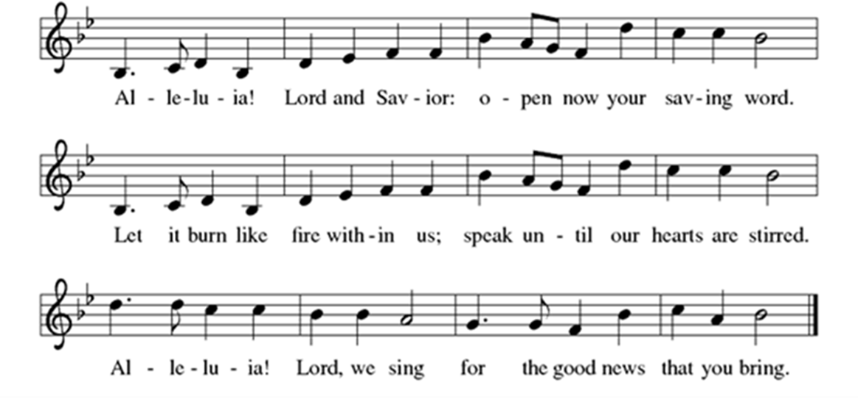

P: The Holy Gospel According to St. Matthew 9th Chapter
C: Glory to You O Lord!

Gospel: Matthew 9:9-13, 18-26
Jesus demonstrates God’s mercy and power, accepting the unacceptable and curing the incurable. Even the dead receive new life.

⁹ As Jesus was walking along, he saw a man called Matthew sitting at the tax-collection station, and he said to him, “Follow me.” And he got up and followed him.
¹⁰ And as he sat at dinner in the house, many tax collectors and sinners came and were sitting with Jesus and his disciples. ¹¹ When the Pharisees saw this, they said to his disciples, “Why does your teacher eat with tax collectors and sinners?” ¹² But when he heard this, he said, “Those who are well have no need of a physician, but those who are sick. ¹³ Go and learn what this means, ‘I desire mercy, not sacrifice.’ For I have not come to call the righteous but sinners.”
¹⁸ While he was saying these things to them, suddenly a leader came in and knelt before him, saying, “My daughter has just died, but come and lay your hand on her, and she will live.” ¹⁹ And Jesus got up and followed him, with his disciples. ²⁰ Then suddenly a woman who had been suffering from a flow of blood for twelve years came up behind him and touched the fringe of his cloak, ²¹ for she was saying to herself, “If I only touch his cloak, I will be made well.” ²² Jesus turned, and seeing her he said, “Take heart, daughter; your faith has made you well.” And the woman was made well from that moment. ²³ When Jesus came to the leader’s house and saw the flute players and the crowd making a commotion, ²⁴ he said, “Go away, for the girl is not dead but sleeping.” And they laughed at him. ²⁵ But when the crowd had been put outside, he went in and took her by the hand, and the girl got up. ²⁶ And the report of this spread through all of that district.

P: The Gospel of the Lord
C: Praise to you, O Christ!
Sermon
*Hymn of the Day ELW 509 God’s Word Is Our Great Heritage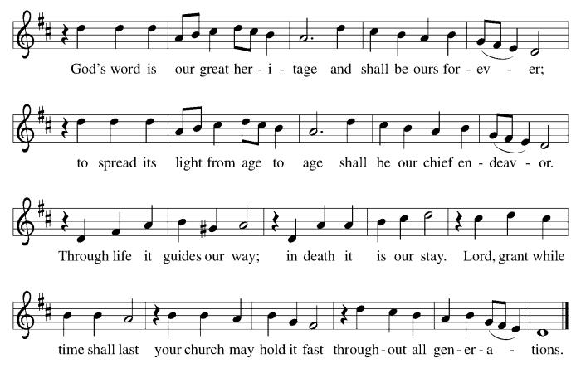
Apostles’ Creed
I believe in God, the Father almighty,
creator of heaven and earth.
I believe in Jesus Christ, God's only Son, our Lord,
who was conceived by the power of the Holy Spirit,
born of the Virgin Mary,
suffered under Pontius Pilate,
was crucified, died, and was buried;
he descended to the dead.
On the third day he rose again;
he ascended into heaven,
he is seated at the right hand of the Father,
and he will come to judge the living and the dead.
I believe in the Holy Spirit,
the holy catholic Church,
the communion of saints,
the forgiveness of sins,
the resurrection of the body,
and the life everlasting. Amen

*Prayers of Intercession
Gathered together by the Holy Spirit, let us pray for the church and the needs of the world.
A brief silence.
God of mercy, you call us to a life filled with acts of mercy. Ground us in following Christ, that we might extend the mercy we receive. God of grace,
C:hear our prayer.
God of creation, all you have made is yours (local landmarks and bodies of water may be named). Revive lands in need of healing and make us wise stewards of all you have given us to tend. God of grace,
C:hear our prayer.
God of the nations, you promise to deliver those who call on you. Bring an end to conflict, bigotry, and injustice in all their forms wherever they are found. God of grace,
C:hear our prayer.
God of comfort, you provide for those in need. Bring an end to addiction. Comfort people as they mourn. Provide tenderly for those in need (especially). God of grace,
C:hear our prayer.
God of blessings, you send the Holy Spirit to provide varieties of gifts in the body of Christ. Accompany those who travel this summer, make our gatherings joyous, and grant us a spirit of hospitality and togetherness. God of grace,
C:hear our prayer.
Here other intercessions may be offered.
God of life, we give you thanks for saints whose lives revealed your faithfulness (like Seattle, chief of the Duwamish Confederacy, whom the church remembers today). May remembering their faithfulness strengthen our own. God of grace,
C:hear our prayer.
Trusting you receive all our prayers, we commend our spoken and unspoken prayers to you, O God, through Jesus our Savior.
C: Amen.

Greeting of Peace
P: The peace of Christ be with you always!
C: And also with you!

Offering (Thank you for your support for our ministry!)

*Doxology ELW 884 (Please stand and join in singing as we share our gifts!)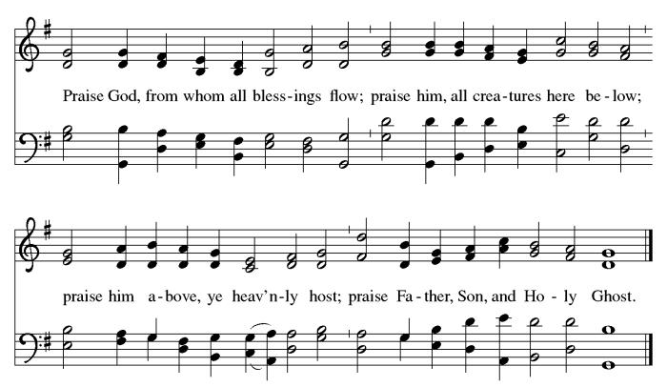

*Offering Prayer
A: Loving God,
C: we offer at your table the gifts of our hearts.
Help us take heart in you and share freely of your love,
so that all creation can taste your abundance.
We ask this in the name of Jesus,
through the Spirit abiding with us now and forever.
Amen!
+MEAL+
*Great Thanksgiving
P: The Lord be with you.
C: And also with you.

P: Lift up your hearts.
C: We lift them to the Lord.

P: Let us give thanks to the Lord our God.
C: It is right to give our thanks and praise.

P: It is indeed right, our duty and our joy,
that we should at all times and in all places
give thanks and praise to you, almighty and merciful God,
through our Savior Jesus Christ;
who on this day overcame death and the grave,
and by his glorious resurrection opened to us the way of everlasting life.
And so, with all the choirs of angels,
with the church on earth and the hosts of heaven,
we praise your name and join their unending hymn:

*Sanctus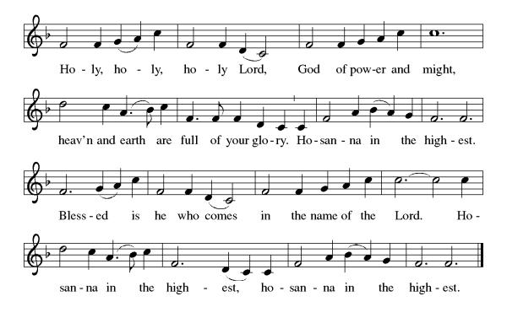
*Eucharistic Prayer
P: Holy God,
you alone are holy,
you alone are God.

The universe declares your praise:
beyond the stars;
beneath the sea;
within each cell;
with every breath.
C:We praise you, O God.

P:Generations bless your faithfulness:
through the water;
by night and day;
across the wilderness;
out of exile;
into the future.
C:We bless you, O God.

P:We give you thanks for your dear Son:
at the heart of human life;
near to those who suffer;
beside the sinner;
among the poor;
with us now.
C:We thank you, O God.

P:In the night in which he was betrayed,
our Lord Jesus took bread,
and gave thanks; broke it,
and gave it to his disciples,
saying: Take and eat;
this is my body, given for you.
Do this for the remembrance of me.

Again, after supper,
he took the cup, gave thanks,
and gave it for all to drink,
saying: This cup
is the new covenant in my blood,
shed for you and for all people
for the forgiveness of sin.
Do this for the remembrance of me.

Remembering his love for us
on the way,
at the table,
and to the end,
we proclaim the mystery of faith:
C:Christ has died.
Christ is risen.
Christ will come again.

P:We pray for the gift of your Spirit:
in our gathering;
within this meal;
among your people;
throughout the world.

Blessing, praise, and thanks
to you, holy God,
through Christ Jesus,
by your Spirit,
in your church,
without end.
C:Amen.

*THE LORD’S PRAYER
Our Father, who art in heaven,
hallowed be thy name,
thy kingdom come,
thy will be done,
on earth as it is in heaven.
Give us this day our daily bread;
and forgive us our trespasses,
as we forgive those
who trespass against us;
and lead us not into temptation,
but deliver us from evil.
For thine is the kingdom,
and the power, and the glory,
forever and ever. Amen.
*Lamb of God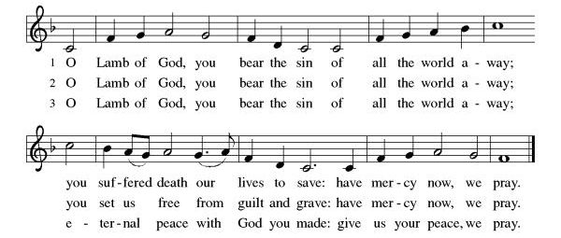
Spiritual Communion Prayer
P: Let us pray for the communion of all present here, those viewing our service virtually, those in our hearts and in our world.
C: Lord Jesus, I believe you are truly present in the Sacrament of Holy Communion. When I cannot receive Communion, I pray that you come into my heart. I know that nothing in Heaven or on earth can separate me from your love. Amen.

Invitation to Communion
P: Heaven has come near.
Come, share in the feast!

C: Thanks be to God!
(All are invited to the communion rail following the guidance of the ushers. Communion will be shared through the host and individual cups. If you would like communion but are unable to join us at the rail, please alert the usher!)

Communion Hymns (Please join in singing!)
ELW 477 I Received The Living God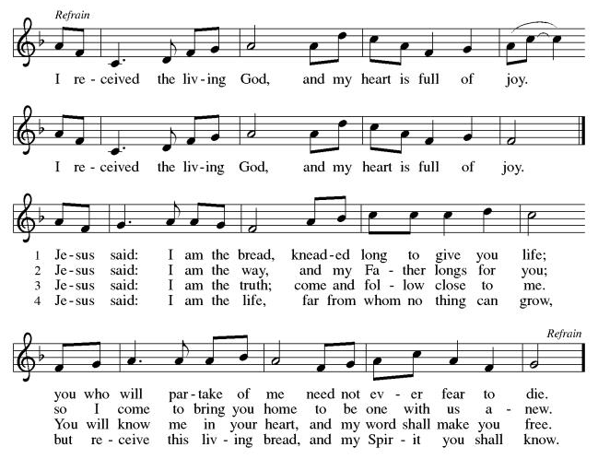
ELW 479 We Come to the Hungry Feast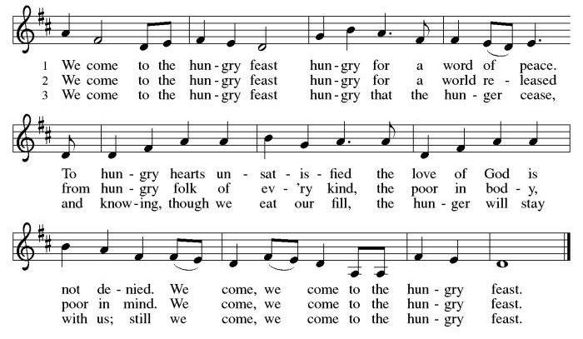

P: The body and blood of our Lord Jesus Christ strengthen you and keep you in his grace. C: Amen!

*Prayer after Communion
A: Compassionate God,
through the gifts of bread and wine
our hearts are filled with the abundance of your love.
Strengthen us that we, through this holy meal,
may share your love freely, as you have shared with us.
We ask this in the name of Jesus,
through the Spirit nourishing us now and forever.
C: Amen.

+Sending+

*Blessing
P: Creator, Redeemer, Sustainer,
☩ one God,
bless, heal, and hold you
today and always.
C: Amen!

*Sending Hymn ELW 537 On Our Way Rejoicing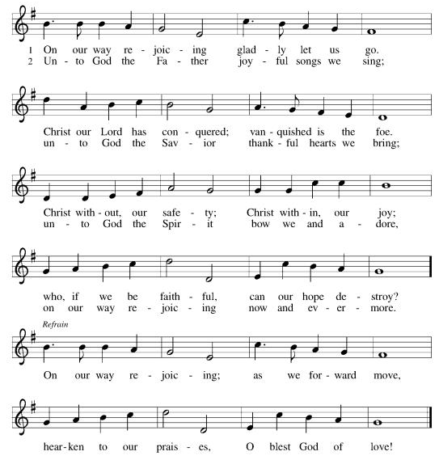

*Dismissal
A: Heaven has come near. Go, share the good news!
C: Thanks be to God. Alleluia!
Postlude

Copyright © 2020 Augsburg Fortress. All rights reserved. Reprinted by permission under Augsburg Fortress Liturgies Annual License #SB106907. New Revised Standard Version Bible, Copyright © 1989, Division of Christian Education of the National Council of the Churches of Christ in the United States of America. Used by permission. All rights reserved. Revised Common Lectionary, Copyright © 1992 Consultation on Common Texts, admin Augsburg Fortress. Used by permission.
Treasurer’s Report
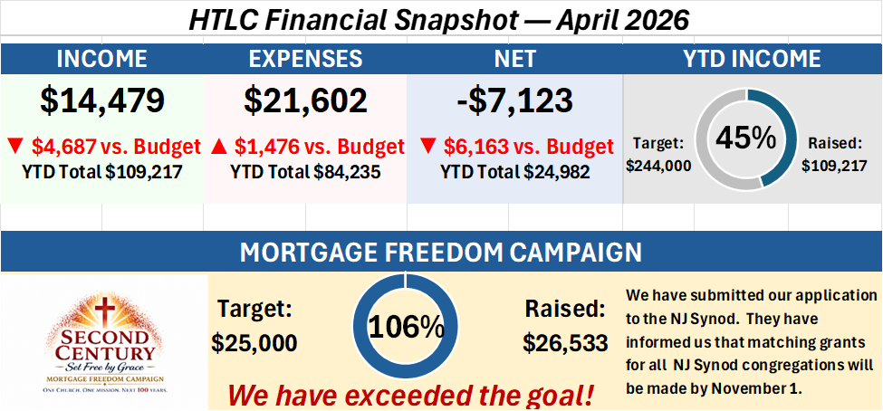

Worship Volunteer Schedule
Date | Asst. Min | Usher | Sacristan | Lector | Counter
June 7 | Keith Bennett | Dan Grillon | Sherry Lee | Jeff Ridberg | Kazmac/Cheek
June 14 | Chris Foard | Kathy Caputo | Joanne Giordano | Bill Spreen | Carleo/Csernica
June 21 | Charlie Rugg | Dan Grillon | Helga Britton | Molly Foard | Bradford/Giordano
June 28 | Linda Coleman | The Gripps | Joanne Giordano | Cynthia Kazmac | Foss/Foard
July 5 | Keith Bennett | Dan Grillon | Carol Rosen | Rosemary Lane | Coleman/Spreen
Coffee Hour- Pot Luck
Altar Flowers In memory of my grandson, Cylan Alexander Hayes, Walter and Sheila Hayes.

ANNOUNCEMENTS Thank you! To all who consistently support our church and ministries through your time, talent, and treasure. Please help us grow by inviting your friends and family to worship and events. You are what makes Holy Trinity a wonderful church family!

Stay in touch! Please visit our church website, www.htlcredbank.org for updates and information. You can also find us on Facebook and view services online. The office is open from 9am to 2pm, Monday to Thursday.

Emails- Notices of many emails being blocked by email hosting servers. We send out at least one email message a week. If you don’t see that email, your email service has block our blasts and emails from the office@htlceredbank.org. To insure that you see all emails from the church, you need to add our email address to your safe senders list. You will need to look up how to do that for your particular email host.

Car Wash-June 14th The car wash will start at 10 AM with churchgoers cars washed first, then will open up to the general public from noon till 2:00 PM. We will need volunteers to wash the cars, dry cars, manage supplies and supervise. Please sign up in the Red Book. Contact Lauren Bennett with questions period proceeds will support Cross Roads Day Camp.

100 Anniversary Committee- Meeting Sunday, June 21st .Please bring your ideas to that meeting and if you are unable to attend, share your thoughts by e-mail or in conversation. We will form better channels of communication as we move forward.

Name Tag Sundays: On the first Sunday of each month, names tags and markers will be at each entrance of the sanctuary. Please fill out a tag and wear one for worship and for coffee hour to welcome visitors and help newcomers put names to faces.

Sunday School in the New Year, we will continue to study stories and lessons from the Old Testament beginning with Jacob. Kids will love the crafts, songs and games that accompany each lesson.The following dates there will be Sunday School:
June- 7 and 14
As was done in the fall, there will be opportunities to volunteer as SS lead teacher. A signup will be emailed out shortly and will also be posted in the red binder. Consider signing up! All lesson materials will be supplied and laid out and a leader guide will be emailed to volunteers approximately 1 week in advance. Blessings for a wonderful 2026!~Lauren

Quilting- The Quilters need gently used any bed sheets of any size! Please leave any donations in the quilters closet in Fellowship Hall. Thank you!

Quilters Need Help
If anyone is traveling through Mechanicsville, PA (near Peddler’s Village), and can add a few extra minutes to your trip, the warehouse for shipping quilts, school kits, etc. is located directly off one of the exits. We accumulate many quilts throughout the year, and we would appreciate sending some quilts with you to deliver. Any questions, please call Sherry Lee or Elaine Theophall.

Weekly Quilting on Wednesdays at 9:30. Bring your lunch and enjoy some fellowship at noon. All are welcome.

Social Ministry
*Year-round collections will continue for food items for Lunch Break. There is a sign-up sheet in the red book for those who can help drop these items to Lunch Break.
*We will also collect adult men's socks to periodically drop at the Red Bank Warming Center.
*For those interested in the Heartwarming Center — the new women's shelter is adjacent to the First Baptist Church of Red Bank at 90 Maple Ave. You can follow up on this mission through their website - https://www.thefeastnj.org- On this site, they also include wish list items that can be purchased through amazon. We will be exploring purchasing some of these through a Thrivent card. If you want to purchase on your own, you can leave items at church, and the Social Ministry will deliver them.

Pastoral Care and Prayer... We are here to care for and pray! Please contact the office to add or adjust prayer requests. If you or someone you know needs pastoral care, please contact the office and Pastor Mack!

THANK YOU for supporting and sustaining our church and ministries! All are welcome here! Please invite your family and friends to worship with us! Find us online at www.htlcredbank.org


AS OF 5/24/2026
Final update next week.
