All Saints Anglican Church
6904 Lougheed Highway, Agassiz, B.C. V0M 1A0
Bulletin June 1st, 2026 – June 7th, 2026

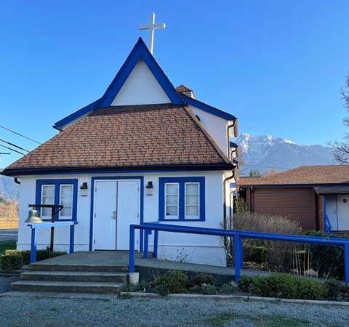

‘The ground we walk does not belong to us; for thousands of years it has been - and remains - the territory of the Stó:lō. We are grateful for their sharing.

Phone: 604-796-3553
Website: www.allsaints-agassiz.ca
https://www.facebook.com/groups/AllSaintsFamily
OUR DOOR IS OPEN AND ALL ARE WELCOME
June 7th, 2026, Second Sunday After Pentecost
Priest in Charge: The Reverend Philip Barker
Hosts: Graham Featherstone/Jennifer Pinlac
Intercessor: Jennifer Pinlac
Lay Administrator: Dorothy Cresswell
Announcer: Virginia Jennings
Organ/Piano: Francesca Froehlich
Readers: Keith Fossey/Lynn Laughlin
Vicar’s cell phone: Revd. Philip Barker. 778-867-2461

Vicar’s Warden: Ginny Jennings. 604-796-2206
People’s Warden: Lynn Laughlin. 604-799-5131
Parish email: revpb1950@gmail.com
Please contact either warden if you have an issue that needs to be brought to the attention of the Vicar - or contact the Vicar direct (see above for details).

All Saint’s Calendar/Announcements:

- Book Club – On June 10th Book Club will be starting "Sensible Shoes" by Sharon Garlough Brown, an experienced leader of spiritual formation retreats in the UK and US. It follows 4 very different and very relatable female characters on their journey together through 12 one-day retreats.
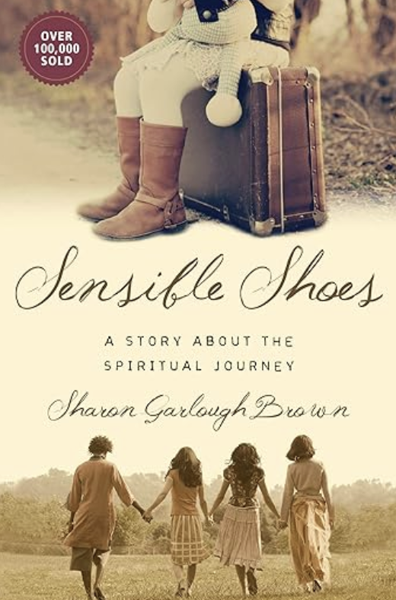

Please contact Sheila Barker at sjbarker0379@gmail.com
if you would like an invitation to the Zoom meetings
at 5.00 pm on Wednesdays or a copy of the book.
The book is available on amazon for $34.11 including tax.

- Bible Study with Karol is every Saturday morning 0830-0900 on Zoom.

- Prayer Requests can be given on a piece of paper to either of the Wardens or the Vicar or entered in the Prayer Request Book on the lectern. Alternatively, you can contact Anthea Lewis at antheamlewis@shaw.ca for Pray First Prayer Circle, which is a confidential online prayer circle.

- Music Requests may be given to the Wardens or the Vicar.

- AA meets in the hall every Tuesday and Friday at noon.

- Every Thursday in the hall 1100-1200 we have a social time with coffee, games if you like or just talk.

- At 1000-1100 on Thursdays there is an Interactive Bible Study on the day’s Lectionary readings. All are welcome – discover the treasures in this amazing book!

- 5th Sunday of each month will be a potluck lunch after the service

Ministerial Meandering
Billy the Bee 2.

Nature was wasteful - Billy could see that. After all, there were plenty of drones in his hive, but only one was going to mate with the next queen. The rest, well, they just died. Lots of bees to do one job. Still, it was the same for the girls; all the potential queens would be stung to death by the first to hatch, and then she would take off on her ‘maiden voyage’ to mate with the ‘lucky’ drone in mid-air, and eviscerate him at the end of their union, where upon he would drop dead to the ground, literally emptied of all he had bee(n).

But humans - Billy couldn’t fathom them. They too had so much wastage - but such a lot of their wastage seemed unnecessary to him. They were so often leaderless, or had leaders who were so obviously NOT leaders, and yet they were given power - and then had no idea how to use it because they were either stupid, or driven mad by the opportunity - or both. And yet the hive still didn’t drive them out!
Then there were the lost ones - there seemed to be so many of those. Humans with no idea what to do with their lives and absolutely no sense of purpose or direction. Those were the ones he wanted to get into his hive and tell them what their meaning in life was supposed to be(e). Hives may not have been the most varied of societies, but each bee knew his or her role - and did it to the best of their ability. He felt both irritated and sad for the lost ones, because they wasted their lives and misbe(e)haved, eating up honey stores and Royal Jelly that was never for them in the first place. When the current queen swarmed, they would be truly lost, never having found a reason for their lives.

Now Billy was no PhD, but he could see value in the idea of getting rid of waste before it built up and clogged the hive. After all, that’s what the worker bees did when they were doing a clean-up on the hive, and they shoved all the excess drones out, where they would die - be(e)ing useless to fend for themselves.

The ideas of eugenics and euthanasia were, as terms, naturally unknown to Billy, but he knew that the topics caused great concern to humans - and he could see why they did. After all, in his society, no defective bee ever became adult, and was instantly shunted out with the trash before it ever buzzed. And the older bees just simply stopped being fed or feeding themselves. The trouble with humans was that they seemed to want to keep both ends of their respective lives going for as long as they could. That caused huge ethical problems for humans, and they held long, agonised debates on the topics - and never came to any useful conclusions. The result was that they needed more and more ’special’ hives, just to look after the bees who needed extra attention. It probably would have been all right if they hadn’t been so successful at doing it, because now there were more and more especially elderly bees who had become more like baby pupa again. And there just weren’t enough hives.

Billy wasn’t sure what the answer for his humans might be(e). Perhaps he would have to talk to his queen…

Philip+

A Little Chuckle…
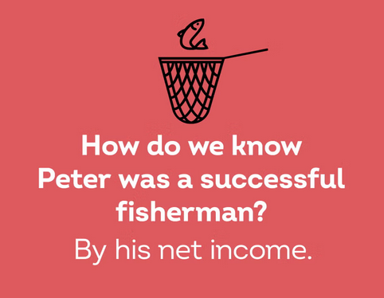

Diocesan Cycle of Prayer: We Pray for the Clergy and Congregation:

Urban Aboriginal Ministry – Mr Stephen Seegerts; National Indigenous Archbishop, Archbishop Chris Harper; St. David, Delta – The Revd Simbarashe Basvi

Anglican Church of Canada Cycle of Prayer – We Pray for:

The theological colleges and training programs within the Ecclesiastical Province of Ontario: Canterbury College, Huron University College, Renison College, the Anglican Studies Program at Saint Paul University, Thorneloe University, Trinity College, Wycliffe College

Collect

O God, you have assured the human family of eternal life through Jesus Christ our Saviour. Deliver us from the death of sin and raise us to new life in him, who lives and reigns with you and the Holy Spirit, one God, now and for ever.

Genesis 12:1-9 Keith Fossey

¹The Lord had said to Abram, “Go from your country, your people and your father’s household to the land I will show you.

² “I will make you into a great nation,
and I will bless you;
I will make your name great,
and you will be a blessing.
³ I will bless those who bless you,
and whoever curses you I will curse;
and all peoples on earth
will be blessed through you.”

⁴ So Abram went, as the Lord had told him; and Lot went with him. Abram was seventy-five years old when he set out from Harran. ⁵ He took his wife Sarai, his nephew Lot, all the possessions they had accumulated and the people they had acquired in Harran, and they set out for the land of Canaan, and they arrived there.

⁶ Abram traveled through the land as far as the site of the great tree of Moreh at Shechem. At that time the Canaanites were in the land. ⁷ The Lord appeared to Abram and said, “To your offspring I will give this land.” So he built an altar there to the Lord, who had appeared to him.

⁸ From there he went on toward the hills east of Bethel and pitched his tent, with Bethel on the west and Ai on the east. There he built an altar to the Lord and called on the name of the Lord.

⁹ Then Abram set out and continued toward the Negev.

Psalm 33:1-12

¹ Sing joyfully to the Lord, you righteous;
it is fitting for the upright to praise him.
² Praise the Lord with the harp;
make music to him on the ten-stringed lyre.
³ Sing to him a new song;
play skillfully, and shout for joy.

⁴ For the word of the Lord is right and true;
he is faithful in all he does.
⁵ The Lord loves righteousness and justice;
the earth is full of his unfailing love.

⁶ By the word of the Lord the heavens were made,
their starry host by the breath of his mouth.
⁷ He gathers the waters of the sea into jars;
he puts the deep into storehouses.
⁸ Let all the earth fear the Lord;
let all the people of the world revere him.
⁹ For he spoke, and it came to be;
he commanded, and it stood firm.

¹⁰ The Lord foils the plans of the nations;
he thwarts the purposes of the peoples.
¹¹ But the plans of the Lord stand firm forever,
the purposes of his heart through all generations.

¹² Blessed is the nation whose God is the Lord,
the people he chose for his inheritance.

Romans 4:13-25 Lynn Laughlin

¹³ It was not through the law that Abraham and his offspring received the promise that he would be heir of the world, but through the righteousness that comes by faith. ¹⁴ For if those who depend on the law are heirs, faith means nothing and the promise is worthless, ¹⁵ because the law brings wrath. And where there is no law there is no transgression.

¹⁶ Therefore, the promise comes by faith, so that it may be by grace and may be guaranteed to all Abraham’s offspring—not only to those who are of the law but also to those who have the faith of Abraham. He is the father of us all. ¹⁷ As it is written: “I have made you a father of many nations.” He is our father in the sight of God, in whom he believed—the God who gives life to the dead and calls into being things that were not.

¹⁸ Against all hope, Abraham in hope believed and so became the father of many nations, just as it had been said to him, “So shall your offspring be.” ¹⁹ Without weakening in his faith, he faced the fact that his body was as good as dead—since he was about a hundred years old—and that Sarah’s womb was also dead. ²⁰ Yet he did not waver through unbelief regarding the promise of God, but was strengthened in his faith and gave glory to God, ²¹ being fully persuaded that God had power to do what he had promised. ²² This is why “it was credited to him as righteousness.” ²³ The words “it was credited to him” were written not for him alone, ²⁴ but also for us, to whom God will credit righteousness—for us who believe in him who raised Jesus our Lord from the dead. ²⁵ He was delivered over to death for our sins and was raised to life for our justification.

Matthew 9:9-13 18-26 Vicar Philip Barker
⁹ As Jesus went on from there, he saw a man named Matthew sitting at the tax collector’s booth. “Follow me,” he told him, and Matthew got up and followed him.

¹⁰ While Jesus was having dinner at Matthew’s house, many tax collectors and sinners came and ate with him and his disciples. ¹¹ When the Pharisees saw this, they asked his disciples, “Why does your teacher eat with tax collectors and sinners?”

¹² On hearing this, Jesus said, “It is not the healthy who need a doctor, but the sick. ¹³ But go and learn what this means: ‘I desire mercy, not sacrifice.’ For I have not come to call the righteous, but sinners.”

¹⁸ While he was saying this, a synagogue leader came and knelt before him and said, “My daughter has just died. But come and put your hand on her, and she will live.” ¹⁹ Jesus got up and went with him, and so did his disciples.

²⁰ Just then a woman who had been subject to bleeding for twelve years came up behind him and touched the edge of his cloak. ²¹ She said to herself, “If I only touch his cloak, I will be healed.”

²² Jesus turned and saw her. “Take heart, daughter,” he said, “your faith has healed you.” And the woman was healed at that moment.

²³ When Jesus entered the synagogue leader’s house and saw the noisy crowd and people playing pipes, ²⁴ he said, “Go away. The girl is not dead but asleep.” But they laughed at him. ²⁵ After the crowd had been put outside, he went in and took the girl by the hand, and she got up. ²⁶ News of this spread through all that region.

