Dodge Center
United Methodist Church
June 7, 2026
Second Sunday after Pentecost
8:30 AM
*Stand as you are able

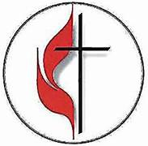

Prelude

Welcome and Announcements

Joys and Concerns

Prayer of Confession (See insert)

* Centering Hymn- UMH #57 “O For a Thousand Tongues to Sing” (vs. 1-4)

* CALL TO WORSHIP
L:The God of new beginnings has called us to this place.
P: We come celebrating the new life that is ours as God’s faithful people.
L: Let your joy ring through the universe and let your vision see to the depths of every soul.
P: We will be shouters of joy and seekers of God’s light wherever we go.
Praise God for this day!

OPENING PRAYER (in unison)
Though our mouths were full of song as the sea, and our tongues of exultation as the multitude of its waves, and our lips of praise as the wide-extended firmament; though our eyes shone with light like the sun and the moon, and our hands were spread forth like the eagles of heaven, and our feet were swift as deer, we should still be unable to thank you and bless your name, O God, for one thousandth or one ten-thousandth part of all you have bestowed upon our ancestors, and upon us. We give you thanks. Amen.¹
¹ Adapted from the Hebrew Morning Service

Hymn of the Day- TFWS #2088 “Lord, I Lift Your Name on High” (sing twice)

New Testament Lesson: Romans 4:13-25
Apostles’ Creed-UMH #882

Prayers and The Lord’s Prayer

*Doxology UMH #95 “Praise God, from Whom All Blessings Flow”

Gospel Lesson – Matthew 9:9-13, 18-26

Sermon – “Distractions” Pastor Michelle Hargrave
(Presented by Kelly Amunrud)

Closing Hymn: UMH #367 “He Touched Me (Shackled by a Heavy Burden)”
(Vs. 1 & 2)

Benediction

L: Go now as the people of God, a family.

*Postlude – “The Lord Bless You and Keep You”



Welcome to Worship!

Visitors, please sign our guest book before leaving.

Looking ahead:
- June 13, 2026-9:30 am-WWAP at the church. Note: This one week earlier than our regular meeting date
- June 14, 2026-Next Sunday is Pastor Daren’s First Sunday with us. We hope you all will come to worship and meet and greet him.

- Annual Conference – June16-18, 2026. Kathy Bartz will be attending from our church
- Our next Community Meal will be Wednesday, June 17th. The dinner menu is brats, hot dogs, mac n' cheese, baked beans, fruit, and cookies. Here's the link for the sign up: https://www.signupgenius.com/go/20F094CA5AC2AA1FA7-64259371-umcfree, or use the signup sheet in the back of the church for donations of food, or to set up, serve or clean up.

Coffee Fellowship There is a sign-up sheet in the back on the small bulletin board to bring treats and serve for coffee fellowship on Sundays. Coffee will be made each Sunday and juice is provided.

Greeters are needed each Sunday. Please let Janet know if you can greet or use the signup sheet in the back.

Thank you to our Worship assistants today, June 7th
Reader: Tyler Kispert
Counters: Tyler Kispert and Kim Marquardt

Speaker: Kelly Amunrud Pianist- Janet Bugarin
Secretary- Janet Bugarin Sound- Colin Lepp

Total donations needed each week- $1,700.00
Last Weeks’ offering amount: $870.00
The offering plate is in the back of the sanctuary. Thank you for placing your offering there.

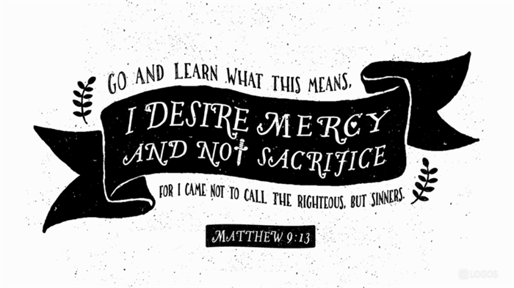

Dodge Center
United Methodist Church
Second Sunday after Pentecost
June 7, 2026
8:30 am

