City Road United Methodist Church
A Lighthouse Congregation

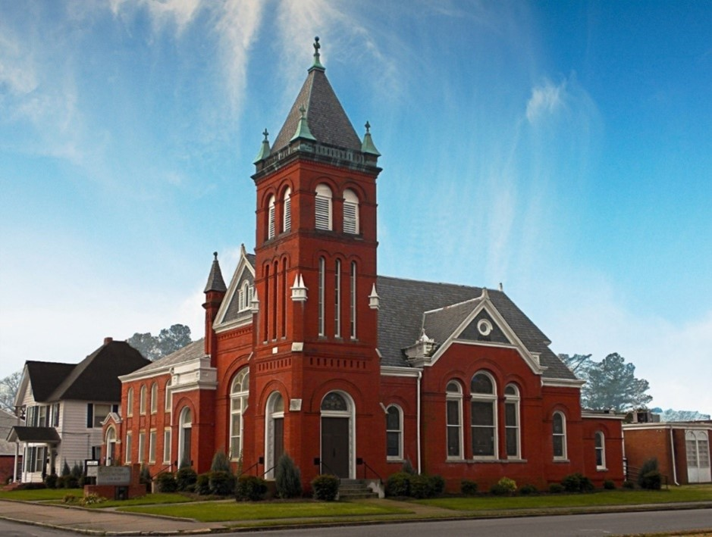
Rev. Josh Tester, Pastor

Office: (252) 335-2658
cityroadec.net crumcec@gmail.com

Facebook: https://www.facebook.com/CityRoadUMC

Sunday School: 10:00 a.m.
Sanctuary Worship: 11:00 a.m.

Tommy Venters- Organist/Choir Director
Dawn Baker- Secretary/Technology Specialist
JoAnn Herring- We Care

Service of Word & Table
Pentecost Season
June 7th, 2026 11:00 am
Gathering
Prelude
*Introit “Spirit of the Living God” UMH 393
Words of Welcome
*Call to Worship
Beloved, the Spirit of Truth gathers us here to receive and discern God’s good news working among us.
Come, Holy Spirit, come!
The Spirit of Love draws us together to receive and restore life-giving relationships with God and one another.
Come, Holy Spirit, come!
The Spirit of Freedom knits us together to receive and renew the bonds of empathy, justice, and peace that bind us together in the work for liberation and wholeness.
Come, Holy Spirit, come!
Beloved, the Holy Spirit is here, moving and working among us. Will you come and receive all the Spirit has to give?
We come to receive the Spirit’s abundant and gracious gifts that we may be a people who live out God’s truth, love, and freedom in our neighborhood, community, and throughout all creation. Amen.

*Prayer of Approach
Spirit of Pentecost, blow open the doors of our shut up hearts. Set our tongues free to proclaim your praise! Bless our youth with visions, and our elders with dreams. Bestow our children with gifts of prophecy and renew the faith of your people throughout the world. Blow into our lives once more Holy One and help us find the strength and courage to become the people you call us to be. Amen.
From Lahaina UMC, Maui, Hawaii

*Sharing Peace
The Peace be with you!
And also with you!

Hymn of Praise “One Bread, One Body” UMH 620

Proclamation & Response
Call to Prayer
Prayers of the People

Children’s Time
Call to the Offering
Offertory
*Doxology
*Prayer of Dedication

*Hymn of Preparation “Spirit Song” UMH 347

Anthem Chancel Choir

Old Testament Lesson Numbers 11:24-30
Epistle Lesson 1 Corinthians 12:3b-13
Message “Spirit Unbounded” Pastor Josh
Unbounded is an adjective meaning having no limits, bounds, or restrictions. It typically describes something vast, infinite, or unrestrained.

Invitation to Christ’s Table 7
Prayer of Confession 8
Psalter of Assurance excerpts from Psalm 104
In the name of Jesus Christ, you are forgiven.
In the name of Jesus Christ, you are forgiven.
Glory to God, Amen!

Holy Communion
Prayer of Great Thanksgiving 9
The Lord’s Prayer
*Receiving the Bread and Cup

*Affirmation of Faith UMH 883
We are not alone, we live in God’s world.
We believe in God:
who has created and is creating,
who has come in Jesus, the Word made flesh,
to reconcile and make new,
who works in us and others by the Spirit.
We trust in God.
We are called to be the Church:
to celebrate God’s presence,
to live with respect in Creation,
to love and serve others,
to seek justice and resist evil,
to proclaim Jesus, crucified and risen,
our judge and our hope.
In life, in death, in life beyond death,
God is with us.
We are not alone.
Thanks be to God. Amen.

*Prayer after Communion

Sending Fourth
*Sending Hymn “We are the Church” UMH 557
*Benediction
*Postlude

