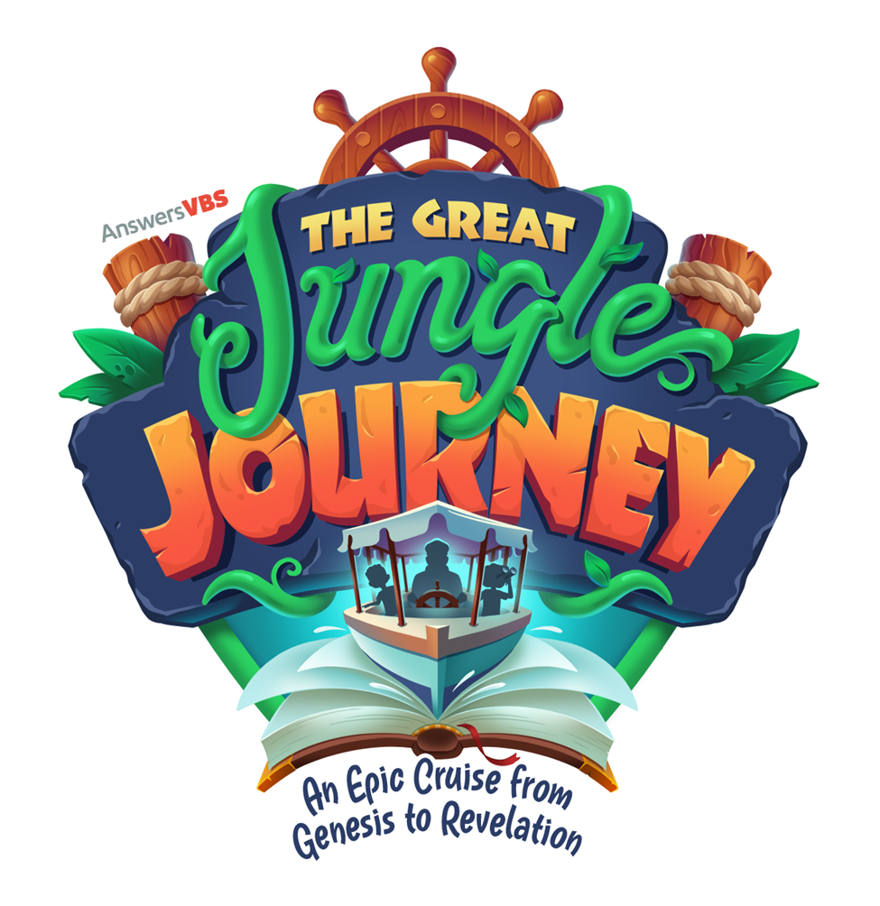
Newtown Reformed Church and Pennsylvania Newtown Christian Church
“The Great Jungle Journey”
2026 Kids Camp Registration
Kids Camp will be held at the Newtown Reformed Church on Thursdays June 25, July 2, 9,16 and 23, 2026 from 6:30 PM to 8 PM. Children who are age 5 and older are welcome to attend each week for fun, games, crafts, songs and Bible lessons.
Understandably, families take summer vacations, and your child might not be available to participate all 5 weeks. In order to help us prepare, please check all the dates that your child will be participating.
Please complete one registration form for each child and email it to Newtownchurchoffice@gmail.com by June 20, 2026 if possible.
* Add Kids Camp on the subject line. Send any questions regarding Kids Camp to that same email address.
Child’s Name: ________________________________
Child prefers to be called: ________________________

Child’s Age: _______ Grade Completed: ______
Allergies or special needs that we should be aware of: _____________________________________________
Days of Kids Camp that the child will be attending:
___Thursday, June 25
___ Thursday, July 2
___ Thursday, July 9
___ Thursday, July 16
___ Thursday, July 23
Parent/Guardian (please print): ________________________________________________
Best phone number for reaching the parent/guardian: ________________________
Email: _______________________________
Address: _____________________________________________________________
Names and phone numbers of people who will be bringing the child to camp and who the child may be released to:
Name: ______________________ PhoneNumber:_______________
______________________ ________________

*I give permission for photos of my child to be used publicly ________ (please initial only if granting permission for photos to be taken and used publicly and for “Kids Camp” promotion by NRC and PNCC)
* I am willing to help with: games ( ), crafts ( ), snacks ( ), registration ( )
Signing this form gives consent for your child to be in the care of the staff of the Newtown Reformed Church and Pennsylvania Newtown Christian Church, Kids Camp summer program 2026 with the understanding that this is a Christian Bible based curriculum. Parents and family members are welcome and encouraged to stay during Kids Camp without interfering with the program.
Parent/Guardian Signature: _________________________________________

