Parkside Lutheran Church
Rediscovering the Radical Love of Jesus
Gathering All
Serving All
Caring For All



June 7th, 2026
Time After Pentecost
Holy Communion 10:00am
Rev. Jeremiah Smith
Parkside Lutheran Values

Proclaiming Grace - Jesus shared and lived out a message of grace, love, and new life. We believe these promises come from God freely, as a gift for all. We are loved and the Spirit inspires us to share this good news in accessible, relevant, and new ways. Luke 4:17-19, John 1:16-17, John 3:16-17, Ephesians 2:8-9

Practicing Hospitality – Jesus welcomed the little children, broke bread with outcasts, and proclaimed the Good News to all. Whether you are strong in faith, wrestling with doubt, or somewhere in between, we affirm that you are welcome here. Jesus is for everyone. Leviticus 19:34, Matthew 9:10, Matthew 19:14, Hebrews 13:2

Loving Boldly - Jesus challenged traditions to demonstrate God’s justice and love of neighbor. His compassionate and sacrificial love inspires us to take risks. Striving to follow his command to love neighbor, our ministries serve, transform, and advocate for folks near and far. Micah 6:8, Mark 11:15-17, Luke 10:25-28, John 15:12-13

Cultivating Community - Jesus built communities that transformed lives. We are the body of Christ and we are called to continue this ministry of transformation. Guided by the Holy Spirit, we build connections within and outside of these walls, and with all of God’s creation. Ecclesiastes 4:9-12, Matthew 28:16-20, 1 Corinthians 12:12-14, Galatians 3:26-29

Welcome Visitors!
Please use QR code to let us know you were here today or to sign up for our weekly enewsletter. Find us on Facebook & Instagram
WIFI: Balcony password: FreeGrace

For your safety in the event of an emergency: In addition to the three exits in the back of the sanctuary, there are exits on either side of the altar (on left side: floor level near piano and up steps past altar. On right side: up steps to the altar, past band area)

Contact us: (716) 836-1361
2 Wallace Ave. Buffalo, NY 14214
parksidelutheran.org | parksidelutheran@gmail.com

GATHER
The Holy Spirit calls us together as the people of God.

Introduction to the Day: Though Jesus was a devout Jew who practiced his faith, he was criticized for eating with tax collectors and sinners—the religious non-observant. Jesus criticizes the self-righteous and reminds us that mercy is to be at the heart of our religious practices. God continues to be made known in those on the margins of society, like Matthew, the tax collector and the hemorrhaging woman. As we gather each Lord’s day we receive the healing that makes us well and sends us forth to be signs of God’s mercy for the world.

Prelude Michael Hooker, Music Director

Call to Worship Please stand as you are able
WA: Healing God, we come together in our brokenness, to call to you in your mercy, to make us whole again.
C: Wholeness–giving God, listen to our prayers, we pray.
WA: Restoring God, we gather to worship you, even as we hopefully seek to be renewed and restored again.
C: God, our Quiet-Center, listen to our prayers this day.
WA: Foundational God, we come to praise and thank you! In the depths of your Holy Being we find peace and rest.
C: God – our Beginning and our End, we hope always in you. Amen.

+Gathering Hymn: Morning Has Broken ELW #556

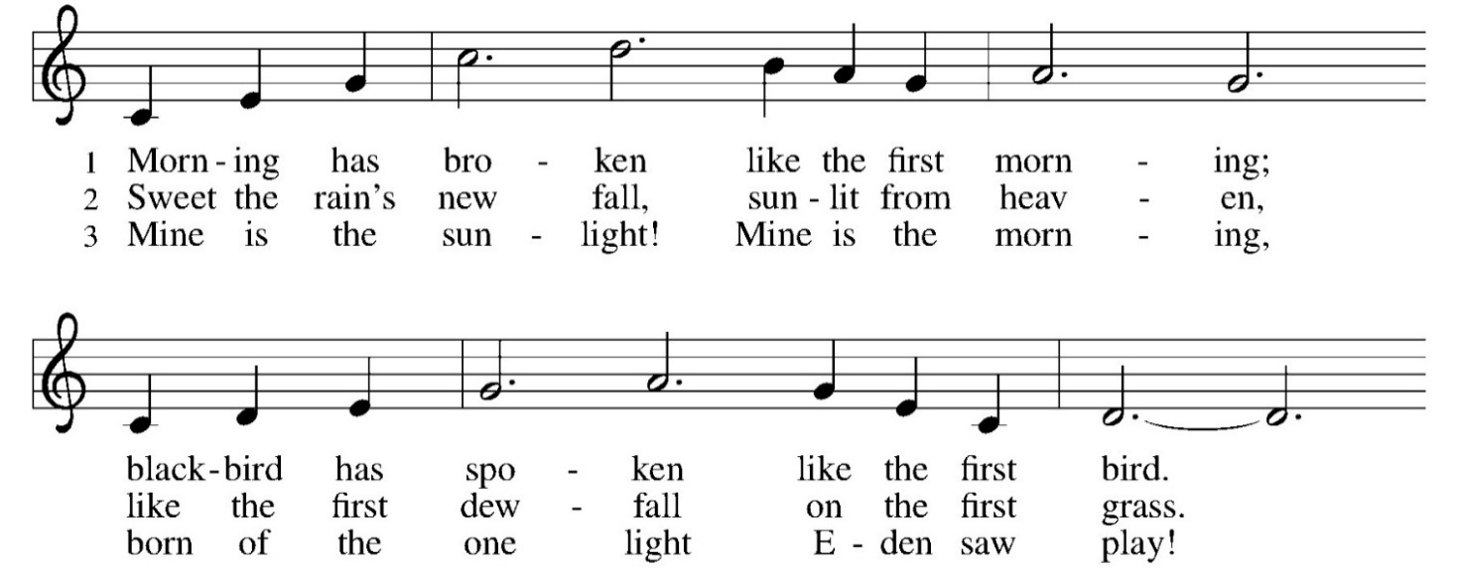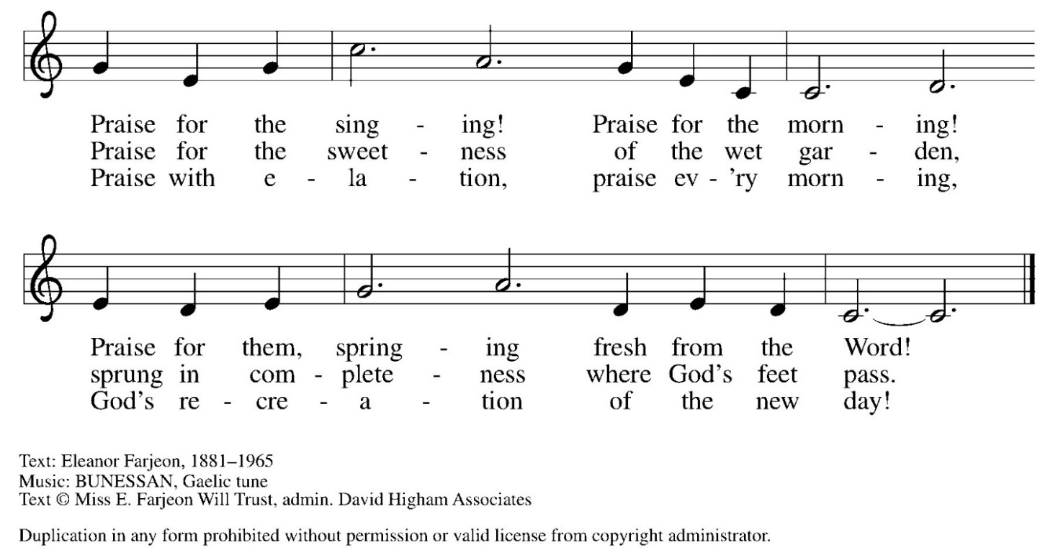

Welcome and Announcements

Confession and Forgiveness
P: Blessed be the holy Trinity, + one God, whose compassion endures forever.
C: Amen.
P: Let us confess our sin to God. (a brief silence for reflection)
Compassionate God,
C: we confess to you all our sins. Our burden is heavy, and we cannot free ourselves. In your mercy, call us back to you. Your yoke is easy and your burden is light. Restore us to dwell in your peace. In Christ’s name we pray, Amen.
P: Jesus says, “Come to me, all you who are weary and are carrying heavy burdens, and I will give you rest.” In the name of God, Father, + Son, and Holy Spirit, your sins are forgiven. Rest in God’s love.
C: Amen.

Greeting

WA: The grace of our Lord, Jesus Christ, the love of God, and the communion of the Holy Spirit be with you all. C: And also with you.

Kyrie ELW #157
(printed next page)
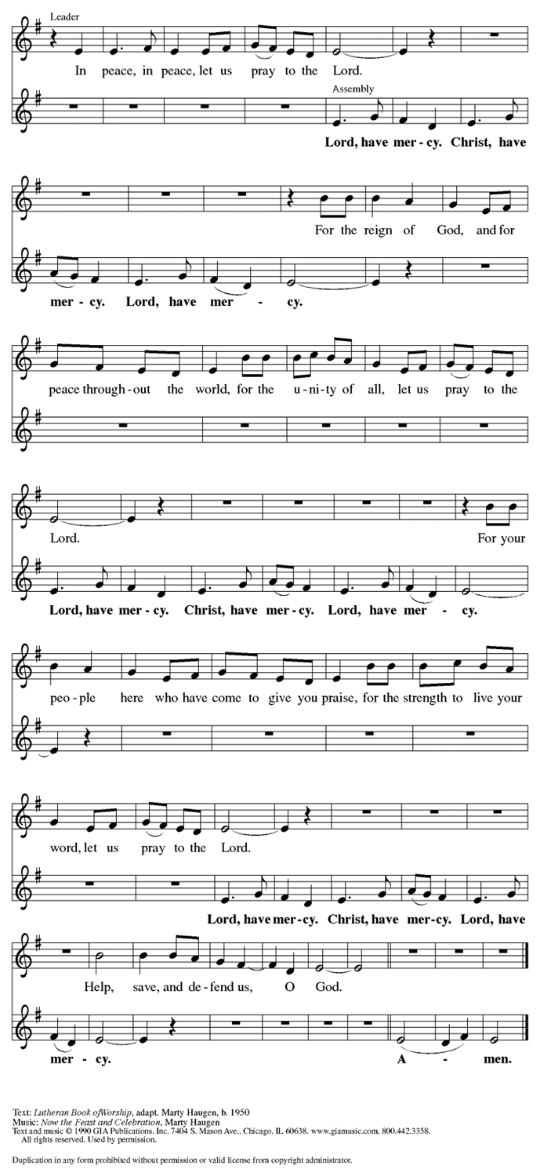

Prayer of the Day
WA: Let us pray together.
C: O God, you are the source of life and the ground of our being. By the power of your Spirit bring healing to this wounded world, and raise us to the new life of your Son, Jesus Christ, our Savior and Lord. Amen.

Children’s Sermon: Jesus said, “Let the little children come to me!”
We welcome children in worship.

WORD
God speaks to us in scripture readings, preaching and song.

First Reading: Hosea 5:15-6:6 Because the people have trusted in military powers instead of God and have engaged in idolatrous worship practices, God decides to withdraw until Israel acknowledges its guilt and seeks God’s face. The response of the people does not acknowledge this guilt and is as fickle as fog or dew burned away quickly by the sun. God desires loyalty rather than words or meaningless deeds. L: ¹⁵ I will return again to my place until they acknowledge their guilt and seek my face. In their distress they will beg my favor:
^{6:1} “Come, let us return to the Lord, for it is he who has torn, and he will heal us; he has struck down, and he will bind us up. ² After two days he will revive us; on the third day he will raise us up, that we may live before him. ³ Let us know, let us press on to know the Lord; his appearing is as sure as the dawn; he will come to us like the showers, like the spring rains that water the earth.”
⁴ What shall I do with you, O Ephraim? What shall I do with you, O Judah? Your love is like a morning cloud, like the dew that goes away early. ⁵ Therefore I have hewn them by the prophets; I have killed them by the words of my mouth, and my judgment goes forth as the light. ⁶ For I desire steadfast love and not sacrifice, the knowledge of God rather than burnt offerings. L: Word of God, word of life. C: Thanks be to God.

Psalm: Psalm 50:7-15 Call upon me in the day of trouble, says your God.
(Ps 50:15)
L: ⁷ “Listen, my people, and I will speak: Israel, I will bear witness against you;
for I am God, your God.
C: ⁸ I do not accuse you because of your sacrifices;
your burnt offerings are always before me.
L: ⁹ I will not accept a calf from your stalls, nor goats from your pens;
C: ¹⁰ for all the wild animals of the forest are mine,
the cattle on a thousand hills.
L: ¹¹ I know every bird of the mountains, and the creatures of the fields are mine.
C: ¹² If I were hungry, I would not tell you,
for the whole world is mine and all that is in it.
L: ¹³ Do you think I eat the flesh of bulls, or drink the blood of goats?
C: ¹⁴ Offer to God a sacrifice of thanksgiving
and make good your vows to the Most High.
L: ¹⁵ Call upon me in the day of trouble;
I will deliver you, and you shall honor me.
L: Word of God, word of life. C: Thanks be to God.

Second Reading: Romans 4:13-25
Paul presents Abraham as a living model of right relationships. For Abraham and for us, a right relationship with God involves trusting that God’s promises will be fulfilled because God makes the dead alive and calls into existence what otherwise does not exist.
L: ¹³ The promise that he would inherit the world did not come to Abraham or to his descendants through the law but through the righteousness of faith. ¹⁴ For if it is the adherents of the law who are to be the heirs, faith is null and the promise is void. ¹⁵ For the law brings wrath, but where there is no law, neither is there transgression.
¹⁶ For this reason the promise depends on faith, in order that it may rest on grace, so that it may be guaranteed to all his descendants, not only to the adherents of the law but also to those who share the faith of Abraham (who is the father of all of us, ¹⁷ as it is written, “I have made you the father of many nations”), in the presence of the God in whom he believed, who gives life to the dead and calls into existence the things that do not exist. ¹⁸ Hoping against hope, he believed that he would become “the father of many nations,” according to what was said, “So shall your descendants be.” ¹⁹ He did not weaken in faith when he considered his own body, which was already as good as dead (for he was about a hundred years old), and the barrenness of Sarah’s womb. ²⁰ No distrust made him waver concerning the promise of God, but he grew strong in his faith as he gave glory to God, ²¹ being fully convinced that God was able to do what he had promised. ²² Therefore “it was reckoned to him as righteousness.” ²³ Now the words, “it was reckoned to him,” were written not for his sake alone ²⁴ but for ours also. It will be reckoned to us who believe in him who raised Jesus our Lord from the dead, ²⁵ who was handed over for our trespasses and was raised for our justification.
L: Word of God, word of life. C: Thanks be to God

Please stand as you are able
Gospel Acclamation Setting 10 (p. 205)
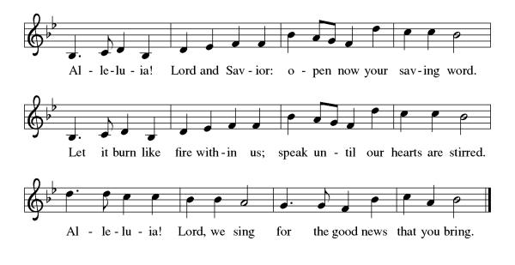

Gospel Reading: Matthew 9:9-13, 18-26
Jesus demonstrates God’s mercy and power, accepting the unacceptable and curing the incurable. Even the dead receive new life.

P: The Holy Gospel according to Matthew. C: Glory to you, O Lord.
P: ⁹ As Jesus was walking along, he saw a man called Matthew sitting at the tax-collection station, and he said to him, “Follow me.” And he got up and followed him.
¹⁰ And as he sat at dinner in the house, many tax collectors and sinners came and were sitting with Jesus and his disciples. ¹¹ When the Pharisees saw this, they said to his disciples, “Why does your teacher eat with tax collectors and sinners?” ¹² But when he heard this, he said, “Those who are well have no need of a physician, but those who are sick. ¹³ Go and learn what this means, ‘I desire mercy, not sacrifice.’ For I have not come to call the righteous but sinners.”
¹⁸ While he was saying these things to them, suddenly a leader came in and knelt before him, saying, “My daughter has just died, but come and lay your hand on her, and she will live.” ¹⁹ And Jesus got up and followed him, with his disciples. ²⁰ Then suddenly a woman who had been suffering from a flow of blood for twelve years came up behind him and touched the fringe of his cloak, ²¹ for she was saying to herself, “If I only touch his cloak, I will be made well.” ²² Jesus turned, and seeing her he said, “Take heart, daughter; your faith has made you well.” And the woman was made well from that moment. ²³ When Jesus came to the leader’s house and saw the flute players and the crowd making a commotion, ²⁴ he said, “Go away, for the girl is not dead but sleeping.” And they laughed at him. ²⁵ But when the crowd had been put outside, he went in and took her by the hand, and the girl got up. ²⁶ And the report of this spread through all of that district.
P: The Gospel of the Lord. C: Praise to you, O Christ.
Sermon Rev. Jeremiah Smith

Please stand as you are able

+Hymn of the Day: Come as You Are
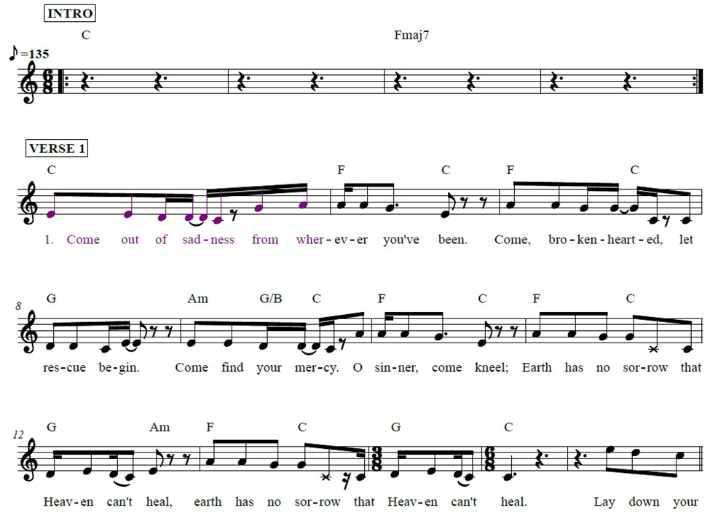
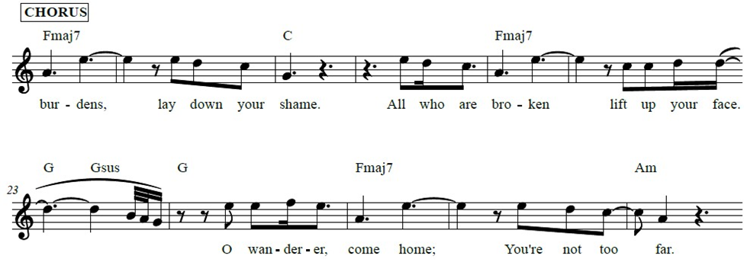
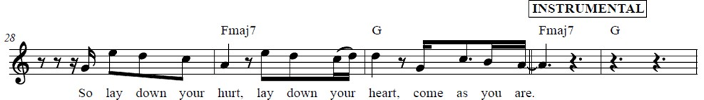
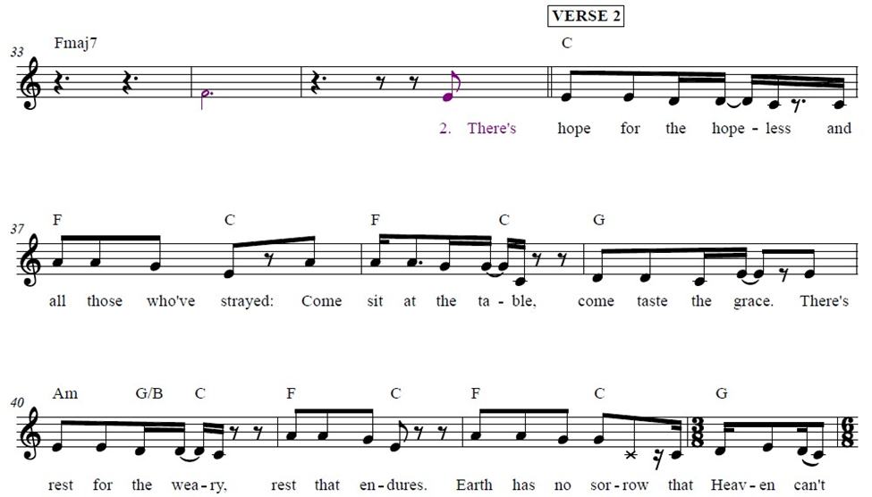
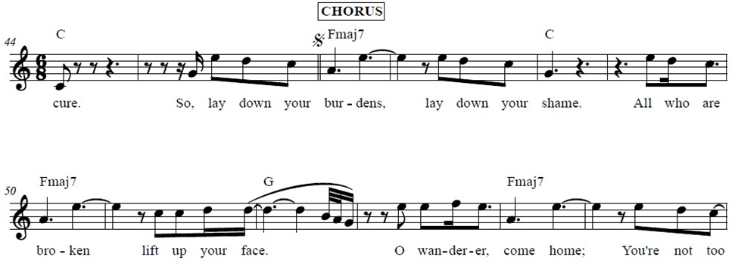
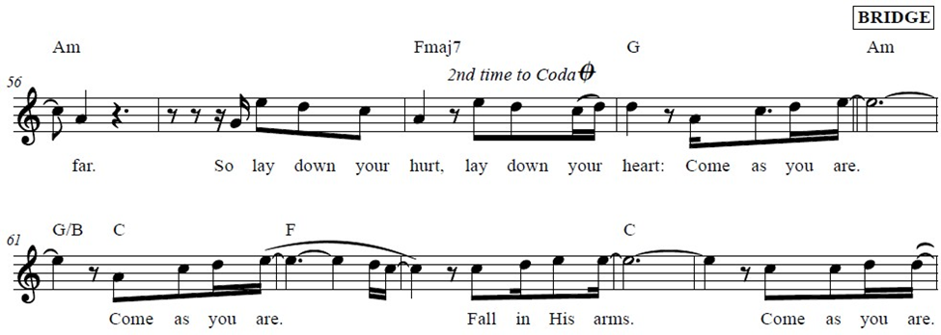
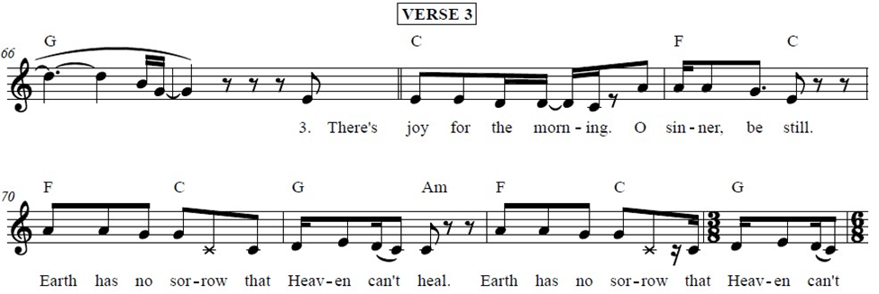
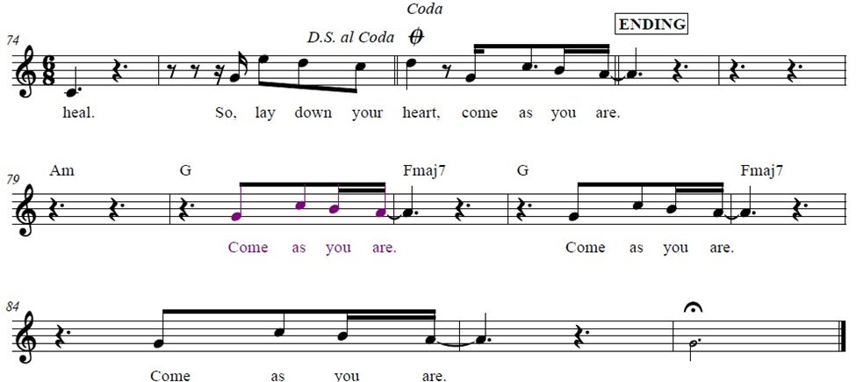

Apostle’s Creed WA: Let us confess the faith using the words of the Apostle’s Creed.
C: I believe in God, the Father almighty, creator of heaven and earth.
I believe in Jesus Christ, God’s only Son, our Lord, who was conceived by the Holy Spirit, born of the virgin Mary, suffered under Pontius Pilate, was crucified, died, and was buried; he descended to the dead. On the third day he rose again; he ascended into heaven, he is seated at the right hand of the Father, and he will come to judge the living and the dead.
I believe in the Holy Spirit, the holy catholic church, the communion of saints, the forgiveness of sins, the resurrection of the body, and the life everlasting. Amen.

Prayers of the People WA: Gathered together by the Holy Spirit, let us pray for the church and the needs of the world. (a brief silence)
WA: God of mercy, you call us to a life filled with acts of mercy. Ground us in following Christ, that we might extend the mercy we receive. God of grace, C: hear our prayer.
WA: God of the nations, you promise to deliver those who call on you. Bring an end to conflict, bigotry, and injustice in all their forms wherever they are found. God of grace, C: hear our prayer.
WA: God of comfort, you provide for those in need. Bring an end to addiction. Comfort people as they mourn. Provide tenderly for those in need. We pray especially for those we name aloud or in the silence of our hearts…. God of grace, C: hear our prayer.

WA: God of blessings, you send the Holy Spirit to provide varieties of gifts in the body of Christ. Accompany those who travel this summer, make our gatherings joyous, and grant us a spirit of hospitality and togetherness. God of grace, C: hear our prayer.

WA: God of life, we give you thanks for saints whose lives revealed your faithfulness. May remembering their faithfulness strengthen our own. God of grace, C: hear our prayer.

WA: Trusting you receive all our prayers, we commend our spoken and unspoken prayers to you, O God, through Jesus our Saviour. C: Amen.

Peace
P: The peace of Christ be with you always. C: And also with you.

Meal - God feeds us with the presence of Jesus Christ
Offering
We are grateful to those who help sustain our mission. To donate online, please use QR code:


+ Offering Prayer
WA: Let us pray together:
C: Loving God, we offer at your table the gifts of our hearts. Help us take heart in you and share freely of your love, so that all creation can taste your abundance. We ask this in the name of Jesus, through the Spirit abiding with us now and forever. Amen.
+ Offertory Song: Let the Vineyards Be Fruitful ELW #184
(printed next page)

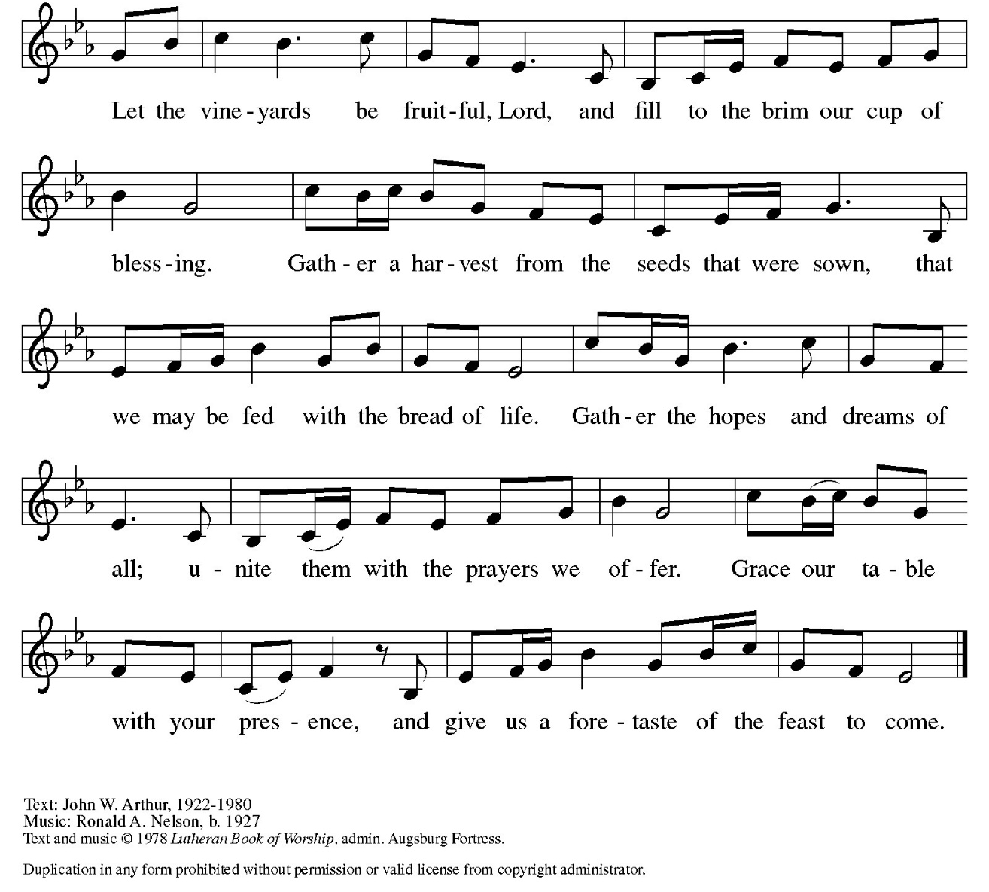

Great Thanksgiving
P: The Lord be with you. C: And also with you.
P: Lift up your hearts. C: We lift them to the Lord.
P: Let us give thanks to the Lord our God.
C: It is right to give our thanks and praise.

Preface
P: It is indeed right, our duty and our joy, that we should at all times and in all places give thanks and praise to you, almighty and merciful God, through our Savior Jesus Christ. You reveal your glory as the glory of the Father, the Son and the Holy Spirit: equal in majesty, undivided in splendor, one Lord, one God, ever to be adored in your eternal glory. And so, with all the choirs of angels, with the church on earth and the hosts of heaven, we praise your name and join their unending hymn:

Holy Holy Holy ELW setting 10 (p. 207)
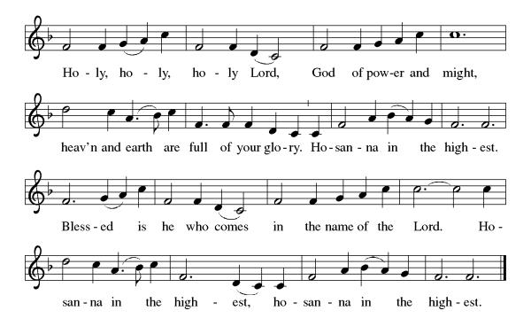

Thanksgiving at the Table

P: In the night in which he was betrayed, our Lord Jesus took bread, and gave thanks; broke it, and gave it to his disciples, saying: Take and eat; this is my body, given for you. Do this for the remembrance of me. Again, after supper, he took the cup, gave thanks, and gave it for all to drink, saying: This cup is the new covenant in my blood, shed for you and for all people for the forgiveness of sin.
Do this for the remembrance of me.

Lord’s Prayer
P: Lord, remember us in your kingdom and teach us to pray.
C: Our Father in heaven, hallowed be your name, your kingdom come, your will be done, on earth as in heaven. Give us today our daily bread. Forgive us our sins as we forgive those who sin against us. Save us from the time of trial and deliver us from evil. For the kingdom, the power, and the glory are yours, now and forever. Amen.

Invitation to the Table
At Parkside Lutheran Church we have an open table. We believe the invitation to receive comes from Jesus himself and all are welcome at Christ’s table. More than just Bread and Wine these are tangible signs of God’s love for you! If you do not wish to receive communion but would like a blessing, come forward and cross your arms over your chest. The Pastor will give you a blessing before you return to your seat via the side aisle. You’ll receive a communion wafer* in your hands. You may dip it in the cup of wine or juice. When giving the bread and cup, the communion ministers say: “The body of Christ, given for you. The blood of Christ, shed for you.”
and each person may respond : Amen
*Please let Pastor know if you need a gluten-free wafer
P: Heaven has come near. Come, share in the feast!

The Communion Distribution

Communion Song ELW setting 10 (p. 208)

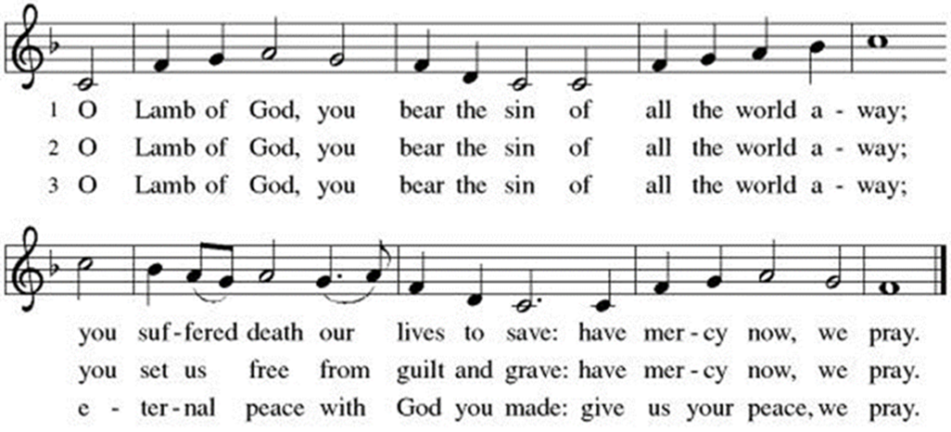

Communion Song: Let Us Break Bread Together ELW # 471
(printed next page)
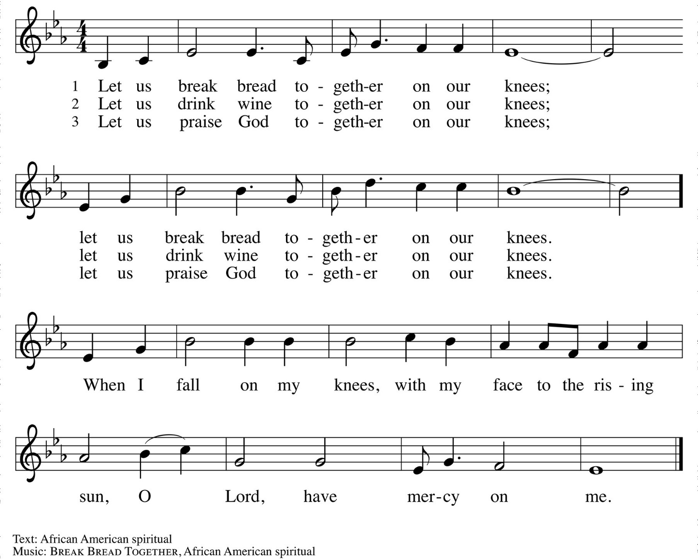

Communion Song: Sanctuary
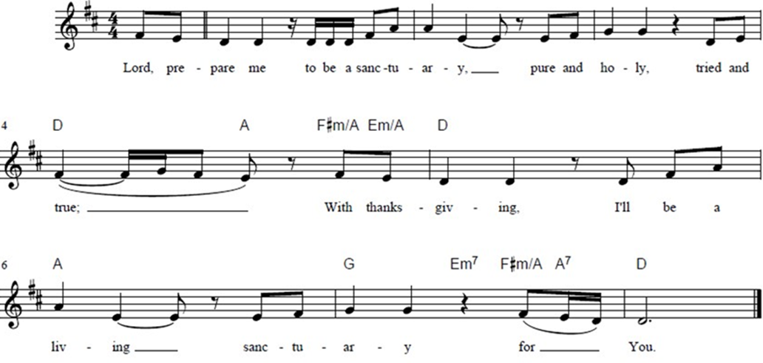

Post Communion Blessing
P: The Body and Blood of our Lord and Savior, Jesus Christ, strengthen you and keep you in God's grace. C: Amen.
Prayer After Communion
WA: Let us pray together.
C: Compassionate God, through the gifts of bread and wine our hearts are filled with the abundance of your love. Strengthen us that we, through this holy meal, may share your love freely, as you have shared with us. We ask this in the name of Jesus, through the Spirit nourishing us now and forever. Amen.

Sending - God blesses us and sends us in mission to the world.

Blessing
P. Creator, Redeemer, Sustainer, + one God, bless, heal, and hold you today and always. C. Amen

Sending Hymn: Joyful, Joyful, We Adore Thee ELW #836
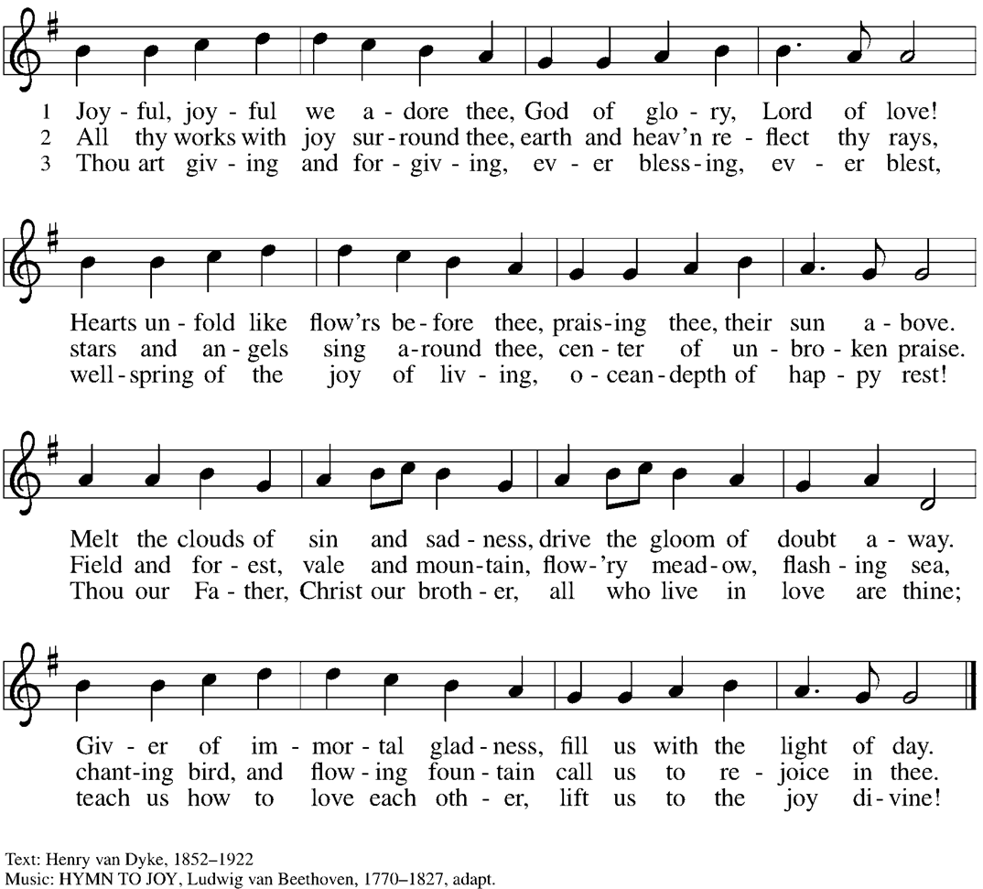

ELW Music licensed from Sundays & Seasons, Augsburg Fortress CCLI MUSIC License # 11440069 , CCLI Streaming License#21835523 Do not duplicate any music or Liturgy herein without license and permission
scripture readings adapted and written by susan lukey
Dismissal and Postlude
P: Parkside Lutheran Church is rediscovering the radical love of Jesus.
C: Gathering All, Serving All, Caring for All
P: Heaven has come near. Go, share the good news!
C: Thanks be to God.

PARKSIDE STAFF:
• The Rev. Jeremiah Smith: prjeremiahpsmith@gmail.com
• Kris Pope & Suzanne Gracie, Admin. Assistants (Church Office): parksidelutheran@gmail.com
• Mike Hooker, Music Director: mrhooker@me.com
CHURCH OFFICE HOURS: M/T/R 10:00am-3:00pm (716)836-1361

Acolytes: |  | Worship Assistants
6/7 – Chris & Katie |  | 6/7 – Susan
6/14 – Genevieve & Emmet |  | 6/14 – Vince
Readers: |  | Ushers:
6/7 – Marlene |  | 6/7 – Joanne, Kathy, Gary
6/14 - Jose |  | 6/14 – Sue, Tom, Zack

Coming up:
June 14th – Congregational Meeting, after Worship
June 17th – Brewing Theology 7pm –
*NEW LOCATION* Nowhere Lounge on Delaware Kenmore
June 28th – Pride Sunday Worship Service

Visit our website for more information about these and other Events at Parkside – www.parksidelutheran.org/events

