TLC Weekly: Sunday, June 7 – June 14
Vicar Angie DeSmith cell: 507-828-4941 email: amgiedesmith316@gmail.com
The Radio Broadcast (KMHL 1400AM or 101.7FM) is sponsored by in honor of Jan Janssen’s 90th birthday by her girls.
Sunday, June 7 9am Worship/Holy Communion
10am Coffee Fellowship
1-3pm Open House Birthday for Jan Janssen
Monday, June 8 9am Men in Mission
Wednesday, June 10 9am Do Day Mission Work Day
Friday, June 12 OFFICE CLOSED
Sunday, June 14 FOOD SHELF SUNDAY
9am Worship
10am Coffee Fellowship

Andy Rand, great- grandson of Jan Janssen, will play piano during offering time

Please continue to Remember in Prayer:
Please…
We are happy to include people in our prayer list, but we must have their permission to be included. Many folks are very private about what is happening in their lives and we want to honor that.
Peggy Isaacson – LaVerne Jessen’s daughter, cancer
Steve Vickerman – health issues
Kim Mickelson – cancer-cousin of Kari Meyer & Kris Tiegs
Vicki Schaar – Cancer

TODAY there is open house in the fellowship hall for Jan Janssen in honor of her 90th birthday, 1-3pm. Everyone welcome.

June Acolyte: Jared Swenhaugen, Caroline Engelkes

June Altar Preparation: Darcy Carlson, Sandy Fultz

June Communion Servers: Addison Kainz, Gail Kropp. Sue Magnuson

Coffee Fellowship: Sunday, June 7 Janssen Family
Sunday, June 14 Carolyn Engelkes, Karen Krog

Scripture Readers: Sunday, June 7 Melissa Christian
Sunday, June 14 Darrell Carlson

Greeters: Sunday, June 7 Dennis & Anita Fultz
Sunday, June 14 OPEN

Sunday Counters: Sunday, June 7 Dennis Fultz
Sunday, June 14 Missie Erbes

Ushers: Sunday, June 7 George Erbes, Jason Lichty, Eric Fultz, Swede Campbell
Sunday, June 14 Khyle Radke, Trent Fischer, Darrell Carlson

Don’t forget to check the kiosk for information on any upcoming events around Tracy.
Radio opening for the month of July: 12th and 26th
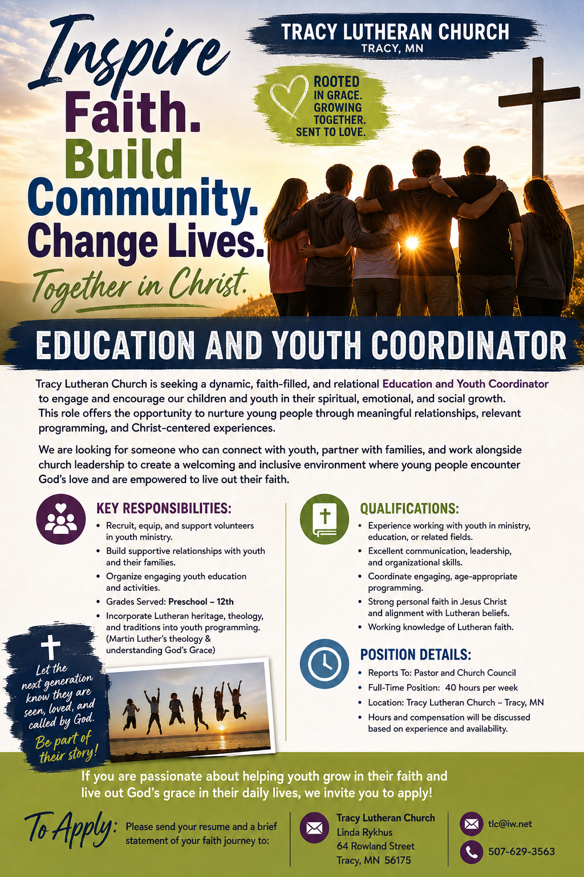
At the request of council president, Dennis Fultz, Tracy Lutheran Church is recognized as a Synod -Authorized Ministry site. Angie DeSmith has been authorized by Southwestern Minnesota Synod Bishop Dee Pederson to preach and preside for
Holy Communion in the congregation . The authorization is granted in accord with the ELCA’s guiding statement, The Use of the Means of Grace , which recognizes the witness of the sacrament as a celebration of the Church, serving its unity and
proclaiming the Gospel; and that where it is not possible to provide ordained pastoral leadership, a synod bishop may authorize a properly trained person to preside at a certain time.

