TLC Weekly: Sunday, May 31 – June 7
Vicar Angie DeSmith cell: 507-828-4941 email: amgiedesmith316@gmail.com
The Radio Broadcast (KMHL 1400AM or 101.7FM) is sponsored by Terry & Kathy Filter in remembrance of their parents
Sunday, May 31 9am Worship
10am Coffee Fellowship
Monday, June 1 9am Men in Mission
Wednesday, June 3 9am Do Day Mission Work Day
Friday, June 5 OFFICE CLOSED
Sunday, June 7 9am Worship/Holy Communion
10am Coffee Fellowship
1-3pm Open House /Jan Janssen 90th birthday

Please continue to Remember in Prayer:
Please…
We are happy to include people in our prayer list, but we must have their permission to be included. Many folks are very private about what is happening in their lives and we want to honor that.
Peggy Isaacson – LaVerne Jessen’s daughter, cancer
Steve Vickerman – health issues
Kim Mickelson – cancer-cousin of Kari Meyer & Kris Tiegs
Vicki Schaar – Cancer

Sunday June 7, 2026 1-3pm there will be an open house in the fellowship hall for Jan Janssen in honor of her 90th birthday. Everyone welcome.

June Acolyte: Jared Swenhaugen, Caroline Engelkes

June Altar Preparation: Darcy Carlson, Sandy Fultz

June Communion Servers: Addison Kainz, Gail Kropp. Sue Magnuson

Coffee Fellowship: Sunday, May 31 Shirley Johnson
Sunday, June 7 Janssen Family

Scripture Readers: Sunday, May 31 Swede Campbell
Sunday, June 7 Melissa Christian

Greeters: Sunday, May 31 Jason & Addison Kainz
Sunday, June 7 OPEN

Sunday Counters: Sunday, May 31 Melody Caron
Sunday, June 7 Dennis Fultz

Ushers: Sunday, May 31: Jim Nicks, Tim Jones, Loren Rykhus, Terry Filter
Sunday, June 7: George Erbes, Jason Lichty, Eric Fultz, Swede Campbell

Don’t forget to check the kiosk for information on any upcoming events around Tracy.
Radio opening for the month of June 28.
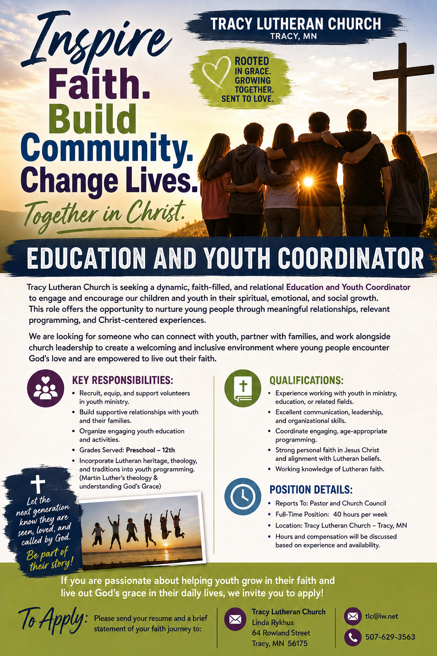
At the request of council president, Dennis Fultz, Tracy Lutheran Church is recognized as a Synod -Authorized Ministry site. Angie DeSmith has been authorized by Southwestern Minnesota Synod Bishop Dee Pederson to preach and preside for
Holy Communion in the congregation . The authorization is granted in accord with the ELCA’s guiding statement, The Use of the Means of Grace , which recognizes the witness of the sacrament as a celebration of the Church, serving its unity and
proclaiming the Gospel; and that where it is not possible to provide ordained pastoral leadership, a synod bishop may authorize a properly trained person to preside at a certain time.

