TRINITY MEMORIAL UNITED CHURCH
Good News: Much of what you see, hear, and experience during our worship is Metaphorical and Symbolic

May 31st, 2026
Trinity Sunday

We Approach
Acknowledgement of Territory & Statement of Inclusivity

Announcements, Joys, Celebrations
Lighting of the Christ Candle

Sing: “This is the Day” MV 122 (twice)
This is the day that God has made,
we will rejoice and be glad! (repeat)
Singing hallelu, singing hallelu, singing hallelu!
We will rejoice and be glad! (repeat)

Call to Worship:
Holy are you, Source and Creator of all things;
We praise you for your gift of life.
Holy are you, Son and Redeemer of all things;
We thank you for your gift of new life.
Holy are you, Spirit and Sustainer of all things;
We worship you in holiness, Ever Three and Ever One.

Opening Prayer
Holy God, you are Three in One and One in Three. Praise to you, Source of life, maker of Heaven and Earth, who created us in your image and called us good. Praise to you, Jesus Christ, born in our flesh to teach us how to love and offer us grace and mercy. Praise to you, Holy Spirit, for the energy you bring us to greet each day as a gift. Holy God, Three in One and One in Three, we praise you for your mystery and mercy. Reveal to us how to live as your people and witness to your wonder and grace. In Jesus’ name, we pray. Amen.
Hymn: “Holy, holy, holy, Lord God Almighty” VU 315

Prayer of Confession:
God of mystery and mercy, you know the details of our lives. You see the sin and the sorrow we bear; you see the problems and the possibilities we face. You see how we fit into the world around us and how we rub each other the wrong way. We confess we do not always see what you see. Open our eyes to the truth of our lives and touch us with your grace. Amen.

Sung Assurance: “Take, O Take Me as I Am” MV 85 (2x)
Take, O take me as I am; summon out what I shall be;
Set your seal upon my heart and live in me.”

Passing the Peace: Peace of Christ be with you.

And also with you.
Take time to say hello to those in attendance.

Young @ Heart: “Ice Cream!!”

Hymn: “I Am a Child of God” MV 157

Scripture Readings: Romans 8: 12 – 17 John 3: 1 – 17
Hear what the Spirit is saying to the Church!
Write these words in our hearts, Dear God.
Anthem: Choir - “Father, Son, and Holy Spirit”
Traditional arr. by Ron Schaufert

Message: “Choreography” Rev. Tracy Fairfield

Hymn: “Bring Many Names” VU 268

“We Keep Watch” – Prayers

After each prayer request, we will respond with:
One: God of Peace,
All: Be with your people in their time of need.

Prayers of the People and for the World

Lord’s Prayer (Spoken Version, trad.)
Invitation to the Offering

The Offering: “What Can I Do” MV 191
What can I do? What can I bring?
What can I say? What can I sing?
I’ll sing with joy. I’ll say a prayer.
I’ll bring my love. I’ll do my share.

Prayer of Dedication

Hymn: “Praise with Joy the World’s Creator” VU 312

Commissioning & Benediction

Sing: “Go Make a Diff’rence” MV 209 (chorus only, 2x)
Go make a diff’rence. We can make a diff’rence.
Go make a diff’rence in the world.
Go make a diff’rence. We can make a diff’rence.
Go make a diff’rence in the world.

Postlude

Music Reproduced with permission under One License
Copyright Cleared Music for Churches #605530
Minister: | Rev. Tracy Fairfield
Choir Director: | Ron Schaufert
Pianist: | Christine Schaufert
Organist: | Donna Poncelet
Song Leader: | Jerry Johnson

We are a community of inclusive spirituality, caring fellowship, and welcoming outreach; one that purposefully seeks to embody the love and respect of God towards all people and Creation.
TRINITY MEMORIAL UNITED CHURCH
We envision a Spiritual home, as a church and followers of Jesus Christ, where all people can fully participate in all aspects of our shared life and ministry and feel safe.
May 31st, 2026
Trinity Sunday
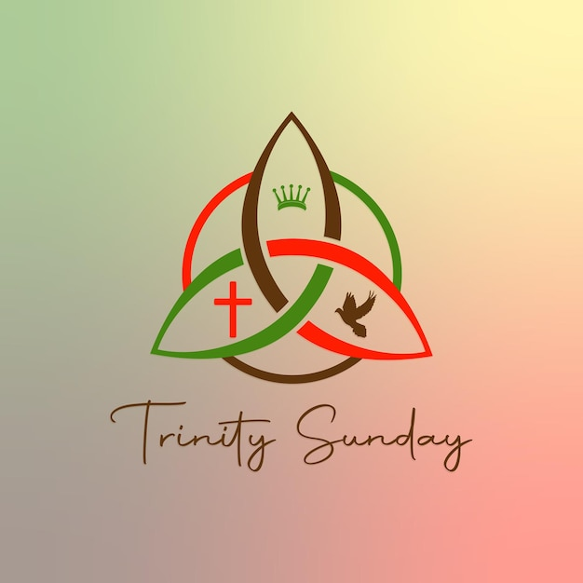

Trinity Memorial is a member church of
Affirm United/S’affirmer ensemble



