All Saints Anglican Church
6904 Lougheed Highway, Agassiz, B.C. V0M 1A0
Bulletin May 25th, 2026 – May 31st, 2026

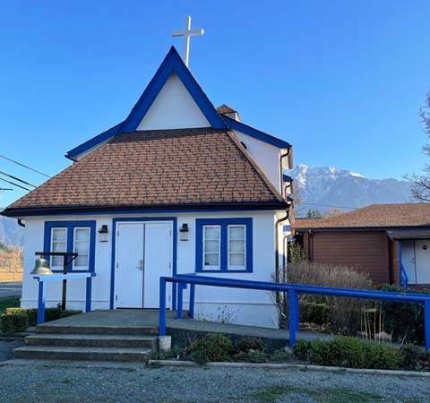

‘The ground we walk does not belong to us; for thousands of years it has been - and remains - the territory of the Stó:lō. We are grateful for their sharing.

Phone: 604-796-3553
Website: www.allsaints-agassiz.ca
https://www.facebook.com/groups/AllSaintsFamily
OUR DOOR IS OPEN AND ALL ARE WELCOME
May 31st, 2026, Trinity Sunday
Priest in Charge: The Reverend Philip Barker
Hosts: Graham Featherstone/Jennifer Pinlac
Intercessor: Keith Fossey
Lay Administrator: Dorothy Cresswell
Announcer: Virginia Jennings
Organ/Piano: Francesca Froehlich
Readers: Ginny Jennings/Sheila Barker
Vicar’s cell phone: Revd. Philip Barker. 778-867-2461

Vicar’s Warden: Ginny Jennings. 604-796-2206
People’s Warden: Lynn Laughlin. 604-799-5131
Parish email: revpb1950@gmail.com
Please contact either warden if you have an issue that needs to be brought to the attention of the Vicar - or contact the Vicar direct (see above for details).

All Saint’s Calendar/Announcements:

- Book Club – On April 8th Book Club will resume Zoom meetings on Wednesdays at 5.00 pm. The first week will be a discussion of the 3 books that were read by members during Lent.

The next book will be "The Last Week: What the Gospels really teach about Jesus' final days in Jerusalem", by Marcus J. Borg and John Dominic Crosson. This will be an appropriate follow on from Holy Week.
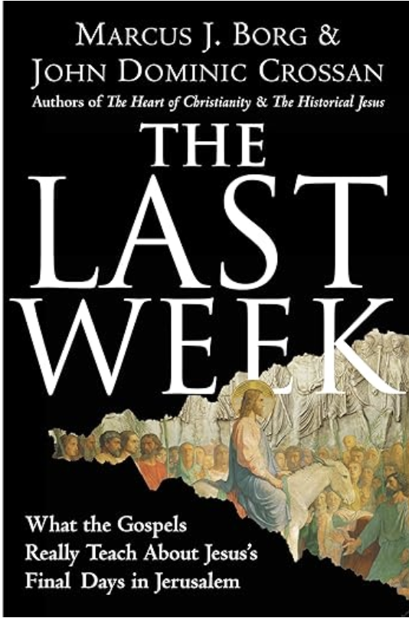
The book is $21.00 in paperback on Amazon and also
available on Kindle.

If you would like to join the group or have a copy of the
book, please contact Sheila at sjbarker0379@gmail.com

- Bible Study with Karol is every Saturday morning 0830-0900 on Zoom.

- Prayer Requests can be given on a piece of paper to either of the Wardens or the Vicar or entered in the Prayer Request Book on the lectern. Alternatively, you can contact Anthea Lewis at antheamlewis@shaw.ca for Pray First Prayer Circle, which is a confidential online prayer circle.

- Music Requests may be given to the Wardens or the Vicar.

- AA meets in the hall every Tuesday and Friday at noon.

- Every Thursday in the hall 1100-1200 we have a social time with coffee, games if you like or just talk.

- At 1000-1100 on Thursdays there is an Interactive Bible Study on the day’s Lectionary readings. All are welcome – discover the treasures in this amazing book!

- 5th Sunday of each month will be a potluck lunch after the service – Next Potluck is Sunday May 31st.

Ministerial Meandering
Billy the Bee (1)

“It doesn’t matter how hard you try, Billy,” his brothers and sisters all kept telling him, “you’ll never lay any eggs and you can’t be a queen. All that straining will only give you a hernia or a massive dump. Or both.”
It has taken Billy quite some time to begin to realise that there are only really three sorts of bees - queens, workers, and drones - and no matter how much he may want to one of the other ones - it just ain’t gonna happen.

Billy’s job is really quite easy - until it isn’t. They have only one purpose in life - to mate with a virgin queen bee. Well, that sounds pretty good! - you might think. Until I tell you that if they actually get to do that, it will kill them. Talk about going out ‘with a bang!’
Most of the time they just hang around the hive being given food and honey by their sister worker bees, and sleeping - sometimes snuggling up to the newly developing baby queens to act as temperature buffers - and perhaps nicking a bit of any spare Royal Jelly that might fall from the workers feeding the babies.
The problem comes around winter, when the workers get fed up with them hanging around having to feed them as well as the baby queens, and kick them out of the hive; that’s really bad news for Billy the drone, as he doesn’t have the wherewithal to forge or feed for himself, so he soon dies of starvation.

Now Billy knew he wasn’t actually PhD material, but he was no academic slouch, and he had been out of the hive enough times to look at the humans (who were planning on stealing the honey) and see how their society worked. And it didn’t seem to be too different. In ‘Bee World’, your sex and your future are determined at birth by Mum. In ‘Human World’, the same is almost certainly true - but the baby developing humans don’t seem to realise that. There seemed to be many who thought and wanted - like Billy - that they should be queens, and just wouldn’t accept that was never going to happen.
Humans seemed to think that they should be able to do whatever they wanted, take whatever they wanted, and live for ever. The idea of having only limited resources or intelligence never seemed to enter their rather limited minds.
Billy understood that he had one season to make the most of, and then it would be over, and if he could end it mating with a virgin queen - well, supernova!

Given the number of eggs the queen of the hive dropped every day (around 2,000), it was amazing that there wasn’t more waste - but if you’re a bee, you accept that 100 or so will never make it to see the outside world. The problem with humans, of course, is that their females only drop one egg per month, and 20 to 50% of those fertilised will have chromosomal abnormalities and miscarry. So humans are not so good at dealing with the natural wastage. It upsets them more. But if they were to spend a little time with the mathematics, they would realize that if all pregnancies ended in live births, there would be another 30 to 45 million people on the earth every year. So quite a lot of those would have to be kicked out of the hive, as there wouldn’t be enough honey or Royal Jelly for all of them.

So how do you choose? For Billy, it wasn’t difficult - his genetics dictated his role in the hive and in the world - but for humans, all trying to be queen bees, there were lots of hernias and piles of poo around.

Billy would have to talk to them…

Philip+

A Little Chuckle…

Did you hear about the baguette at the zoo?

It was bread in captivity

Birthdays this Month May

Karol Henrotte – 2 Allen Low – 7
Lijo George – 8 Sidney Toy – 10

Diocesan Cycle of Prayer: We Pray for the Clergy and Congregation:

The Deanery of Yale – The Revd Matt Koovisk, Regional Dean; Primate of the Anglican Church of Canada, Archbishop Shane Parker; St. George, Maple Ridge - The Revd David Edgerton

Anglican Church of Canada Cycle of Prayer – We Pray for:

The Rt. Rev. Andrew Asbil, Bishop; The Rt. Rev. Kevin Robertson, Suffragan Bishop; The Rt. Rev. Riscylla Shaw, Suffragan Bishop, and the clergy and people of the Diocese of Toronto

Collect

Father, we praise you: through your Word and Holy Spirit you created all things. You reveal your salvation in all the world by sending to us Jesus Christ, the Word made flesh. Through your Holy Spirit you give us a share in your life and love. Fill us with the vision of your glory, that we may always serve and praise you, Father, Son, and Holy Spirit, one God, for ever and ever.

Genesis 1:1—2:4a Ginny Jennings

¹In the beginning God created the heavens and the earth. ² Now the earth was formless and empty, darkness was over the surface of the deep, and the Spirit of God was hovering over the waters.

³ And God said, “Let there be light,” and there was light. ⁴ God saw that the light was good, and he separated the light from the darkness. ⁵ God called the light “day,” and the darkness he called “night.” And there was evening, and there was morning—the first day.

⁶ And God said, “Let there be a vault between the waters to separate water from water.” ⁷ So God made the vault and separated the water under the vault from the water above it. And it was so. ⁸ God called the vault “sky.” And there was evening, and there was morning—the second day.

⁹ And God said, “Let the water under the sky be gathered to one place, and let dry ground appear.” And it was so. ¹⁰ God called the dry ground “land,” and the gathered waters he called “seas.” And God saw that it was good.

¹¹ Then God said, “Let the land produce vegetation: seed-bearing plants and trees on the land that bear fruit with seed in it, according to their various kinds.” And it was so. ¹² The land produced vegetation: plants bearing seed according to their kinds and trees bearing fruit with seed in it according to their kinds. And God saw that it was good. ¹³ And there was evening, and there was morning—the third day.

¹⁴ And God said, “Let there be lights in the vault of the sky to separate the day from the night, and let them serve as signs to mark sacred times, and days and years, ¹⁵ and let them be lights in the vault of the sky to give light on the earth.” And it was so. ¹⁶ God made two great lights—the greater light to govern the day and the lesser light to govern the night. He also made the stars. ¹⁷ God set them in the vault of the sky to give light on the earth, ¹⁸ to govern the day and the night, and to separate light from darkness. And God saw that it was good. ¹⁹ And there was evening, and there was morning—the fourth day.

²⁰ And God said, “Let the water teem with living creatures, and let birds fly above the earth across the vault of the sky.” ²¹ So God created the great creatures of the sea and every living thing with which the water teems and that moves about in it, according to their kinds, and every winged bird according to its kind. And God saw that it was good. ²² God blessed them and said, “Be fruitful and increase in number and fill the water in the seas, and let the birds increase on the earth.” ²³ And there was evening, and there was morning—the fifth day.

²⁴ And God said, “Let the land produce living creatures according to their kinds: the livestock, the creatures that move along the ground, and the wild animals, each according to its kind.” And it was so. ²⁵ God made the wild animals according to their kinds, the livestock according to their kinds, and all the creatures that move along the ground according to their kinds. And God saw that it was good.

²⁶ Then God said, “Let us make mankind in our image, in our likeness, so that they may rule over the fish in the sea and the birds in the sky, over the livestock and all the wild animals, and over all the creatures that move along the ground.”

²⁷ So God created mankind in his own image,
in the image of God he created them;
male and female he created them.

²⁸ God blessed them and said to them, “Be fruitful and increase in number; fill the earth and subdue it. Rule over the fish in the sea and the birds in the sky and over every living creature that moves on the ground.”

²⁹ Then God said, “I give you every seed-bearing plant on the face of the whole earth and every tree that has fruit with seed in it. They will be yours for food. ³⁰ And to all the beasts of the earth and all the birds in the sky and all the creatures that move along the ground—everything that has the breath of life in it—I give every green plant for food.” And it was so.

³¹ God saw all that he had made, and it was very good. And there was evening, and there was morning—the sixth day.

Thus the heavens and the earth were completed in all their vast array.

² By the seventh day God had finished the work he had been doing; so on the seventh day he rested from all his work. ³ Then God blessed the seventh day and made it holy, because on it he rested from all the work of creating that he had done.

⁴ This is the account of the heavens and the earth when they were created, when the Lord God made the earth and the heavens.

Psalm 8 Sheila Barker

¹ Lord, our Lord,
how majestic is your name in all the earth!
You have set your glory
in the heavens.
² Through the praise of children and infants
you have established a stronghold against your enemies,
to silence the foe and the avenger.
³ When I consider your heavens,
the work of your fingers,
the moon and the stars,
which you have set in place,
⁴ what is mankind that you are mindful of them,
human beings that you care for them?

⁵ You have made them a little lower than the angels
and crowned them with glory and honor.
⁶ You made them rulers over the works of your hands;
you put everything under their feet:
⁷ all flocks and herds,
and the animals of the wild,
⁸ the birds in the sky,
and the fish in the sea,
all that swim the paths of the seas.

⁹ Lord, our Lord,
how majestic is your name in all the earth!

2 Corinthians 13:11-13 Sheila Barker

¹¹ Finally, brothers and sisters, rejoice! Strive for full restoration, encourage one another, be of one mind, live in peace. And the God of love and peace will be with you.

¹² Greet one another with a holy kiss. ¹³ All God’s people here send their greetings.

Matthew 28:16-20 Vicar Philip Barker

¹⁶ Then the eleven disciples went to Galilee, to the mountain where Jesus had told them to go. ¹⁷ When they saw him, they worshiped him; but some doubted. ¹⁸ Then Jesus came to them and said, “All authority in heaven and on earth has been given to me. ¹⁹ Therefore go and make disciples of all nations, baptizing them in the name of the Father and of the Son and of the Holy Spirit, ²⁰ and teaching them to obey everything I have commanded you. And surely I am with you always, to the very end of the age.”

Odds and Ends



Quiz Night will be on June 5th in our hall. Please let Ginny know this week if you would like to be on the All Saints team of 8 participants.

