City Road United Methodist Church
A Lighthouse Congregation

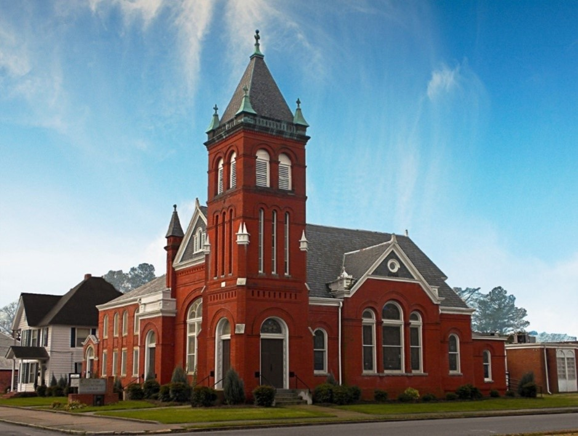
Rev. Josh Tester, Pastor

Office: (252) 335-2658
cityroadec.net crumcec@gmail.com

Facebook: https://www.facebook.com/CityRoadUMC

Sunday School: 10:00 a.m.
Sanctuary Worship: 11:00 a.m.

Tommy Venters- Organist/Choir Director
Dawn Baker- Secretary/Technology Specialist
JoAnn Herring- We Care

Service of Word
Season of Easter
May 31st, 2026 11:00 am
Gathering
Prelude
*Introit “Something Beautiful” UMH 394
Words of Welcome
*Call to Worship
King of all the earth, Creator of the universe, Holy Triune God, From everlasting to everlasting, you are Lord. Your law brings life, O Lord, and we meditate on it day and night;
Happy are we when we walk in your ways, O Lord.
You are a rich stream of living waters, and we would immerse ourselves in you;
Happy are we when we walk in your ways, O Lord.
You bring forth fruit in due season and establish the work of our hands;
Happy are we when we walk in your ways, O Lord.
Who is like our God, the One whose ways are full of life?
Happy are we when we walk in your ways, O Lord.
This is our God, the Holy One.
Come with thanksgiving and offer a sacrifice of praise.

*Prayer of Approach
Lord Jesus Christ, who prayed for your disciples that they might be one, even as you are one with the Father; draw us to yourself, that in common love and obedience to you we may be united to one another, in the fellowship of the one Spirit, that the world may believe that you are Lord, to the glory of God the Father. Amen.

*Sharing Peace
As a people forgiven and freed, we reach out to lift others up, offering the peace of Christ. Peace be with you!
And also with you!
You are invited to share the Peace with those around you [remembering to send your peace through the camera to those worshiping remotely*

Hymn of Praise “Great is Thy Faithfulness” UMH 140

Proclamation & Response
Call to Prayer
Prayers of the People
The Lord’s Prayer
Our Father who art in heaven, hallowed be thy name. Thy kingdom come; thy will be done on earth as it is in heaven. Give us this day our daily bread, and forgive us our trespasses, as we forgive those who trespass against us; and lead us not into temptation but deliver us from evil. For thine is the kingdom, and power, and glory forever. Amen

Children’s Time
Call to the Offering
Offertory
*Doxology
*Prayer of Dedication

*Hymn of Preparation “Take my Life and Let it Be” UMH 399
1st Verse

Anthem Chancel Choir

New Testament Lesson Luke 10: 38-42 & John 12:1-8
Message “Three Spirits of Legacy” Lynn Benson

Sending Fourth
*Sending Hymn “Faith of Our Fathers” UMH 710
*Benediction

