The Day of Pentecost
Unity Service
May 24, 2026

Holy Spirit Lutheran Church
&
Shepherd of The Glen Lutheran Church

Holy Spirit Lutheran Church
2205 Old Liberty Road, Eldersburg, MD 21784.
Church Office- 410-795-6333
Church Email- hslc.eldersburg@comcast.net
HSLC Website- www.hslceldersburgmd.org

Shepherd of The Glen Lutheran Church
14551 Burntwoods Rd., Glenwood, MD 21738.
Church Office- 410-489-0063
Church Email- shepherdoftheglen@gmail.com
SOTG Website- shepherdoftheglen.org

The Rev. Tom Kaye, Sr., Pastor
A Shared Ministry in the Evangelical Lutheran Church in America
We extend the warmest welcome to all worshipping with us today. No matter who you are: if this is your first time worshipping with us, if you haven’t been here in a while, if you are here regularly, if you are seeking a community of people trying their best to follow Jesus, if you are curious about Jesus, or even if you are not entirely sure what or who you are looking for; know that you are welcomed in this place, and we are so glad you are here! If this is your first time with us, we ask that you sign our Friendship Book, so that we might pray with/for you, get to know you better, and check-in with you from time to time.

Holy Communion is open to all. In this church, we preach, teach, and confess that this is the table of Jesus. It is Jesus who invites you to His table. You need not be a member of this church, or any other church; anyone who desires a deeper walk with Christ is invited. The ushers will direct you to proceed up the center aisle. You are invited to take an empty, individual cup from the silver tray near the baptismal font, and red wine, the blood of Christ, will be poured for you at the altar rail. You will also find red grape juice, the blood of Christ, in sealed individual cups in that same tray. As you come to the altar rail, you may stand or kneel as you are able, and the minister will place bread, the body of Christ, in your hand. If you are in need of a gluten free host, please let the minister know. If you prefer not to receive the Communion elements, Jesus still invites you into His Holy Communion; at the altar rail you may fold your arms and the minister will pray with and bless you.

We believe the varied sounds and actions from children of all ages during worship is evidence of Jesus among us, and bears witness to the life, growth, present and future of the Church. If your child makes noise, you are not bothering anyone, you are blessing everyone. If you would like an activity bag for your child during worship, please ask the greeter who handed you this bulletin.

We stream our worship service on a private zoom link and publicly on Facebook. We also setup a laptop in the lobby area, just outside of the sanctuary, so that we might connect with our members who regularly “Zoom-in” for service. Please stop by to say hello!

PRELUDE
ANNOUNCEMENTS
LIGHTING OF THE CANDLES
Let us prepare our hearts and minds for worship.
Please rise, in body or spirit.
INVOCATION, CONFESSION, AND FORGIVENESS
P: The Spirit of God hovered over the face of the waters,
C: And the voice of God spoke from a burning bush,
P: Jesus breathed peace on the disciples,
C: And the Spirit of God, like tongues of fire, rested on all who gathered.
P: So God’s Holy Spirit moves among us this day as we gather In the name of the Father, and of the ☩ Son, and of the Holy Spirit.
C: Amen.
P: On this holy day of Pentecost, let us confess our sin in the presence of God and one another.
(We pause for reflection)
P: Sometimes we are like those disciples so long ago:
C: Huddled in fear of what others will think, of what others will do, of what God will do.
P: Sometimes we are like passive bystanders.
C: Making fun of what we do not understand. Tearing down what is sacred to another. Waiting until we are sure it’s okay.
P: Always God is with us.
C: Nudging us like a gentle breeze. Stirring us with flames of hope. Speaking to us with words engraved in our hearts.

P: Sisters and brothers in Christ, God’s Spirit did not leave us after that first Pentecost. The Holy Spirit is still with us, empowering us to know and proclaim mercy, grace, forgiveness, service, and love. Through Christ, empowered by the Holy Spirit, we proclaim the Good News: Alleluia, Christ is Risen!
C: Christ is Risen indeed, alleluia!
P: Alleluia, we are forgiven!
C: We are forgiven, indeed! alleluia!

Gathering Hymn: Gather Us In – WOV (Blue) – #718.

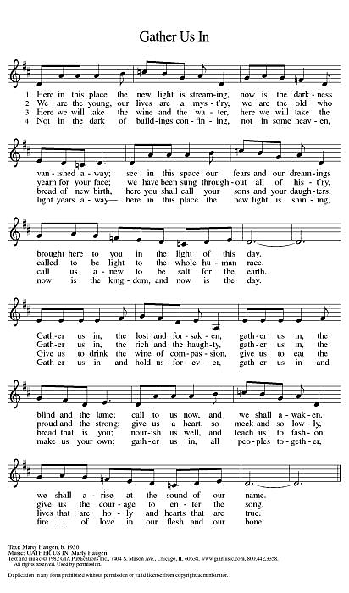
Greeting
P: The grace of our Lord Jesus Christ, the love of God, and the communion of the Holy Spirit be with you all.
C: And also with you.

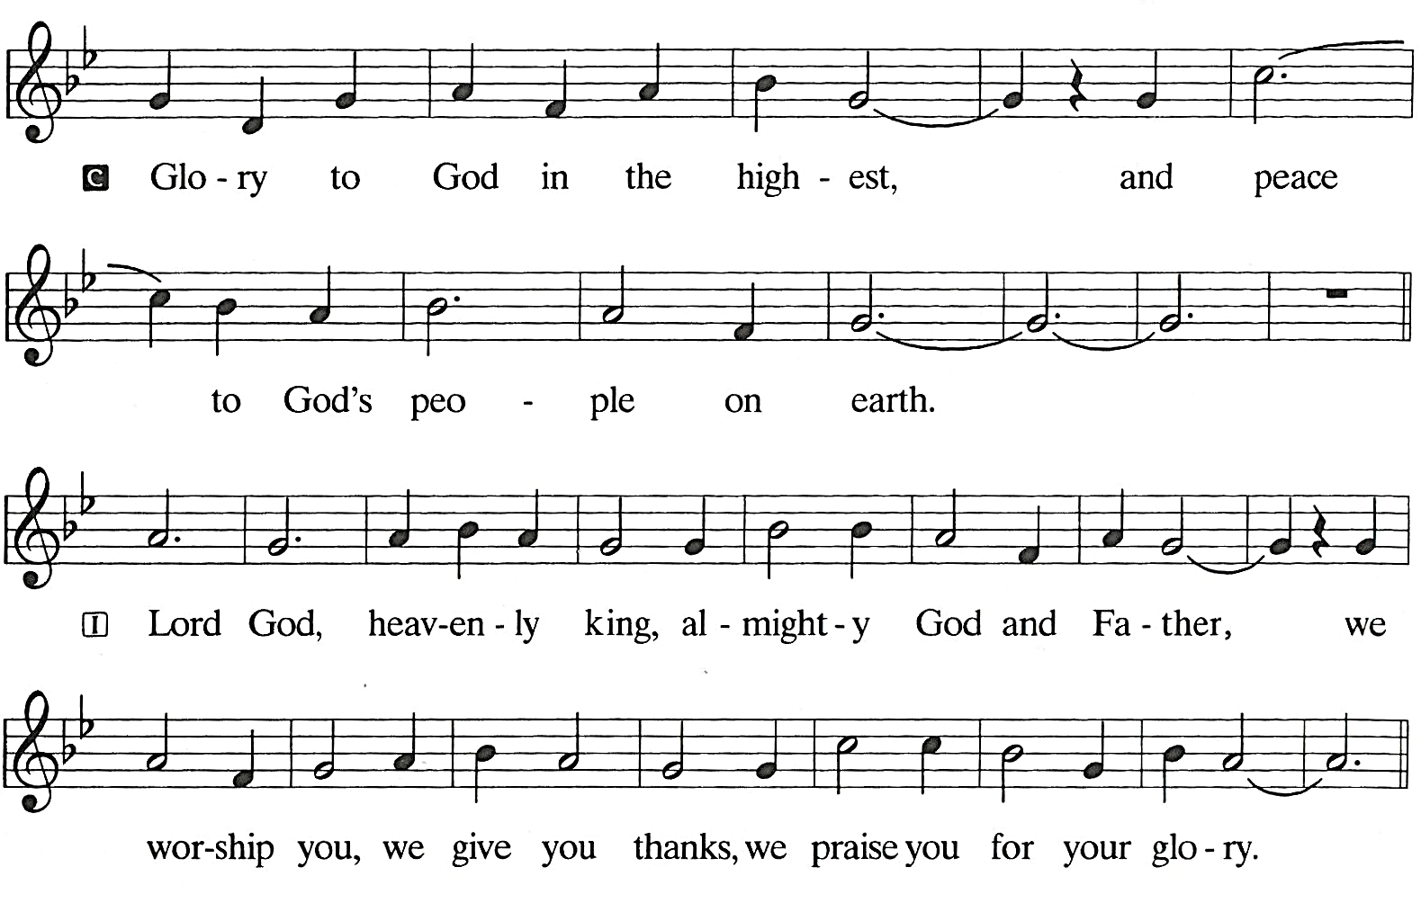
HYMN OF PRAISE We all sing together; the refrain twice, the verse once, then the refrain once more.

PRAYER OF THE DAY
P: Let us pray. O God, on this day you open the hearts of your faithful people by sending into us your Holy Spirit. Direct us by the light of that Spirit, that we may have a right judgment in all things and rejoice at all times in your peace, through Jesus Christ, your Son and our Lord, who lives and reigns with you and the Holy Spirit, one God, now and forever.
C: Amen.
Please be seated

FIRST READING: Acts 2:1-21
(Pentecost was a Jewish harvest festival that marked the fiftieth day after Passover. Luke portrays the Holy Spirit being poured out upon the disciples before the gathered and astonished people assembled in Jerusalem for the festival. Filled with the Spirit, the disciples were able to witness to the power of Christ’s resurrection.)

A reading from Acts:
¹ When the day of Pentecost had come, [the apostles] were all together in one place. ² And suddenly from heaven there came a sound like the rush of a violent wind, and it filled the entire house where they were sitting. ³ Divided tongues, as of fire, appeared among them, and a tongue rested on each of them. ⁴ All of them were filled with the Holy Spirit and began to speak in other languages, as the Spirit gave them ability.

⁵ Now there were devout Jews from every people under heaven living in Jerusalem. ⁶ And at this sound the crowd gathered and was bewildered, because each one heard them speaking in the native language of each. ⁷ Amazed and astonished, they asked, “Are not all these who are speaking Galileans? ⁸ And how is it that we hear, each of us, in our own native language? ⁹ Parthians, Medes, Elamites, and residents of Mesopotamia, Judea and Cappadocia, Pontus and Asia, ¹⁰ Phrygia and Pamphylia, Egypt and the parts of Libya belonging to Cyrene, and visitors from Rome, both Jews and proselytes, ¹¹ Cretans and Arabs—in our own languages we hear them speaking about God’s deeds of power.” ¹² All were amazed and perplexed, saying to one another, “What does this mean?” ¹³ But others sneered and said, “They are filled with new wine.”
¹⁴ But Peter, standing with the eleven, raised his voice and addressed them, “Fellow Jews and all who live in Jerusalem, let this be known to you, and listen to what I say. ¹⁵ Indeed, these are not drunk, as you suppose, for it is only nine o’clock in the morning. ¹⁶ No, this is what was spoken through the prophet Joel:
¹⁷ ‘In the last days it will be, God declares,
that I will pour out my Spirit upon all flesh,
and your sons and your daughters shall prophesy,
and your young men shall see visions,
and your old men shall dream dreams.
¹⁸ Even upon my slaves, both men and women,
in those days I will pour out my Spirit,
and they shall prophesy.
¹⁹ And I will show portents in the heaven above
and signs on the earth below,
blood, and fire, and smoky mist.
²⁰ The sun shall be turned to darkness
and the moon to blood,
before the coming of the Lord’s great and glorious day.
²¹ Then everyone who calls on the name of the Lord shall be saved.’”
L: The word of the Lord.
C: Thanks be to God.

Psalm: Psalm 104:24-34, 35b
²⁴ How manifold are your works, O Lord!
In wisdom you have made them all; the earth is full of your creatures.
²⁵ Yonder is the sea, great and wide, with its swarms too many to number,
living things both small and great.
²⁶ There go the ships to and fro,
and Leviathan, which you made for the sport of it.
²⁷ All of them look to you
to give them their food in due season.
²⁸ You give it to them; they gather it;
you open your hand, and they are filled with good things.
²⁹ When you hide your face, they are terrified;
when you take away their breath, they die and return to their dust.
³⁰ You send forth your Spirit, and they are created;
and so you renew the face of the earth.
³¹ May the glory of the Lord endure forever;
O Lord, rejoice in all your works.
³² You look at the earth and it trembles;
you touch the mountains and they smoke.
³³ I will sing to the Lord as long as I live;
I will praise my God while I have my being.
³⁴ May these words of mine please God.
I will rejoice in the Lord.
^{35b} Bless the Lord, O my soul. Hallelujah!

Second Reading: 1 Peter 4:12-14; 5:6-11
(Paul is helping the Corinthians understand the relationship between our God-given unity and Spirit-created diversity. The Spirit creates the unity of faith and gives all Christians diverse gifts for the common benefit of all. We need one another’s diverse spiritual gifts because the same Spirit has given them to each person for the common good.)

A reading from 1st Corinthians.
^{3b} No one can say “Jesus is Lord” except by the Holy Spirit.
⁴ Now there are varieties of gifts but the same Spirit, ⁵ and there are varieties of services but the same Lord, ⁶ and there are varieties of activities, but it is the same God who activates all of them in everyone. ⁷ To each is given the manifestation of the Spirit for the common good. ⁸ To one is given through the Spirit the utterance of wisdom and to another the utterance of knowledge according to the same Spirit, ⁹ to another faith by the same Spirit, to another gifts of healing by the one Spirit, ¹⁰ to another the working of powerful deeds, to another prophecy, to another the discernment of spirits, to another various kinds of tongues, to another the interpretation of tongues. ¹¹ All these are activated by one and the same Spirit, who allots to each one individually just as the Spirit chooses.
¹² For just as the body is one and has many members, and all the members of the body, though many, are one body, so it is with Christ. ¹³ For in the one Spirit we were all baptized into one body—Jews or Greeks, slaves or free—and we were all made to drink of one Spirit.

L: The word of the Lord.
C: Thanks be to God.
Please rise, in body or spirit.
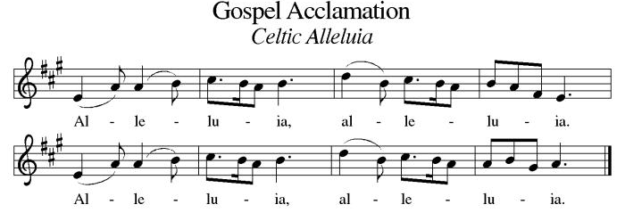
Gospel Acclamation Congregation sings acclamation once.

Holy Gospel: John 17:1-11
(The risen Jesus appears to his disciples, offering them a benediction, a commission, and the gift of the Holy Spirit.)

P: The Holy Gospel according to St. John, the seventeenth chapter.
C: Glory to you, O Lord.
¹⁹ When it was evening on that day, the first day of the week, and the doors were locked where the disciples were, for fear of the Jews, Jesus came and stood among them and said, “Peace be with you.” ²⁰ After he said this, he showed them his hands and his side. Then the disciples rejoiced when they saw the Lord. ²¹ Jesus said to them again, “Peace be with you. As the Father has sent me, so I send you.” ²² When he had said this, he breathed on them and said to them, “Receive the Holy Spirit. ²³ If you forgive the sins of any, they are forgiven them; if you retain the sins of any, they are retained.”

P: The Gospel of the Lord
C: Praise to you, O Christ.
Please be seated

Children’s Message

SERMON
After the sermon, please rise, in body or spirit, as we lift our hearts and voices together in song.

Hymn of the Day: Gracious Spirit, Heed Our Pleading – WOV (Blue) #687

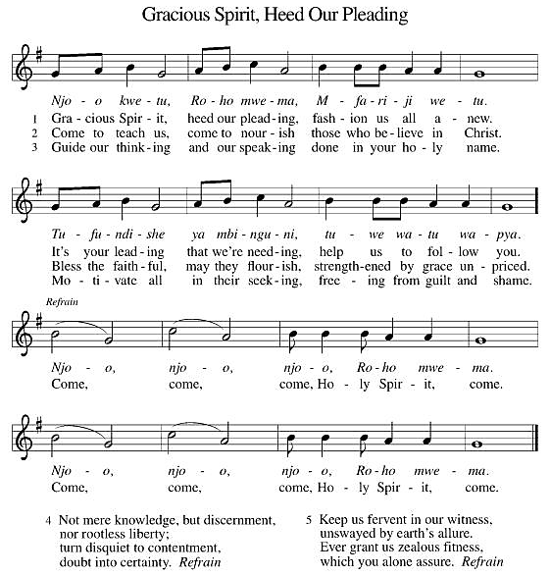

NICENE Creed
A: Let us confess our faith in the words of the Nicene Creed,
C: We believe in one God, the Father, the Almighty, maker of heaven and earth, of all that is, seen and unseen. We believe in one Lord, Jesus Christ, the only Son of God, eternally begotten of the Father, God from God, Light from Light, true God from true God, begotten, not made, of one Being with the Father; through him all things were made. For us and for our salvation he came down from heaven, was incarnate of the Holy Spirit and the virgin Mary and became truly human. For our sake he was crucified under Pontius Pilate; he suffered death and was buried. On the third day he rose again in accordance with the scriptures; he ascended into heaven and is seated at the right hand of the Father. He will come again in glory to judge the living and the dead, and his kingdom will have no end. We believe in the Holy Spirit, the Lord, the giver of life, who proceeds from the Father and the Son, who with the Father and the Son is worshiped and glorified, who has spoken through the prophets. We believe in one holy catholic and apostolic church. We acknowledge one baptism for the forgiveness of sins. We look for the resurrection of the dead, and the life of the world to come. Amen.

Prayers of Intercession
A: Trusting in the power of Christ’s resurrection to heal and redeem our broken world, let us pray for the needs of all creation.
A brief silence.
A: O God, you send the Holy Spirit to gather your church into one. Inspire all ministers of the gospel to speak prophetic and hope-filled words to all whom they encounter. Bless the work of interreligious dialogue. Merciful God,
C: Receive our prayer.
A: You send the Holy Spirit to renew the face of the earth. Protect all living things, bring forth clean water and abundant food, and grant us wonder as we contemplate all you have made. Merciful God,
C: Receive our prayer.
A: You send the Holy Spirit to break down the barriers of communication among nations. Bestow peace in war-torn areas, guide all in government and society to work for justice, and guard those serving in the armed forces, especially this weekend as we remember those who died in service to their country. Merciful God,
C: Receive our prayer.
A: You send the Holy Spirit to accompany those who feel abandoned. Provide food for those who hunger and drink for those who thirst, soothe those who are anxious or bereaved, comfort those who are sick or suffering, and answer all who call upon your name.
Merciful God,
C: Receive our prayer.
A: You send the Holy Spirit through the gift of baptism. Bless both those preparing for or affirming their baptism. May they be encouraged by this community of faith as they live out their baptismal promises. Merciful God,
C: Receive our prayer.
A: You send the Holy Spirit to console us in our grief. We give you thanks for our ancestors in the faith whose witness to your mighty works continues to inspire our lives. Merciful God,
C: Receive our prayer.
A: God of resurrection power, use us and these prayers to proclaim the good news of new life to all the world, through Jesus Christ, our risen Savior.
C: Amen.

PaSSING THE PEACE
P: The Peace of the Lord be with you always!
C: And also, with you.
P: Let us share a sign of peace with one another.

Please be seated

SPecial music
O Lord on High- composed by Mozart Harry Ransom &
Patty Bush

Offering
Here at Holy Spirit Lutheran Church, there are many ways you are able to give. Our ushers will pass around an offering plate, in which you can place your weekly offering. If you are attending worship online or you simply wish to give online, you may do so by visiting our website, hslceldersburgmd.org/give. We give thanks to God for the ways you continually offer your time, talent, and treasure for the sake of God and neighbor in our ministry.

Please rise, in body or spirit.
OFFERTORY HYMN
We lift our voices, we lift our hands, we lift our lives up to You: We are an offering. Lord, use our voices, Lord, use our hands. Lord use our lives, they are Yours. We are an offering; we are an offering

OFFERING PRAYER
P: Let us pray,
Merciful God, accept the fruits of our labor, gathered to give you glory. You have set a table before us, a glimpse of that great day when we will hunger and thirst no more. Nourish us with the body and blood of Jesus, that goodness and mercy may follow us and bless the world you love. In the name of Jesus, Amen.

THE GREAT THANKSGIVING
P: The Lord be with you.
C: And also with you.
P: Lift up your hearts.
C: We lift them to the Lord.
P: Let us give thanks to the Lord our God.
C: It is right to give our thanks and praise.

PREFACE
P: It is indeed right, our duty and our joy,
that we should at all times and in all places
give thanks and praise to you, almighty and merciful God,
through our Savior Jesus Christ.
Fulfilling the promise of the resurrection,
you pour out the fire of your Spirit,
uniting in one body people of every nation and tongue.
And so, with Mary Magdalene and Peter and all the witnesses of the resurrection, with earth and sea and all their creatures,
and with angels and archangels, cherubim and seraphim,
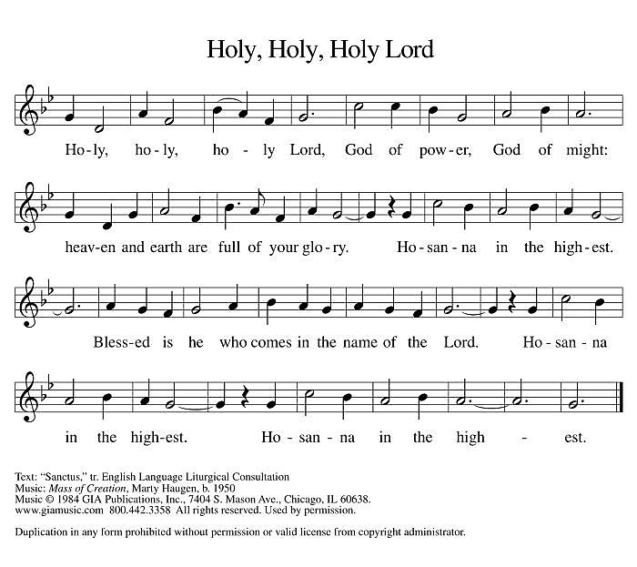
we praise your name and join their unending hymn:

EUCHARISTIC PRAYER & WORDS OF INSTITUTION
P: Blessed are you, O God of the universe.
Your mercy is everlasting
and your faithfulness endures from age to age.
You formed the earth from chaos;
you encircled the globe with air;
you created fire for warmth and light;
you nourish the lands with water.
You molded us in your image,
and with mercy higher than the mountains,
with grace deeper than the seas,
you blessed the Israelites and cherished them as your own.

P: That also we, estranged and dying,
might be adopted to live in your Spirit,
you called to us through the life and death of Jesus.

P: In the night in which he was betrayed,
our Lord Jesus took bread, and gave thanks;
broke it, and gave it to his disciples, saying:
Take and eat; this is my body, given for you.
Do this for the remembrance of me.

P: Again, after supper, he took the cup, gave thanks, and gave it for all to drink, saying: This cup is the new covenant in my blood, shed for you and for all people for the forgiveness of sin.
Do this for the remembrance of me.

P: Holy God, holy and merciful one, holy and compassionate,
send upon us and this meal your Holy Spirit,
whose breath revives us for life,
whose fire rouses us to love.
Enfold in your arms all who share this holy food.
Nurture in us the fruits of the Spirit,
that we may be a living tree, sharing your bounty with all the world.
C: Amen. Come, Holy Spirit.

P: Holy and benevolent God,
receive our praise and petitions,
as Jesus received the cry of the needy,
and fill us with your blessing,
until, needy no longer and bound to you in love,
we feast forever in the triumph of the Lamb:
through whom all glory and honor is yours, O God,
with the Holy Spirit, now and forever.
C: Amen.
THE LORD'S PRAYER
P: Gathered into one by the Holy Spirit, let us pray the prayer our Lord Jesus taught us, in the language of our hearts:
C: Our Father, who art in heaven, hallowed be thy name, thy kingdom come, thy will be done, on earth as it is in heaven. Give us this day our daily bread; and forgive us our trespasses, as we forgive those who trespass against us; and lead us not into temptation but deliver us from evil. For thine is the kingdom, and the power, and the glory, forever and ever. Amen.

INVITATION TO COMMUNION
P: Jesus invites you. Jesus welcomes you. All are invited. All are welcome. Come taste and see that the Lord is good! C: Amen.
Please be seated.

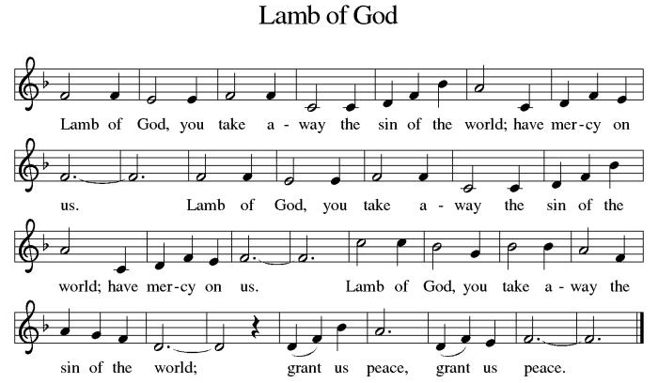
COMMUNION HYMN

Please come forward at the direction of the ushers. After all have communed, please rise, in body or spirit.
COMMUNION BLESSING
P: May the body and blood of our Lord Jesus Christ bless us and keep us in God’s grace, from now and until life everlasting. C: Amen.

POST-COMMUNION PRAYER
A: Let us pray,
O God, our life, our strength, our food; we give you thanks for sustaining us with the body and blood of your Son. By your Holy Spirit, enliven us to be Christ’s body in the world, that more and more we will give you praise and serve your earth and its many peoples, In the name of Jesus we pray,
C: Amen.

BENEDICTION
P: You are exactly who God created you to be. Created in Christ Jesus for good works. Created and called holy. Created and called beloved. Now go forth into the world in peace and be of good courage. Hold fast to that which is good. Render to no one an evil thing for an evil thing. Strengthen the fainthearted. Support the weak. Help the afflicted. Show Christ’s love to everyone and let the blessing of almighty God, the Father, the +Son, and the Holy Spirit, be among you and remain with you now and forever.
C: Amen.

Sending Hymn: Holy Spirit, Ever Dwelling – LBW (Green) – #523
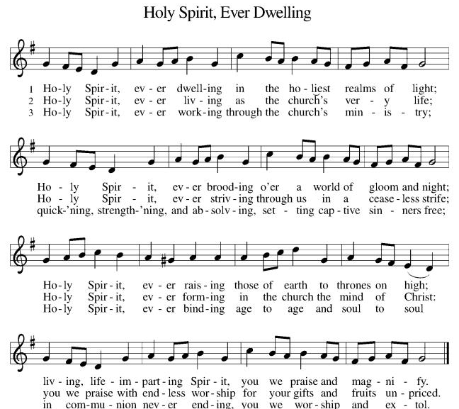
DISMISSAL
P: Go in peace, be of good heart!
C: Thanks be to God!
A: Our purpose is to love God,
C: And bring people into a growing relationship with Jesus and his church.

“We all serve as ministers in the mission of the Church.”
From Sundays and Seasons.com. Copyright 2012 Augsburg Fortress. All rights reserved.
Reprinted by permission under Augsburg Fortress Liturgies Annual License #23995.
New Revised Standard Version Bible, copyright 1989, Division of Christian Education of the National Council of the Churches of Christ in the United States of America. Used by permission. All rights reserved.

ACTIVITIES AT HOLY SPIRIT LUTHERAN CHURCH:
Sunday (05/24) Unity Sunday: The Day of Pentecost.
No Sunday School
9:30am -- Fellowship
11:00 am – Service

Sunday (05/31) 9:30 am -- Sunday School
10:30 am -- Fellowship
11:00am – Worship w/Holy Communion

Please see the “Events” tab on our website for all of our upcoming events.

Please contact Pastor Tom by email at HSLC.pastor@comcast.net if you would like to meet, have any questions, or for any pastoral emergencies.
Volunteers
 | This Week (05-24-2026) | Next Week (05-31-2026)
Greeters | TBD | TBD
Ushers | John F.  Luke F. | Rob T.  Bradley T.
Acolyte | Maryann F. | Abby P.
Assisting Minister | Krissy K. | Megan F.
Communion Assistant | Krissy K. | John F.
Lector | Lily K. | Cara K.
Altar Care | Linda L. | Heather T.
Fellowship/Coffee | Hall | Brecker

Upcoming Events Reminder

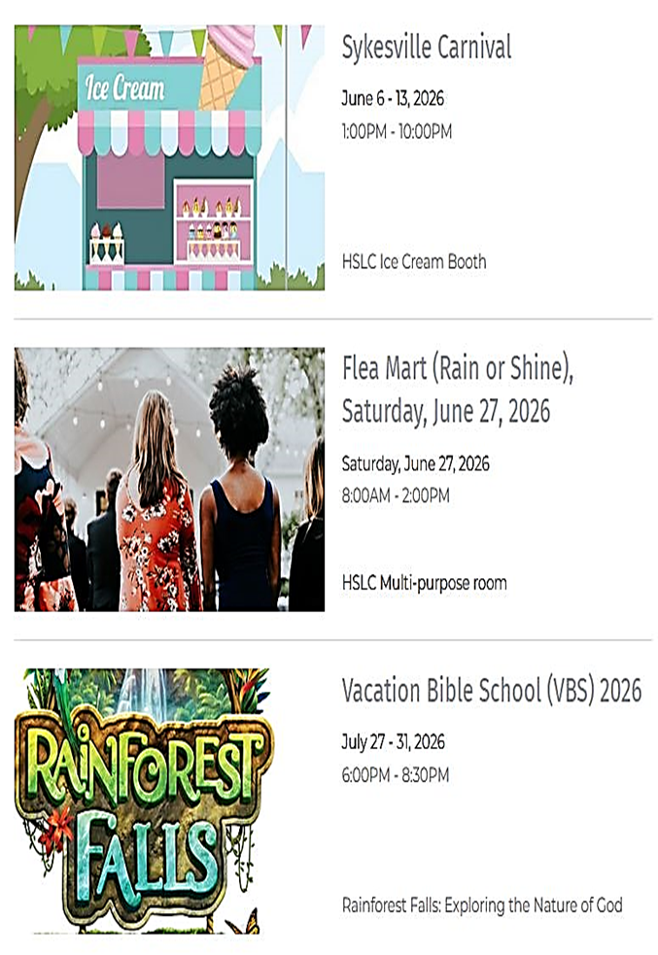

Pray in May: Refreshed and Renewed
Sisters and brothers in Christ,
During the month of May, echoing the prophets and saints who have gone before us, I am personally inviting all of you to be Refreshed and Renewed; to Pray in May.
The call to pray rings throughout scripture: 1 Thessalonians 5:16–18, Ephesians 6:18, Philippians 4:4–7, and Colossians 4:2–4. Life in the early church was bound together by prayer: Acts 2:42. Therefore, let us, too, be bound together, Refreshed and Renewed, through prayer.
Maybe you have an idea about how to renew your prayer life. Maybe you have no idea where to start. In any case, here’s how I am renewing mine, and I invite you to use my structure as it suits you:
1. Find a time and space to pray out loud. It’s best if the time is the same each day for the sake of structure and consistency. For me, it’s right before lunch. I also encourage you to pray out loud because Jesus promised us that when we pray, God listens.
2. Identify someone or something to pray for. In this season of life and ministry, I will pray for the Holy Spirit to embrace all on our Parish Prayer List, the Parish Prayer List at Shepherd of The Glen, and name each person out loud before God. I will then pray for the Church and world as a whole; that God’s Spirit of peace be known to all people. Maybe you’d like to pray something like the Prayer of St. Francis, or the full Serenity Prayer; all of which are powerful prayers which have united Christians for centuries.
3. Spend 1-2 minutes in silence before God. The Holy Spirit moves in many ways. When we silence our hearts and minds before God, it creates space for the Spirit. If you are “not good and being silent or still,” I encourage you to try being silent and still for smaller increments of time.
Lastly, I’d like to encourage you; no one is good at anything the first, or even the tenth time they try something new. It takes practice and consistency; silence, stillness, quietness, and prayer in general, are of no exception. Keep at it. Ask for help if needed. May God’s grace and peace be with you now and always, in Jesus’ name.

With all my love and prayers,
The Rev. Tom Kaye, Sr.

