St. Paul
UNITED CHURCH OF CHRIST

April 19, 2026 10:30am
Welcome! Whether you are a guest, friend or member, we are delighted that you are here. Large print bulletins are available at either door. Ask a greeter for any directions you may need.

“Please note that this service will be live-streamed on Facebook. If you do not wish to be visible on camera, please let an usher know so we can take appropriate measures to ensure
your privacy."

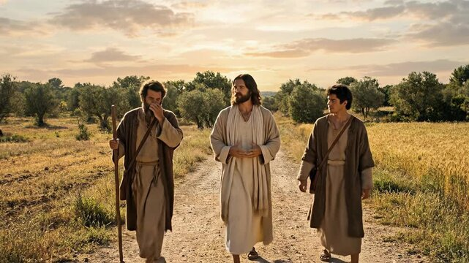

Rev. Jim Oleson, Pastor
Christopher Dickmeyer, Musician
Third Sunday of Easter
*Please rise in body or spirit
Ringing of the Bell
Welcome & Announcements
We welcome you today in the name of the One who frees us from every burden, renews our spirits and inspires hope and joy in our living. May this time of worship encourage and lift you up.
Prelude and Lighting of the Candles
*Call to Worship
Minister: By this will all people know that you are Christ’s disciples.
Congregation: If you have love for one another.
Minister: We can love because he first loved us.
Congregation: Praise God from the heavens! Praise God from the heights!
Minister: Young men and young women together, the elderly and little children!
Congregation: Praise the Lord!
*Invocation
Wonderful and Gracious God, some of us come to you weary from the stress and strain of our days, seeking the rest that only you can give. Some of us come doubting or lukewarm in faith, seeking your spiritual quickening.
But whatever our condition of mind, heart, or spirit, we come giving thanks that you accept and welcome us, and in your transforming love, are even now changing the old clothing of our souls for new.
We open ourselves to your working within and among us, as we lift our spirits into the light of your holy presence, and our voices in praise of your goodness. As you are present to us O God, help us be present to you. Guide and lead us and help us to follow - that we might be both blessed and a blessing. Amen.
*Hymn of Praise #233 New Century Christ the Lord is Risen Today
UNISON PRAYER (Unison)
O God, you have ordered this wondrous world, and know all the things in earth and in heaven. In this hour, fill our hearts with trust in you that by night and by day, at all times and in all seasons that we may commit to you all that we are and all that we have without fear. Grant that we, through the power of the Holy Spirit, may also commit all that we ever hope to be to your never-failing love for this life and the life to come. This we ask in Jesus' Name. Amen.
*Response of Praise
Glory be to the Father, and to the Son, and to the Holy Ghost; As it was in the beginning, is now, and ever shall be, World without end. Amen. Amen.
Written Word Acts 2:14a, 36-41
1 Peter 1:17-23
Luke 24:13-35
Hymn #336 New Century Here, O My Lord, I See You Face to Face
Message Somewhere on the Road Rev. Jim Oleson
Luke 24:13-35
Church in Prayer
Pastoral Prayer
Lord’s Prayer (Debts, Debtors)
Offertory
Invitation to Generosity
*Doxology (Tune: Old Hundredth)
Praise God, from Whom all blessings flow; Praise Him, all creatures here below;
Praise Him above, ye heavenly host; Praise Father, Son, and Holy Ghost. Amen.
*Prayer of Dedication
Almighty God, you have again filled us the blessing of your grace. Having been fulfilled we offer ourselves, our bodies, and our souls, as an offering, that we may grow daily in faith, may rejoice in hope, and may enrich ourselves in love. Bless us and these gifts to your work in this world. Amen.
*Closing Hymn #386 New Century The Church’s One Foundation
*Commission and Benediction
*Christ’s Light Leads Us into the World
*Congregational Response #531 New Century God, Speak to Me, That I May Speak
(Verse 1)
*Ringing of the Bell and Postlude

903 Meier Road, Old Monroe, Missouri 63369
stpauluccom@gmail.com
Website: stpauluccom.com
636-665-5329

OFFICE HOURS
Wednesday: 9:00am – 3:00pm
Friday: 9:00am - Noon

It Happens
Here St. Paul UCC
Weekly Calendar
April 19th – April 26th

April 19th Third Sunday of Easter
9:15am Bible/Book Study
10:30am Worship
11:30am Fellowship Hour

April 20th
5:15pm Council Meeting

April 26th Fourth Sunday of Easter
9:15am Bible/Book Study
10:30am Worship
11:30am Fellowship Hour

Looking Ahead

April 20th
9:00am-3:00pm Joann will be in the office

April 21-24 Joann on vacation

________________________________________________________________________________________
OUR GIVING IN 2026
Needed weekly to meet our commitments $2190.29 $ 2190.29
General Fund Offering April 12th $ 1290.00 March Average $ 1160.00 Stewardship Offering April 12th $ 0.00 February Average $ 1226.25
______ __________________________________________________ __ ____________________ ________

HAPPENING IN OUR COMMUNITY`

Thank you to all our volunteers!

Greeters/Ushers
Gerald Hackman & Joe Walker

Acolyte
Joyce Noble

Liturgist

Fellowship Hour
Finance

In our prayers …

We continue to keep in our prayers Lauretta, Lynn and Ron D., Ernie M., Eileen T., Chuck and Marlene, Lyle R., Jamie, Nor, Rick C., Bob R., Sandy R., Carolyn M., Kristie N., Jackie, Norma K., Diane B., the family of Donna V. and the family of Hunter G.

We lift up in our prayers those who need prayers for their long-term circumstances: Carol Jean P.

REMINDER…Please DO NOT adjust the programmable thermostat in the Sanctuary.

The Worship Committee is looking for a volunteer to be the Communion Stewart. This is a person who prepares Communion on the first Sunday of the month and for special services. Also requires cleaning up and putting away the Communion ware. If there are any questions, please see a Worship Committee member.
“April Showers bring May Flowers”. During the month of April, the Food Pantry would like to “shower” clients with household cleaning supplies and toiletries. We are asking for donations of these items. Thank you.
Food Pantry Committee

