St. Paul
UNITED CHURCH OF CHRIST

May 10, 2026 10:30am
Welcome! Whether you are a guest, friend or member, we are delighted that you are here. Large print bulletins are available at either door. Ask a greeter for any directions you may need.

“Please note that this service will be live-streamed on Facebook. If you do not wish to be visible on camera, please let an usher know so we can take appropriate measures to ensure
your privacy."

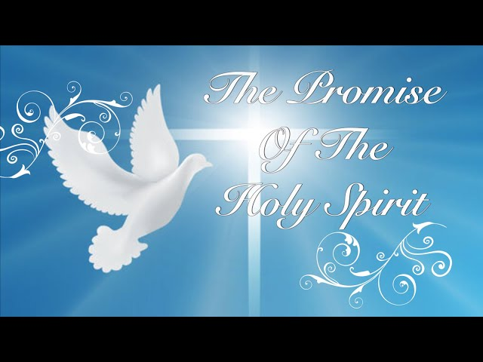

Rev. Jim Oleson, Pastor
Carolyn Meier, Musician
Sixth Sunday of Easter - Mother’s Day
*Please rise in body or spirit
Ringing of the Bell
Welcome & Announcements
We welcome you today in the name of the One who frees us from every burden, renews our spirits and inspires hope and joy in our living. May this time of worship encourage and lift you up.
Prelude and Lighting of the Candles
*Call to Worship (Responsive)
Leader: Within each of our lives there is a longing for community and the Presence of God.
People: Sometimes we worry that we will walk alone, unnoticed and afraid.
Leader: This day Christ tells us that we will never be alone. An Advocate will share our journey.
People: And this journey calls for us to continue to keep to the teachings of our Lord.
Leader: May the ever-present love of God be with you.
People: And may the joy of Christ surround you.
Leader: May we know the presence of the Advocate as we gather in this community of peace, continuing to share the cost of discipleship with deeds of bold mercy and courageous justice.
All: As an Easter People following a Risen Lord, may the life of Jesus live on in us and through us. Amen.
*Invocation
Still-speaking God, we have come here today for many reasons, each with our own story.
May these reasons and stories be immersed in your Sacred Story, finding ourselves caught up in the drama and beauty of Jesus’ teachings, life, and ministry.
Through your Holy Spirit enable us to move boldly into the future and to fulfill the hope of love that Jesus taught. Amen.
*Hymn of Praise #307 New Century Glorious Things of You Are Spoken

UNISON PRAYER
Living God, long ago, faithful women proclaimed the good news of Jesus' resurrection, and the world was changed forever. Today, we remember those women of faith, as well as the women of faith in our own lives, those women who have mothered us, whether they have actually borne children or not. Teach us to keep faith with them, that our witness may be as bold, our love as deep, and our faith as true. Amen.
*Response of Praise
Glory be to the Father, and to the Son, and to the Holy Ghost; As it was in the beginning, is now, and ever shall be, World without end. Amen. Amen.
Written Word Acts 17:22-31
1 Peter 3:13-22
John 14:15-21
Hymn #63 New Century Holy Spirit, Truth Divine
Message Such a Lonely Word Rev. Jim Oleson
John 14:15-21
Church in Prayer
Pastoral Prayer
Lord’s Prayer (Debts, Debtors)
Offertory
Invitation to Generosity
*Doxology (Tune: Old Hundredth)
Praise God, from Whom all blessings flow; Praise Him, all creatures here below;
Praise Him above, ye heavenly host; Praise Father, Son, and Holy Ghost. Amen.
*Prayer of Dedication
May these gifts, O God, become action and intention, fulfilling Christ’s commandment to love. Amen.
*Closing Hymn #473 New Century Blessed Assurance
*Commission and Benediction

*Christ’s Light Leads Us into the World
*Congregational Response #531 New Century God, Speak to Me, That I May Speak
(Verse 1)
*Ringing of the Bell and Postlude

903 Meier Road, Old Monroe, Missouri 63369
stpauluccom@gmail.com
Website: stpauluccom.com
636-665-5329

OFFICE HOURS
Wednesday: 9:00am – 3:00pm
Friday: 9:00am - Noon

It Happens
Here St. Paul UCC
Weekly Calendar
May 10th – May 17th

May 10th Sixth Sunday of Easter
Mother’s Day
9:15am Bible/Book Study
10:30am Worship
11:30am Fellowship Hour

May 11th
5:15pm Council Meeting

May 17th Seventh Sunday of Easter
9:15am Bible/Book Study
10:30am Worship
11:30am Fellowship Hour

Looking Ahead

May 16th
5:30pm Trivia

________________________________________________________________________________________
OUR GIVING IN 2026
Needed weekly to meet our commitments $2190.29 $ 2190.29
General Fund Offering May 3rd $ 7615.00 April Average $ 1080.00 Stewardship Offering May 3rd $ 265.00 March Average $ 1160.00
______ __________________________________________________ __ ____________________ ________

HAPPENING IN OUR COMMUNITY`

Thank you to all our volunteers!

Greeters/Ushers
Glenda & Karol Keeteman

Acolyte
Bobby Rowkowske

Liturgist

Fellowship Hour
Food Pantry

In our prayers …

This week we added Belinda D. to our prayers.

We continue to keep in our prayers Lauretta, Lynn and Ron D., Ernie M., Eileen T., Chuck and Marlene, Lyle R., Jamie, Nor, Rick C., Bob R., Sandy R., Carolyn M., Jackie, Norma K., Diane B., and Ray C.

We lift up in our prayers those who need prayers for their long-term circumstances: Carol Jean P. and Jane M.

It is time to update the church Telephone Directory. If you have had a change in address, email or phone number, please let Joann know this coming week.

REMINDER…Please DO NOT adjust the programmable thermostat in the Sanctuary.

The Worship Committee is looking for a volunteer to be the Communion Stewart. This is a person who prepares Communion on the first Sunday of the month and for special services. Also requires cleaning up and putting away the Communion ware. If there are any questions, please see a Worship Committee member.

