PARISH HOUSE: Items for May
Items Needed: Canned Corn, Mixed Vegetables,
Shampoo, Toilet Paper

Upcoming Events:
TODAY – 4th Sunday Lunch
May 27th – 6:00pm Choir Practice
6:30pm The Chosen – “I Saw You”
June 3rd – 7:00pm Team Leadership Meeting

NEEDED: Salads and cookies for Salad
Luncheon during Annual Conference.
Candy will be at Church June 10th at
9:00am. Items can be dropped off or
come and help.

MAY BIRTHDAYS

Corbin George – 6th, Mark George – 9th

MAY ANNIVERSARIES
Ron & Susie Sheets – 18th

Tithes and Offerings: Give your gifts,
tithes, and offerings through PayPal. It is
quick, easy, and safe! Just use the
camera on your phone to scan the QR
Code. All donations will be placed into
our General Account unless otherwise
stated.

TENNERTON
United Methodist Church
May 24, 2026
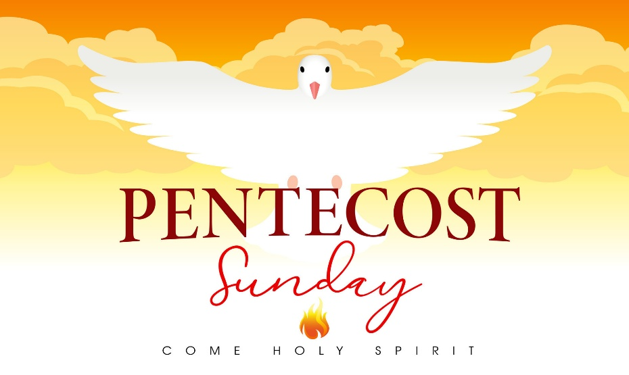
Pastor Jim Minutelli
304-629-9398

Office: 126 Tallmansville Rd.
Buckhannon, WV 26201
Office Phone: 304-472-1064
Sermon by Phone: 304-460-0029
Website: https://tennertonumc.org
Email: umc.tennerton@gmail.com
Facebook: https://www.facebook.com/thetennertonumc
Prayer Concerns: Call Candy George @ 304-613-6424

JOYS & CONCERNS
WELCOME/OPENING PRAYER Pastor
*OPENING HYMN: “Breathe on Me, Breath of God”
(14/29) UMH 420

CALL TO WORSHIP: Psalm 104: 24-35 UMH 826

*OFFERING/DOXOLOGY/PRAYER UMH 95
CHOIR: “We Are the Church” (19/18) UMH 558
CHILDREN MESSAGE Vickie Snyder
ANNOUNCEMENTS (ON BACK PAGE)
READING: I Corinthians 12: 3 – 13

*HYMN: “Spirit of God, Descend Upon My Heart”
(17/24) UMH 500
SCRIPTURE READING:
SERMON:

*CLOSING HYMN: “The Church’s One Foundation”
(19/2) UMH 545
*BENEDICTION

*Please stand if you are able. Don’t Forget to Feed the Pig

GREETERS & WORSHIP LEADERS
If you would like to be a greeter or lead worship service,
print your name on the clip board on the front pew.
This Week
GREETER(S): Neale Hinkle & Linda Ball
WORSHIP LEADER: Lynn Frum
Next Week
GREETER(S): Shane & Billi West
WORSHIP LEADER: Vickie Snyder

Quote of the Week:

“We do not need to wait for the Holy
Spirit to come; he came on the day of
Pentecost. He has never left the church.”
John Stott

