PARISH HOUSE: Items for April
Items Needed: Canned Vegetables, Laundry
Detergent, Deodorant, Toothpaste

Upcoming Events:

Today - 1:30pm “The Chosen”
Invitations
April 22nd & 29th – No Choir Practice or
` Bible Study
April 26th – 4th Sunday Lunch
1:30pm “The Chosen”
I Am He
May 2nd – 9:00am Women’s Meeting
May 6th - 7:00pm Leadership Team Meeting
May 9th – 8:00am Men’s Meeting at
Brushy Fork Community Building

APRIL BIRTHDAYS

Mary Carson – 16th, Billi West – 17th, Patsy Burgess – 28th

Tithes and Offerings: Give your gifts,
tithes, and offerings through PayPal. It is
quick, easy, and safe! Just use the
camera on your phone to scan the QR
Code. All donations will be placed into
our General Account unless otherwise
stated.

TENNERTON
United Methodist Church
April 19, 2026

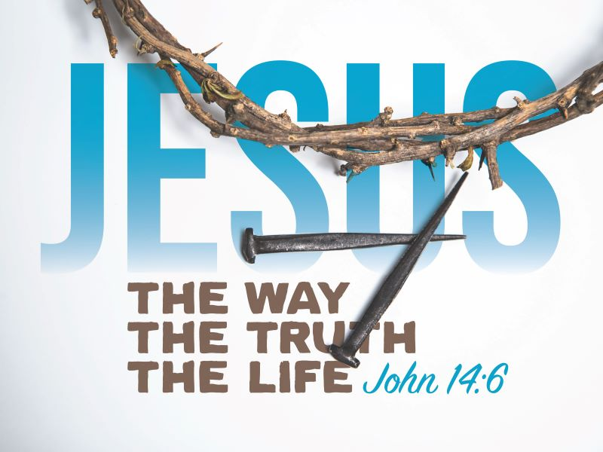
Pastor Jim Minutelli
304-629-9398

Office: 126 Tallmansville Rd.
Buckhannon, WV 26201
Office Phone: 304-472-1064
Sermon by Phone: 304-460-0029
Website: https://tennertonumc.org
Email: umc.tennerton@gmail.com
Facebook: https://www.facebook.com/thetennertonumc
Prayer Concerns: Call Candy George @ 304-613-6424

JOYS & CONCERNS
WELCOME/OPENING PRAYER Pastor
*OPENING HYMN: “Breathe on Me, Breath of God”
14/29 UMH 420

CALL TO WORSHIP: Psalm 34: 1-10 UMH 769

*OFFERING/DOXOLOGY/PRAYER UMH 95
*HYMN: “Rock of Ages, Cleft for Me” 12/17 UMH 361
CHILDREN MESSAGE Vickie Snyder
ANNOUNCEMENTS (ON BACK PAGE)
READING: I Peter 1: 17 – 23

*HYMN: “What a Friend We Have in Jesus”
18/11 UMH 526
SCRIPTURE READING:
SERMON:

*CLOSING HYMN: “Only Trust Him”
11/20 UMH 337
*BENEDICTION

*Please stand if you are able. Don’t Forget to Feed the Pig

GREETERS & WORSHIP LEADERS
If you would like to be a greeter or lead worship service,
print your name on the clip board on the front pew.

This Week
GREETER(S): Neale Hinkle & Linda Ball
WORSHIP LEADER: Lynn Frum

Next Week
GREETER(S): Shahna West
WORSHIP LEADER: Vickie Snyder

Quote of the Week
“The Son of God became a man
to enable men to become
the sons of God.”
C.S. Lewis

