St. Paul
UNITED CHURCH OF CHRIST

May 17, 2026 10:30am
Welcome! Whether you are a guest, friend or member, we are delighted that you are here. Large print bulletins are available at either door. Ask a greeter for any directions you may need.

“Please note that this service will be live-streamed on Facebook. If you do not wish to be visible on camera, please let an usher know so we can take appropriate measures to ensure
your privacy."

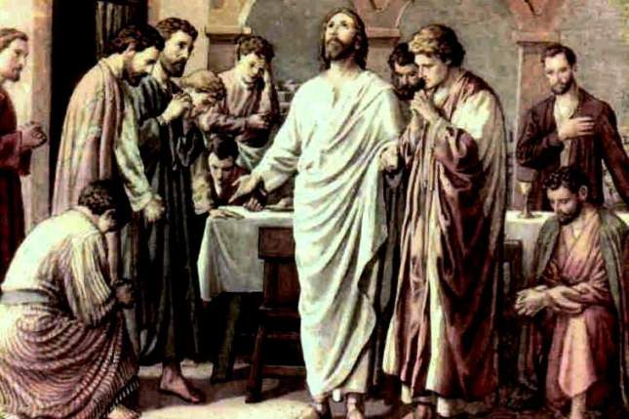

Rev. Jim Oleson, Pastor
Carolyn Meier, Musician
Seventh Sunday of Easter
*Please rise in body or spirit
Ringing of the Bell
Welcome & Announcements
We welcome you today in the name of the One who frees us from every burden, renews our spirits and inspires hope and joy in our living. May this time of worship encourage and lift you up.
Prelude and Lighting of the Candles
*Call to Worship (Responsive – Based on Ps. 68)
Leader: We shout for joy to God who rides upon the clouds!
People: We sing praises to our awe-inspiring God, before whom the earth quakes, and whose abundant blessings provide for all in need!
Leader: God is Sovereign over the earth, Defender of the defenseless, and Parent to orphans; God creates families for those who are alone.
People: God leads captives to freedom and breaks the yoke of oppression.
Leader: God goes forth before the people, marching through the wilderness of their lives, bringing forth restoration and justice.
People: Sing praise to God, Rider of the ancient skies, who dwells in holiness.
Leader: Proclaim the power of God!
People: O God, how awesome you are in your sanctuary! You give power and strength to your people.
Leader: Let us worship God!
*Invocation
God Most High, we gather to honor and glorify you. Receive our invitation to dwell with us. Enfold us in your presence and fill us again with holy awe and mystery. We are yours and we claim you as our God. Amen.
*Hymn of Praise #304 New Century All Hail the Power of Jesus’ Name
Prayer for Transformation and New Life
Blessed One, you created human beings for your glory and pleasure. Forgive us for being self-absorbed and choosing to live solely for ourselves. Forgive us for ignoring the prompting of your Spirit, your purpose for our lives, and for placing our will above yours. Grant us courage to share in Christ’s sufferings, to be his witnesses, and to carry your loving compassion to a hurting world. Amen.
<pause for silent reflection >
Words of Grace
As the Body of Christ, we are empowered by the Holy Spirit to be Christ’s witnesses.
Each of us has our own story of what Jesus’ life means for us.
Through our stories we can convey hope to the hopeless, joy to the downtrodden, and peace where there is turmoil. Therefore, let us “clothe ourselves in humility,” sharing the Good News of Christ, that we “may all be one.” In this God is well pleased.
*Response of Praise
Glory be to the Father, and to the Son, and to the Holy Ghost; As it was in the beginning, is now, and ever shall be, World without end. Amen. Amen.
Written Word Acts 1:6-14
1 Peter 4:12-14, 5:6-11
John 17:1-11
Hymn #257 New Century Alleluia! Gracious Jesus!
Message The Waiting Is the Hardest Part Rev. Jim Oleson
John 17:1-11 & Acts 1:6-14
Church in Prayer
Pastoral Prayer
Lord’s Prayer (Debts, Debtors)
Offertory
Invitation to Generosity
*Doxology (Tune: Old Hundredth)
Praise God, from Whom all blessings flow; Praise Him, all creatures here below;
Praise Him above, ye heavenly host; Praise Father, Son, and Holy Ghost. Amen.
*Prayer of Dedication
Ever-present and loving God, your Word tells us to cast our cares on you because you care for us. In faith and trust we present these gifts, and ourselves, to you. Bless and multiply them to meet the needs, both hidden and apparent, of your beloved ones.
Inspire each of us to live as Christ’s witnesses, today and ever more. By the power of the Holy Spirit, we pray. Amen.
*Closing Hymn #395 New Century In Christ There is No East or West

*Commission and Benediction
*Christ’s Light Leads Us into the World
*Congregational Response #531 New Century God, Speak to Me, That I May Speak
(Verse 1)
*Ringing of the Bell and Postlude

903 Meier Road, Old Monroe, Missouri 63369
stpauluccom@gmail.com
Website: stpauluccom.com
636-665-5329

OFFICE HOURS
Wednesday: 9:00am – 3:00pm
Friday: 9:00am - Noon

It Happens
Here St. Paul UCC
Weekly Calendar
May 17th – May 24th

May 17th Seventh Sunday of Easter
9:15am Bible/Book Study
10:30am Worship
11:30am Fellowship Hour

May 24th Pentecost Sunday
9:15am Bible/Book Study
10:30am Worship
11:30am Fellowship Hour

Looking Ahead

________________________________________________________________________________________
OUR GIVING IN 2026
Needed weekly to meet our commitments $2190.29 $ 2190.29
General Fund Offering May 10th $ 920.00 April Average $ 1080.00 Stewardship Offering May 10th $ 0.00 March Average $ 1160.00
______ __________________________________________________ __ ____________________ ________

HAPPENING IN OUR COMMUNITY`

Thank you to all our volunteers!

Greeters/Ushers
Bob Bothe & Jennifer Schulte

Acolyte
Jennifer Schulte

Liturgist

Fellowship Hour
PPR

In our prayers …

We continue to keep in our prayers Lauretta, Lynn and Ron D., Ernie M., Eileen T., Chuck and Marlene, Lyle R., Jamie, Nor, Rick C., Bob R., Sandy R., Carolyn M., Jackie, Norma K., Diane B., Ray C., and Belinda D.

We lift up in our prayers those who need prayers for their long-term circumstances: Carol Jean P. and Jane M.

Articles for the June Messenger are due.

REMINDER…Please DO NOT adjust the programmable thermostat in the Sanctuary.

The Worship Committee is looking for a volunteer to be the Communion Stewart. This is a person who prepares Communion on the first Sunday of the month and for special services. Also requires cleaning up and putting away the Communion ware. If there are any questions, please see a Worship Committee member.

