TLC Weekly: Sunday, May 24 -31
Vicar Angie DeSmith cell: 507-828-4941 email: amgiedesmith316@gmail.com
The Radio Broadcast (KMHL 1400AM or 101.7FM) is sponsored in memory of Elaine Nyquist by her family.
Sunday, May 24 9am Worship/Holy Communion
10am Coffee Fellowship
Monday, May 25 OFFICE CLOSED Memorial Day Observed
Wednesday, May 27 9am Do Day Mission Work Day
Friday, May 29 OFFICE CLOSED
Sunday, May 31 9am Worship
10am Coffee Fellowship

Please continue to Remember in Prayer:
Please…
We are happy to include people in our prayer list, but we must have their permission to be included. Many folks are very private about what is happening in their lives and we want to honor that.
Peggy Isaacson – LaVerne Jessen’s daughter, cancer
Scott Horn – Recovering from cancer surgery
Dan Nyquist – Recovering at home
Steve Vickerman – health issues
Kim Mickelson – cancer-cousin of Kari Meyer & Kris Tiegs
Vicki Schaar – Cancer
Sharon Kosse – recovering at home from a fall
Sue Nackerud – health issues
Mary Kay Eustice – friend of Muriel & John Coulter

May Acolyte Danica Paulsen
June Acolyte: Jared Swenhaugen, Caroline Engelkes

May Altar Preparation: Carolyn Engelkes, Karen Krog
June Altar Preparation: Darcy Carlson, Sandy Fultz

May Communion Servers: Brenda Wieme, Gail Kropp, Shirley Johnson
June Communion Servers: Addison Kainz, Gail Kropp. Sue Magnuson

Coffee Fellowship: Sunday, May 24 Melody & Makenna Caron
Sunday, May 31 OPEN

Scripture Readers: Sunday, May 24 Matt Pierson
Sunday, May 31 Swede Campbell

Greeters: Sunday, May 24 Terry & Kathy Filter
Sunday, May 31 Jason & Addison Kainz

Sunday Counters: Sunday, May 24 Darci Anderson
Sunday, May 31 Melody Caron

Ushers: Sunday, May 24: Dennis Fultz, Chad Anderson, Jim Christian
Sunday, May 31: Jim Nicks, Tim Jones, Loren Rykhus, Terry Filter

Don’t forget to check the kiosk for information on any upcoming events around Tracy.
Radio opening for the month of June 28.
Congratulations to the recipients of the scholarships that were awarded last Sunday, congratulations to Addison Kainz, Cheyene Hoffman, and Aliyah Loftness. Also a big “thank you” to the anonymous donor for the donation to fund these scholarships. “THANK YOU”
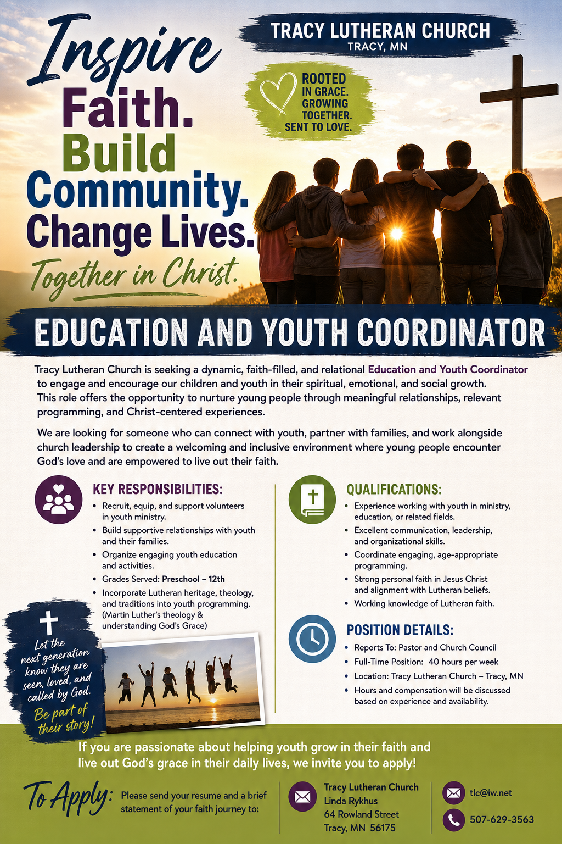
At the request of council president, Dennis Fultz, Tracy Lutheran Church is recognized as a Synod -Authorized Ministry site. Angie DeSmith has been authorized by Southwestern Minnesota Synod Bishop Dee Pederson to preach and preside for
Holy Communion in the congregation . The authorization is granted in accord with the ELCA’s guiding statement, The Use of the Means of Grace , which recognizes the witness of the sacrament as a celebration of the Church, serving its unity and
proclaiming the Gospel; and that where it is not possible to provide ordained pastoral leadership, a synod bishop may authorize a properly trained person to preside at a certain time.

