City Road United Methodist Church
A Lighthouse Congregation

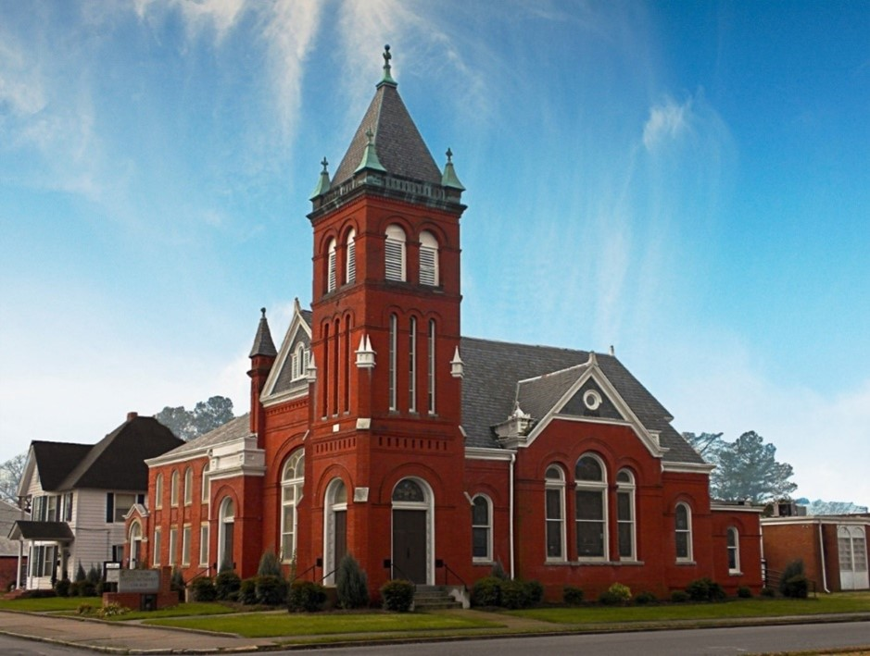
Rev. Josh Tester, Pastor

Office: (252) 335-2658
cityroadec.net crumcec@gmail.com

Facebook: https://www.facebook.com/CityRoadUMC

Sunday School: 10:00 a.m.
Sanctuary Worship: 11:00 a.m.

Tommy Venters- Organist/Choir Director
Dawn Baker- Secretary/Technology Specialist
JoAnn Herring- We Care

Service of Word
Season of Easter
May 24th, 2026 11:00 am
Gathering
Prelude
Introit “Morning has Broken”
Words of Welcome
*Call to Worship
Easter people, Christ has completed the work of salvation, reconciling us to God so that we may know eternal life.
Through Christ, we are made one with God.
In life, death, and Resurrection, Christ guides us into eternal life with God here and now.
Through Christ, we are made one in God.
Through prayer and teaching, healing and serving, Christ draws us together as the people of God, diverse members of the one body.
Through Christ, we are made one with God and one another.
So, come, let us worship God who saves us into eternal life with God and one another!
Thanks be to God! Amen.

*Prayer of Approach
Almighty God, by your Holy Spirit you have made us one with your saints in heaven and on earth: Help us to see your presence burning in the hearts of others; grant that we may be united in a fellowship of love and prayer; give us the courage to pick up our cross and respond to the needs of the world, give us the stamina to follow you, to be your hands and heart in the world; enable us to witness to your grace and mercy. We pray all this through the love your son, Jesus Christ. Amen.

*Sharing Peace
As a people forgiven and freed, we reach out to lift others up, offering the peace of Christ. Peace be with you!
And also with you!
You are invited to share the Peace with those around you [remembering to send your peace through the camera to those worshiping remotely*

Hymn of Praise “Freely, Freely” UMH 389

Proclamation & Response
Call to Prayer
Prayers of the People
The Lord’s Prayer
Our Father who art in heaven, hallowed be thy name. Thy kingdom come; thy will be done on earth as it is in heaven. Give us this day our daily bread, and forgive us our trespasses, as we forgive those who trespass against us; and lead us not into temptation but deliver us from evil. For thine is the kingdom, and power, and glory forever. Amen

Children’s Time
Call to the Offering
Offertory
*Doxology
*Prayer of Dedication

Hymn of Preparation “Hymn of Promise” UMH 707

Anthem Chancel Choir

New Testament Lesson Acts 2:1-17
Message “Surprising Spirit” Jeanne Murray

Sending Fourth
*Sending Hymn “Pass It On” UMH 572
*Benediction

