Holy Trinity Lutheran Church
150 River Road Red Bank, NJ 07701
Church Office: (732) 741-9241 Fax: (732) 741-9577
email: holytrinitychurch4@verizon.net
Website: htlcredbank.org
Pastor: Rev. John Mack, Jr.
Cell: (336)-392-5839
Minister of Music: Peter Isherwood
Parish Administrator: Deanna Vergari
Council President: Cynthia Kazmac



May 17, 2026

Seventh Sunday of Easter

Introduction
In these days between Ascension and Pentecost, we gather with the disciples in the upper room, waiting for the Spirit to transform the church around the world. In today’s gospel Jesus prays for his followers and for their mission in his name. Amid religious, social, and economic divisions, we seek the unity that Jesus had with his Father. Made one in baptism, we go forth to live our faith in the world, eager for the unity that God intends for the whole human family.
Welcome & Announcements (Please remember to silence your cell phone!)

Prelude (We prayerfully prepare our hearts and minds to worship!)

+ GATHERING +
Thanksgiving for Baptism
All may make the sign of the cross, the sign that is marked at baptism, as the presiding minister begins.
P:Alleluia! Christ is risen.
C:Christ is risen indeed. Alleluia!
P:Salvation belongs to our God who is seated on the throne
and to the Lamb!
C:Amen.
P:Let us give thanks for the gifts of baptism.
Water may be poured into the font as the presiding minister continues.
P:Merciful God,
you are the one who was, who is, and who is to come.
You lead us beside still waters.
We thank you for the waters of creation:
morning dew, gentle rain, roaring waves.
We thank you for the waters that nourish us (local waters may be named).
Blessed are you.
C:You guide us to springs of the water of life.
P:Jesus Christ, you are the faithful witness
who accompanies us on our journeys.
We give you thanks for your life-giving death and resurrection.
We praise you for joining us in joy and sorrow.
Blessed are you.
C:You guide us to springs of the water of life.
P:Holy Spirit, you anoint our head with oil and our cup overflows.
Break down barriers that divide us.
Fill us with the breath of peace.
Blessed are you.
C:You guide us to springs of the water of life.
P:Holy One, we thank you for the gifts and grace of baptism,
and for making us a new creation.
We join with saints and angels, giving you honor and praise,
now and forever.
C:Amen.

*Gathering Hymn ELW 389 Christ is Alive! Let Christians Sing
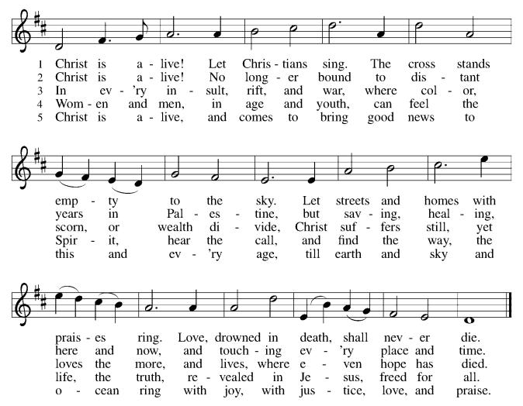

*Pastoral Greeting

P: The Grace of our Lord Jesus Christ, the love of God, and the communion of the Holy Spirit be with you all.

C: And also with you!

Hymn of Praise

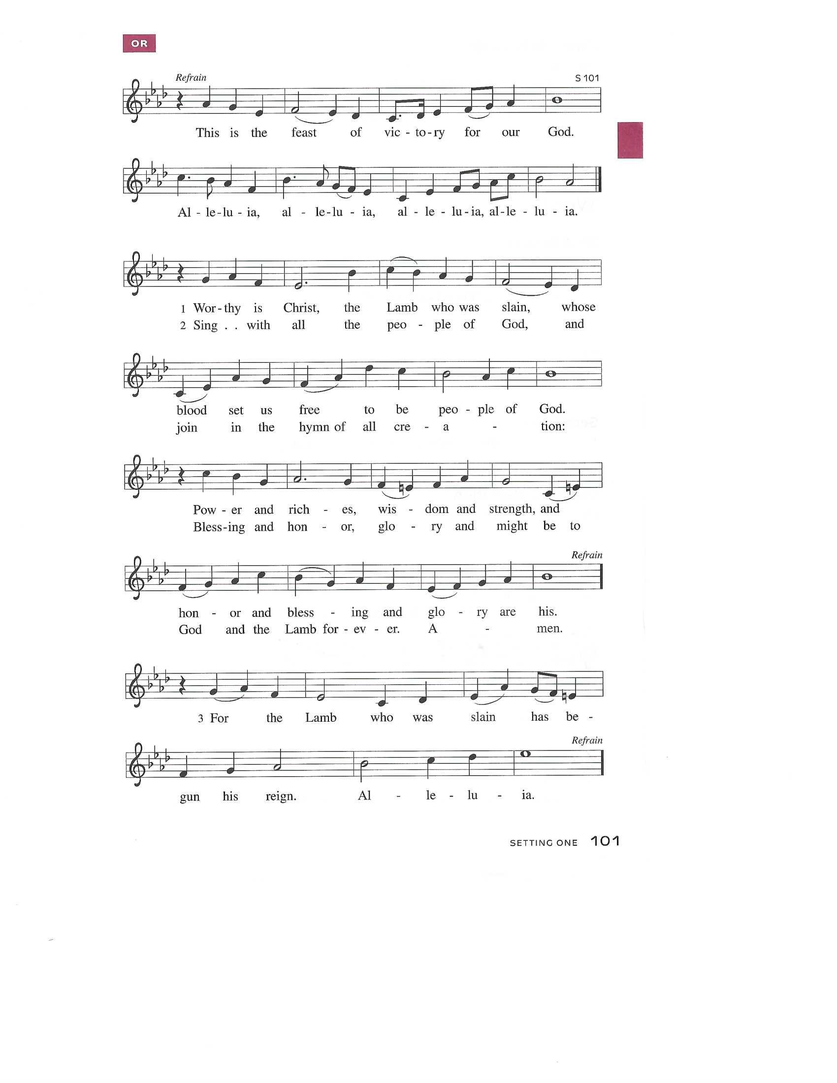

Prayer of the Day
P: O God of glory, your Son Jesus Christ suffered for us and ascended to your right hand. Unite us with Christ and each other in suffering and in joy, that all the world may be drawn into your bountiful presence, through Jesus Christ, our Savior and Lord, who lives and reigns with you and the Holy Spirit, one God, now and forever.
C: Amen!

Children’s Message

+WORD+

First First Reading: Acts 1:6-14
Today’s reading is part of the introduction to the narrative of the outpouring of the Spirit on Pentecost. These verses tell of the risen Lord’s conversation with his disciples on the eve of his ascension, in which he promises that they will receive the power of the Holy Spirit.

⁶ When [the apostles] had come together, they asked [Jesus], “Lord, is this the time when you will restore the kingdom to Israel?” ⁷ He replied, “It is not for you to know the times or periods that the Father has set by his own authority. ⁸ But you will receive power when the Holy Spirit has come upon you, and you will be my witnesses in Jerusalem, in all Judea and Samaria, and to the ends of the earth.” ⁹ When he had said this, as they were watching, he was lifted up, and a cloud took him out of their sight. ¹⁰ While he was going and they were gazing up toward heaven, suddenly two men in white robes stood by them. ¹¹ They said, “Men of Galilee, why do you stand looking up toward heaven? This Jesus, who has been taken up from you into heaven, will come in the same way as you saw him go into heaven.”
¹² Then they returned to Jerusalem from the mount called Olivet, which is near Jerusalem, a Sabbath day’s journey away. ¹³ When they had entered the city, they went to the room upstairs where they were staying: Peter, and John, and James, and Andrew, Philip and Thomas, Bartholomew and Matthew, James son of Alphaeus, and Simon the Zealot, and Judas son of James. ¹⁴ All these were constantly devoting themselves to prayer, together with certain women, including Mary the mother of Jesus, as well as his brothers.

Psalm: Psalm 68:1-10, 32-35
Sing to God, who rides upon the clouds. (Ps. 68:4)
¹ Let God arise, and let God’s ene- | mies be scattered;
let those who | hate God flee.
² As smoke is driven away, so you should drive | them away;
as the wax melts before the fire, so let the wicked perish at the pres- | ence of God.
³ But let the righteous be glad and rejoice | before God;
let them also be mer- | ry and joyful.
⁴ Sing to God, sing praises to God’s name; exalt the one who | rides the clouds;
I Am is that name, rejoice | before God!
⁵ In your holy habita- | tion, O God,
you are a father to orphans, defend- | er of widows;
⁶ you give the solitary a home and bring forth prisoners | into freedom;
but the rebels shall live in | desert places.
⁷ O God, when you went forth be- | fore your people,
when you marched | through the wilderness,
⁸ the earth quaked, and the skies poured down rain, at the presence of God, the | God of Sinai,
at the presence of God, the | God of Israel.
⁹ You sent a bountiful | rain, O God;
you restored your inheritance | when it languished.
¹⁰ Your people found their | home in it;
in your goodness, O God, you have made provision | for the poor. R
³² Sing to God, O kingdoms | of the earth;
sing praises | to the Lord.
³³ You ride in the heavens, O God, in the | ancient heavens;
you send forth your voice, your | mighty voice.
³⁴ Ascribe pow- | er to God,
whose majesty is over Israel; whose strength is | in the skies.
³⁵ How wonderful you are in your holy places, O | God of Israel,
giving strength and power to your people! | Blessed be God!

Second Reading: 1 Peter 4:12-14; 5:6-11
Our faith in Christ does not make us immune from the scorn of others. Nevertheless, we are to resist the designs of evil when we experience disparagement from others because we trust God’s grace will strengthen and guide us.

¹² Beloved, do not be surprised at the fiery ordeal that is taking place among you to test you, as though something strange were happening to you. ¹³ But rejoice insofar as you are sharing Christ’s sufferings, so that you may also be glad and shout for joy when his glory is revealed. ¹⁴ If you are reviled for the name of Christ, you are blessed, because the spirit of glory, which is the Spirit of God, is resting on you.
^{5:6} Humble yourselves, therefore, under the mighty hand of God, so that he may exalt you in due time. ⁷ Cast all your anxiety on him, because he cares for you. ⁸ Discipline yourselves; keep alert. Like a roaring lion your adversary the devil prowls around, looking for someone to devour. ⁹ Resist him, steadfast in your faith, for you know that your brothers and sisters in all the world are undergoing the same kinds of suffering. ¹⁰ And after you have suffered for a little while, the God of all grace, who has called you to his eternal glory in Christ, will himself restore, support, strengthen, and establish you. ¹¹ To him be the power forever and ever. Amen.

*Gospel Acclamation
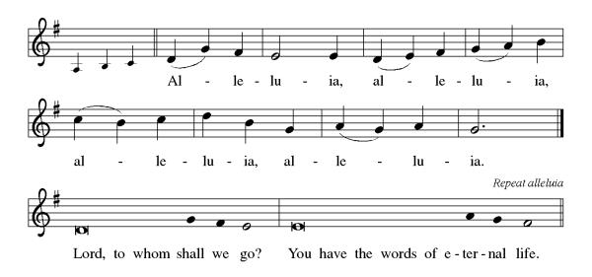

P: The Holy Gospel According to St. John 17th Chapter
C: Glory to You O Lord!

Gospel: John 17:1-11
On the night before his crucifixion, Jesus prays to his heavenly Father, asking that those who continue his work in this world will live in unity.

¹ After Jesus had spoken these words [to his disciples,] he looked up to heaven and said, “Father, the hour has come; glorify your Son so that the Son may glorify you, ² since you have given him authority over all people, to give eternal life to all whom you have given him. ³ And this is eternal life, that they may know you, the only true God, and Jesus Christ, whom you have sent. ⁴ I glorified you on earth by finishing the work that you gave me to do. ⁵ So now, Father, glorify me in your own presence with the glory that I had in your presence before the world existed.
⁶ “I have made your name known to those whom you gave me from the world. They were yours, and you gave them to me, and they have kept your word. ⁷ Now they know that everything you have given me is from you, ⁸ for the words that you gave to me I have given to them, and they have received them and know in truth that I came from you, and they have believed that you sent me. ⁹ I am asking on their behalf; I am not asking on behalf of the world but on behalf of those whom you gave me, because they are yours. ¹⁰ All mine are yours, and yours are mine, and I have been glorified in them. ¹¹ And now I am no longer in the world, but they are in the world, and I am coming to you. Holy Father, protect them in your name that you have given me, so that they may be one, as we are one.”

P: The Gospel of the Lord
C: Praise to you, O Christ!
Sermon
*Hymn of the Day ELW 383 Christ is Risen! Shout Hosanna!
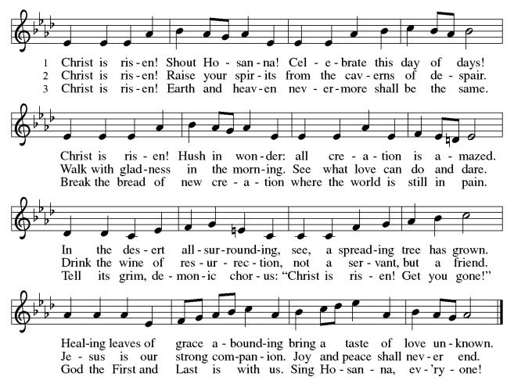
*Nicene Creed
We believe in one God,
the Father, the Almighty,
maker of heaven and earth,
of all that is, seen and unseen.
We believe in one Lord, Jesus Christ,
the only Son of God,
eternally begotten of the Father,
God from God, Light from Light,
true God from true God,
begotten, not made,
of one Being with the Father;
through him all things were made.
For us and for our salvation
he came down from heaven,
was incarnate of the Holy Spirit and the Virgin Mary
and became truly human.
For our sake he was crucified under Pontius Pilate;
he suffered death and was buried.
On the third day he rose again
in accordance with the Scriptures;
he ascended into heaven
and is seated at the right hand of the Father.
He will come again in glory to judge the living and the dead,
and his kingdom will have no end.
We believe in the Holy Spirit, the Lord, the giver of life,
who proceeds from the Father and the Son,
who with the Father and the Son is worshiped and glorified,
who has spoken through the prophets.
We believe in one holy catholic and apostolic church.
We acknowledge one baptism for the forgiveness of sins.
We look for the resurrection of the dead,
and the life of the world to come. Amen.

*Prayers of Intercession
Trusting in the power of Christ’s resurrection to heal and redeem our broken world, let us pray for the needs of all creation.
A brief silence.
O God, your people sing praises throughout the church. By your Holy Spirit, inspire musicians, deacons, pastors, and bishops to proclaim the gospel of Jesus. Merciful God,
C:receive our prayer.
Your creative power fills the universe. Bring favorable weather, nurture plants and animals, protect us from natural disasters, and guide us to care for all you have made. Merciful God,
C:receive our prayer.
Your justice is exercised in society by those in authority. Instill in political leaders, business leaders, school administrators, and all who care for others a desire for peace and equity. Merciful God,
C:receive our prayer.
Your compassion and care come through the gifts of medicine and relationships. Soothe the anxious, protect widows and orphans, comfort those living with memory loss and their families, and heal the sick (especially). Merciful God,
C:receive our prayer.
Your love radiates from communities gathered in your name. Bless those experiencing significant transitions in life such as graduation, retirement, new employment (other transitions may be named), and accompany us in our prayers during these times. Merciful God,
C:receive our prayer.
Here other intercessions may be offered.
O God, your promise of eternal life is certain and sure. Inspire us by the steadfast faith of those who have gone before us, so that we may be confident in the assurances you give. Merciful God,
C:receive our prayer.
God of resurrection power, use us and these prayers to proclaim the good news of new life to all the world, through Jesus Christ, our risen Savior.
C: Amen.

Greeting of Peace
P: The peace of Christ be with you always!
C: And also with you!

Offering (Thank you for your support for our ministry!)

*Doxology ELW 384 v.4 That Easter Day with Joy Was Bright (Please stand and join in singing as we share our gifts!)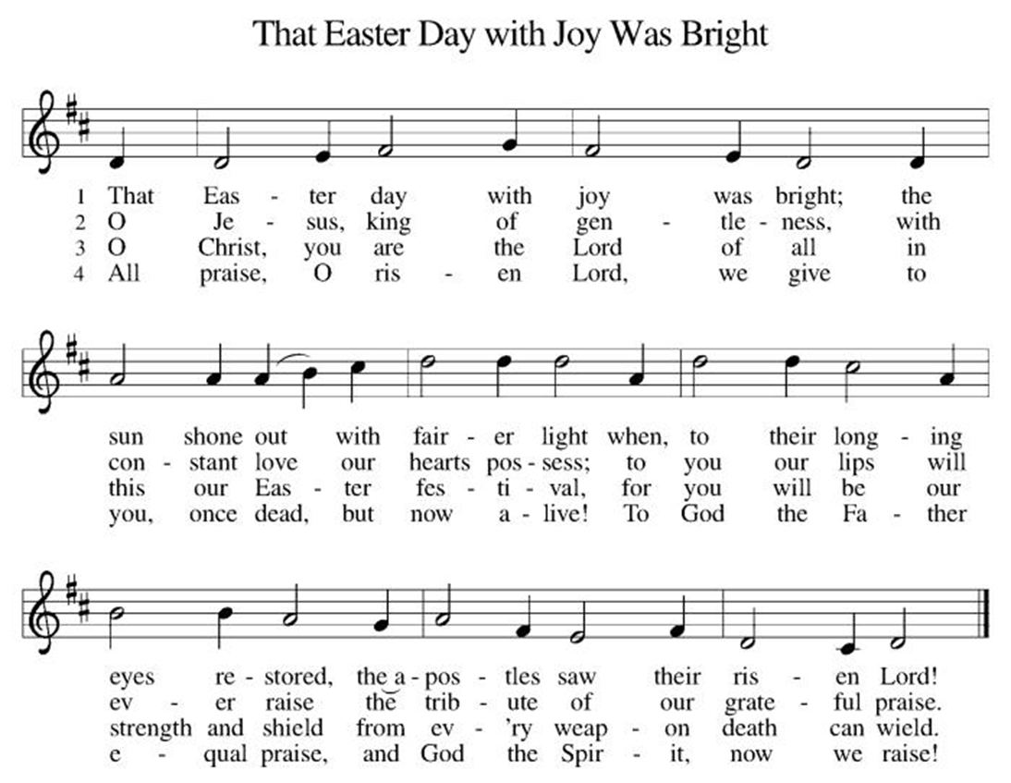

*Offering Prayer
A: Merciful God,
C: accept the fruits of our labor, gathered to give you glory.
You have set a table before us, a glimpse of that great day
when we will hunger and thirst no more.
Nourish us with the body and blood of Jesus,
that goodness and mercy may follow us
and bless the world you love.
In the name of Jesus,
Amen!

+MEAL+
*Great Thanksgiving
P: The Lord be with you.
C: And also with you.

P: Lift up your hearts.
C: We lift them to the Lord.

P: Let us give thanks to the Lord our God.
C: It is right to give our thanks and praise.

P: It is indeed right, our duty and our joy,
that we should at all times and in all places
give thanks and praise to you, almighty and merciful God,
for the glorious resurrection of our Savior Jesus Christ,
the true Paschal Lamb who gave himself to take away our sin;
who in dying has destroyed death,
and in rising has brought us to eternal life.
And so, with Mary Magdalene and Peter and all the witnesses of the resurrection, with earth and sea and all their creatures,
and with angels and archangels, cherubim and seraphim,
we praise your name and join their unending hymn:

*Sanctus
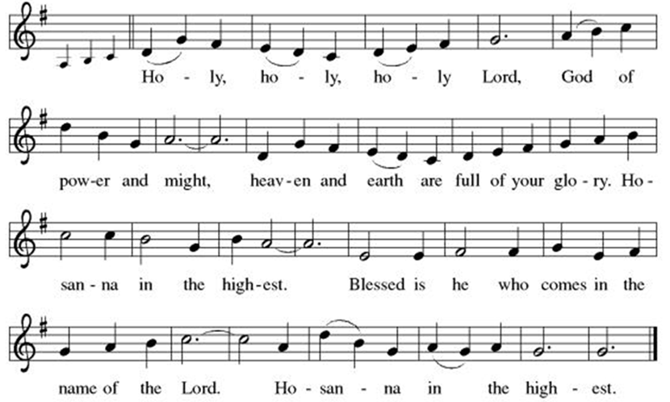

*Eucharistic Prayer
P: Holy, mighty, and merciful Lord,
heaven and earth are full of your glory.

In great love you sent to us Jesus, your Son,
who reached out to heal the sick and suffering,
who preached good news to the poor,
and who, on the cross, opened his arms to all.

In the night in which he was betrayed,
our Lord Jesus took bread, and gave thanks;
broke it, and gave it to his disciples, saying:
Take and eat; this is my body, given for you.
Do this for the remembrance of me.

Again, after supper, he took the cup, gave thanks,
and gave it for all to drink, saying:
This cup is the new covenant in my blood,
shed for you and for all people for the forgiveness of sin.
Do this for the remembrance of me.

Remembering, therefore, his death, resurrection, and ascension,
we await his coming in glory.

Pour out upon us the Spirit of your love, O Lord,
and unite the wills of all who share this heavenly food,
the body and blood of Jesus Christ, our Lord;
to whom, with you and the Holy Spirit,
be all honor and glory, now and forever.

C: Amen!

*THE LORD’S PRAYER
Our Father, who art in heaven,
hallowed be thy name,
thy kingdom come,
thy will be done,
on earth as it is in heaven.
Give us this day our daily bread;
and forgive us our trespasses,
as we forgive those
who trespass against us;
and lead us not into temptation,
but deliver us from evil.
For thine is the kingdom,
and the power, and the glory,
forever and ever. Amen.
*Lamb of God
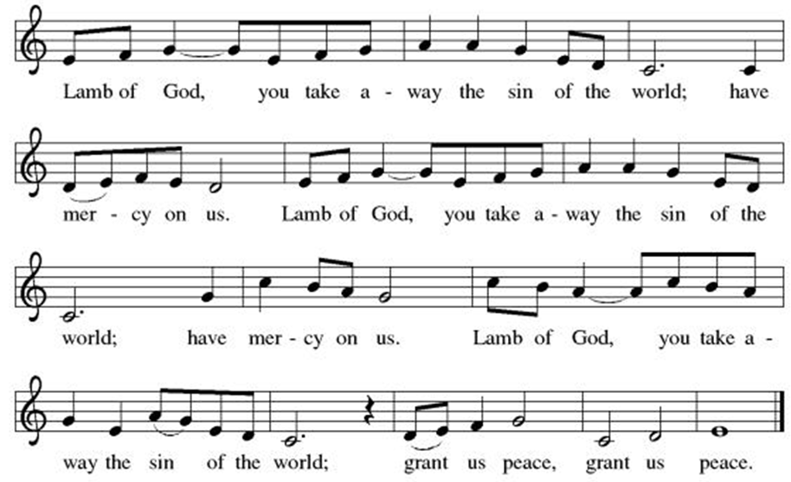

Spiritual Communion Prayer
P: Let us pray for the communion of all present here, those viewing our service virtually, those in our hearts and in our world.
C: Lord Jesus, I believe you are truly present in the Sacrament of Holy Communion. When I cannot receive Communion, I pray that you come into my heart. I know that nothing in Heaven or on earth can separate me from your love. Amen.

Invitation to Communion
P: Come to the table of new life.
Receive the risen Lord.

C: Thanks be to God!
(All are invited to the communion rail following the guidance of the ushers. Communion will be shared through the host and individual cups. If you would like communion but are unable to join us at the rail, please alert the usher!)

Communion Hymns (Please join in singing!)
ELW 496 One Bread, One Body
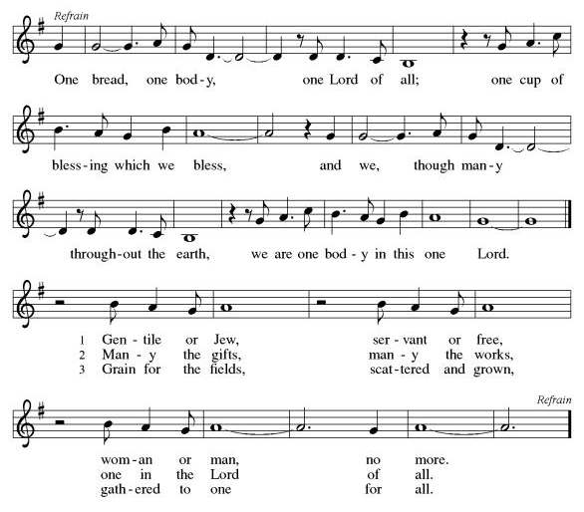

ELW 376 Thine Is the Glory 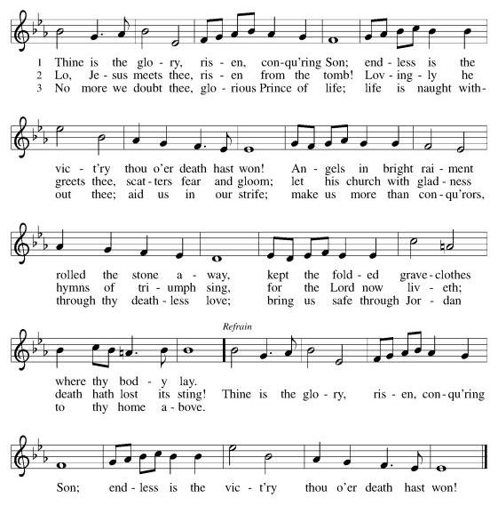

P: The body and blood of our Lord Jesus Christ strengthen you and keep you in his grace. C: Amen!

*Prayer after Communion
A: Holy One,
through this meal you have made your home among us
and are making all things new.
Send us now to speak peace to anxious hearts,
to love our enemies,
and to bring your healing to the nations.
In the name of Jesus,
C: Amen.
+Sending+

*Blessing
P: God Almighty, who is the beginning and the end,
Jesus Christ, the firstborn of the dead,
and the Spirit, our advocate and peace,
☩ bless you now and forever.
C: Amen!
*Sending Hymn TFF 159 Take the Name of Jesus with You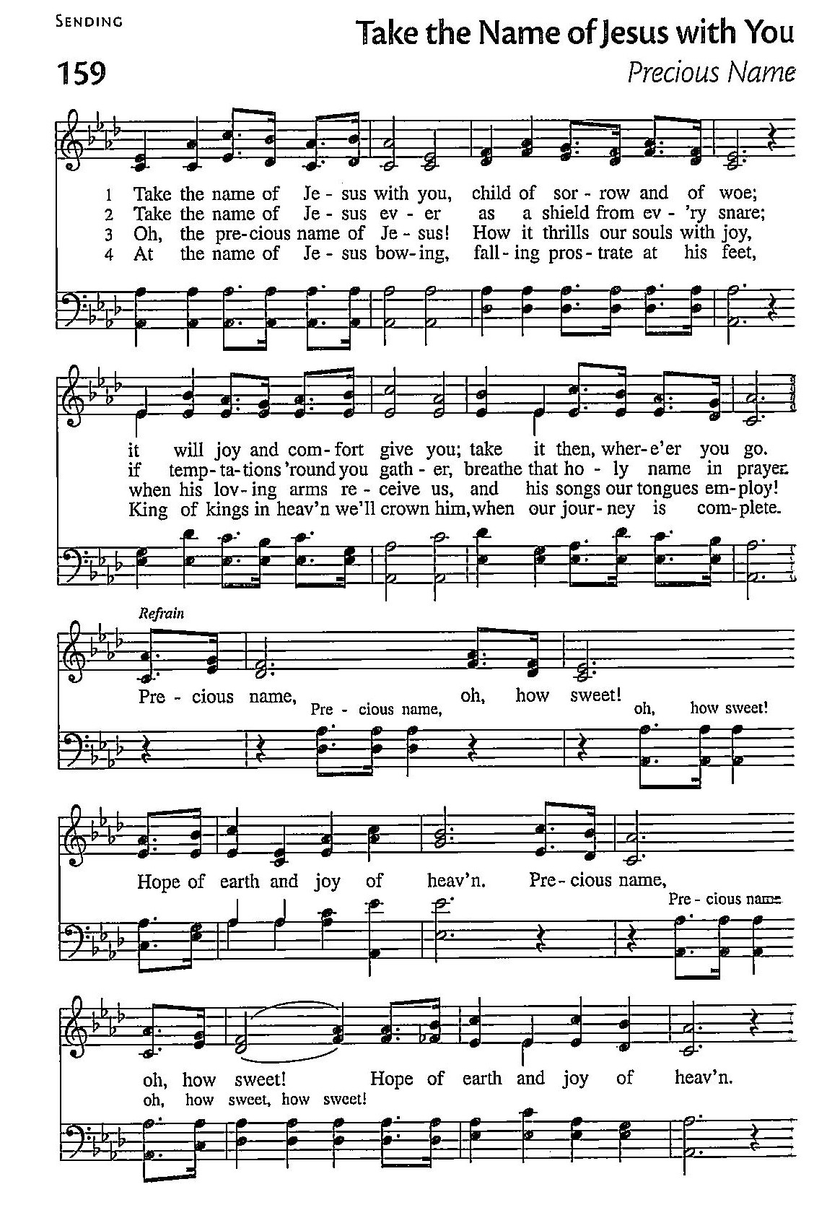
*Dismissal
A: Go in peace. Praise the Lord. Alleluia!
C: Thanks be to God. Alleluia!
Postlude

Copyright © 2020 Augsburg Fortress. All rights reserved. Reprinted by permission under Augsburg Fortress Liturgies Annual License #SB106907. New Revised Standard Version Bible, Copyright © 1989, Division of Christian Education of the National Council of the Churches of Christ in the United States of America. Used by permission. All rights reserved. Revised Common Lectionary, Copyright © 1992 Consultation on Common Texts, admin Augsburg Fortress. Used by permission.
Treasurer’s Report


HTLC remains in a strong financial position, with giving through April reaching 45% of our annual operating goal while only 33% of the year has passed. As support grows for the Mortgage Freedom Campaign, continued regular operating giving will remain important to sustain the ongoing ministries and mission of the congregation.

Worship Volunteer Schedule
Date | Asst. Min | Usher | Sacristan | Lector | Counter
May 3 | Keith Bennett | Kathy Caputo | Sherry Lee | Bill Spreen | Socha/Cheek
May 10 | Keith Bennett | Dan Grillon | Helga Britton | Cynthia Kazmac | Carleo/Spreen
May 17 | Chris Foard | Jill Socha | Nancy Poole | Molly Foard | Foss/Foard
May 24 | Charlie Rugg | Andy Wehr/Dan Grillon | Pat Pienkos | Rosemary Lane | Bradford/Coleman
May 31 | Linda Coleman | Keith Bennett | Joanne Giordano | Emily Kaster | Socha/Bohner

Coffee Hour- Pot Luck
Altar Flowers In memory of Rober Coppotelli, Lisa Lynch

ANNOUNCEMENTS Thank you! To all who consistently support our church and ministries through your time, talent, and treasure. Please help us grow by inviting your friends and family to worship and events. You are what makes Holy Trinity a wonderful church family!

Stay in touch! Please visit our church website, www.htlcredbank.org for updates and information. You can also find us on Facebook and view services online. The office is open from 9am to 2pm, Monday to Thursday.

NEW DATE!! Car Wash-JUNE 14th The car wash will start at 10 AM with churchgoers cars washed first, then will open up to the general public from noon till 2:00 PM. We will need volunteers to wash the cars, dry cars, manage supplies and supervise. Please sign up in the Red Book. Contact Lauren Bennett with questions period proceeds will support Cross Roads Day Camp.

100 Anniversary Committee- Meeting Sunday, May 17.Please bring your ideas to that meeting and if you are unable to attend, share your thoughts by e-mail or in conversation. We will form better channels of communication as we move forward.

Interested in becoming an usher? Would you like to be a substitute if needed? Or maybe you need to brush up on your skills? Dan Grillon will be leading an Usher Training/Refresher class Sunday, May 24, after worship service. Sign up below, all are welcome!

Name Tag Sundays: On the first Sunday of each month, names tags and markers will be at each entrance of the sanctuary. Please fill out a tag and wear one for worship and for coffee hour to welcome visitors and help newcomers put names to faces.

Sunday School in the New Year, we will continue to study stories and lessons from the Old Testament beginning with Jacob. Kids will love the crafts, songs and games that accompany each lesson.
The following dates there will be Sunday School:
April- 12 and 26, May- 3, 17 and 31, June- 7 and 14
As was done in the fall, there will be opportunities to volunteer as SS lead teacher. A signup will be emailed out shortly and will also be posted in the red binder. Consider signing up! All lesson materials will be supplied and laid out and a leader guide will be emailed to volunteers approximately 1 week in advance. Blessings for a wonderful 2026!~Lauren

Choir The Holy Trinity Choir welcomes our singers back for a preparation rehearsal on Sunday, September 7th at 9am in the church hall. All are welcome to join us in song as often as you are able. Choir meets each Sunday at 9am to practice and prepare our music. Join us and help us grow by spreading the word about the HTLC Choir!

Quilting- The Quilters need gently used any bed sheets of any size! Please leave any donations in the quilters closet in Fellowship Hall. Thank you!

Quilters Need Help
If anyone is traveling through Mechanicsville, PA (near Peddler’s Village), and can add a few extra minutes to your trip, the warehouse for shipping quilts, school kits, etc. is located directly off one of the exits. We accumulate many quilts throughout the year, and we would appreciate sending some quilts with you to deliver. Any questions, please call Sherry Lee or Elaine Theophall.

Weekly Quilting on Wednesdays at 9:30. Bring your lunch and enjoy some fellowship at noon. All are welcome.

Holy Trinity Blanket Sunday – Mother’s Day May 10,2026 –
In the midst of crisis, faith guides a loving response. That’s how the CWS Blanket program started.
Please place your donation payable to “Holy Trinity Evangelical Lutheran Church” in the CWS envelope provided in the bulletin and return it to church. If you are doing eGiving, please select “WELCA Appeal” for the purpose of your gift. Thank you.

Social Ministry
*Year-round collections will continue for food items for Lunch Break. There is a sign-up sheet in the red book for those who can help drop these items to Lunch Break.
*We will also collect adult men's socks to periodically drop at the Red Bank Warming Center.
*For those interested in the Heartwarming Center — the new women's shelter is adjacent to the First Baptist Church of Red Bank at 90 Maple Ave. You can follow up on this mission through their website - https://www.thefeastnj.org- On this site, they also include wish list items that can be purchased through amazon. We will be exploring purchasing some of these through a Thrivent card. If you want to purchase on your own, you can leave items at church, and the Social Ministry will deliver them.

Pastoral Care and Prayer... We are here to care for and pray! Please contact the office to add or adjust prayer requests. If you or someone you know needs pastoral care, please contact the office and Pastor Mack!

THANK YOU for supporting and sustaining our church and ministries! All are welcome here! Please invite your family and friends to worship with us! Find us online at www.htlcredbank.org

Please wear red on May 24th for the Day of Pentecost.


Every gift matched up to 2-to-1
$25K + Synod Match → Mortgage Paid Off
Progress: ███████████░░░░░░░░░
$13,813 of $25,000 (55%)
Scan to Give

Use Designated Envelopes
Use Any Envelope and note: “Mortgage Freedom”

