This Week at PPBC
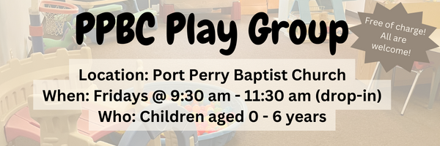
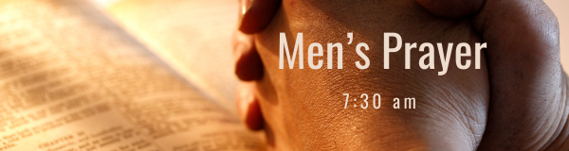



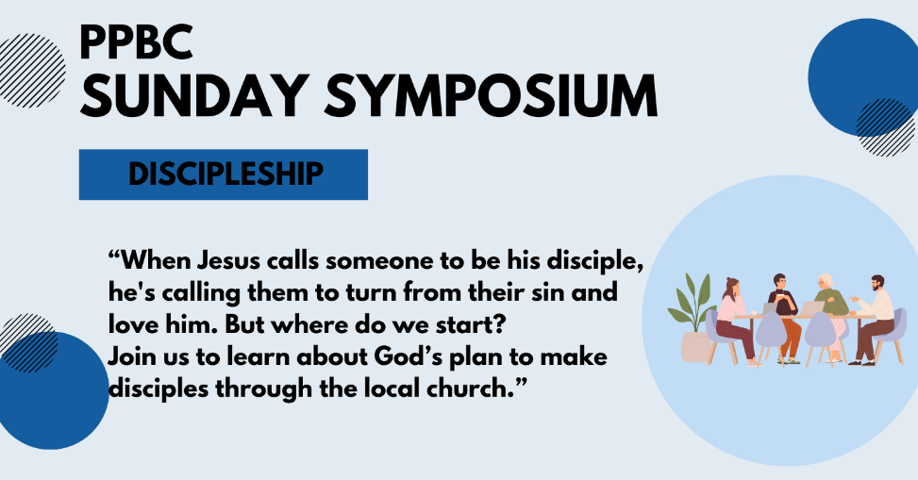
May 24, 2026
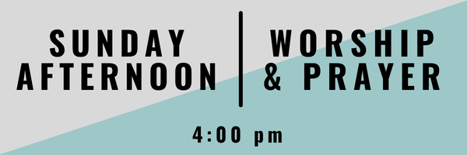
Join us Sunday, May 31st for a time of worship & prayer

May 31st, 2026


June 13, 2026
Sunday, June 7th, 2026 @ noon
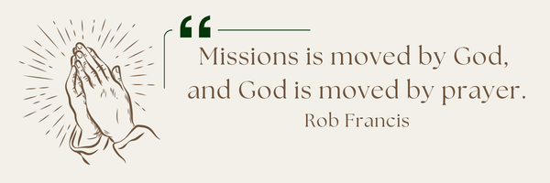
A Prayer Request from AOJ: Continue to pray for Brock Heard, Mission Director, as he leads the mission faithfully and diligently. AOJ has 8 mission teams scheduled for this year, 2026. Pray for the teams that are serving, for their safety, health, and unity, and that God would use each one in mighty ways to advance His Kingdom through both their work and their witness.

Sunday Ministry Schedules
Below are ministry schedules for Nursery, Jr. Church, Greeters, Ushers, and Sound & Video:
Nursery
May 17: Kathryn denOuden, Brantley Colwell
May 24: Jan Gerrow, Alyssa Summers
Infant Nursery
May 17: Lisa Dallas, Amber Saunders
May 24: Karen Clemens, Rosalie McLaren
Jr. Church; ages 3 to grade 1
May 17: Christine McLaren, Kelsey Schoenrock
May 24: Deb Brown, Hailey Ferguson
Jr. Church; Grades 2 to 6
May 17: Gregg & Karen Anderson, Tiffany Green
May 24: Miriam Bolsonello, Jen Owens
Greeters
May 17: Steve & Wendy Angrove
May 24: Roy & Elizabeth Werner
Ushers
May 17: Eric Duchesne, Nick Woytowich
May 24: Leno Araujo, Mark McLaren
Sound & Video
May 17: Sound: Wyatt Werner | Video: Josh Myers
May 24: Sound: Eric Duchesne | Video: William Conley

Sunday Service
Welcome
Song – Guide Me O Thou Great Jehovah
Scripture
Song – In the Valley
Song – It Is Well With My Soul
Scripture
Song – Holy Spirit
Prayer
Message – Pastor Jim Clemens
Song – Christ Our Hope in Life and Death

Praise & Prayer Highlights
PRAY for our Soccer Outreach continuing this Wednesday. PRAY for the Volunteers as they demonstrate the gospel to the children & their families. PRAY that hearts would be open and respond to the gospel.
PRAY for Darren & Brooke VanUden. Brooke will be induced on Monday morning. PRAY for a safe and healthy delivery for both mom and baby.
PRAY for Martin & Tina McCurley and their ongoing health concerns.
PRAY for Laurie Buismans sister Debbie and their family. PRAISE that Debbie has been discharged from Hospital and transferred to long term care. Thank you for your ongoing prayers for Laurie and her sister.
PRAY for Jess & Grayson as they prepare for their wedding and marriage this Saturday, May 16th. PRAY for Gods wisdom and grace as they start a life together.
PRAY for David Bengel as he continues to recover after a stroke. PRAY for his healing as he prepares to go back to work soon.
PRAY for the 10 small groups that meet each week. PRAY for the spiritual growth and discipleship in these groups.
PRAY for Scott & Catherine Willison's great nephew River and his ongoing health concerns. PRAY for his parents, Kylie and Jordi Stewart and the entire family as they trust God during this time.
Giving
Just as a reminder, there are several ways you can give:
In Person using the offering box located on the back wall of the sanctuary. Donation envelopes are available at the Welcome Centre. Please contact the church office if you would like a box of donation envelopes (office@portperrybaptist.ca)
Through your online banking, you may send electronic transfers to ppbcdonations@gmail.com.
You can also give through Canada Helps. Donation receipts will be provided by Canada Helps, and transaction fees apply.
***********************************************************************
Weekly Newsletter
The PPBC Newsletter is emailed to the church family every Friday. If you would like to be added to the weekly email list, please contact the office by phone: 905-985-8681 or by email: office@portperrybaptist.ca.
*****************************************************************
Church Information:
Location:
2210 Hwy 7A
Port Perry, ON
L9L 1B4
Office Hours:
Monday: 8:30am – 4:00pm
Tuesday: 8:30am – 4:00pm
Wednesday: Closed
Thursday: 8:30am – 4:00pm
Friday: 8:30 am - 3:00 pm
Contact:
Phone: 905.985.8681
Email: office@portperrybaptist.ca
Website: www.portperrybaptist.ca
Staff:
Sr. Pastor – Rev. Jim Clemens
Administrative Assistant – Madeline Werner
Family Ministries Director – Josh Anderson
Pastoral Intern – Scott McKenzie

PPBC Newsletter
Sunday, May 17, 2026


Sunday Starting Point
Sunday, May 17, 2026 - 9:30 am
“Beginning the day with the Word and prayer”
Adults:
Adults will meet in the sanctuary for a time of study and prayer.
Youth:
Jr High (Grades 7-8) will meet in room 18 with Kate Anderson to study Thessalonians.
Children:
Children ages 3 - grade 6 will meet in room 26.
(Please note nursery is unavailable during Starting Point)
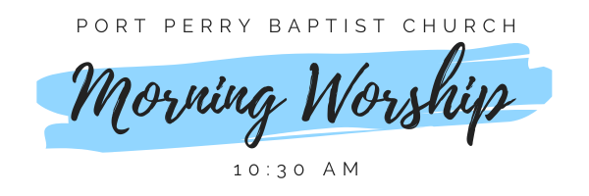Sunday Morning Worship
Sunday, May 17, 2026 - 10:30 am
We are meeting in the sanctuary and will continue to live-stream for those who are unable to attend.
Message: Marriage in a Fallen World Part 1
Scripture: 1 Corinthians 7:10-11
Pastor Jim Clemens

