Parkside Lutheran Church
Rediscovering the Radical Love of Jesus
Gathering All
Serving All
Caring For All

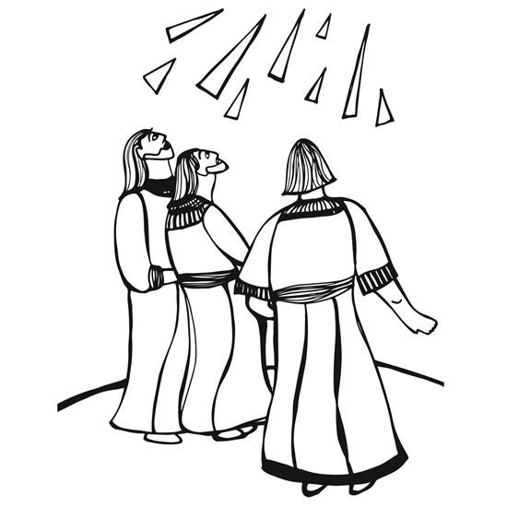

May 17th, 2026
Ascension Sunday
Holy Communion 10:00am
Rev. Jeremiah Smith
Parkside Lutheran Values

Proclaiming Grace - Jesus shared and lived out a message of grace, love, and new life. We believe these promises come from God freely, as a gift for all. We are loved and the Spirit inspires us to share this good news in accessible, relevant, and new ways. Luke 4:17-19, John 1:16-17, John 3:16-17, Ephesians 2:8-9

Practicing Hospitality – Jesus welcomed the little children, broke bread with outcasts, and proclaimed the Good News to all. Whether you are strong in faith, wrestling with doubt, or somewhere in between, we affirm that you are welcome here. Jesus is for everyone. Leviticus 19:34, Matthew 9:10, Matthew 19:14, Hebrews 13:2

Loving Boldly - Jesus challenged traditions to demonstrate God’s justice and love of neighbor. His compassionate and sacrificial love inspires us to take risks. Striving to follow his command to love neighbor, our ministries serve, transform, and advocate for folks near and far. Micah 6:8, Mark 11:15-17, Luke 10:25-28, John 15:12-13

Cultivating Community - Jesus built communities that transformed lives. We are the body of Christ and we are called to continue this ministry of transformation. Guided by the Holy Spirit, we build connections within and outside of these walls, and with all of God’s creation. Ecclesiastes 4:9-12, Matthew 28:16-20, 1 Corinthians 12:12-14, Galatians 3:26-29

Welcome Visitors!
Please use QR code to let us know you were here today or to sign up for our weekly enewsletter. Find us on Facebook & Instagram
WIFI: Balcony password: FreeGrace

For your safety in the event of an emergency: In addition to the three exits in the back of the sanctuary, there are exits on either side of the altar (on left side: floor level near piano and up steps past altar. On right side: up steps to the altar, past band area)

Contact us: (716) 836-1361
2 Wallace Ave. Buffalo, NY 14214
parksidelutheran.org | parksidelutheran@gmail.com

GATHER
The Holy Spirit calls us together as the people of God.

Introduction to the Day: In today’s readings the risen Christ ascends into heaven and his followers are assured that the Spirit will empower them to be witnesses throughout the earth. The disciples were told not to gaze up into heaven to look for Jesus (Acts 1:11); we find his presence among us as we proclaim the word and share the Easter feast. We too long for the Spirit to enliven our faith and invigorate our mission.

Prelude Michael Hooker, Music Director

Call to Worship Please stand as you are able
WA: You have heard what was written about Jesus in Scripture—
C: how he would suffer and die and then rise from the dead on the third day;
WA: how the same power that raised Jesus from the dead raised Him to heaven and seated Him at the right hand of God, where he now lives to intercede on our behalf.
C: So let us come before God with confidence, through the loving intercession of our risen Lord, Jesus Christ!

+Gathering Hymn: A Hymn of Glory Let Us Sing ELW #393
(printed next page)

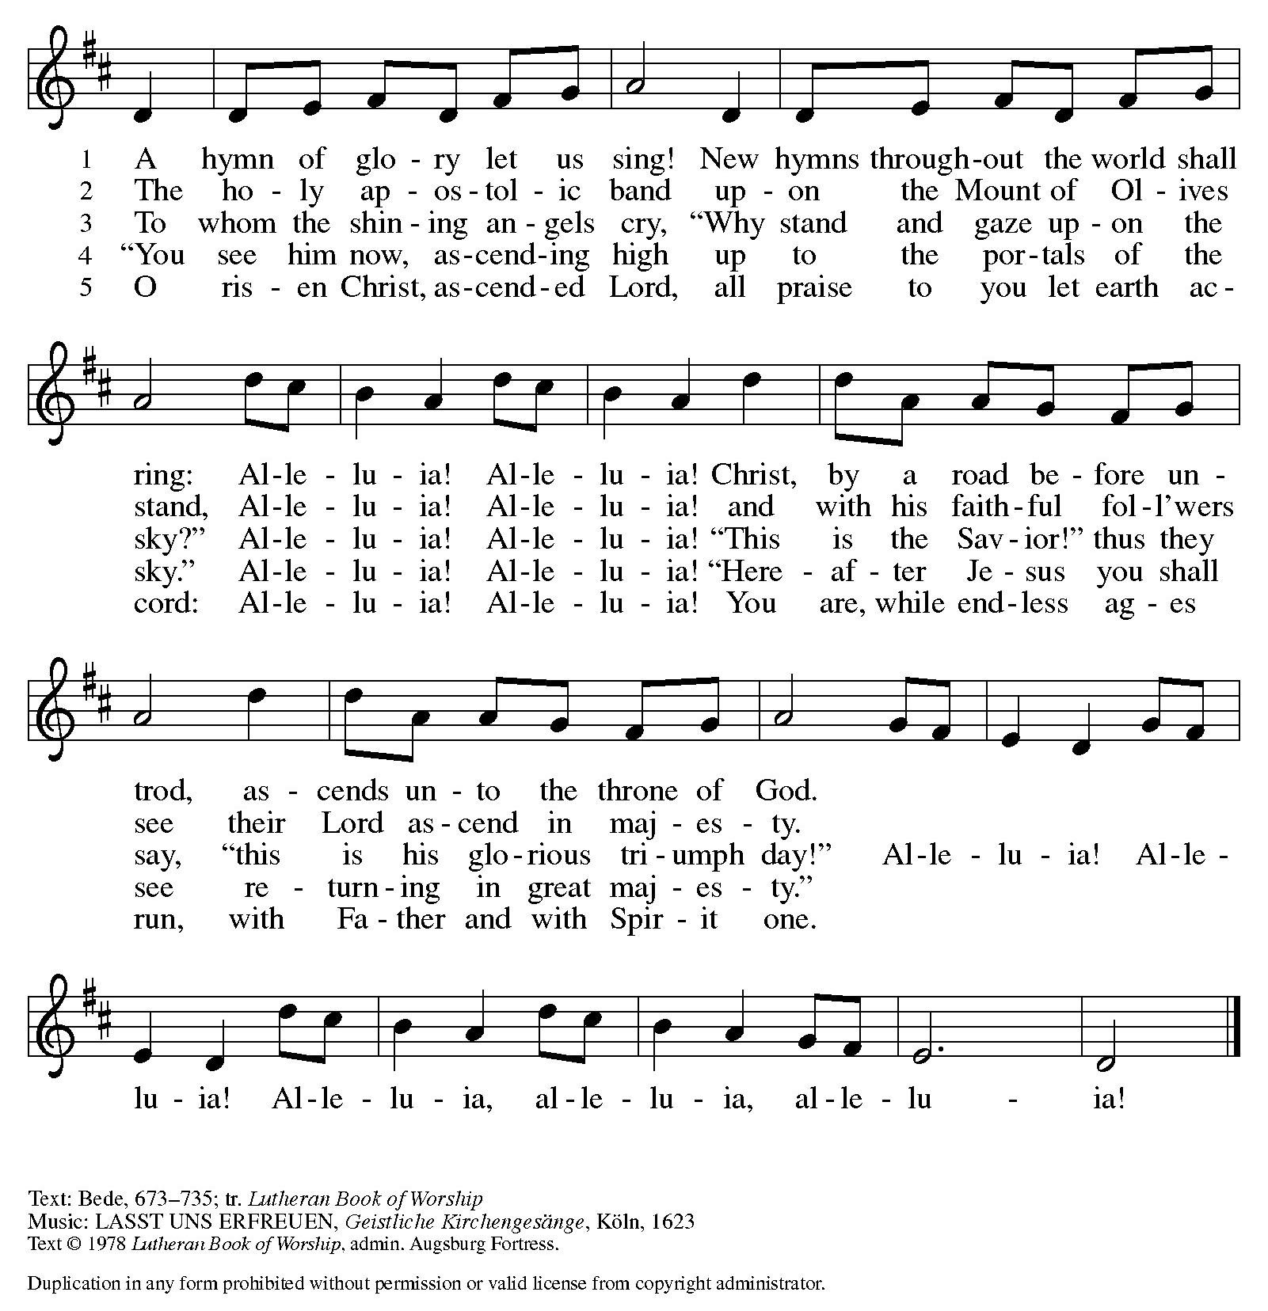

Welcome and Announcements

Thanksgiving for Baptism
P: Alleluia! Christ is risen.
C: Christ is risen indeed. Alleluia!
P: Salvation belongs to our God who is seated on the throne and to the Lamb!
C: Amen.
P: Let us give thanks for the gifts of baptism.
Water may be poured into the font as the presiding minister continues.
P: Merciful God, you are the one who was, who is, and who is to come. You lead us beside still waters. We thank you for the waters of creation: morning dew, gentle rain, roaring waves. We thank you for the waters that nourish us.
Blessed are you.
C: You guide us to springs of the water of life.
P: Jesus Christ, you are the faithful witness who accompanies us on our journeys.
We give you thanks for your life-giving death and resurrection. We praise you for joining us in joy and sorrow. Blessed are you.
C: You guide us to springs of the water of life.
P: Holy Spirit, you anoint our head with oil and our cup overflows. Break down barriers that divide us. Fill us with the breath of peace. Blessed are you.
C: You guide us to springs of the water of life.
P: Holy One, we thank you for the gifts and grace of baptism, and for making us a new creation. We join with saints and angels, giving you honor and praise,
now and forever.
C: Amen.

Greeting

WA: The grace of our Lord, Jesus Christ, the love of God, and the communion of the Holy Spirit be with you all. C: And also with you.

Canticle of Praise ELW p. 149
(printed next page)

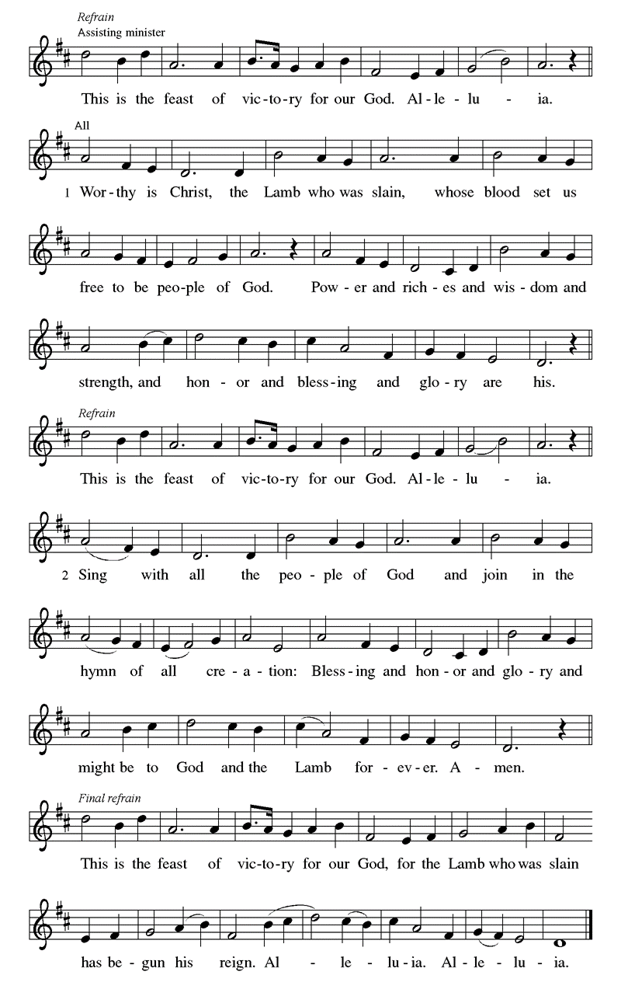
Prayer of the Day
WA: Let us pray together.
C: Almighty God, your blessed Son, our Savior Jesus Christ, ascended far above all heavens that he might fill all things. Mercifully give us faith to trust that, as he promised, he abides with us on earth to the end of time, who lives and reigns with you and the Holy Spirit, one God, now and forever. Amen.

Children’s Sermon: Jesus said, “Let the little children come to me!”
We welcome children in worship.

WORD
God speaks to us in scripture readings, preaching and song.

First Reading: Acts 1:1-11 Before he is lifted into heaven, Jesus promises that the missionary work of the disciples will spread out from Jerusalem to all the world, and that the disciples will be accompanied and empowered by the Holy Spirit. His words provide an outline of the book of Acts. L: [Luke writes:] ¹ In the first book, Theophilus, I wrote about all that Jesus began to do and teach ² until the day when he was taken up to heaven, after giving instructions through the Holy Spirit to the apostles whom he had chosen. ³ After his suffering he presented himself alive to them by many convincing proofs, appearing to them during forty days and speaking about the kingdom of God. ⁴ While staying with them, he ordered them not to leave Jerusalem but to wait there for the promise of the Father. “This,” he said, “is what you have heard from me; ⁵ for John baptized with water, but you will be baptized with the Holy Spirit not many days from now.”
⁶ So when they had come together, they asked him, “Lord, is this the time when you will restore the kingdom to Israel?” ⁷ He replied, “It is not for you to know the times or periods that the Father has set by his own authority. ⁸ But you will receive power when the Holy Spirit has come upon you, and you will be my witnesses in Jerusalem, in all Judea and Samaria, and to the ends of the earth.” ⁹ When he had said this, as they were watching, he was lifted up, and a cloud took him out of their sight. ¹⁰ While he was going and they were gazing up toward heaven, suddenly two men in white robes stood by them. ¹¹ They said, “Men of Galilee, why do you stand looking up toward heaven? This Jesus, who has been taken up from you into heaven, will come in the same way as you saw him go into heaven.” L: Word of God, word of life. C: Thanks be to God.

Psalm: Psalm 47 God has gone up with a shout. (Ps 47:5)
L: ¹ Clap your hands, all you peoples; shout to God with a joyful sound.
C: ² For the Lord Most High is to be feared: a great king over all the earth,
L: ³ who subdues the peoples under us, and the nations under our feet;
C: ⁴ who chooses our inheritance for us,
the pride of Jacob, whom God loves.
L: ⁵ God has gone up with a shout,
the Lord with the sound of the ram’s horn.
C: ⁶ Sing praises to God, sing praises;
sing praises to our king, sing praises.
L: ⁷ For God is king of all the earth; sing praises with a song.
C: ⁸ God reigns over the nations; God is enthroned on high.
L: ⁹ The nobles of the peoples have gathered as the people of the God of Abraham.
The rulers of the earth belong to God, who is highly exalted. L: Word of God, word of life. C: Thanks be to God.

Second Reading: Ephesians 1:15-23
The risen and exalted Christ reigns over the entire universe. The author of Ephesians prays that we are given the wisdom to know the power of the risen Christ and the empowering hope that the knowledge of this inheritance provides.
L: ¹⁵ I have heard of your faith in the Lord Jesus and your love toward all the saints, and for this reason ¹⁶ I do not cease to give thanks for you as I remember you in my prayers, ¹⁷ that the God of our Lord Jesus Christ, the Father of glory, may give you a spirit of wisdom and revelation as you come to know him, ¹⁸ so that, with the eyes of your heart enlightened, you may perceive what is the hope to which he has called you, what are the riches of his glorious inheritance among the saints, ¹⁹ and what is the immeasurable greatness of his power for us who believe, according to the working of his great power. ²⁰ God put this power to work in Christ when he raised him from the dead and seated him at his right hand in the heavenly places, ²¹ far above all rule and authority and power and dominion and above every name that is named, not only in this age but also in the age to come. ²² And he has put all things under his feet and has made him the head over all things for the church, ²³ which is his body, the fullness of him who fills all in all.
L: Word of God, word of life. C: Thanks be to God

Please stand as you are able

Gospel Acclamation ELW #174
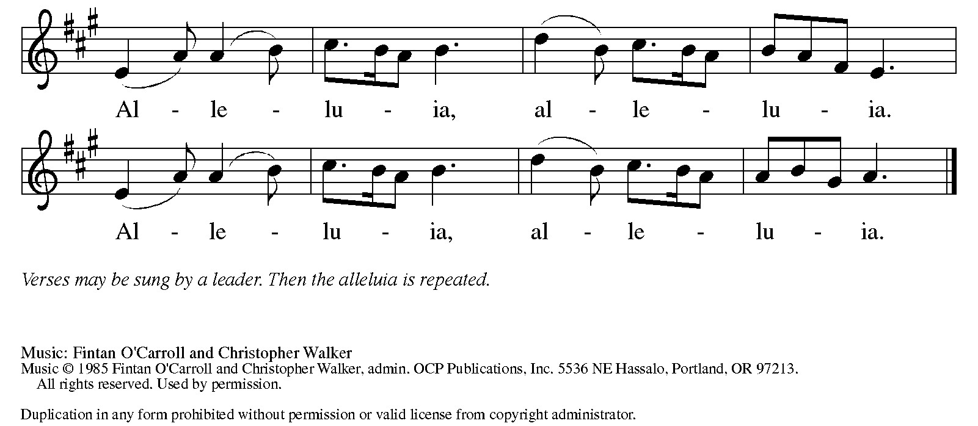

Gospel Reading: Luke 24:44-53
On this day of his ascension, Jesus leaves his disciples with a commission, a blessing, and a promise of the Holy Spirit.

P: The Holy Gospel according to Luke. C: Glory to you, O Lord.
P: ⁴⁴ [Jesus said to the eleven and those with them,] “These are my words that I spoke to you while I was still with you—that everything written about me in the law of Moses, the prophets, and the psalms must be fulfilled.”⁴⁵ Then he opened their minds to understand the scriptures, ⁴⁶ and he said to them, “Thus it is written, that the Messiah is to suffer and to rise from the dead on the third day ⁴⁷ and that repentance and forgiveness of sins is to be proclaimed in his name to all nations, beginning from Jerusalem. ⁴⁸ You are witnesses of these things. ⁴⁹ And see, I am sending upon you what my Father promised, so stay here in the city until you have been clothed with power from on high.”
⁵⁰ Then he led them out as far as Bethany, and, lifting up his hands, he blessed them. ⁵¹ While he was blessing them, he withdrew from them and was carried up into heaven. ⁵² And they worshiped him and returned to Jerusalem with great joy, ⁵³ and they were continually in the temple blessing God.
P: The Gospel of the Lord. C: Praise to you, O Christ.

Sermon Rev. Jeremiah Smith

Please stand as you are able

+Hymn of the Day: Rejoice for Christ is King ELW #430
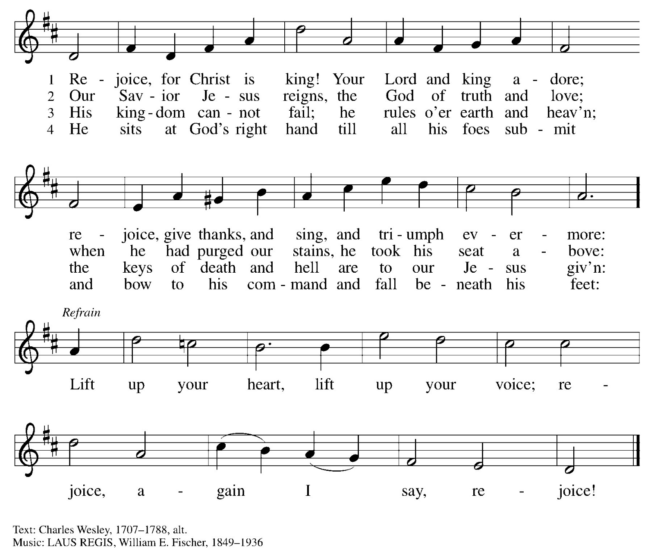

Nicene Creed WA: Let us confess the faith using the words of the Nicene Creed.
C: We believe in one God, the Father, the Almighty, maker of heaven and earth, of all that is, seen and unseen.
We believe in one Lord, Jesus Christ, the only Son of God, eternally begotten of the Father, God from God, Light from Light,
true God from true God, begotten, not made, of one Being with the Father; through him all things were made. For us and for our salvation he came down from heaven, was incarnate of the Holy Spirit and the virgin Mary and became truly human. For our sake he was crucified under Pontius Pilate; he suffered death and was buried. On the third day he rose again in accordance with the scriptures; he ascended into heaven and is seated at the right hand of the Father. He will come again in glory to judge the living and the dead, and his kingdom will have no end.
We believe in the Holy Spirit, the Lord, the giver of life, who proceeds from the Father and the Son, who with the Father and the Son is worshiped and glorified, who has spoken through the prophets. We believe in one holy catholic and apostolic church. We acknowledge one baptism for the forgiveness of sins. We look for the resurrection of the dead, and the life of the world to come. Amen.

Prayers of the People WA: Trusting in the power of Christ’s resurrection to heal and redeem our broken world, let us pray for the needs of all creation. (a brief silence)
WA: Source of all grace, your Son Jesus ascended to fill all time and space and is present with all people. By your Holy Spirit, lead your church and its leaders in faith, hope, and love, and in sharing the presence of Christ. Merciful God, C: receive our prayer.
WA: Source of all peace, your Son Jesus sits at your right hand and rules the cosmos. Inspire national and local politicians to lead with equity and fairness, raise up advocates and activists for those seeking justice, and cultivate peace throughout the world. Merciful God, C: receive our prayer.
WA: Source of all mercy, your Son Jesus carries with him the scars of suffering as our wounded healer. Guide with your wisdom the work of surgeons, pharmacists, midwives, and all medical specialists and bring your healing touch to all who are sick. Hold all in any need in your loving hands. We pray especially for those we name aloud or in the silence of our hearts…. Merciful God,
C: receive our prayer.

WA: Source of all love, your Son Jesus reveals the depths of you love and gathers all people to himself. Accompany us in our work and play to make your presence known in all that we do. Merciful God, C: receive our prayer.

WA: Source of all life, by his death and resurrection, your Son Jesus destroyed death forever. With thanksgiving we remember those who rest from their labors, assured of your promise of everlasting life. Merciful God, C: receive our prayer.

WA: God of resurrection power, use us and these prayers to proclaim the good news of new life to all the world, through Jesus Christ, our risen Savior. C: Amen.

Peace
P: The peace of Christ be with you always. C: And also with you.
Meal - God feeds us with the presence of Jesus Christ

Offering
We are grateful to those who help sustain our mission. To donate online, please use QR code:


Choir Anthem

+ Offering Prayer
WA: Let us pray together:
C: Merciful God, accept the fruits of our labor, gathered to give you glory. You have set a table before us, a glimpse of that great day when we will hunger and thirst no more. Nourish us with the body and blood of Jesus, that goodness and mercy may follow us, and bless the world you love. In the name of Jesus. Amen.

+ Offertory Song
Praise God, from whom all blessings flow;
praise God, all creatures here below;
praise God above, ye heav’nly host;
praise Father, Son, and Holy Ghost. Amen.

Great Thanksgiving
P: The Lord be with you. C: And also with you.
P: Lift up your hearts. C: We lift them to the Lord.
P: Let us give thanks to the Lord our God.
C: It is right to give our thanks and praise.

Preface
P: It is indeed right, our duty and our joy, that we should at all times and in all places give thanks and praise to you, almighty and merciful God, for the glorious resurrection of our Savior Jesus Christ; who, enthroned forever at your right hand, intercedes for us as our great high priest. And so, with Mary Magdalene and Peter and all the witnesses of the resurrection, with earth and sea and all their creatures, and with angels and archangels, cherubim and seraphim,
we praise your name and join their unending hymn:

Holy Holy Holy ELw setting 4 (p. 153)
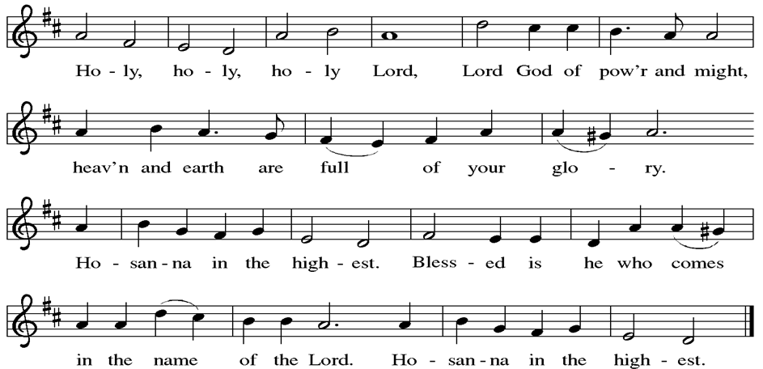

Thanksgiving at the Table

P: Blessed are you, O God of the universe. Your mercy is everlasting and your faithfulness endures from age to age.
Praise to you for creating the heavens and the earth. Praise to you for saving the earth from the waters of the flood. Praise to you for bringing the Israelites safely through the sea. Praise to you for leading your people through the wilderness to the land of milk and honey. Praise to you for the words and deeds of Jesus, your anointed one. Praise to you for the death and resurrection of Christ. Praise to you for your Spirit poured out on all nations.
In the night in which he was betrayed, our Lord Jesus took bread, and gave thanks; broke it, and gave it to his disciples, saying: Take and eat; this is my body, given for you. Do this for the remembrance of me. Again, after supper, he took the cup, gave thanks, and gave it for all to drink, saying: This cup is the new covenant in my blood, shed for you and for all people for the forgiveness of sin.
Do this for the remembrance of me.
With this bread and cup we remember our Lord’s passover from death to life
as we proclaim the mystery of faith:
C: Christ has died. Christ is risen. Christ will come again.
P: O God of resurrection and new life: Pour out your Holy Spirit on us
and on these gifts of bread and wine. Bless this feast. Grace our table with your presence.
C: Come, Holy Spirit.
P: Reveal yourself to us in the breaking of the bread. Raise us up as the body of Christ for the world. Breathe new life into us. Send us forth, burning with justice, peace, and love. C: Come, Holy Spirit.
P: With your holy ones of all times and places, with the earth and all its creatures, with sun and moon and stars, we praise you, O God, blessed and holy Trinity, now and forever. C: Amen.

Lord’s Prayer
P: Lord, remember us in your kingdom and teach us to pray.
C: Our Father, who art in heaven, hallowed be thy name, thy kingdom come, thy will be done, on earth as it is in heaven. Give us this day our daily bread; and forgive us our trespasses, as we forgive those who trespass against us; and lead us not into temptation, but deliver us from evil. For thine is the kingdom, and the power, and the glory, forever and ever. Amen.

Invitation to the Table
At Parkside Lutheran Church we have an open table. We believe the invitation to receive comes from Jesus himself and all are welcome at Christ’s table. More than just Bread and Wine these are tangible signs of God’s love for you! If you do not wish to receive communion but would like a blessing, come forward and cross your arms over your chest. The Pastor will give you a blessing before you return to your seat via the side aisle. You’ll receive a communion wafer* in your hands. You may dip it in the cup of wine or juice. When giving the bread and cup, the communion ministers say: “The body of Christ, given for you. The blood of Christ, shed for you.”
and each person may respond : Amen
*Please let Pastor know if you need a gluten-free wafer
P: Come to the table of new life. Receive the risen Lord.

The Communion Distribution

Communion Song ELW setting 4 (p. 154)
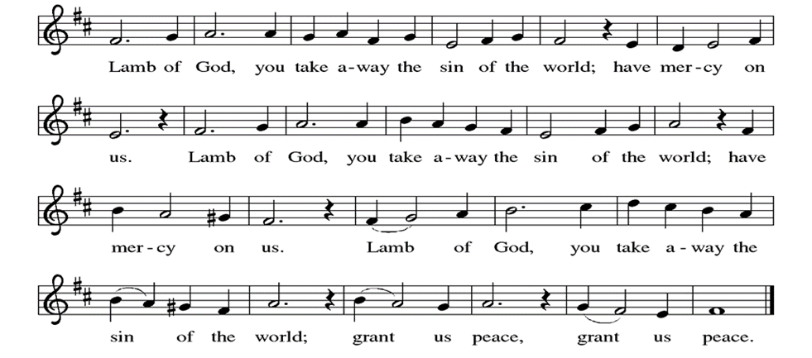

Communion Song: I am the Bread of Life ELW # 485
(printed next page)
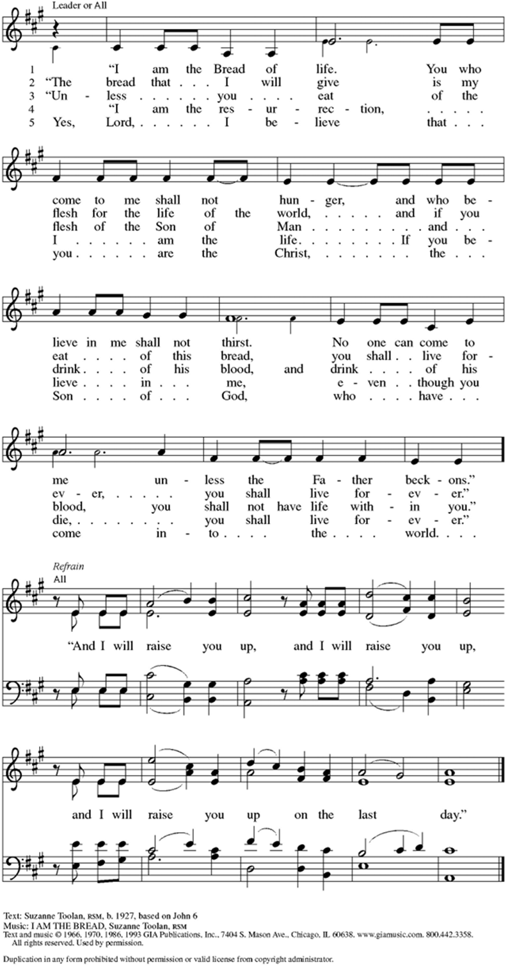
Communion Song: Sanctuary
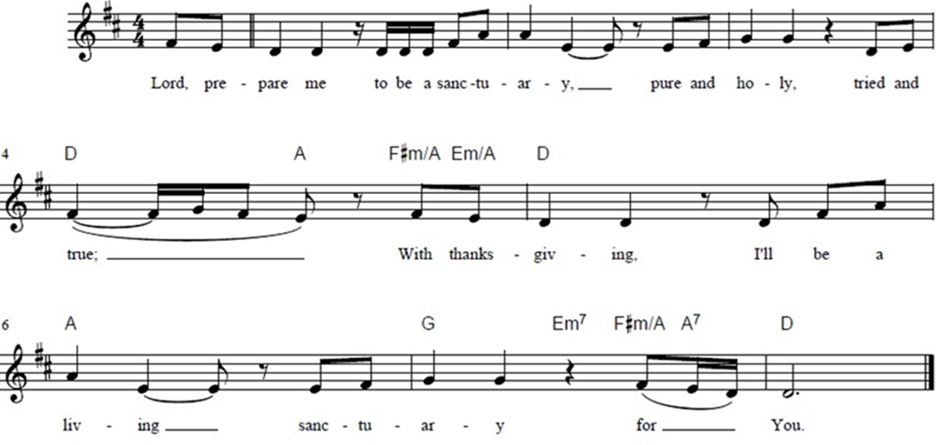

Post Communion Blessing
P: The Body and Blood of our Lord and Savior, Jesus Christ, strengthen you and keep you in God's grace. C: Amen.

Prayer After Communion
WA: Let us pray together.
C: Holy One, through this meal you have made your home among us and are making all things new. Send us now to speak peace to anxious hearts, to love our enemies, and to bring your healing to the nations. In the name of Jesus. Amen.

Sending - God blesses us and sends us in mission to the world.

Blessing
P. May almighty God bless you with the knowledge that the Creator’s only Son has ascended into heaven to prepare a place for you.
C: Amen
P. May you be lifted up and guided by Christ's intercession at God's right hand.
C. Amen.
P. At Christ's promised return, may you know the joy of God's eternal kingdom.
C. Amen
P. And may the source of all Love, Father, + Son, and Holy Spirit, bless you now and forever.
C. Amen
Sending Hymn: Crown Him with Many Crowns ELW #855
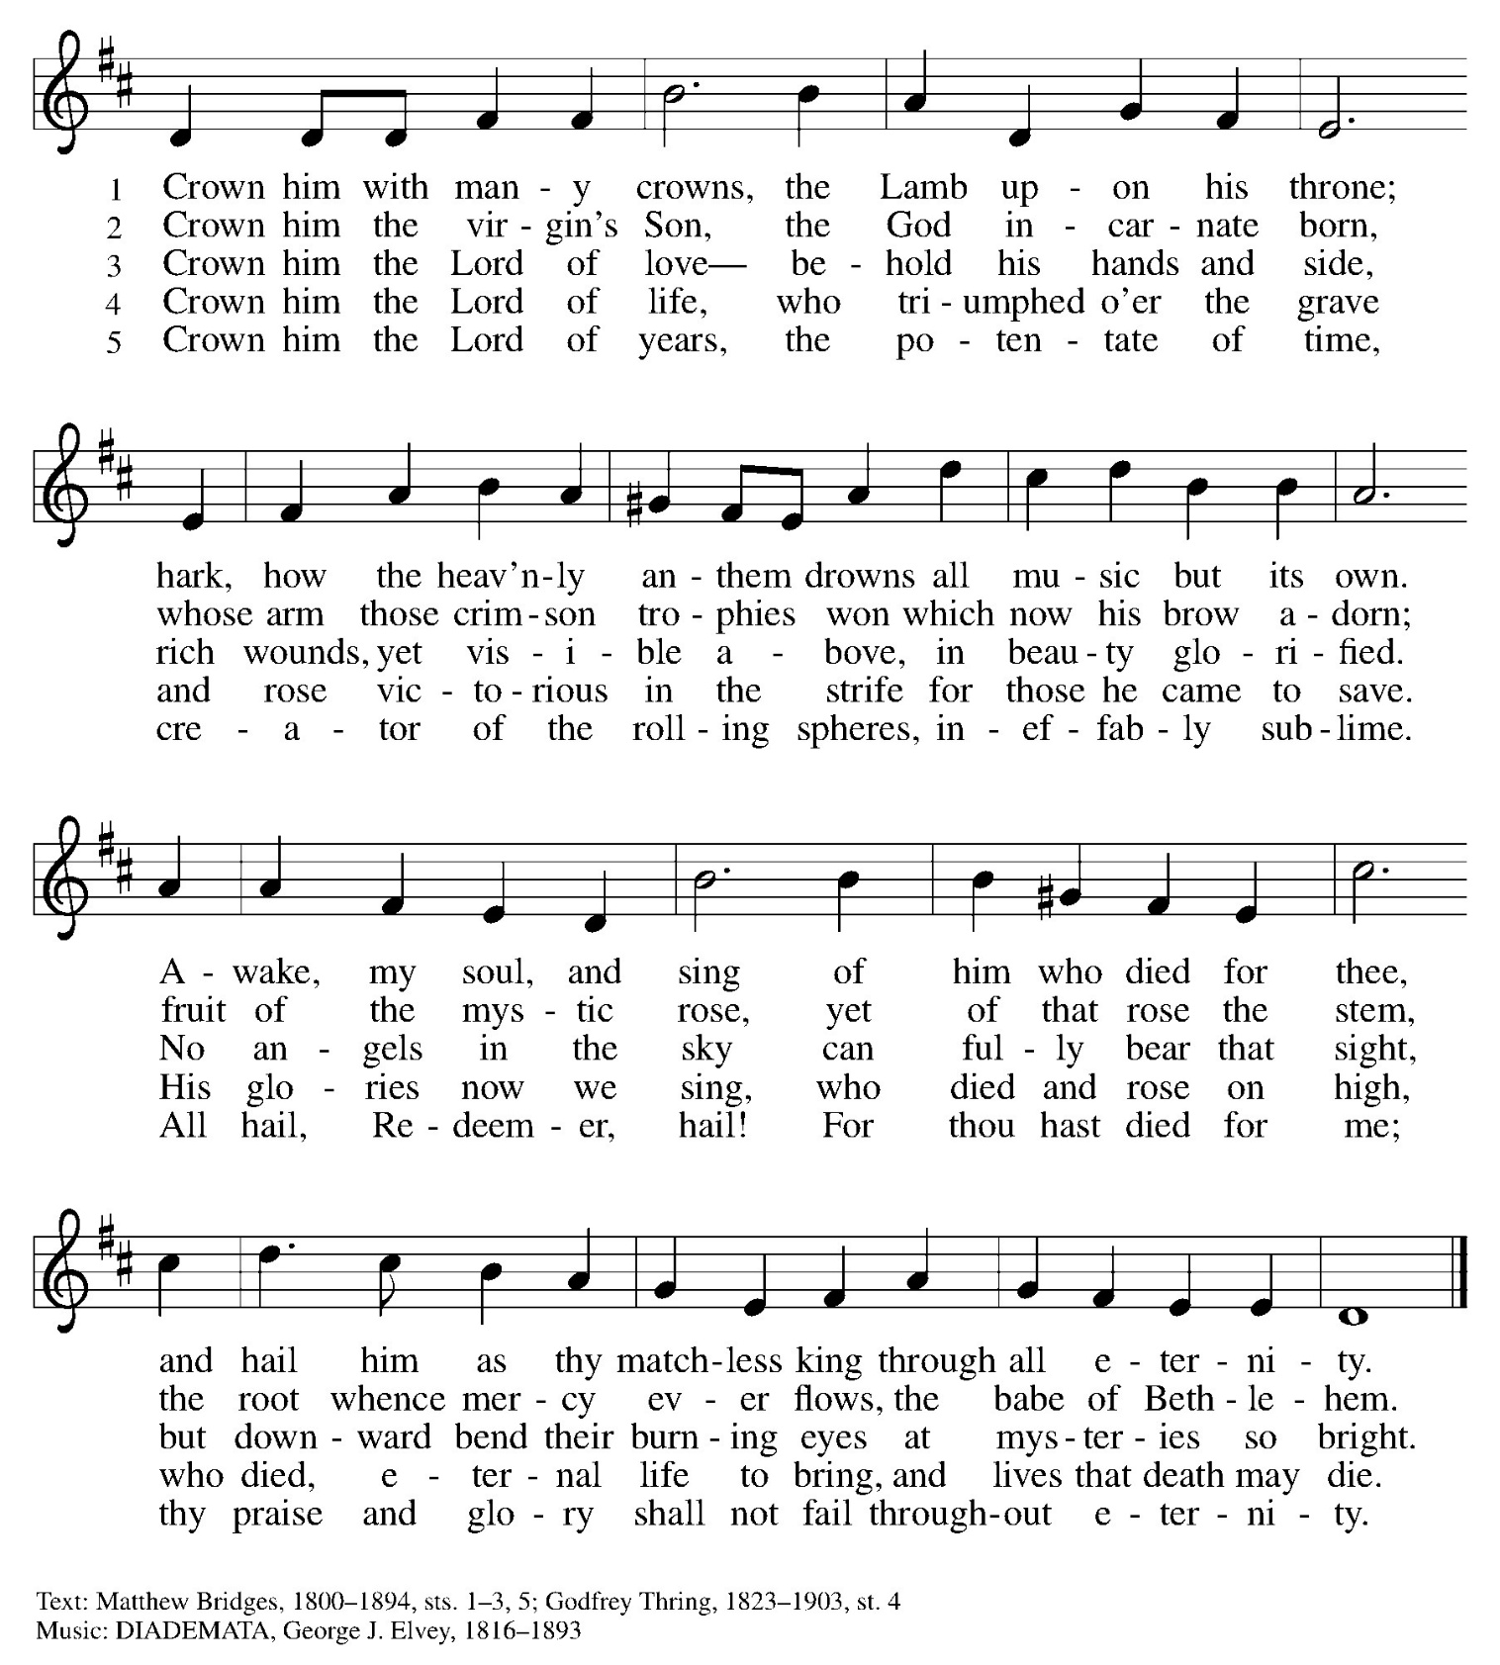

Dismissal and Postlude
P: Parkside Lutheran Church is rediscovering the radical love of Jesus.
C: Gathering All, Serving All, Caring for All
P: Go in peace. Praise the Lord. Alleluia!
C: Thanks be to God. Alleluia! Alleluia!

ELW Music licensed from Sundays & Seasons, Augsburg Fortress CCLI MUSIC License # 11440069 , CCLI Streaming License#21835523 Do not duplicate any music or Liturgy herein without license and permission
scripture readings adapted and written by susan lukey
PARKSIDE STAFF:
• The Rev. Jeremiah Smith: prjeremiahpsmith@gmail.com
• Kris Pope & Suzanne Gracie, Admin. Assistants (Church Office): parksidelutheran@gmail.com
• Mike Hooker, Music Director: mrhooker@me.com
CHURCH OFFICE HOURS: M/T/R 10:00am-3:00pm (716)836-1361

Acolytes: |  | Worship Assistants:
5/17 – Katie & Chris |  | 5/17 – Onda
5/24 – Franklin & Hudson |  | 5/24 – Vince
Readers: |  | Ushers:
5/17 – Sarah |  | 5/17 – Shannon, Rickey, Joanne
5/24 – Josiah |  | 5/24 – Joanne, Zack, Sue

Coming up:
- TODAY – New Usher Training, after Worship
- TODAY – Volunteer Orientation & Package Assembly for Migrant Families, after Worship
- May 20th – Brewing Theology – 7pm at Chandler Street Brewing
- May 23rd – Teresa O’Connor - Rite of Ordination at 2pm
- May 24th – Breakfast Church
- May 29th – Middle School Game Night in Stowell Lounge

Visit our website for more information about these and other Events at Parkside – www.parksidelutheran.org/events

BURRITO PROJECT DONATIONS ARE NEEDED!
Our funding for the Buffalo Burrito Project is running low and we need your help. Donations can be left in the collection plate (please label for Burrito Project) or via Tithely QR Code (select Burrito Project Fund) ~~>
Feed 10 people - $9.00
Feed 20 people - $18.00
Feed 50 people - $45.00
Feed 100 people - $90.00
Fund the Burrito Project for one month - $180
Fund the Burrito Project for one quarter - $540

