R E V I V A L

JESUS
“Light, Fire, Water, Wind”

Perrysville Church
88 Amsterdam Rd. SE
St Rt 164
Scio, Ohio 43988

Sunday May 17th – Sunday May 24th
^{7:00 p.m.}

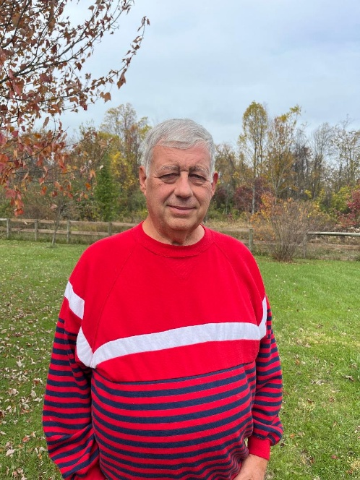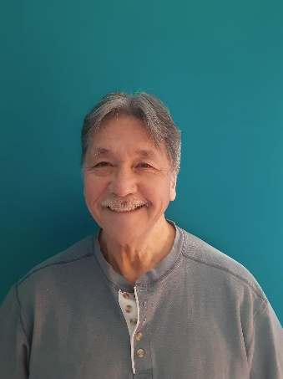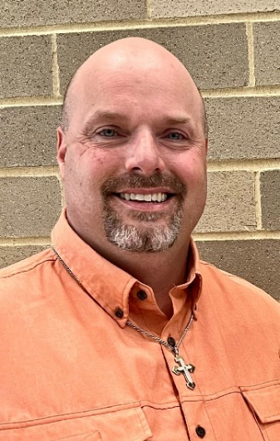
Pastor Dixie McHugh Dr. Marvin Scholler Pastor Roy Gatts Pastor Mike Cunningham
Sunday May 17th Monday May 18th Tuesday May 19th Wednesday May 20th

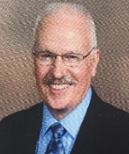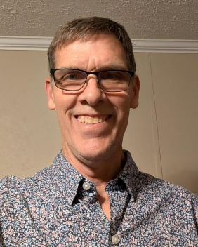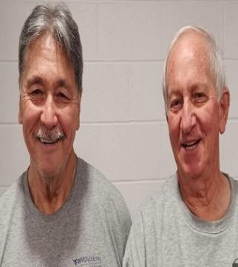
Pastor Mickey Fostor Evangelist Chuck Mehl Pastor Roy & Brian McHugh Pastor Dixie McHugh
Thursday May 21st Friday May 22nd Saturday May 23rd Sunday May 24th

“Therefore let us not sleep, as do others; but let us watch and be sober.”
1 Thessalonians 5:6

