Holy Trinity Lutheran Church
150 River Road Red Bank, NJ 07701
Church Office: (732) 741-9241 Fax: (732) 741-9577
email: holytrinitychurch4@verizon.net
Website: htlcredbank.org
Pastor: Rev. John Mack, Jr.
Cell: (336)-392-5839
Minister of Music: Peter Isherwood
Parish Administrator: Deanna Vergari
Council President: Cynthia Kazmac



May 10, 2026

Sixth Sunday of Easter

Introduction
Jesus does not abandon his followers. Through the Holy Spirit, Jesus comes to abide with his disciples of every generation. As Pentecost draws near, we are reminded that the risen Christ dwells in us as the Spirit of truth. We receive this Spirit in baptism and pray that in our gathering around the Lord’s table the Spirit will transform us to be the body of the risen Christ in the world.

Welcome & Announcements (Please remember to silence your cell phone!)

Prelude (We prayerfully prepare our hearts and minds to worship!)

+ GATHERING +

Thanksgiving for Baptism
All may make the sign of the cross, the sign that is marked at baptism, as the presiding minister begins.
P: Alleluia! Christ is risen.
C: Christ is risen indeed. Alleluia!
P: Salvation belongs to our God who is seated on the throne
and to the Lamb!
C: Amen.
P: Let us give thanks for the gifts of baptism.
Water may be poured into the font as the presiding minister continues.
P: Merciful God,
you are the one who was, who is, and who is to come.
You lead us beside still waters.
We thank you for the waters of creation:
morning dew, gentle rain, roaring waves.
We thank you for the waters that nourish us (local waters may be named).
Blessed are you.
C: You guide us to springs of the water of life.
P:Jesus Christ, you are the faithful witness
who accompanies us on our journeys.
We give you thanks for your life-giving death and resurrection.
We praise you for joining us in joy and sorrow.
Blessed are you.
C: You guide us to springs of the water of life.
P: Holy Spirit, you anoint our head with oil and our cup overflows.
Break down barriers that divide us.
Fill us with the breath of peace.
Blessed are you.
C: You guide us to springs of the water of life.
P: Holy One, we thank you for the gifts and grace of baptism,
and for making us a new creation.
We join with saints and angels, giving you honor and praise,
now and forever.
C: Amen.

*Gathering Hymn ELW 625 Come, We That Love the Lord
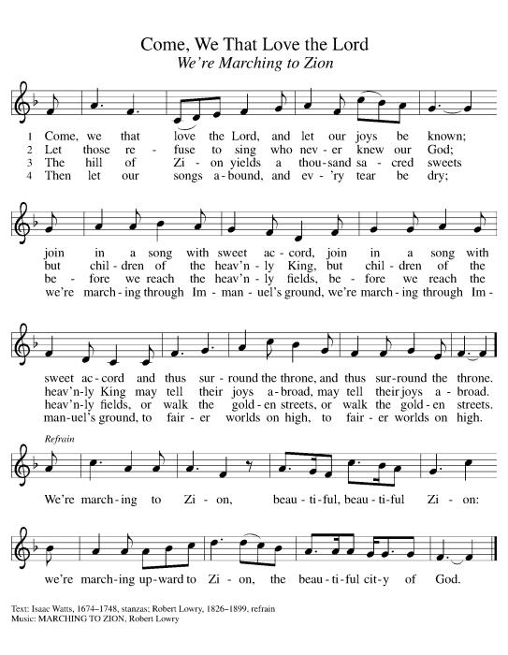

*Pastoral Greeting

P: The Grace of our Lord Jesus Christ, the love of God, and the communion of the Holy Spirit be with you all.

C: And also with you!

Hymn of Praise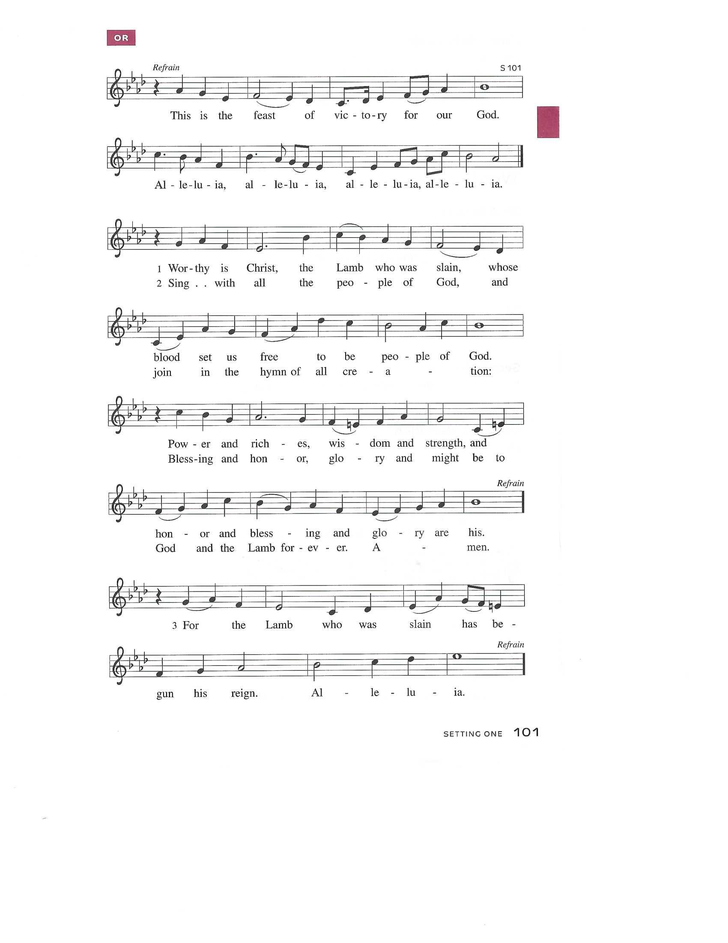

Prayer of the Day
P: Almighty and ever-living God, you hold together all things in heaven and on earth. In your great mercy receive the prayers of all your children and give to all the world the Spirit of your truth and peace, through Jesus Christ, our Savior and Lord, who lives and reigns with you and the Holy Spirit, one God, now and forever.
C: Amen!

+WORD+

First Reading: Acts 17:22-31
In Athens, Paul faces the challenge of proclaiming the gospel to Greeks who know nothing of either Jewish or Christian tradition. He proclaims that the “unknown god” whom they worship is the true Lord of heaven and earth who will judge the world with justice through Jesus, whom God has raised from the dead.

²² Paul stood in front of the Areopagus and said, “Athenians, I see how extremely spiritual you are in every way. ²³ For as I went through the city and looked carefully at the objects of your worship, I found among them an altar with the inscription, ‘To an unknown god.’ What therefore you worship as unknown, this I proclaim to you. ²⁴ The God who made the world and everything in it, he who is Lord of heaven and earth, does not live in shrines made by human hands, ²⁵ nor is he served by human hands, as though he needed anything, since he himself gives to all mortals life and breath and all things. ²⁶ From one ancestor he made all peoples to inhabit the whole earth, and he allotted the times of their existence and the boundaries of the places where they would live, ²⁷ so that they would search for God and perhaps fumble about for him and find him—though indeed he is not far from each one of us. ²⁸ For ‘In him we live and move and have our being’; as even some of your own poets have said,
‘For we, too, are his offspring.’
²⁹ “Since we are God’s offspring, we ought not to think that the deity is like gold or silver or stone, an image formed by the art and imagination of mortals. ³⁰ While God has overlooked the times of human ignorance, now he commands all people everywhere to repent, ³¹ because he has fixed a day on which he will have the world judged in righteousness by a man whom he has appointed, and of this he has given assurance to all by raising him from the dead.”

Psalm: Psalm 66:8-20
Bless our God, you peoples; let the sound of praise be heard. (Ps. 66:8)

⁸ Bless our | God, you peoples;
let the sound of | praise be heard.
⁹ Our God has kept us among the living
and has not allowed our | feet to slip.
¹⁰ For you, O God, have | tested us;
you have tried us just as sil- | ver is tried.
¹¹ You brought us in- | to the net;
you laid heavy burdens up- | on our backs.
¹² You let people ride over our heads; we went through | fire and water,
but you brought us out into a place | of refreshment.
¹³ I will enter your house | with burnt offerings
and will pay | you my vows—
¹⁴ those that I promised | with my lips
and spoke with my mouth when I | was in trouble.
¹⁵ I will offer you burnt offerings of fatlings with the | smoke of rams;
I will give you ox- | en and goats.
¹⁶ Come and listen, all you | who believe,
and I will tell you what God has | done for me.
¹⁷ I called out to God | with my mouth,
and praised the Lord | with my tongue.
¹⁸ If I had cherished evil | in my heart,
the Lord would | not have heard me;
¹⁹ but in truth | God has heard me
and has attended to the sound | of my prayer.
²⁰ Blessed be God, who has not reject- | ed my prayer,
nor withheld unfailing | love from me.

Second Reading: 1 Peter 3:13-22
The author of 1 Peter encourages Christians to remain faithful even in the face of defamation and persecution. In baptism we are made clean to act in accordance with what is right.

¹³ Now who will harm you if you are eager to do what is good? ¹⁴ But even if you do suffer for doing what is right, you are blessed. Do not fear what they fear, and do not be intimidated, ¹⁵ but in your hearts sanctify Christ as Lord. Always be ready to make your defense to anyone who demands from you an accounting for the hope that is in you, ¹⁶ yet do it with gentleness and respect. Maintain a good conscience so that, when you are maligned, those who abuse you for your good conduct in Christ may be put to shame. ¹⁷ For it is better to suffer for doing good, if suffering should be God’s will, than to suffer for doing evil. ¹⁸ For Christ also suffered for sins once for all, the righteous for the unrighteous, in order to bring you to God. He was put to death in the flesh but made alive in the spirit, ¹⁹ in which also he went and made a proclamation to the spirits in prison, ²⁰ who in former times did not obey, when God waited patiently in the days of Noah, during the building of the ark, in which a few, that is, eight lives, were saved through water. ²¹ And baptism, which this prefigured, now saves you—not as a removal of dirt from the body but as an appeal to God for a good conscience, through the resurrection of Jesus Christ, ²² who has gone into heaven and is at the right hand of God, with angels, authorities, and powers made subject to him.

*Gospel Acclamation
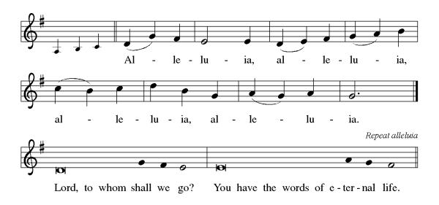

P: The Holy Gospel According to St. John 14th Chapter
C: Glory to You O Lord!

Gospel: John 14:15-21
In final words to his disciples on the night of his arrest, Jesus encourages obedience to his commandments and speaks of the Spirit, who will be with them forever.

[Jesus said to the disciples:] ¹⁵ “If you love me, you will keep my commandments. ¹⁶ And I will ask the Father, and he will give you another Advocate, to be with you forever. ¹⁷ This is the Spirit of truth, whom the world cannot receive because it neither sees him nor knows him. You know him because he abides with you, and he will be in you.
¹⁸ “I will not leave you orphaned; I am coming to you. ¹⁹ In a little while the world will no longer see me, but you will see me; because I live, you also will live. ²⁰ On that day you will know that I am in my Father, and you in me, and I in you. ²¹ They who have my commandments and keep them are those who love me, and those who love me will be loved by my Father, and I will love them and reveal myself to them.”

P: The Gospel of the Lord
C: Praise to you, O Christ!
Sermon
*Hymn of the Day ELW 391 The Joyful Eastertide
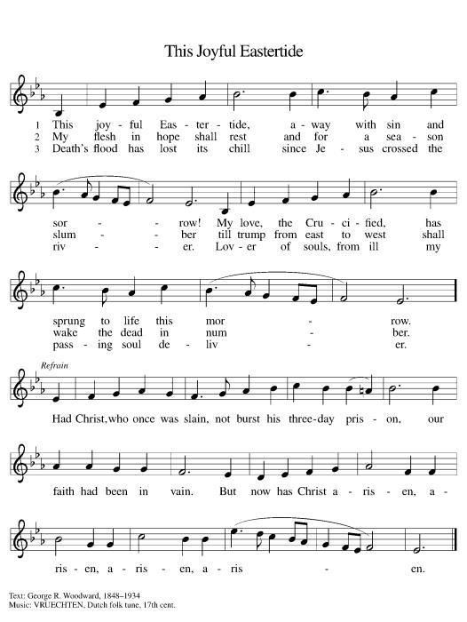

*Nicene Creed
We believe in one God,
the Father, the Almighty,
maker of heaven and earth,
of all that is, seen and unseen.
We believe in one Lord, Jesus Christ,
the only Son of God,
eternally begotten of the Father,
God from God, Light from Light,
true God from true God,
begotten, not made,
of one Being with the Father;
through him all things were made.
For us and for our salvation
he came down from heaven,
was incarnate of the Holy Spirit and the Virgin Mary
and became truly human.
For our sake he was crucified under Pontius Pilate;
he suffered death and was buried.
On the third day he rose again
in accordance with the Scriptures;
he ascended into heaven
and is seated at the right hand of the Father.
He will come again in glory to judge the living and the dead,
and his kingdom will have no end.
We believe in the Holy Spirit, the Lord, the giver of life,
who proceeds from the Father and the Son,
who with the Father and the Son is worshiped and glorified,
who has spoken through the prophets.
We believe in one holy catholic and apostolic church.
We acknowledge one baptism for the forgiveness of sins.
We look for the resurrection of the dead,
and the life of the world to come. Amen.

*Prayers of Intercession
Trusting in the power of Christ’s resurrection to heal and redeem our broken world, let us pray for the needs of all creation.
A brief silence.
God of new life, you call us through the waters of baptism to be in relationship with you and one another. Guide the church and its leaders to proclaim Christ’s righteousness throughout the world. Merciful God,
C: receive our prayer.
You create the world and all that is in it. Shelter budding plants and young animals, provide unpolluted habitats and clean water, and raise up stewards for the environment. Merciful God,
C: receive our prayer.
You set civil servants in the places where we live. Instill truth and equity among judges and lawyers, gentleness and courage among first responders, and peace among leaders of towns and nations. Merciful God,
C: receive our prayer.
You provide comfort in times of trouble. Heal those who are sick, shelter any who are unhoused, feed those undernourished, and accompany and console all who are lonely, bereaved, anxious, or ill (especially). Merciful God,
C: receive our prayer.
You are love and you desire that we love one another. As a mother hen cares for her chicks, bless all who provide motherly care in our lives, and inspire us to care for one another. Merciful God,
C: receive our prayer.
Here other intercessions may be offered.
God of new life, your steadfast love endures forever. Inspire us by the example of the faithful departed, who clung to your promises of life, forgiveness of sins, and salvation. Merciful God,
C: receive our prayer.
God of resurrection power, use us and these prayers to proclaim the good news of new life to all the world, through Jesus Christ, our risen Savior.
C: Amen.

Greeting of Peace
P: The peace of Christ be with you always!
C: And also with you!

Offering (Thank you for your support for our ministry!)

*Doxology ELW 384 v.4 That Easter Day with Joy Was Bright (Please stand and join in singing as we share our gifts!)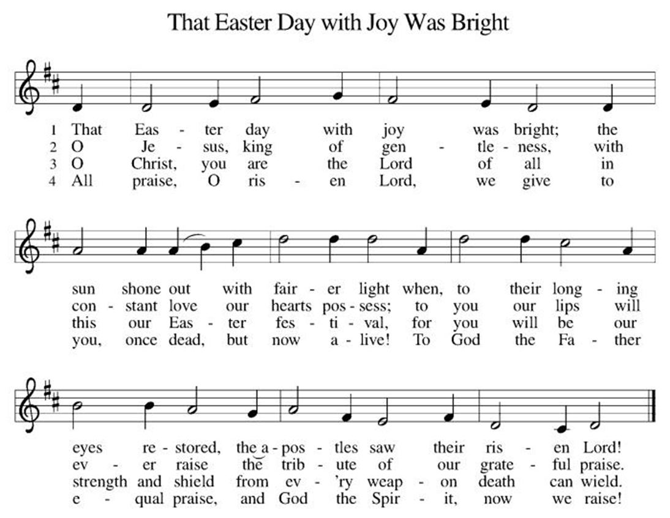

*Offering Prayer
A: Merciful God,
C: accept the fruits of our labor, gathered to give you glory.
You have set a table before us, a glimpse of that great day
when we will hunger and thirst no more.
Nourish us with the body and blood of Jesus,
that goodness and mercy may follow us
and bless the world you love.
In the name of Jesus,
Amen!

+MEAL+
*Great Thanksgiving
P: The Lord be with you.
C: And also with you.

P: Lift up your hearts.
C: We lift them to the Lord.

P: Let us give thanks to the Lord our God.
C: It is right to give our thanks and praise.

P: It is indeed right, our duty and our joy,
that we should at all times and in all places
give thanks and praise to you, almighty and merciful God,
for the glorious resurrection of our Savior Jesus Christ,
the true Paschal Lamb who gave himself to take away our sin;
who in dying has destroyed death,
and in rising has brought us to eternal life.
And so, with Mary Magdalene and Peter and all the witnesses of the resurrection, with earth and sea and all their creatures,
and with angels and archangels, cherubim and seraphim,
we praise your name and join their unending hymn:

*Sanctus
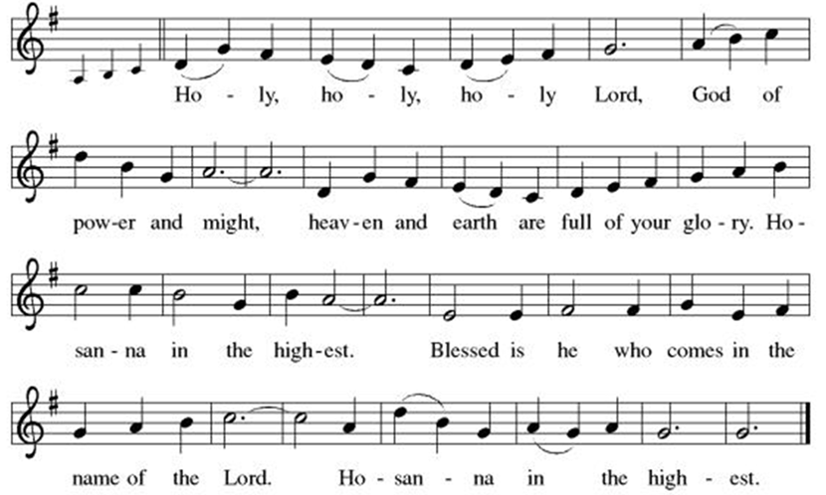

*Eucharistic Prayer
P: Holy, mighty, and merciful Lord,
heaven and earth are full of your glory.

In great love you sent to us Jesus, your Son,
who reached out to heal the sick and suffering,
who preached good news to the poor,
and who, on the cross, opened his arms to all.

In the night in which he was betrayed,
our Lord Jesus took bread, and gave thanks;
broke it, and gave it to his disciples, saying:
Take and eat; this is my body, given for you.
Do this for the remembrance of me.

Again, after supper, he took the cup, gave thanks,
and gave it for all to drink, saying:
This cup is the new covenant in my blood,
shed for you and for all people for the forgiveness of sin.
Do this for the remembrance of me.

Remembering, therefore, his death, resurrection, and ascension,
we await his coming in glory.

Pour out upon us the Spirit of your love, O Lord,
and unite the wills of all who share this heavenly food,
the body and blood of Jesus Christ, our Lord;
to whom, with you and the Holy Spirit,
be all honor and glory, now and forever.

C: Amen!

*THE LORD’S PRAYER
Our Father, who art in heaven,
hallowed be thy name,
thy kingdom come,
thy will be done,
on earth as it is in heaven.
Give us this day our daily bread;
and forgive us our trespasses,
as we forgive those
who trespass against us;
and lead us not into temptation,
but deliver us from evil.
For thine is the kingdom,
and the power, and the glory,
forever and ever. Amen.
*Lamb of God
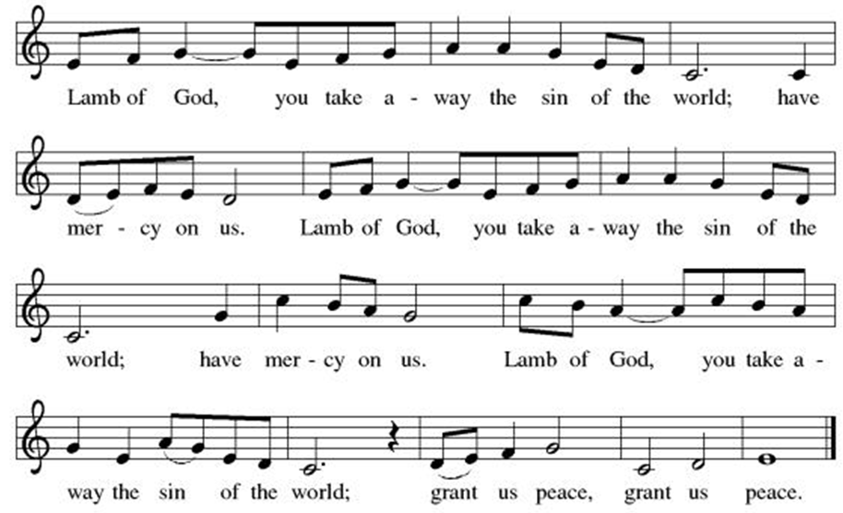

Spiritual Communion Prayer
P: Let us pray for the communion of all present here, those viewing our service virtually, those in our hearts and in our world.
C: Lord Jesus, I believe you are truly present in the Sacrament of Holy Communion. When I cannot receive Communion, I pray that you come into my heart. I know that nothing in Heaven or on earth can separate me from your love. Amen.

Invitation to Communion
P: Come to the table of new life.
Receive the risen Lord.

C: Thanks be to God!
(All are invited to the communion rail following the guidance of the ushers. Communion will be shared through the host and individual cups. If you would like communion but are unable to join us at the rail, please alert the usher!)
Communion Hymns (Please join in singing!)
ELW 628 Jerusalem, My Happy Home
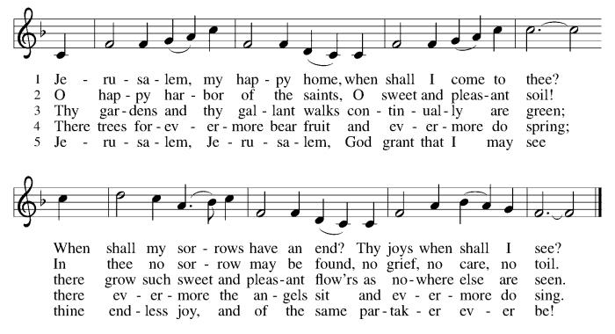

ELW 785 When Peace like a River 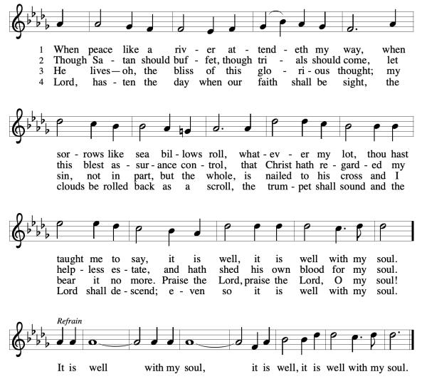

P: The body and blood of our Lord Jesus Christ strengthen you and keep you in his grace. C: Amen!

*Prayer after Communion
A: Holy One,
through this meal you have made your home among us
and are making all things new.
Send us now to speak peace to anxious hearts,
to love our enemies,
and to bring your healing to the nations.
In the name of Jesus,
C: Amen.
+Sending+

*Blessing
P: God Almighty, who is the beginning and the end,
Jesus Christ, the firstborn of the dead,
and the Spirit, our advocate and peace,
☩ bless you now and forever.
C: Amen!

Mother’s Day Prayer
Mothering God, you give us biological families and families we choose. Thank you for all who serve as mothers. Comfort those who mourn the death of a mother, or alienation from their mother. Send your Spirit to those who long for motherhood, and those who have never know their mothers. Mother us all with your unfailing love.

*Sending Hymn God Bless America

God bless America, land that I love
Stand beside her and guide her
Through the night with a light from above
From the mountains to the prairies
To the oceans white with foam
God bless America, my home sweet home
God bless America, my home sweet home
From the mountains to the prairies
To the oceans white with foam
God bless America, my home sweet home
God bless America, my home sweet home

*Dismissal
A: Go in peace. Praise the Lord. Alleluia!
C: Thanks be to God. Alleluia!
Postlude

Copyright © 2020 Augsburg Fortress. All rights reserved. Reprinted by permission under Augsburg Fortress Liturgies Annual License #SB106907. New Revised Standard Version Bible, Copyright © 1989, Division of Christian Education of the National Council of the Churches of Christ in the United States of America. Used by permission. All rights reserved. Revised Common Lectionary, Copyright © 1992 Consultation on Common Texts, admin Augsburg Fortress. Used by permission.
Treasurer’s Report

March giving totaled $24,026, putting us ahead of pace toward our 2026 Challenge goal of $244,000, with 39% raised in just 25% of the year. Continued participation through regular or additional Challenge gifts will help ensure we fully fund HTLC’s ministry and mission in the months ahead.

Worship Volunteer Schedule
Date | Asst. Min | Usher | Sacristan | Lector | Counter
May 10 | Keith Bennett | Dan Grillon | Helga Britton | Cynthia Kazmac | Carleo/Spreen
May 17 | Chris Foard | Jill Socha | Nancy Poole | Molly Foard | Foss/Foard
May 24 | Charlie Rugg | Andy Wehr/Dan Grillon | Pat Pienkos | Rosemary Lane | Bradford/Coleman
May 31 | Linda Coleman | Keith Bennett | Joanne Giordano | Emily Kaster | Socha/Bohner

Coffee Hour- The Men in honor of Mother’s Day
Altar Flowers Debbie Yetka in honor of George Yetka Jr.

ANNOUNCEMENTS Thank you! To all who consistently support our church and ministries through your time, talent, and treasure. Please help us grow by inviting your friends and family to worship and events. You are what makes Holy Trinity a wonderful church family!

Stay in touch! Please visit our church website, www.htlcredbank.org for updates and information. You can also find us on Facebook and view services online. The office is open from 9am to 2pm, Monday to Thursday.

Car Wash-May 17th The car wash will start at 10 AM with churchgoers cars washed first, then will open up to the general public from noon till 2:00 PM. We will need volunteers to wash the cars, dry cars, manage supplies and supervise. Please sign up in the Red Book. Contact Lauren Bennett with questions period proceeds will support Cross Roads Day Camp.

100 Anniversary Committee- Meeting Sunday, May 17.Please bring your ideas to that meeting and if you are unable to attend, share your thoughts by e-mail or in conversation. We will form better channels of communication as we move forward.

Interested in becoming an usher? Would you like to be a substitute if needed? Or maybe you need to brush up on your skills? Dan Grillon will be leading an Usher Training/Refresher class Sunday, May 24, after worship service. Sign up below, all are welcome!

Name Tag Sundays: On the first Sunday of each month, names tags and markers will be at each entrance of the sanctuary. Please fill out a tag and wear one for worship and for coffee hour to welcome visitors and help newcomers put names to faces.

Sunday School in the New Year, we will continue to study stories and lessons from the Old Testament beginning with Jacob. Kids will love the crafts, songs and games that accompany each lesson.
The following dates there will be Sunday School:
April- 12 and 26, May- 3, 17 and 31, June- 7 and 14
As was done in the fall, there will be opportunities to volunteer as SS lead teacher. A signup will be emailed out shortly and will also be posted in the red binder. Consider signing up! All lesson materials will be supplied and laid out and a leader guide will be emailed to volunteers approximately 1 week in advance. Blessings for a wonderful 2026!~Lauren

Choir The Holy Trinity Choir welcomes our singers back for a preparation rehearsal on Sunday, September 7th at 9am in the church hall. All are welcome to join us in song as often as you are able. Choir meets each Sunday at 9am to practice and prepare our music. Join us and help us grow by spreading the word about the HTLC Choir!

Quilting- The Quilters need gently used any bed sheets of any size! Please leave any donations in the quilters closet in Fellowship Hall. Thank you!

Quilters Need Help
If anyone is traveling through Mechanicsville, PA (near Peddler’s Village), and can add a few extra minutes to your trip, the warehouse for shipping quilts, school kits, etc. is located directly off one of the exits. We accumulate many quilts throughout the year, and we would appreciate sending some quilts with you to deliver. Any questions, please call Sherry Lee or Elaine Theophall.

Weekly Quilting on Wednesdays at 9:30. Bring your lunch and enjoy some fellowship at noon. All are welcome.

Holy Trinity Blanket Sunday – Mother’s Day May 10,2026 –
In the midst of crisis, faith guides a loving response. That’s how the CWS Blanket program started.
Please place your donation payable to “Holy Trinity Evangelical Lutheran Church” in the CWS envelope provided in the bulletin and return it to church. If you are doing eGiving, please select “WELCA Appeal” for the purpose of your gift. Thank you.

Social Ministry
*Year-round collections will continue for food items for Lunch Break. There is a sign-up sheet in the red book for those who can help drop these items to Lunch Break.
*We will also collect adult men's socks to periodically drop at the Red Bank Warming Center.
*For those interested in the Heartwarming Center — the new women's shelter is adjacent to the First Baptist Church of Red Bank at 90 Maple Ave. You can follow up on this mission through their website - https://www.thefeastnj.org- On this site, they also include wish list items that can be purchased through amazon. We will be exploring purchasing some of these through a Thrivent card. If you want to purchase on your own, you can leave items at church, and the Social Ministry will deliver them.

JBJ Soul Kitchen Day of Hope Walk– Tuesday, May 12, 2026
Holy Trinity Church has participated in this event for several years. We’re excited to participate again this year in the annual Day of Hope Walk on Tuesday, May 12th! There will be a sign up in the red book.
Event Details: Location: Begins at Riverside Gardens Park, Red Bank & concludes at JBJ Soul Kitchen Check-in: 10:00AM Walk Begins: 11:00AM Refreshments: Available at JBJ Soul Kitchen after the walk.

Pastoral Care and Prayer... We are here to care for and pray! Please contact the office to add or adjust prayer requests. If you or someone you know needs pastoral care, please contact the office and Pastor Mack!

THANK YOU for supporting and sustaining our church and ministries! All are welcome here! Please invite your family and friends to worship with us! Find us online at www.htlcredbank.org


Every gift matched up to 2-to-1
$25K + Synod Match → Mortgage Paid Off
Progress: ████░░░░░░░░░░░░░░░░
$4,759 of $25,000 (19%)
Scan to Give

Use Designated Envelopes
Use Any Envelope and note: “Mortgage Freedom”

