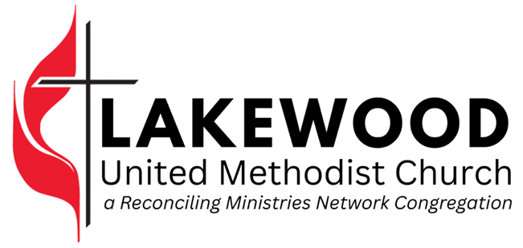


6th Sunday of Easter
May 10, 2026
9:30 am • Sanctuary & Online

CHURCH OFFICE
5995 Dr. Martin Luther King Jr St. S • St. Petersburg, FL 33705
(727) 867-1744 • lakewoodunitedmethodist.org

Wednesdays • 9 am-12:30 pm
The pastors are available by appt

Co-Pastor – Rev. Erick Ashley – erick@spconnection.org
Co-Pastor – Rev. Tracie Ashley – tracie@spconnection.org
Associate Pastor – Rev. Ellie Fox – ellie@spconnection.org
Administrative Asst – Patti Marshall – lakewoodumc@tampabay.rr.com
Pianist – Jennifer Gray – JenniferGrayMusic@yahoo.com
Custodian – Amy Barker – lakewoodumc@tampabay.rr.com

Bishop of the Florida Annual Conference – Rev. Tom Berlin
Gulf Central District Superintendent – Rev. Emily Hotho
WELCOME

Welcome to Lakewood United Methodist Church. Each and every week we look forward to this time to gather as a community. We are glad YOU are here today with us!

You can use this bulletin to help lead through worship and throughout the week. We truly hope you enjoy your time here this morning and hope you return soon.

Some logistics you may find helpful:
- Worship runs about an hour, sometimes a bit shorter & sometimes a bit longer.

- Grab a nametag from the table at the entrance. If you are a guest, our Connect Team will happily make one for you.

- Restrooms are in the narthex, on the right as you are walking toward the exit.

- Prayer Cards are available in the pew in front of you.
  - Please place your prayer card in the offering plate. It is our joy and privilege to be praying with and for you.

- We have several ways you can give financially to support the mission of Lakewood UMC.
  - Place cash/check in the offering plate/boxes or mail to the church.
  - Text any amount to (833) 959-1469.
  - Visit https://www.lakewoodunitedmethodist.org/pages/give
  - Use your bank’s bill payer system.

ORDER OF WORSHIP
UMH: United Methodist Hymnal • TFWS: The Faith We Sing
*Please stand as you are able

WE GATHER
Welcome & Announcements
Call to Worship*
Worship Music* | Crown Him With Many Crowns – UMH 327

WE PROCLAIM
Affirmation of Faith* | An Adaptation of The Apostle’s Creed
Gloria Patri* | Glory Be To The Father – UMH 70
Pastoral Prayer
Passing of the Peace*
Worship Music* | Rejoice, The Lord Is King – UMH 715
Prayer For Illumination
Scripture Reading | Philippians 1: 1-18a CEB
Choral Response | He Is Lord – UMH 177
Message | Joy That Can’t Be Chained - Rev. Tracie Ashley

WE RESPOND
Presentation of Tithes and Offerings
Offertory Music
Doxology* | Praise God, From Whom All Blessings Flow – UMH 95
Offertory Prayer*

WE GO OUT
Worship Music* | Joyful, Joyful We Adore Thee – UMH 89
Benediction*

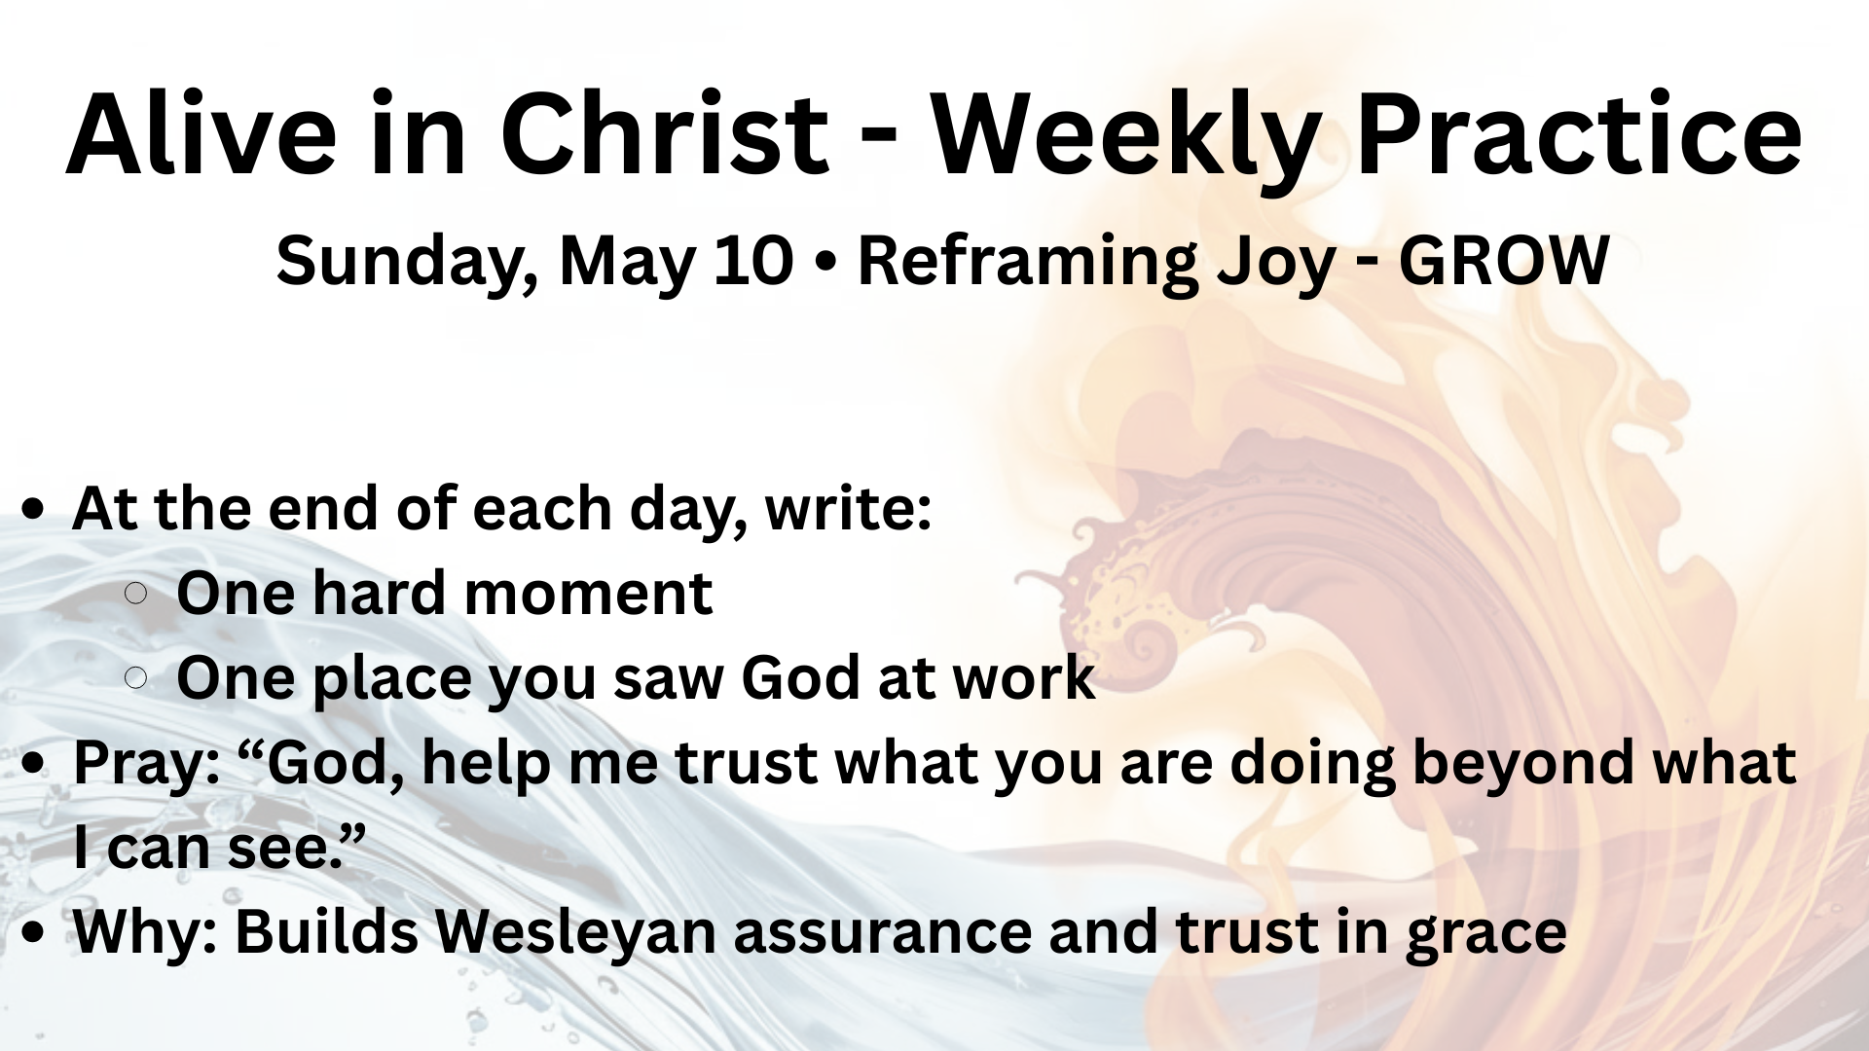

WHAT’S HAPPENING?

Church Sale – We are continuing negotiations with the Bill Edwards Foundation regarding the sale of the church property.

Women's Spring Luncheon – SAVE THE DATE! Saturday, May 16 at 1:30 pm. Sign up in the Fellowship Hall or at fumcgulfport.org.

Basic Lay Servant Ministry Training – Oakhurst UMC is hosting a Basic Lay Servant Ministry Training for those who feel called to serve more deeply in the life of the church through leadership, caregiving, prayer, worship, and communication. This course offers practical tools and spiritual grounding to help you grow as a disciple and serve others.

The cost is $15 plus the book. To become a Certified Lay Servant, participants must complete this Basic Course and one Advanced Course. Visit https://bit.ly/4mZzo1i to register.

LAKEWOOD - WEEKLY CALENDAR

SUNDAY, MAY 10 – 6th Sunday of Easter – Mother’s Day
- Worship, 9:30 am – Sanctuary & Online

MONDAY, MAY 11
- NuBody Fitness, 10 am – Fellowship Hall
- NuBody Fitness, 6 pm – Fellowship Hall

TUESDAY, MAY 12
- Grace Group, 10 am – Sanctuary Narthex

WEDNESDAY, MAY 13
- Office Open, 9 am – 12:30 pm
- NuBody Fitness, 10 am – Fellowship Hall

THURSDAY, MAY 14
- NuBody Fitness, 6 pm – Fellowship Hall

FRIDAY, MAY 15
- Nothing Scheduled

SATURDAY, MAY 16
- Fellowship Hall Booked

SUNDAY, MAY 17 – 7th Sunday of Easter
- Worship, 9:30 am – Sanctuary & Online

SOUTH PINELLAS CONNECTION UPCOMING DATES
May 12 | UWIF Friendship Meeting | 10 am | SL
May 12 | Women’s Bible Study | 11 am | SL
May 16 | Yard Sale Market | 8 am - Noon | GP
May 16 | Women's Spring Luncheon | 1:30 pm | GP
May 20 | UWIF Luncheon Meeting | 12 pm | GP
May 23 | Lay Servant Ministry – Basic Course  Oakhurst UMC | 9am - 4 pm | CV
Jun 4-6 | Annual Conference  Florida Southern College | - | -
Jun 29 | Pastor Sue arrives in St. Petersburg | - | -

KEY
Clearview (CV) | First Gulfport (FG) | Lakewood (LW) | St. Luke's (SL)

STEWARDSHIP OF PRESENCE & GIFTS

Week of May 3 |  | 2026 Year To Date
Worship | 12 | Worship (avg weekly) | 15
Online Worship | 0 | Online (avg weekly) | 8
Giving Received | $4,257.00 | Giving Received | $36,548.00
Giving Needed | $1,634.62 | Giving Needed | $29,42316
Surplus/Loss | $2,622.38 | Surplus/Loss | $7,124.84

Prayer Requests
Complete a Prayer Card from the pew
and place it in the offering plate

May 3: Continued prayers for Jennifer Gray and her insurance company to allow the medications she needs.

Pray for the sale of our campus to the Bill Edwards Foundation or for another buyer to come forward.
