This Week at PPBC
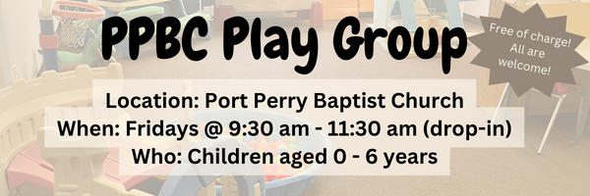


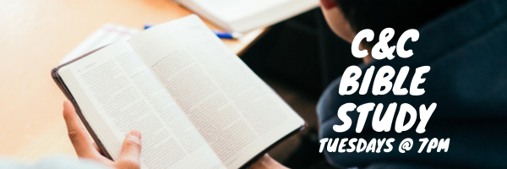

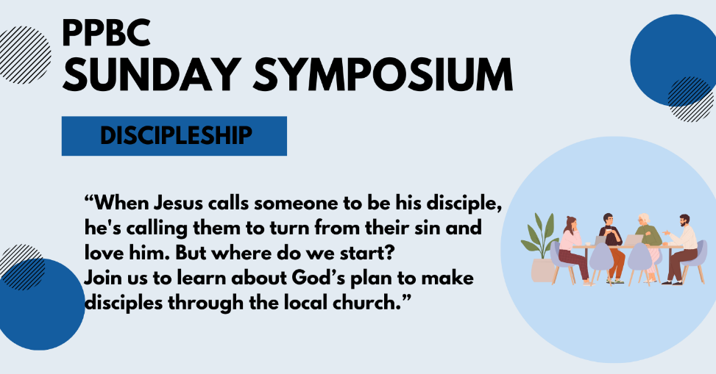
May 24, 2026

Join us Sunday, May 31st for a time of worship & prayer

May 31st, 2026


June 13, 2026

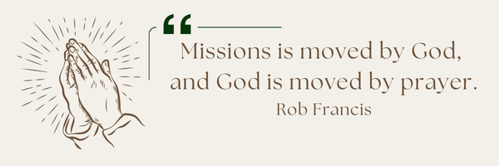
A Prayer Request from the Lambs: Recruiting the next generation of missionaries is always on their hearts. They had no students in training for this year’s training session, which is really discouraging for their team, but it’s the harsh reality as recruitment across Canada is getting harder and harder. “Pray the Lord of the harvest to raise up laborers.” Martin has been meeting with a couple who are interested in coming into our Bible school training and also serving at our HQ - so that’s been encouraging.

Sunday Ministry Schedules
Below are ministry schedules for Nursery, Jr. Church, Greeters, Ushers, and Sound & Video:
Nursery
May 10: Brenda Clemens, Audrianna Angrove
May 17: Kathryn denOuden, Brantley Colwell
Infant Nursery
May 10: Stephanie Anderson, Karis Henkelman
May 17: Lisa Dallas, Amber Saunders
Jr. Church; ages 3 to grade 1
May 10: Justine McKenzie, Grace Brown
May 17: Christine McLaren, Kelsey Schoenrock
Jr. Church; Grades 2 to 6
May 10: Kate Anderson, Graeme Anderson
May 17: Gregg & Karen Anderson, Tiffany Green
Greeters
May 10: Graeme & Barb Foster
May 17: Steve & Wendy Angrove
Ushers
May 10: Paul Sammut, Joe Colwell
May 17:Eric Duchesne, Mark McLaren
Sound & Video
May 10: Sound: Charlie Deane | Video: William Conley
May 10: Sound: | Video:

Sunday Service
Song – Standing on the Promises
Welcome
Baptism - Elise
Song – My Hope is in The Lord
Scripture
Prayer
Song – Come to Jesus (Rest in Him)
Song – Amazing Grace
Message – Pastor Jim Clemens
Song – Yet Not I but Through Christ in Me

Praise & Prayer Highlights
PRAY for our Soccer Outreach continuing this Wednesday. PRAY for the Volunteers as they demonstrate the gospel to the children & their families. PRAY that hearts would be open and respond to the gospel.
PRAISE for the upcoming baptisms this month. PRAY that God would continue to stir hearts in our congregation towards this step of obedience.
PRAY for Martin & Tina McCurley and their ongoing health concerns.
PRAY for Laurie Buismans sister Debbie and their family. Debbie is in Lakeridge health Hospital under observation. PRAY for the family and the doctors who are caring for them.
PRAY for Jess & Grayson as they prepare for their wedding and marriage next Saturday May 16th. PRAY for Gods wisdom and Grace as they start a life together.
PRAY for David Bengel who is still in Hospital after a stroke. PRAY for his healing and the wisdom of the doctors and nurses caring for him.
PRAY for the 10 small groups that meet each week. PRAY for the spiritual growth and discipleship in these groups.
PRAY for Scott & Catherine Willison's great nephew River who is experiencing surgery complications. PRAY for God's gracious and powerful work in River. PRAY for his parents, Kylie and Jordi Stewart and the entire family as they trust God in this difficult moment.

Giving
Just as a reminder, there are several ways you can give:
In Person using the offering box located on the back wall of the sanctuary. Donation envelopes are available at the Welcome Centre. Please contact the church office if you would like a box of donation envelopes (office@portperrybaptist.ca)
Through your online banking, you may send electronic transfers to ppbcdonations@gmail.com.
You can also give through Canada Helps. Donation receipts will be provided by Canada Helps, and transaction fees apply.
***********************************************************************
Weekly Newsletter
The PPBC Newsletter is emailed to the church family every Friday. If you would like to be added to the weekly email list, please contact the office by phone: 905-985-8681 or by email: office@portperrybaptist.ca.
*****************************************************************
Church Information:
Location:
2210 Hwy 7A
Port Perry, ON
L9L 1B4
Office Hours:
Monday: 8:30am – 4:00pm
Tuesday: 8:30am – 4:00pm
Wednesday: Closed
Thursday: 8:30am – 4:00pm
Friday: 8:30 am - 3:00 pm
Contact:
Phone: 905.985.8681
Email: office@portperrybaptist.ca
Website: www.portperrybaptist.ca
Staff:
Sr. Pastor – Rev. Jim Clemens
Administrative Assistant – Madeline Werner
Family Ministries Director – Josh Anderson
Pastoral Intern – Scott McKenzie

PPBC Newsletter
Sunday, May 10, 2026


Sunday Starting Point
Sunday, May 10, 2026 - 9:30 am
“Beginning the day with the Word and prayer”
Adults:
Adults will meet in the sanctuary for a time of study and prayer.
Youth:
Jr High (Grades 7-8) will meet in room 18 with Kate Anderson to study Thessalonians.
Children:
Children ages 3 - grade 6 will meet in room 26.
(Please note nursery is unavailable during Starting Point)
Sunday Morning Worship
Sunday, May 10, 2026 - 10:30 am
We are meeting in the sanctuary and will continue to live-stream for those who are unable to attend.
Message: Marriage in a Fallen World
Scripture: 1 Corinthians 7:10-16
Pastor Jim Clemens

