TLC Weekly: Sunday, May 10 – May 17
Vicar Angie DeSmith cell # 507-828-4941 email: angiedesmith316@gmail.com
The Radio Broadcast (KMHL 1400AM or 101.7FM) is sponsored by Loren Rykhus in memory of Robert’s birthday.
Sunday, May 10 Mother’s Day
9am Worship
10am Coffee Fellowship
Monday, May 11 9am Men in Mission
6:30pm Council Meeting
Wednesday, May 13 9am Do Day Mission Work Day
6:30pm Chancel Choir
Friday, May 15 OFFICE CLOSED
Sunday, May 17 9am Senior Sunday Worship
10am Coffee Fellowship

Please continue to Remember in Prayer:
Please…
We are happy to include people in our prayer list, but we must have their permission to be included. Many folks are very private about what is happening in their lives and we want to honor that.
Peggy Isaacson – LaVerne Jessen’s daughter, cancer
Steve Vickerman – health issues
Kim Mickelson – cancer-cousin of Kari Meyer & Kris Tiegs
Vicki Schaar – Cancer
Mary Kay Eustice – friend of Muriel & John Coulter
James Abbott – Cancer, brother of Dan & Carl Nyquist
Astrid Rezac – grand niece of Carl & Dan Nyquist
Tom Hesse – Hospitalized but now Recovering at home from illness
Keep the family of Don Engelkes in your prayers as they mourn his passing. Don’s funeral was held yesterday.

May Acolytes: Danica Paulsen,

May Altar Preparation: Carolyn Engelkes, Karen Krog

May Communion Servers: Brenda Wieme, Gail Kropp, Shirley Johnson

Coffee Fellowship: Sunday, May 10 Chris & Diane Kamrud
Sunday, May 17 Senior Youth

Scripture Readers: Sunday, May 10 Mary Kay Frisvold
Sunday, May 17 Senior Youth

Greeters: Sunday, May 10 Tim & Nancy Jones
Sunday, May 17 Senior Youth

Sunday Counters: Sunday, May 10 Melody Caron
Sunday, May 17 Kari Meyer

Ushers: Sunday, May 10 Mark Peterson, Jim Julien, Mike Carlson, Larry Retzlaff
Sunday, May 17 Bruce Lerohl, Greg Carlson, Tom Streifel, Matt Loftness

Don’t forget to check the kiosk for any information on any upcoming events around Tracy.
Radio opening for the month of June, 21, & 28 are available.
FOUND: There is a extra-large women’s black Columbia coat hanging on the coat rack-does it belong to you? There is a person’s name on the label but unable to read. Also a black Columbia jacket/coat, size large was found in the narthex Sunday morning (before church).
Thank you to Darcy Carlson and Sandy Fultz for the new communion trays that were blessed and used this past Sunday. Thank you both.
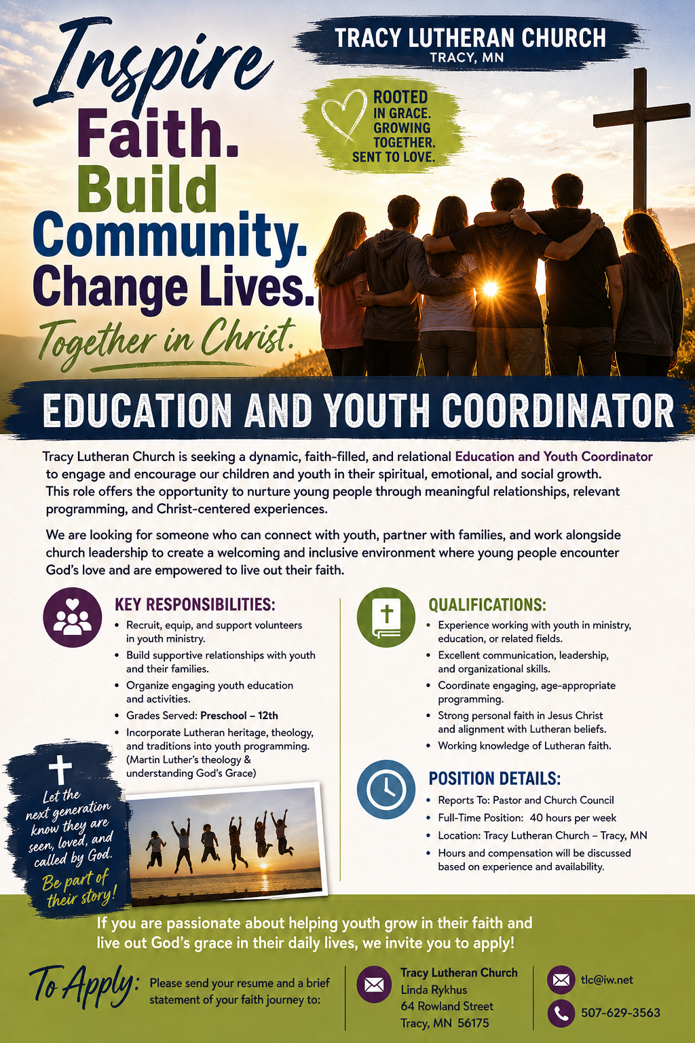
At the request of council president, Dennis Fultz, Tracy Lutheran Church is recognized as a Synod -Authorized Ministry site. Angie DeSmith has been authorized by Southwestern Minnesota Synod Bishop Dee Pederson to preach and preside for Holy Communion in the congregation . The authorization is granted in accord with
the ELCA’s guiding statement, The Use of the Means of Grace , which recognizes the witness of the sacrament as a celebration of the Church, serving its unity and proclaiming the Gospel; and that where it is not possible to provide ordained pastoral leadership, a synod bishop may authorize a properly trained person to preside at a certain time.

